PETES PIT

Change History

Index

Introduction 7

Overview of the pit 7

Major Components of the Pit 9

To Do’s 10

The Primary display 11

Multiple Displays 12

Working with Projectors 13

Steam Gauges 19

Customised Steam Gauges 23

RWR 25

Adding a real GPS to the Simulator 25

Warning Panels 31

The Multi-Function Displays 35

F4 Glass 39

MFDs and FreeFD 41

WideFS and FreeFD 41

Multiple FreeFD Applications and a single interface 42

Adding Sound 47

Input Devices 49

Getting Keystrokes into the Simulator 49

GoFlight Modules 54

The Throttle Assembly 56

Inputs on Plasma MM 64

2007 Analog input rebuild 65

Pinouts for the Cyclic Connector to MM2-1 67

Amplifying and Offset the Analog signal 69

Calibration of the Analog Amplifiers 71

The Flight Stick 71

Tuning the Joystick Axis 73

Helicopter Inputs 78

Linking Multiple computers 79

Touch Screens 81

Touch Screen Setup 82

Touchbuddy Installation 82

Touchbuddy Configuration 82

Additional Configuration 83

Running Touchbuddy 83

Appendix 84

Simulator Startup Procedures 84

Startup Procedure for FS2004 84

Startup Procedure for Falcon 4 87

Startup Procedure for LOMAC 88

Installation and Configuration of the computers 89

FSUIPC and WideFS 89

FSUIPC Post Upgrade Test Routine 89

FreeFD Versions 89

Macro Manager 90

Primary Computer 90

Second Computer 92

Third Computer 92

Sources of Information Forums and Sites 96

The Motion Platform 96

Safety in the pit 97

Wiring the pit 97

Back of Panel PCB 98

Wiring the JAY-EL switches 100

Earlier Versions 102

Lighting the Pit 106

Approach Plates 108

Building the Frame 109

Creating the Panels 114

Creating this document 114

About the Builder 120

Now If I had a Million Dollars 123

Other Brisbane Pit Builders 125

Programming the simulator 126

What is FS-Server 132

FS Server Code Change History 132

Why Bother? 133

High Level Design 133

Understanding FSUIPC 134

Global Variables 135

Values used by FreeFD 136

Lat/Long Conversion 137

Distributing FS Information Between Computers 137

Generating the Lookup Tables 140

Data Type Creation 140

Case Statement Creation 141

Master Variable Initialisation 142

Database Structure 142

Challenges encountered 143

Known Issues 143

Unable to process multiple requests concurrently 143

Discovery of Offsets Use by other products 144

Inter-process and Inter-machine communication 146

To Time or not to time 147

The Shared Memory Programs 147

Batch Files to Launch IO Code 148

The Physical IO Programs 148

Shared Memory - SimDualStack.vbp 149

Shared Memory - SimParallaxServo 150

Shared Memory – PhidgetIOA and PhigdetIOB 151

Shared Memory PhidgetLedA 152

Shared Memory PhidgetLedB 153

Shared Memory PhidgetServo 153

Shared Memory LCDText 154

PTTRCLink 154

Debugging and Monitoring Code 155

Phidgets Performance 156

Overall Performance with Multiple Programs 156

Working with LCD Displays 157

Manual Initialisation of LCD 164

Interfacing the LCD to Falcon 4 165

Modifying a Real VOR 169

Visual Basic Code To Drive Motor 171

Determining the Dial Position using potentiometers. 172

Driving the Analog Meters 175

Servo Interface 176

More on Programming the Pit 178

USB Connectivity 186

Primary Computer 186

Finding other aircraft 187

System Performance Comparisons 188

Lock-on Modern Air Combat 1.11 LUA Export 188

Driving the GPS from LOMAC 200

Working with Serial Ports and Visual Basic 200

Driving the Flight Illusion Dual Engine Gauges 201

Programming the Seven Segment displays 204

An Analog Clock 205

Magnetic Switches 208

Mapping the output devices to the simulators 208

Button Mappings 213

ICP 219

Button Mappings 222

Key layout summary 227

Xkeys Pinouts 229

Key Labels for the Button Array 233

LEDs and Lights 233

Attitude Indicator Pinouts 240

ICP Wiring Diagram 241

Read From shared Memory 244

Write from Shared Memory to LCD 247

LCD Pinout for Graphical LCD 247

Planning the F16 Pit 248

Backlighting 251

Pinouts for the PCBs 251

Falcon 4 Allied Forces Shared Memory format 253

FSUIPC Offsets utilisation by product 259

Flight Illusion Dual Engine Stack 259

FreeFD EADI 259

FreeFD ECAS 262

FreeFD ND 265

Simkits TRC Link 3.3 266

Simkits MultiController 1.4 270

Mapping Falcon 4 to FSUIPC Values 272

Lomac Export LUA Script (as of 6th Feb 2006) 280

Output from Lomac Data 287

LUA Script to Get Coordinates 288

PCB Circuit Diagrams 290

PCB Connectors – Quantities 306

PCB Connectors Alphabetically Sorted 309

# Introduction

This document describes a project that has been incubating since I fixed flew a primitive flight simulator on a Sinclair ZX-81. The Goflight modules made the concept of building a simulator that much more of a reality, so the project began.

This document is a combination of how and why things were done, as well as reference material for me when changing the pit. It has plenty of photos, diagrams and tables.

# Overview of the pit

The pit is not intended to look like a specific aircraft as I enjoy flying Beechcraft 350s, as much as F16s, and A10s, and more recently the SU25T. As no single flight simulator supports all of these aircraft I designed the pit to support different simulators.

As of November 2005 I’m flying FS2004, Falcon 4 (and its variants including Allied Forces), Lock-on Modern Air Combat (LOMAC) (and its add-on Flaming Cliffs).

As each of these simulators offer API interfaces, I have written programs to interface the simulator to the hardware pit.

The pit currently uses three PCs, a Primary PC for the simulator itself, a second PC running the bulk of my code, and a third for driving the MFDs.

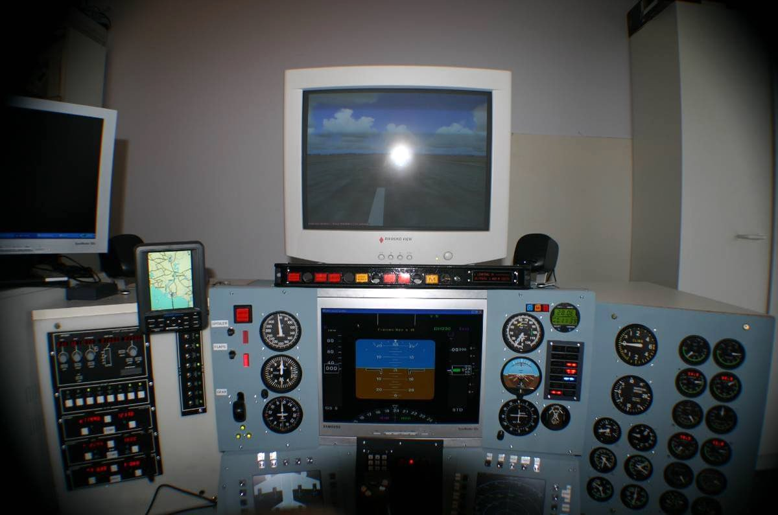

Photo 1 - Overview of the Pit Oct 2005

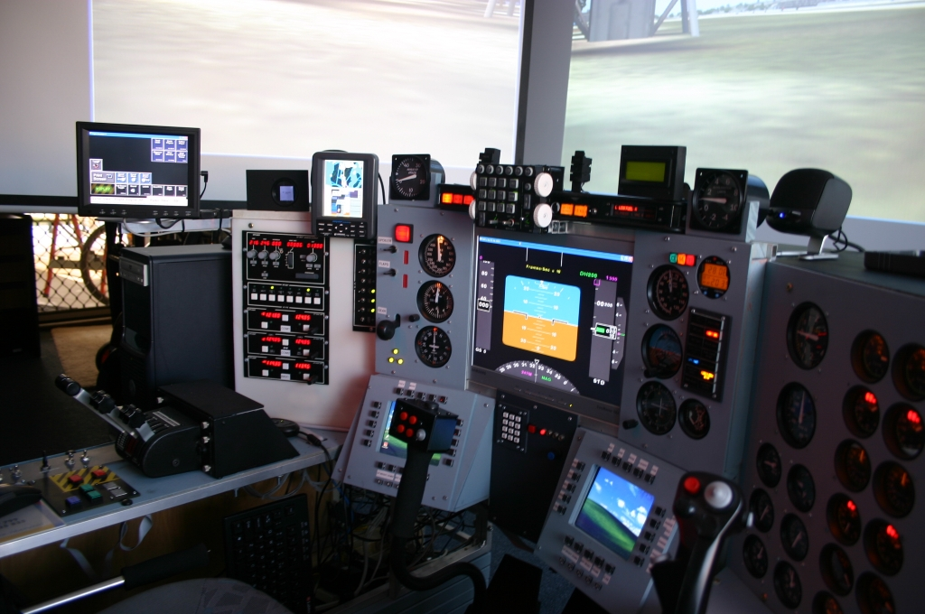

Photo 2 October 2006

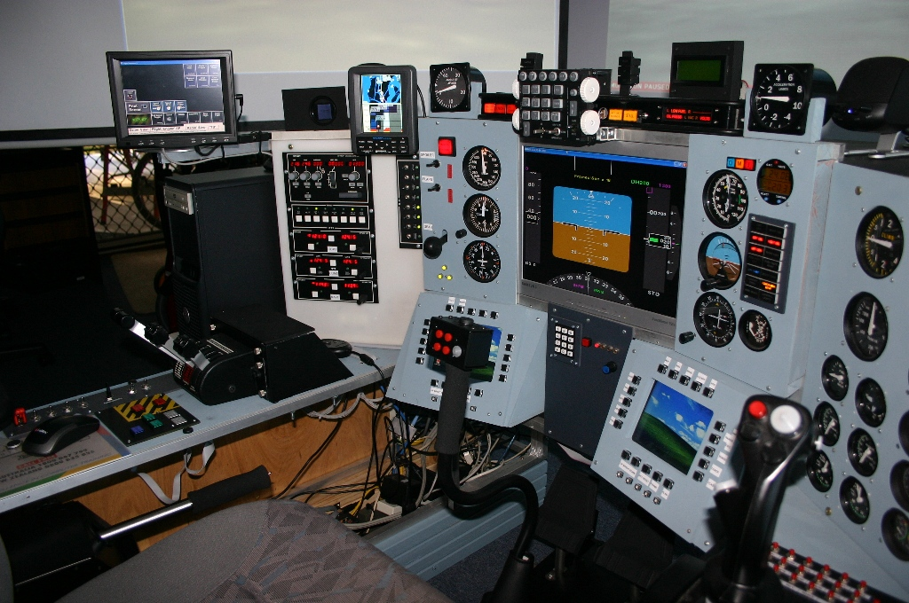

# Major Components of the Pit

Whilst the components are covered in detail throughout the document, here’s an overview of the electronics/modules in the pit.

Adding some outputs to the cockpit adds another dimension to the simulator experience. As with a real cockpit, gauges and warning LEDs/Lights enable you to spend more time looking at the window, and less time bringing up gauges on screen.

I use a mix of the Simkits CCU (Central Control Unit), Phidgets, and Beta Innovations devices in the pit. The Simkits CCU primarily drives the gauges, the Phidgets devices drive LEDs, LCDs, and Lights (i.e. incandescent bulbs). The Goflight modules and Flight Illusion Gauges are prebuilt systems that just plug into the pit.

# To Do’s

* Built 28 Pin adaptor for MFD PCBs
* Lookat floodlight options
* Verify PCB assembly assuming pit is split into three sections
* PCB design to account for power buses on PCBs
* Consider test points for suprises
* Add leds as power bus indicators
* Check canopy options
* Add Led brightness code to new shared memory modules
* Use spare I/O port to turn off/on backlight on LCD module
* Explore Speedbrake and gear setting, should be proportional currently binary
* Fix
  + Falcon Right hand Gen light
  + Sticky fire warning
  + Inverted VSI values for Falcon
* Tidy up document for HOTAS assignments
* Fix il2 working with multiple sticks
* Label LHS switch panel:
  + Master Arm, Smoke, tba
* Test voltages for stability of Parallax, seems to constantly hang measured 8.2V
* Add Eject button under seat, connect to Left Hand Panel and connect to seat adjustor.
* Document:
  + Two xkeys running for MFD
  + Nrew Throttle Quadrant
  + New cyclic and collective configs
  + Record switch types purchased and required

# The Primary display

When the pit was originally built I used the Matrox Parhelia as the display.

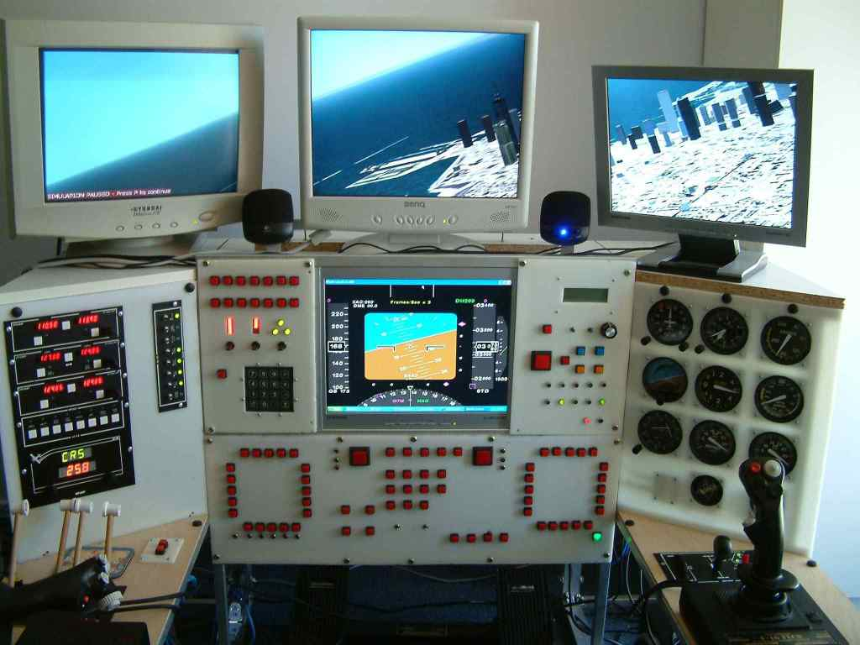

The Parhelia gave great situational awareness for flying civil aircraft, but ended up being a liability when dog fighting in LOMAC as it just wasn’t fast enough.

A 9800XT replaced the Parhelia with a 19” CRT. What really gives the wow factor is when it is projected up onto the wall.

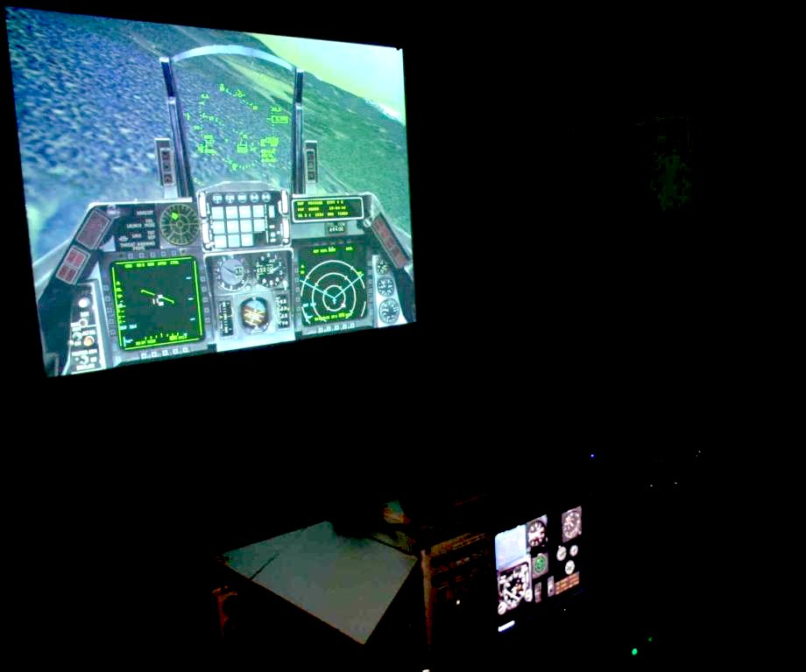

Figure 46 Earlier version of pit using projector

The first projector was a Sony with an 800*600 resolution that had a relatively long throw. The current project is a Mitsubishi 1024*768 with a shorter throw, which makes the image much larger and crisper. One of the interesting threads in the Viperpit forums was a discussion about using a mirror to distort the picture to enable it to be thrown onto a curved screen. In the shorter term I’m planning to use a flat mirror to increase the throw distance to overcome the narrowness of the simulator room.

# Multiple Displays

The early versions of the pit used a Matrox Parhelia card with three displays attached. Whilst this gave a nice surround view, the Parhelia did not have the horsepower to effectively drive newer generation games such as LOMAC.

The 9800XT which replaced the Parhelia in the primary computer does have two video outputs, so one of the to-dos was to attach two Projectors and see what the results looked like. Unfortunately it wasn’t quite was I was hoping for, in that the displays are ‘joined’ in the same way as the Parhelia does. The good news is FS2004 still is able to work nicely across multiple displays. You may need to switch FS2004 from Full Screen Mode to get this to work.

Start FS and move it to one of the displays. Once this is done, double click to make it full screen. Now add a new view, the new view will be sitting on top of the existing window. The new view can now be dragged into the other window, and dragged to enlarge to the full screen.

Using the view menu, select which FS view and zoom to be used. Before launching into the view menu, remember which view is in which window. Once the correct views and zoom ratio have been selected the top menu can be hidden by Right-Click hide menu bar.

I’ve found two modes have been useful. The first for general flying, which uses a zoom ratio of 1.0 and uses the Front, and Front Left view. The second mode is when you are really wanting to look out the left windows as things go flying by. For this mode of flying a zoom ratio of 0.8 is used for the front view, and 0.7 for the Left view.

## Working with Projectors

I now have three screens that are driven by a Matrox Triple-Head-To-Go splitter. For FS2004, in addition to the front view I use the front left view but with a zoom of 0.8. I create new views and drag them around the screen. This means I can run the front screen at a normal zoom, but the side screen gets a slightly wider field of view.

These LOMAC photos are composites as I don’t have a camera with a 150◦ field of view.

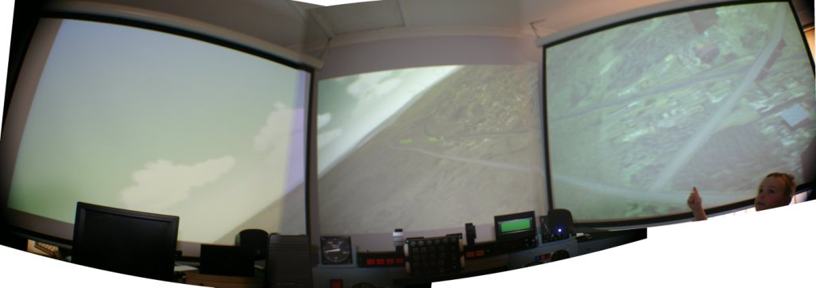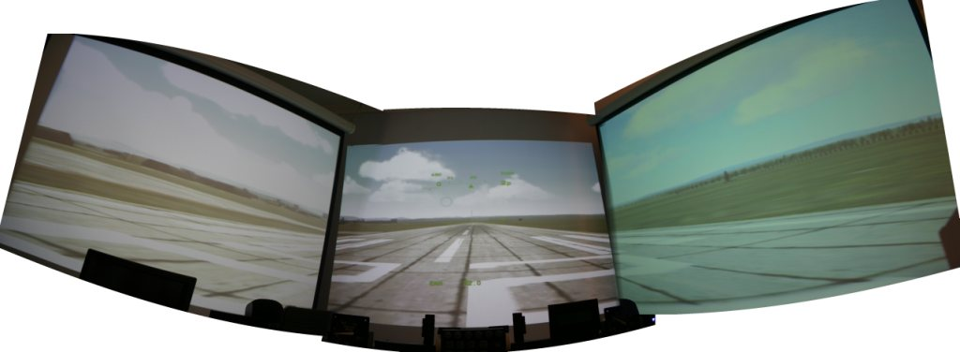

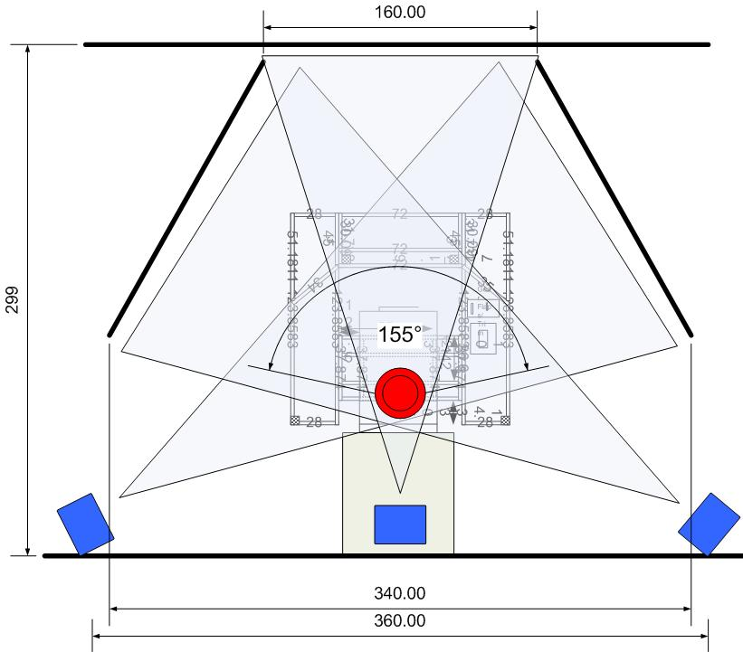

Both FS2004 and LOMAC have no problems at all driving the Triple head to go. Falcon4 isn’t being so co-operative, I know others have successfully done it, I keep getting CTD.

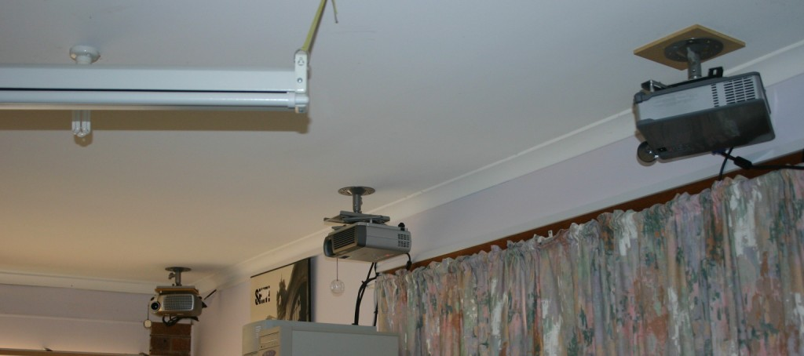

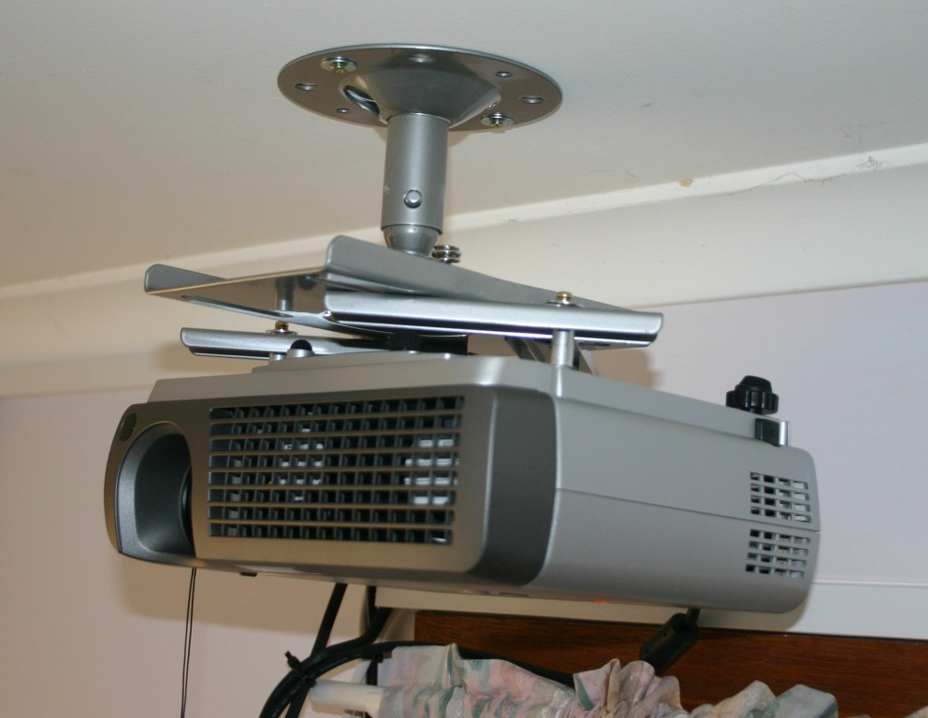

I didn’t originally plan to have three projectors, it just evolved… There are two different Mitsubishi’s 1024*768 and a Dell 800*600 projector. If I was to start afresh, all three projectors would be 1024*768 and exactly the same make and model to get colour consistency. Ceiling mounting the projectors wasn’t originally in the plan, but as it turns out you have less challenges with keystone and the cockpit doesn’t throw any unwanted shadows when the projectors are mounted well above the pit.

There is a small gap between the screens, I find I don’t notice the gap all that much as it is a small fraction of the total viewing area.

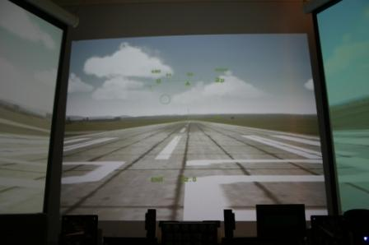

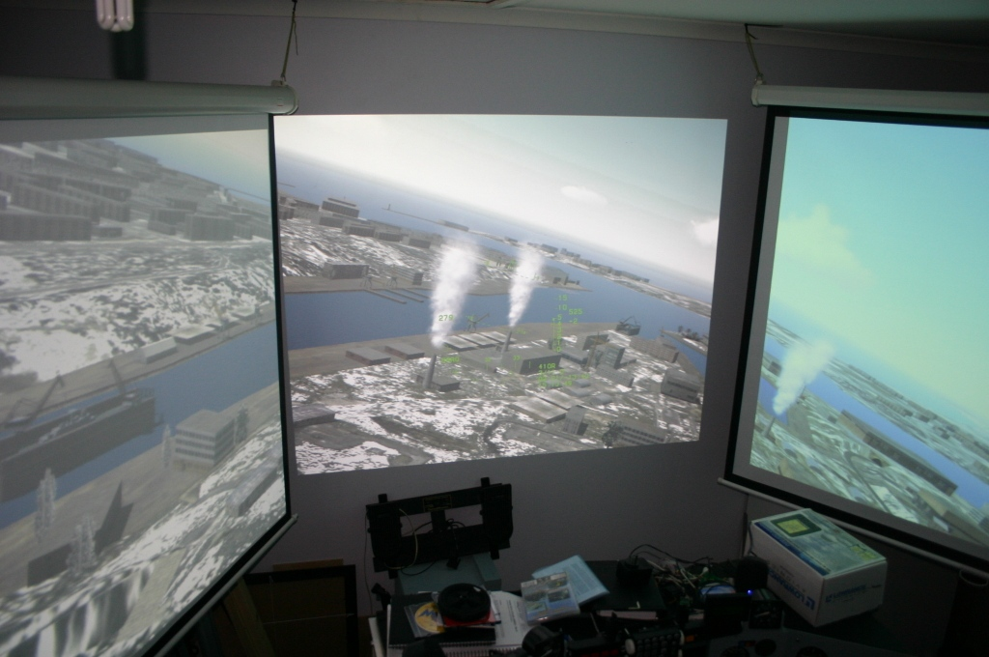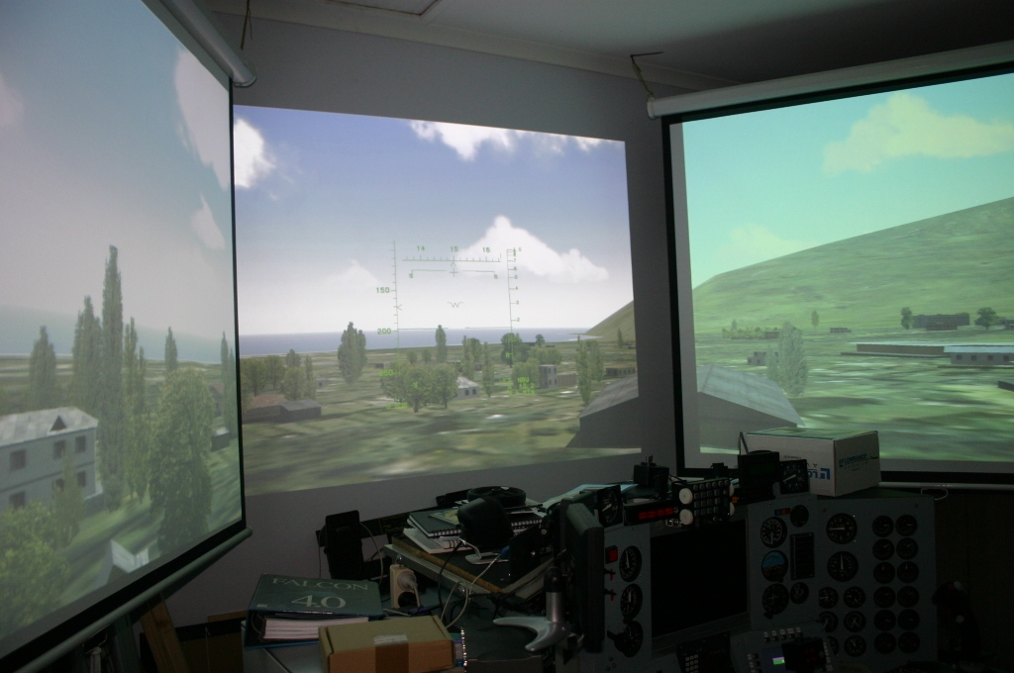

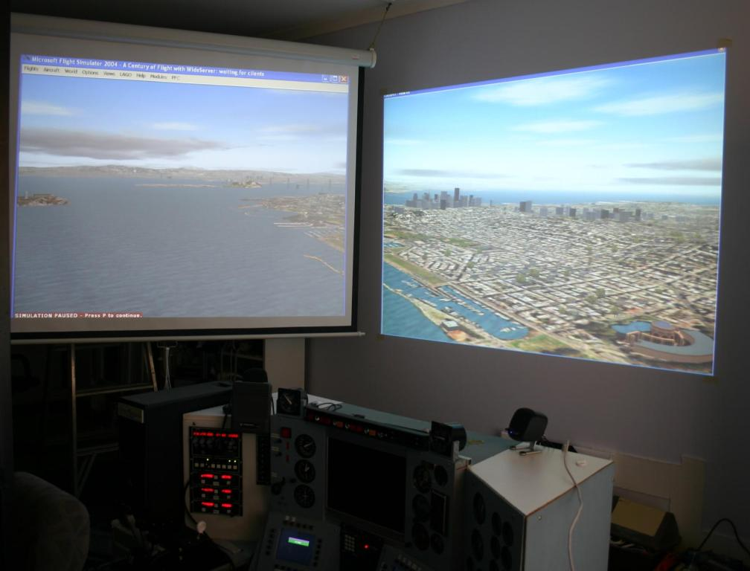

Photo 3 Earlier version with two screens

Plan A involved the use of mirrors, as it turned out it was easier to correctly mount the projector than to try and correctly position a large mirror. One of the challenges to be overcome was ensuring the pilots head didn’t cast a shadow in the image. This is largely handled by positioning the projectors well above the pilots head, and aiming them downward. Whilst this does mean keystone correction is required, there are no nasty shadows.

Something that will need considering if the cockpit has a frame above the pilot is the frame’s impact on shadows. One of the easier ways to deal with this is to project the image onto the back of the screen.

There is an interesting thread on projectors and curved mirrors here

<http://www.flightdecksolutions.com/forum/viewtopic.php?t=1251&postdays=0&postorder=asc&start=0>

# Steam Gauges

Simkits have been the primary backbone of the steam gauges in the pit. A problem with Simkits in the earlier days was the lack of support for dual engine instrumentation. As a workaround I used a 4 Port PhidgetServo along with some VB code to address this shortcoming. In 2005, Simkits introduced the MCU, which supported multi-engine configurations, which I ordered with some engine gauges. While I was waiting for the MCU to arrive, Flight Illusions released their Dual Engine Stack. This was added to the wish-list and installed in the pit a few months later ☺. This means I have a few gauges that are duplicated, looking for new roles.

Since flying LOMAC Flaming Cliffs one gauge that is a must is Angle-Of-Attack (AOA). I hadn’t noticed it as a major issue in other simulations, but in Flaming Cliffs, once you depart outside the AOA range things do not go well.

One of the current challenges is neither Flight Illusions (Dual Engine Stack) nor Simkits (MCU) offer an API to enable pit builders to interface the gauges to simulators other than FS200X. Simkits does offer a very usable API for the CCU, but that doesn’t support dual engine aircraft (one of the nice things about the CCU SDK is that is natively supports networking, so you are able to drive the gauges from the another computer if required… something I do use). Also of concern is Flight Illusions does not have ‘safeties’ in the driver for the dual engine stack. The impact of this was if you moved from the Beachcraft to a Boeing 737 is some of the gauges can be knocked out of alignment. I still have to fix my Oil Pressure Temp and Pressure gauges after running the stack up on a 737, hopefully this is something that will be addressed in the future.

The Flight Illusions products come assembled and are based on Stepper Motors. The Simkits range are servo based and can either be purchased in kit form or assembled. Both products families are well constructed, but also have their quirks.

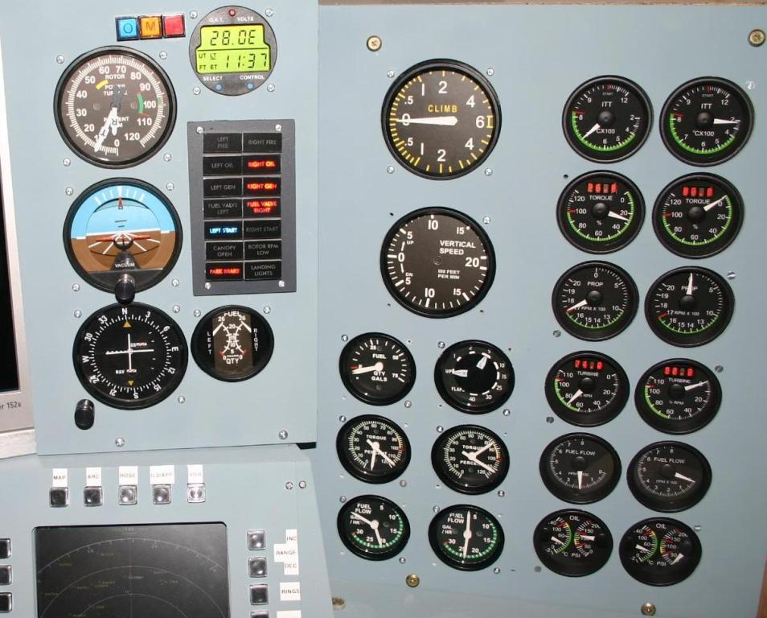

Figure 28 Right Hand Gauges

***Gauges in the Pit***

|  |  |  |
| --- | --- | --- |
| Gauge Name | Panel | Manufacturer |

|  |  |  |
| --- | --- | --- |
|  |  |  |

|  |  |  |
| --- | --- | --- |
| Airspeed | Front Left | Simkits via CCUv2 |

|  |  |  |
| --- | --- | --- |
| Altimeter | Front Left | Simkits via CCUv2 |

|  |  |  |
| --- | --- | --- |
| Heading Indicator | Front Left | Simkits via CCUv2 |

|  |  |  |
| --- | --- | --- |
|  |  |  |

|  |  |  |
| --- | --- | --- |
| Helicopter Rotor/Turbine | Front Right | Simkits via MCU (Parallax) |

|  |  |  |
| --- | --- | --- |
| Clock | Front Right | Simkits via CCUv2 |

|  |  |  |
| --- | --- | --- |
| Attitude Indicator | Front Right | Simkits via CCUv2 |

|  |  |  |
| --- | --- | --- |
| VOR | Front Right | Simkits via CCUv2 |

|  |  |  |
| --- | --- | --- |
| Fuel Gauge | Front Right | Simkits via CCUv2 |

|  |  |  |
| --- | --- | --- |
|  |  |  |

|  |  |  |
| --- | --- | --- |
| Angle Of Attack | Top | Custom via Phidgets Servo |

|  |  |  |
| --- | --- | --- |
| G-Force | Top | Custom via Phidgets Servo |

|  |  |  |
| --- | --- | --- |
|  |  |  |

|  |  |  |
| --- | --- | --- |
| VSI | Far Right | Simkits via CCUv2 |

|  |  |  |
| --- | --- | --- |
| Radar Altimeter | Far Right | Custom via Phidgets Servo |

|  |  |  |
| --- | --- | --- |
| Flaps Position (dual gauge) | Far Right | Parallax |

|  |  |  |
| --- | --- | --- |
| Fuel Centre | Far Right | Parallax |

|  |  |  |
| --- | --- | --- |
| Fuel Left | Far Right | Parallax |

|  |  |  |
| --- | --- | --- |
| Fuel Right | Far Right | Parallax |

|  |  |  |
| --- | --- | --- |
| Total_Load_Amps (2824) | Far Right | Parallax |

|  |  |  |
| --- | --- | --- |
| Main_Bus_Voltage (2840) | Far Right | Parallax |

|  |  |  |
| --- | --- | --- |
|  |  |  |

|  |  |  |
| --- | --- | --- |
| ITT Left | Far Right | Flight Illusions Dual Stack |

|  |  |  |
| --- | --- | --- |
| ITT Right | Far Right | Flight Illusions Dual Stack |

|  |  |  |
| --- | --- | --- |
| Torque Left | Far Right | Flight Illusions Dual Stack |

|  |  |  |
| --- | --- | --- |
| Torque Right | Far Right | Flight Illusions Dual Stack |

|  |  |  |
| --- | --- | --- |
| Prop RPM Left | Far Right | Flight Illusions Dual Stack |

|  |  |  |
| --- | --- | --- |
| Prop RPM Right | Far Right | Flight Illusions Dual Stack |

|  |  |  |
| --- | --- | --- |
| Turbine RPM Left | Far Right | Flight Illusions Dual Stack |

|  |  |  |
| --- | --- | --- |
| Turbine RPM right | Far Right | Flight Illusions Dual Stack |

|  |  |  |
| --- | --- | --- |
| Fuel Flow Left | Far Right | Flight Illusions Dual Stack |

|  |  |  |
| --- | --- | --- |
| Fuel Flow Right | Far Right | Flight Illusions Dual Stack |

|  |  |  |
| --- | --- | --- |
| Oil Temp Left | Far Right | Flight Illusions Dual Stack |

|  |  |  |
| --- | --- | --- |
| Oil Pressure Left | Far Right | Flight Illusions Dual Stack |

|  |  |  |
| --- | --- | --- |
| Oil Temp Right | Far Right | Flight Illusions Dual Stack |

|  |  |  |
| --- | --- | --- |
| Oil Pressure Right | Far Right | Flight Illusions Dual Stack |

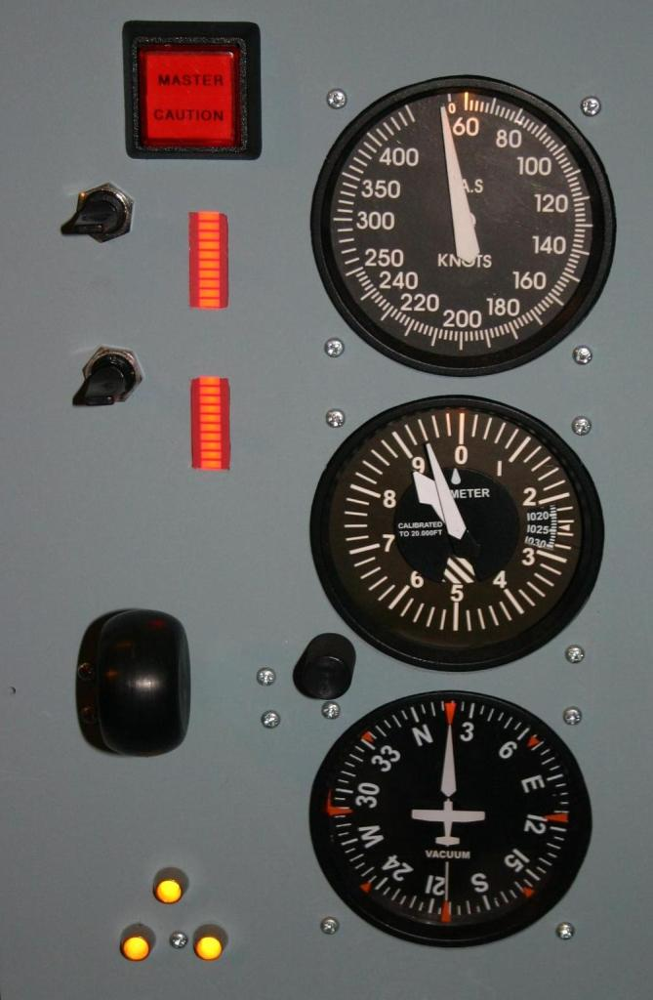

Figure 29 Front Left Panel

# Customised Steam Gauges

As Simkits do not offer every possible gauge for every aircraft a couple of the gauges have modified faceplates. Although the MCU holds promise it is limited in that it does not offer an SDK or the pit builder a complete choice of FSUIPC offsets to use. To address this I’m using a Phidgets 4 Port Servo card and a Parallax USB to Servo card to drive a subset of the gauges.

The gauge faceplates are edited in a normal editing program (such as Visio), saved as JPEG. The files are then taking down to the nearest place that prints photos and printed out. You get a long lasting faceplate for less than 30cents, much easier than fighting with bubble-jets.

The gauges which have been completely customised are:

* Radar altimeter
* Angle of Attack
* G Meter
* Bus Amps
* Bus Volts
* Fuel – Left, Centre, Right

For the large gauges the face plate is 78mm across

.

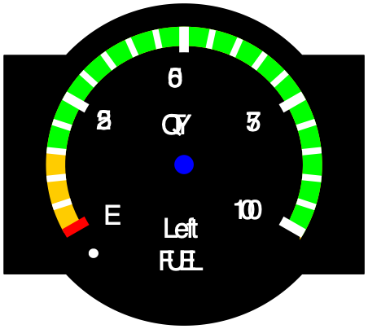

24Volts 24 Volt battery 28V Alternator

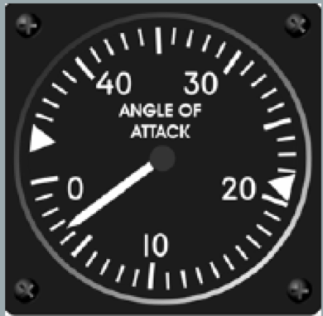

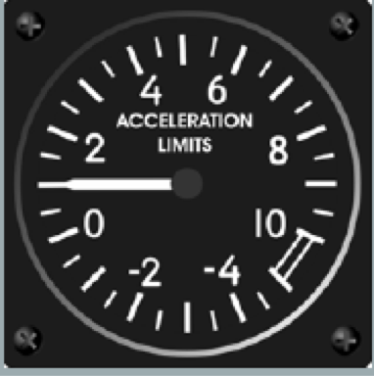

From <http://www.viperpit.org/forum/viewtopic.php?t=349&highlight=font>

Cockpit font is Trade Gothic Condensed 18 and Monotype News Gothic Condensed.

# RWR

The RWR is connected to Port E of the ElectronFlux. Despite my original concerns, the F4IDM software does run across the Lan using F4Glass Data mirror.

The Red lead of the DA board connects to the Y input, the Purple connects to the X input. Set DC coupling for input and 0.5V/Div for gain. The trigger is set to XY mode. Intensity set to 60% Will need to use the blanking input as the ‘home’ position is visible, L/R position may be used to get it off screen.

Note that nothing is displayed until a threat is seen.

# Adding a real GPS to the Simulator

Ever been flying around in F4 world and wondered just where you were? This idea is based on the work done by Peter Dowson for FS2004. Basically take a real GPS, turn the radio off, and throw serial data at it from the sim. I tried this first with FS2004 and found it so useful, I applied to F4. The GPS is mounted on the bottom LHS of the second F4 Glass screen.

Fragment of FSUIPC/GPSOut configurations files

On Server GPSOUT.INI

***[GPSout]***

***Sentences=RMC,PGRMZ,GGA***

***Interval=300***

***Port=WideFS***

***Speed=19200***

***PosTo6Decimal=Yes***

On Second computer with GPS Attached WIDECLIENT.INI

***[GPSout]***

***Port=COM1***

***Speed=19200***

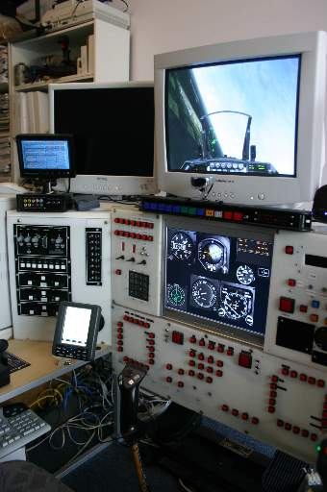  
The GPS is a Lowrance Airmap 2000C with the Asia Pacific base Map. I had thought I was going to be using some real horrible maths to convert the X/Y co-ordinates to the lat/longs needed by the GPS. Fortunately for me the developers of F4 must have belonged to the flat earth society 

Instead of trying to work out formulas that looked like  
d=2*asin(sqrt((sin((lat1-lat2)/2))^2 + cos(lat1) * cos(lat2) * (sin((lon1-lon2) /2))^2))

All I needed to do was start from a reference point, find a couple of multipliers for the X and Y axis, and vola, a real moving map, with ability to store flight plans.  
  
Here's a pretty much max zoomed out view of Korea

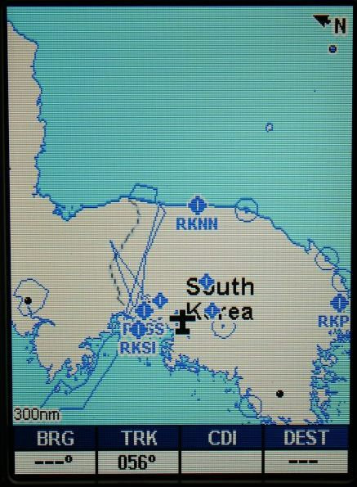  
And getting in a little closer. The land mass, rivers, and lakes are very accurately mapped in F4, the only downer is that the airbases are sometimes 4 miles out from where they are located in F4. It almost seems as though this was done on purpose as the lat/long list I have doesn't directly align with the list in F4. Good news in the GPS at least gets me close to an airport for a topup and windscreen clean. 

The even more good news is that in lomac 1.1, you get lat/longs, so you can use your GPS for FS2004, F4, and Lomac... cool. As LOMAC directly exports lat/longs no maths is required to map x/y to lat/longs. The co-ordinates from LOMAC map accurately to the real world, so the GPS can be used for airport approaches. Data is exported from the host PC using LUA, pushing the data into UDP packets. As I also use F4 Glass, and don’t want to sent the data twice from the host PC, I had written a program which takes the data from the UDP packets and maps it into two memory mapped files. One of the files is used by F4 Glass, the second by the program that outputs the serial data to the UPS. For more details on the how this is done, read the FSServer technical guide.

Falcon 4 Allied forces has both the Korean and European theatres, meaning there are different zero points for the theatres. For Falcon 4 the following parameters where used for the zero point and X/Y multipliers:

|  |  |  |
| --- | --- | --- |
|  | Korea | Europe |

|  |  |  |
| --- | --- | --- |
| Feet_in_lat | 365519.613 | 334000 |

|  |  |  |
| --- | --- | --- |
| XFeet_In_Lat | 365500 | 337000 |

|  |  |  |
| --- | --- | --- |
| Lat_Zero_Point | 123 | 10.98 |

|  |  |  |
| --- | --- | --- |
| Long_zero_point | 3.851 | 36.658 |

|  |  |  |
| --- | --- | --- |
|  |  |  |

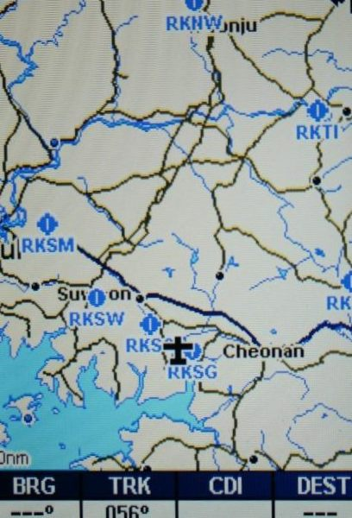

With Falcon 4 Allied Forces another theatre was added which, unlike the Korean Peninsula, the airports are in their real location. Now the GPS can be used for Approaches! As can be seen here approaching an airport near Venice.

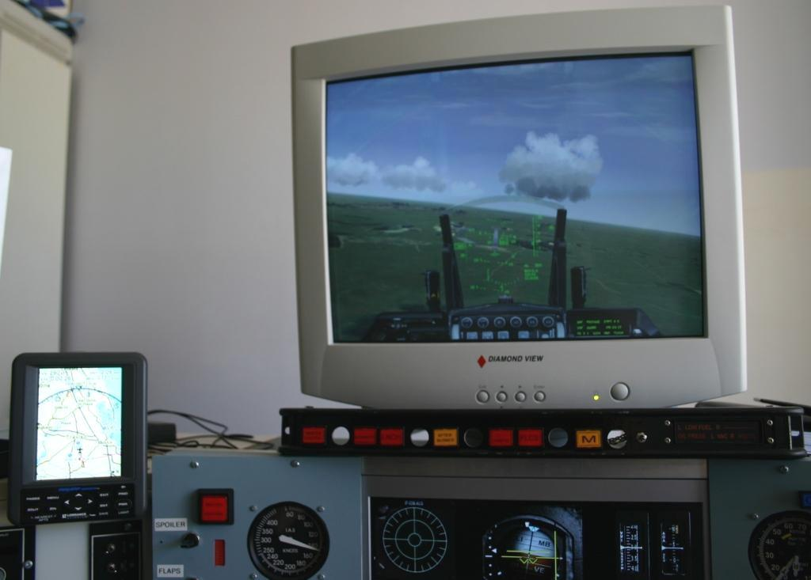

Figure 15 Heading to an Airport near Venice

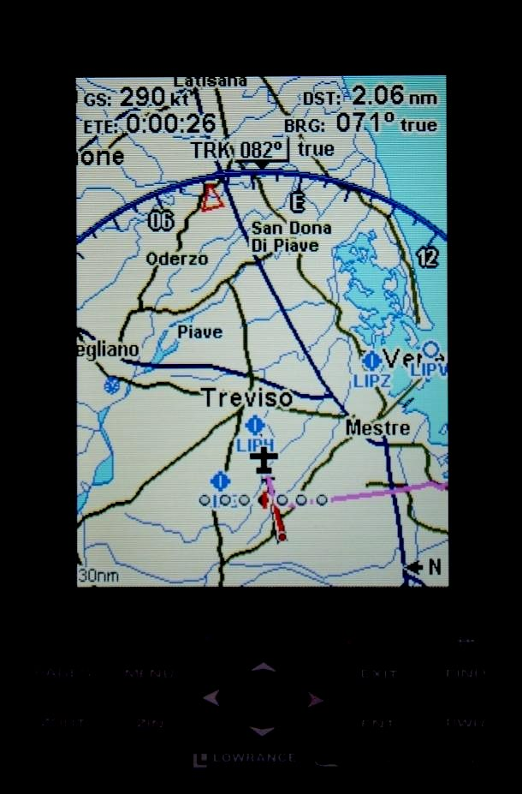

Figure 16 Close up on approach around Venice

Whilst tearing the pit and code apart, thought I revist the warning panel (normally down on the bottom RHS in a real F16 pit). I used the approach used by a couple of others and grabbed a car video display with an S-Video connector. Attached it to the second port on a 9800XT, and vola, a realistic warning panel without requiring me to wire up more bulbs. Its sitting on the top LHS of the pit. The photo doesn't do it justice, it looks smick, thanks again to Erwin for F4 Glass!!  
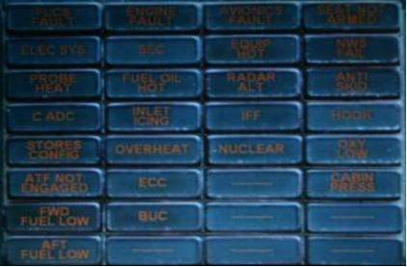

Now that Lomac has LUA and the ability to export coordinates, that’s one of my next projects:

The code should look something like[1]

MyPlane = LoGetObjectById(LoGetPlayerPlaneId())

Lat = MyPlane.LatLongAlt.Lat

Long = MyPlane.LatLongAlt.Long

Alt = MyPlane.LatLongAlt.Alt

# Warning Panels

Having real indicators in the pit liven up the flight, right from engine startup to shutdown. Whilst other builders have had success using clear film and inverse lettering through a laser printer, I wasn’t able to get the contrast I wanted for the pit. Fortunately Flight Deck Solutions (FDS) makes annunicator legends and is happy to do custom lettering. Each annunicator supports two leds. You can order the leds from FDS or get them from your local electronics supplier. I’d strongly recommend getting higher-intensity leds as ordinary leds aren’t bright enough for daylight flying. As I drive the Leds with a PhidgetLed, I was not too concerned about the leds being too bright as they are able to be dimmed via software.

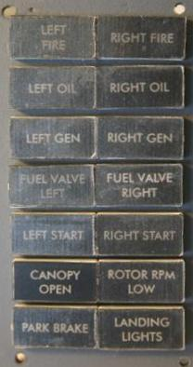

Figure 23 Panel before installation

You’ll note that the ‘Canopy Open’ annunicator is clearer than the other ones. This is because I had removed the protective covering on it. Now the unit is installed the protective covering has been removed from the other annunicators.

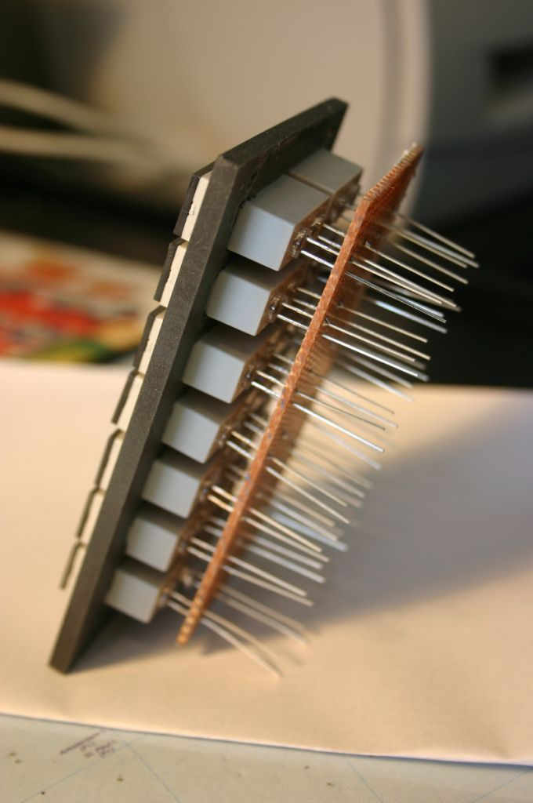

Figure 24 Warning Panel before leds are trimmed

The leds are mounted on veroboard, using a press fit to attach the annunicators. As with other panels the connections are aggregated into a single IDC connector.

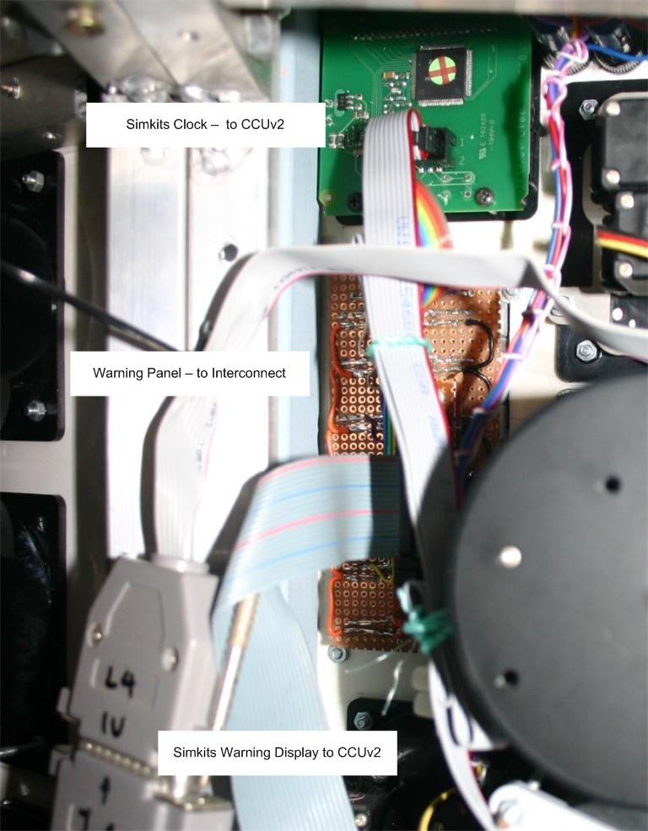

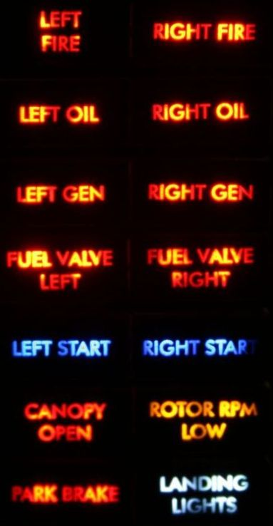

Figure 25 Warning Panel all lit up

# The Multi-Function Displays

The pit has two MFDs, which have two distinct roles, the first as data entry sources, and the second role as display devices. In the first iteration of my pit project I had just focused on the data entry, i.e. the buttons around the display. Given some interesting threads on the Viper Pit forum, I decided that displays were a must for the second generation of the pit.

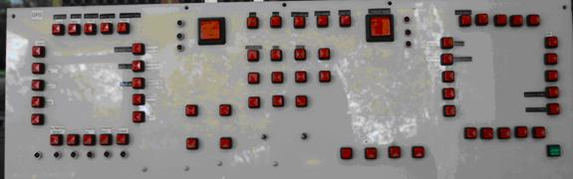

Figure 17 Mark 1 MFD without displays

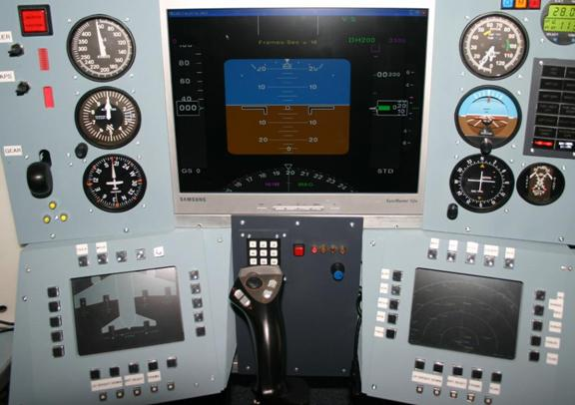

Figure 18 Mark II MFD displays included

The photo was taken with FS2004 and FreeFd driving the centre and bottom MFDs. There are currently three computers driving the simulator, one for the primary simulator, a second for driven the centre MFDs, and my code to drive the Phidget devices, and the third for driving the bottom MFDs.

Initially I had looked at using the Parhelia card for this, but it didn’t want to run at the lower resolutions, so I ended up buying some PCI video cards (ATI 9250s). These cards won’t win any performance races, but do the job as a display for the MFDs. Why PCIs and not AGPs (or PCI Express for that matter), basically it’s a density issue, I wanted three displays, two for MFDs (but limited to only 640*480), and then a higher resolution screen for running applications. The higher resolution screen normally sits to the top left hand side of the pit and is switched off once the applications have been started.

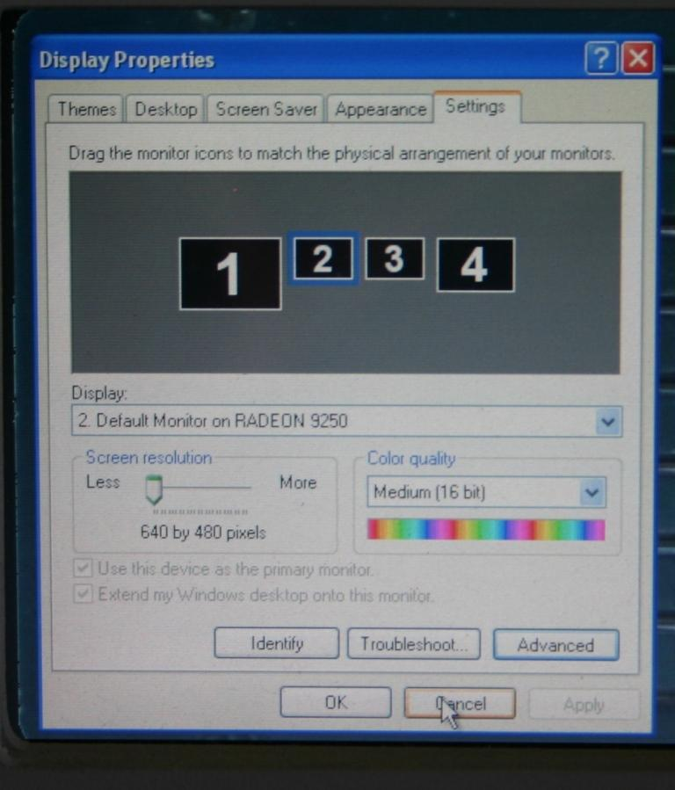

Figure 19 Display Settings for MFDs

Something I did learn while setting this up was not all resolutions are displayed at this screen. To see more resolutions (like 640*480) Select Advanced – Adaptor – List All Modes.

Also the screens can be rearranged, you can drag the monitors on the display settings screen to get the left right order correct.

Assembling the MFDs was a challenge as the displays slant upwards and inwards. The surrounds of the MFD are made from wood, the front sections are made from plastic sheets that have been cut and glued together. The MFD has to be reasonably sturdy to deal with forces of people pressing the MFD buttons. The sticky tape around the front of the monitor is to hold glass in place to protect the screen against falling objects and sticky fingers.

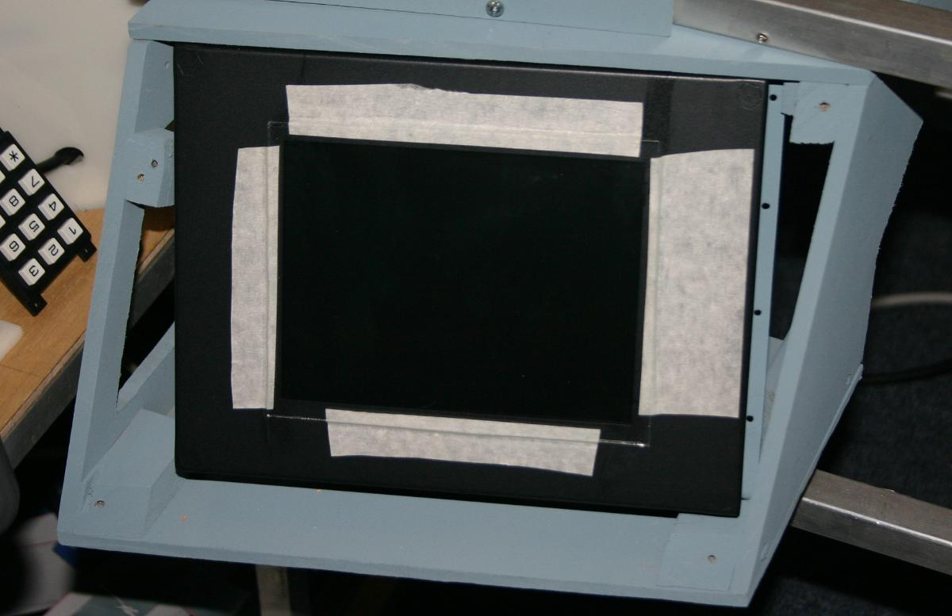

Once the monitor fitted, then it was time to add the keys.

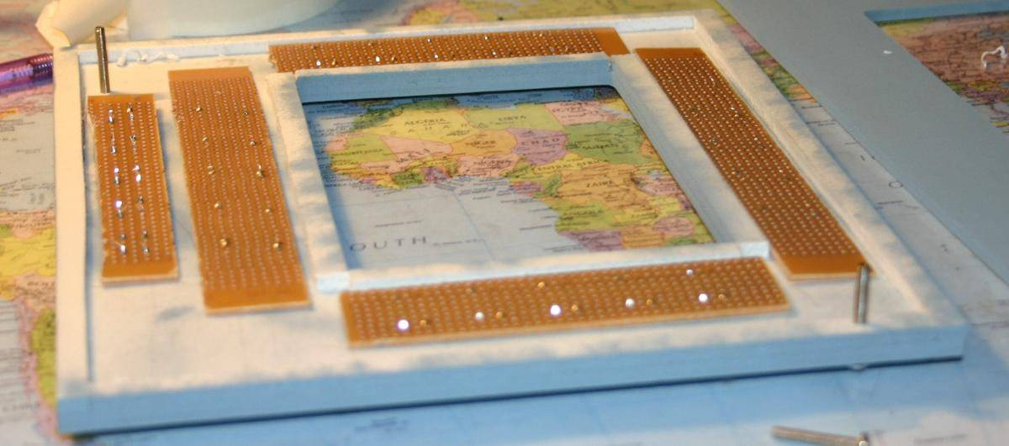

The push buttons have dual contacts, this will enable me to drive both the third computer driving the screens, but also to drive the primary flight computer.

Why bother driving the third computer? Well programs such as FreeFD take keystrokes to change Range, select parameters to be displayed, as well as things such as brightness.

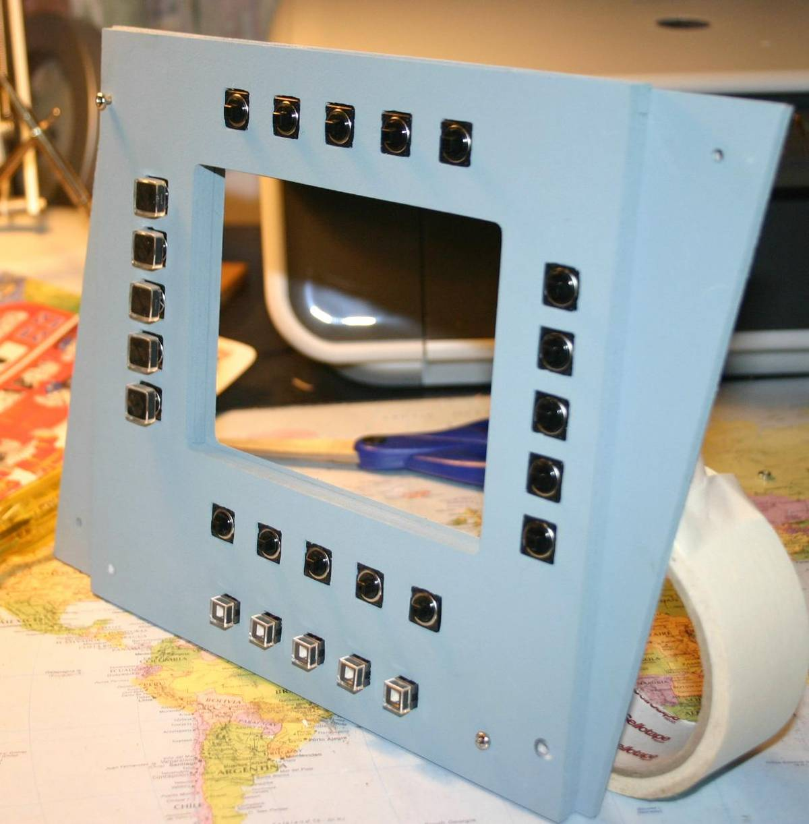

As the buttons are all momentary the buttons connect to an X-Keys matrix card.

This is still a work in progress, as I haven’t dual-interfaced the buttons around the display.

# F4 Glass

F4 Glass is a great tool that interfaces with Falcon 4 to provide external gauges, on both local and remote computers.

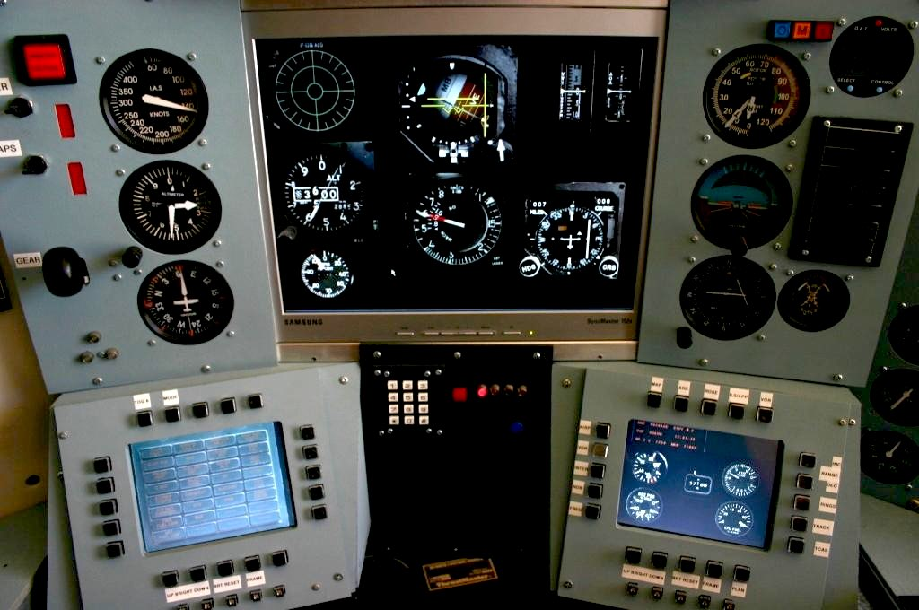

Figure 20 F4 Glass across multiple monitors

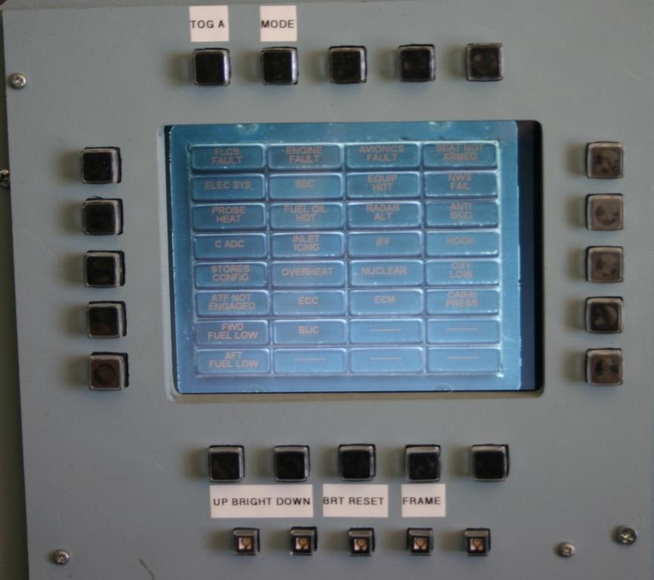

Figure 21 F4 Glass Left MFD

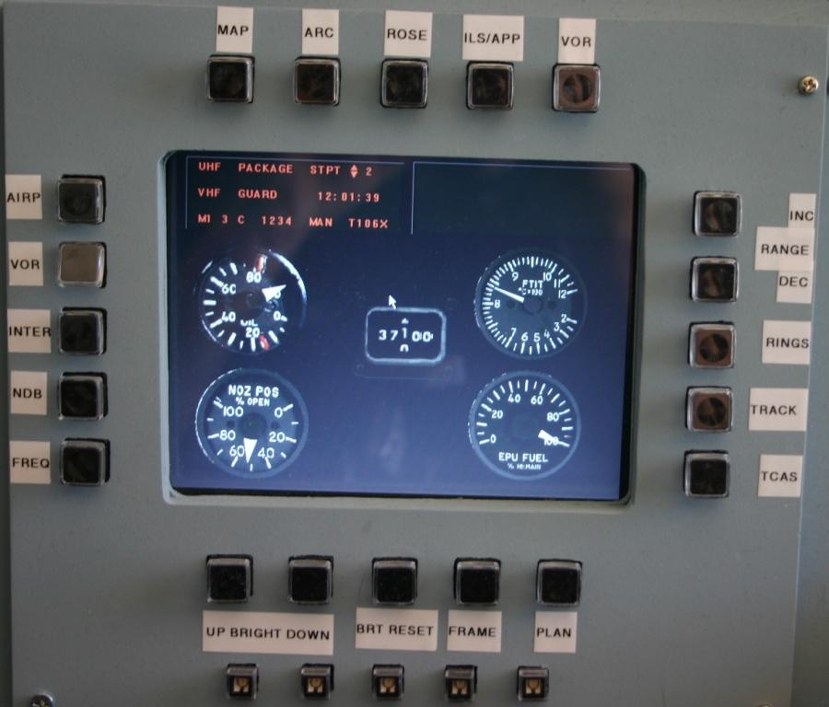

Figure 22 F4 Glass Right MFD

# MFDs and FreeFD

The third computer is currently driving the two MFDs at the bottom of the pit. FreeFD is a set of applications, EADI, ECAS and ND, all of these individual applications use FSUIPC as the data source. To access flight information from another computer Wide-FS is used to provide the FSUIPC bridge, i.e. it provides FSUIPC interface on a computer remote from the simulator.

Using a group of applications on a remote computer introduces some challenges, one of which is not seen if a single application is running on a remote computer. The first challenge is CPU resourcing, the second is getting keystrokes to individual applications from a single source.

# WideFS and FreeFD

If you are running a singe instance of a FreeFD and WideFS on a PC you’ll probably never see this issue. It is manifested by the display data either freezing, lacking well behind the aircraft, or just given the bizarrest of results. Root cause is CPU starvation. When running under Windows XP a process can run with any one of six priorities, ranging from Low, Below Normal, Normal, Above Normal, High, and Realtime. As you’d expect processes normally start at Normal ☺

The challenge is that an applications priority is ‘bumped around’ depending on whether it is running in the foreground or not. So what can happen (and has happened in my Pit), was the one of the FreeFD applications ‘hoggs’ the CPU. This means WideFS doesn’t get the CPU resources it needs, and in turn, provides invalid or out of date information through the FSUIPC interface… net result is wrong readings on the FreeFD displays.

This is resolved by lowering the priority of the two FreeFD applications to below normal using Windows Task Manager.

* Start Task Manager
* Click on one of the FreeFD applications
* Right-Click go to process
* Right-Click on the process
* Set Priority – Below Normal
* Repeat for the other FreeFD application

# Multiple FreeFD Applications and a single interface

As described above, I run two FreeFD applications on the third computer to drive the two MFDs. As you know, at any one point in time only a single application runs in the foreground in Windows, and it is only this application that receives mouse clicks and keystrokes.

This means if using xkeys or a plain old keyboard, the user has to mouse click on the MFD before sending any keystrokes to ensure the application gets the keystrokes. Now given the desired user experience is to just press on a button on either of the MFDs and get a result, a work around needed to be found.

I ended up cutting some code that sits in the foreground (on a third screen off to the side of the pit) that collects keystrokes and then sends the keystrokes to either of the FreeFD applications. The trigger for sending the keystroke is having two or more characters in the text box.

X-Keys

MFD-Control

EICAS

ND

**Keystroke flow with Dual FreeFD Applications**

The interface is simple, the text box receives the character strings from xkeys, and depending on the sequence sends characters to the FreeFD applications.

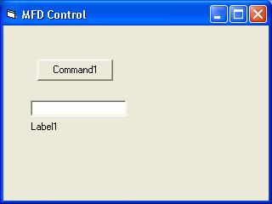

The xkeys module uses the default test sequence, e.g. A1, A2, and so on.

Getting keystrokes to applications is not always as easy as it should be, MFDControl uses a Windows API SendInput, and its associated data structures. This at least works with the FreeFD suite of applications. It may not work with applications using DirectX APIs.

When working with the touch screen and MFD Control you need to launch the touchbuddy first, then MFD contro, and only resize touchbuddy using the stylus, not the mouse. Otherwise MFDControl won’t be able to set itself to receive the keystrokes.

Mapping of input keys to applications

|  |  |  |
| --- | --- | --- |
| MFD Button | Application | Virtual Key |

|  |  |  |
| --- | --- | --- |
| RH_Bottom_1 | ND 0.9 | VK_9, "Ignore" |

|  |  |  |
| --- | --- | --- |
| RH_Bottom_2 | ND 0.9 | VK_0, "Ignore" |

|  |  |  |
| --- | --- | --- |
| RH_Bottom_3 | ND 0.9 | VK_8 |

|  |  |  |
| --- | --- | --- |
| RH_Bottom_4 | ND 0.9 | VK_F |

|  |  |  |
| --- | --- | --- |
| RH_Bottom_5 | ND 0.9 | VK_P, "Upper" |

|  |  |  |
| --- | --- | --- |
| RH_Top_1 | ND 0.9 | VK_A, "Upper" |

|  |  |  |
| --- | --- | --- |
| RH_Top_2 | ND 0.9 | VK_R, "Upper" |

|  |  |  |
| --- | --- | --- |
| RH_Top_3 | ND 0.9 | VK_M, "Upper" |

|  |  |  |
| --- | --- | --- |
| RH_Top_4 | ND 0.9 | VK_I, "Upper" |

|  |  |  |
| --- | --- | --- |
| RH_Top_5 | ND 0.9 | VK_V, "Upper" |

|  |  |  |
| --- | --- | --- |
| RH_Left_1 | ND 0.9 | VK_A, "Lower" |

|  |  |  |
| --- | --- | --- |
| RH_Left_2 | ND 0.9 | VK_V, "Lower" |

|  |  |  |
| --- | --- | --- |
| RH_Left_3 | ND 0.9 | VK_I, "Lower" |

|  |  |  |
| --- | --- | --- |
| RH_Left_4 | ND 0.9 | VK_N, "Lower" |

|  |  |  |
| --- | --- | --- |
| RH_Left_5 | ND 0.9 | VK_S, "Upper" |

|  |  |  |
| --- | --- | --- |
| RH_Right_1 | ND 0.9 | VK_OEM_MINUS, "Ignore" |

|  |  |  |
| --- | --- | --- |
| RH_Right_2 | ND 0.9 | VK_OEM_PLUS, "Ignore" |

|  |  |  |
| --- | --- | --- |
| RH_Right_3 | ND 0.9 | VK_R |

|  |  |  |
| --- | --- | --- |
| RH_Right_4 | ND 0.9 | VK_H, "Upper" |

|  |  |  |
| --- | --- | --- |
| RH_Right_5 | ND 0.9 | VK_C, "Lower" |

|  |  |  |
| --- | --- | --- |
| LH_Top_1 | OSS EICAS 0.6 | VK_S, "Lower" |

|  |  |  |
| --- | --- | --- |
| LH_Top_2 | OSS EICAS 0.6 | VK_V, "Lower" |

|  |  |  |
| --- | --- | --- |
| LH_Bottom_1 | OSS EICAS 0.6 | VK_9, "Ignore" |

|  |  |  |
| --- | --- | --- |
| LH_Bottom_2 | OSS EICAS 0.6 | VK_0, "Ignore" |

|  |  |  |
| --- | --- | --- |
| LH_Bottom_4 | OSS EICAS 0.6 | VK_F |

Constant mappings

|  |
| --- |
| Constant |

|  |
| --- |
| RH_Top_1 = "l5" |

|  |
| --- |
| RH_Top_2 = "m5" |

|  |
| --- |
| RH_Top_3 = "n5" |

|  |
| --- |
| RH_Top_4 = "o5" |

|  |
| --- |
| RH_Top_5 = "p5" |

|  |
| --- |
|  |

|  |
| --- |
| RH_Bottom_1 = "p2" |

|  |
| --- |
| RH_Bottom_2 = "o2" |

|  |
| --- |
| RH_Bottom_3 = "n2" |

|  |
| --- |
| RH_Bottom_4 = "m2" |

|  |
| --- |
| RH_Bottom_5 = "l2" |

|  |
| --- |
|  |

|  |
| --- |
| RH_Left_1 = "p4" |

|  |
| --- |
| RH_Left_2 = "o4" |

|  |
| --- |
| RH_Left_3 = "n4" |

|  |
| --- |
| RH_Left_4 = "m4" |

|  |
| --- |
| RH_Left_5 = "l4" |

|  |
| --- |
|  |

|  |
| --- |
| RH_Right_1 = "l1" |

|  |
| --- |
| RH_Right_2 = "m1" |

|  |
| --- |
| RH_Right_3 = "n1" |

|  |
| --- |
| RH_Right_4 = "o1" |

|  |
| --- |
| RH_Right_5 = "p1" |

|  |
| --- |
|  |

|  |
| --- |
| LH_Top_1 = "e5" |

|  |
| --- |
| LH_Top_2 = "f5" |

|  |
| --- |
| LH_Top_3 = "g5" |

|  |
| --- |
| LH_Top_4 = "h5" |

|  |
| --- |
| LH_Top_5 = "i5" |

|  |
| --- |
|  |

|  |
| --- |
| LH_Bottom_1 = "i2" |

|  |
| --- |
| LH_Bottom_2 = "h2" |

|  |
| --- |
| LH_Bottom_3 = "g2" |

|  |
| --- |
| LH_Bottom_4 = "f2" |

|  |
| --- |
| LH_Bottom_5 = "e2" |

# Adding Sound

As can been seen by the photos the cockpit sound is primarily provided by a Logitech 4.1 sound system. The subwoofer sits underneath the right hand panel.

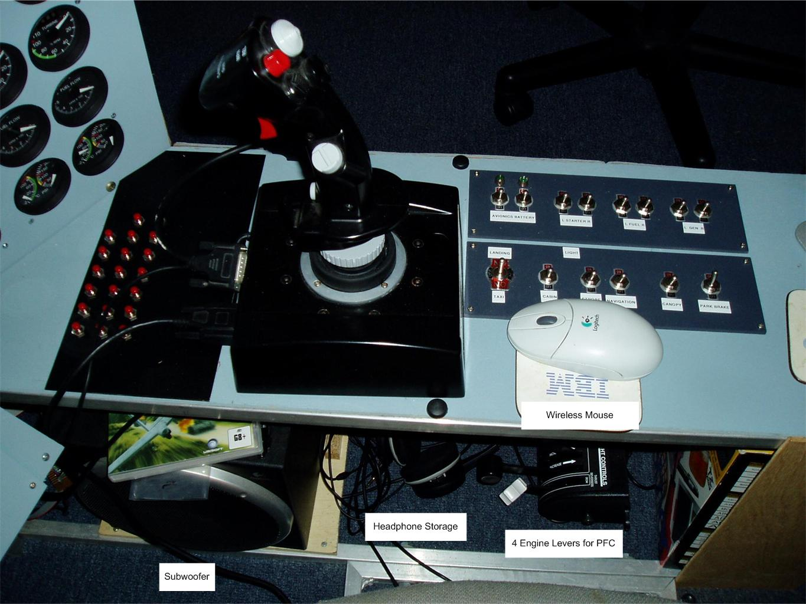

Figure 26 Subwoofer Location

As the cockpit lives in shared space (it just to be dads computer room in the early 90’s.. now it’s the household computer room)

Given I can’t also have the Flight Simulator running at 100dB whilst others are in the room, I added some plumbing from the sound card to the rear of the pit.

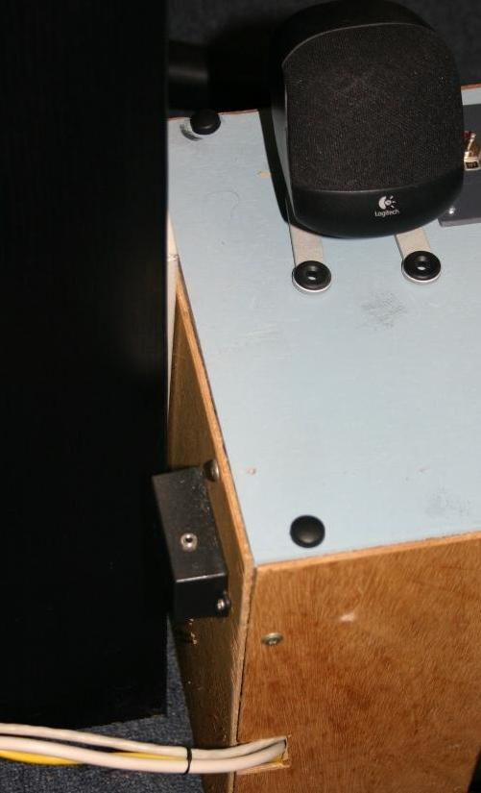

Figure 27 Headphone output at the rear of pit

With this I can put on the headset without getting out of the pit and turn off the external speakers to be socially responsible.

# Input Devices

To really get the feel of a Sim you need both good joysticks and switch inputs. As the pit is multi-purposed there are two joysticks, two throttles, a Helicopter Collective, and a nice set of pedals. The sticks are permanently connected, the Throttles are swapped.

When flying fighter jets the Cougar and its throttle is used, for civilian flights the cougar throttle is replaced by a heavily modified PFC Throttle Quadrant. As the helicopter collective is ‘out of the way’, it remains permanently wired.

In addition to the tradional control inputs, the pit has switches for controlling landing gear, flaps, speed-brakes, park brakes and so on. Both Beta Innovations and X-Keys controllers are used to translate the switch inputs into either keystrokes or Joystick button inputs.

Something that had bugged me for the longest time was having to dedicate physical switches for simulator controls such as change views, zoom, simulator pause, exit. Touch-buddy and some touch screens have nicely solved this problem.

# Getting Keystrokes into the Simulator

Like many other first time cockpit builders I started with tearing apart a keyboard

and soldering switches onto keypads.

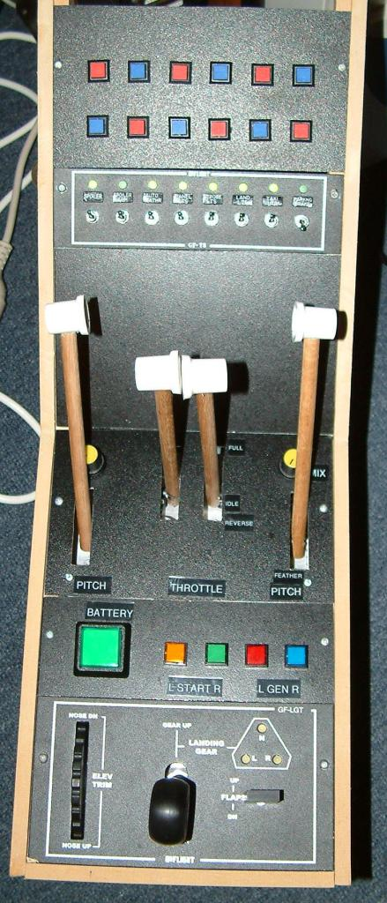

Figure 1 The start of a expensive hobby

The challenge with the soldering pads off old keyboards is that it doesn't scale and really is not flexible enough... there are only so many switches in a keyboard.  So after some surfing found [X-keys](http://www.xkeys.com/).  This is a USB Matrix device that enables you to map multiple keystrokes to a single switch, and send different sequences on switch-close and switch-open.  Initially these modules had to be manually programmed, i.e. press the switch, then enter the keystrokes via a keyboard, that was painful when working with a large number of switches and different simulators.  Now xkeys have Macroworks which makes working with the module a breeze.

Figure 2 Back of original Flaps/Brake Panel

I initially started by using a box with DB25s, and dedicated two x-keys USB switch rows for each DB25.  Whilst it seemed like a good idea at the time :), it lead to cables hanging out of other cables as some panels only had a few switches, and other panels needed lots of switches (more than two DB25s worth).

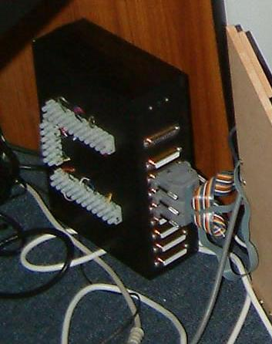

Figure 3 Original XKeys housing with DB25s

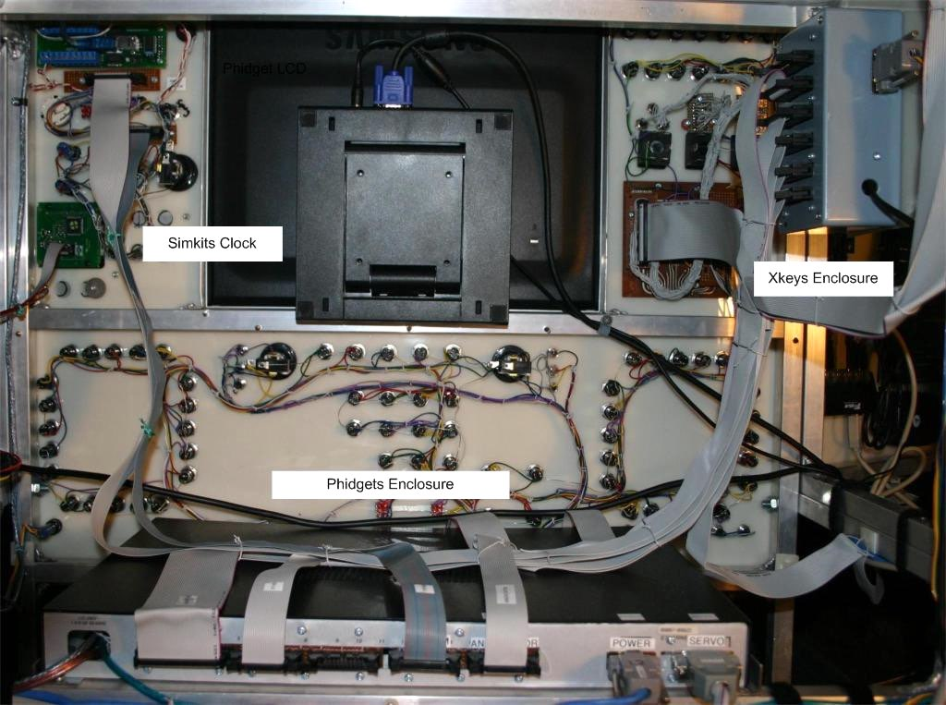

Figure 4 First Generation of Pit Electronics

After some thought I changed both the approach and connectors, I used IDC headers which gave me a high density connector along with easy to make cables, i.e. I could cut the cable to length and easily terminate it.

All x-keys signals are presented on all sockets, meaning that any cable can be plugged into any port of the enclosure.  This simplifies testing of cables and switch panels.

This panel has a large number of connections, using several rows. A useful way to keep track of what pin combinations have been used is to label what each panel uses, this can save a lot of angst when testing.

As part of recabling the pit I added an xkeys/keyboard test routine, which I used to verify that all possible xkeys combinations have been used and none have been duplicated.

To start the test routine the xkeys module is loaded with the default factory settings, each key is programmed with its row/column intersection (e.g. A1, A2, etc).

The first time a key combination is hit the intersection is turned green.  The second time the intersection turns red, and a text to voice message is read out.

As the simulator works with multiple simulators, different keystroke mappings are used for different simulators.  X-keys Macroworks allows you to swap keystroke profiles.

During the 2005 rebuild a second xkeys module was added to support the buttons on the MFDs. The second module is connected to the third computer to support the FreeFD applications.

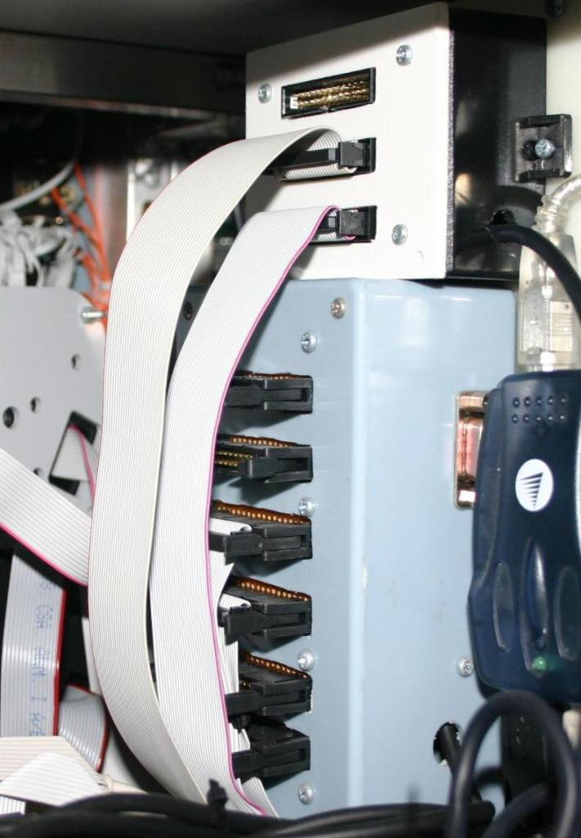

Figure 5 Two Xkeys modules

In 2005 I added the Gammaray from Beta innovations to the pit. The complemented the capabilities of the xkeys matrix card by allow you to use toggle switches without needing diodes. It is strongly recommended that you use diodes with xkeys when there is a likelihood of multiple keys being ‘pressed’ or activated at the same time. This is due to the phantom keys being generated.

As the Gama-Ray uses a different approach, diodes are not needed when using toggle switches, this comes at a cost of a lower supported switch density.

I use both the Xkeys and Beta Innovations in my pit, typically assigned lower density push buttons and toggle switches to beta innovations Gamma-Ray, and the high density push buttons.

Something I removed during the 2005 renovation, which probably will reappear, is the PhidgetsTextLCD. It has 8 inputs that can trigger events in code. I had used one of these inputs is the first generation of the pit to select the scaling of the gauges driven by Phidgets Servo (Jet motors spin a whole lot faster than piston motors, so the scale had to change depending on the aircraft I was flying).

# GoFlight Modules

The Goflight modules are the things that got me into pit building. Doyle continues to add new features and models to the GoFlight family. One of the features I’d been especially waiting for was the KeyMapper S/W that enables you to use Goflight modules in sims other than FS200X. He also has an API that can be used to drive the displays in the modules. The Goflight family also includes modules built specifically for pit builders, where the PCBs can be mounted remotely from the input switches and display.

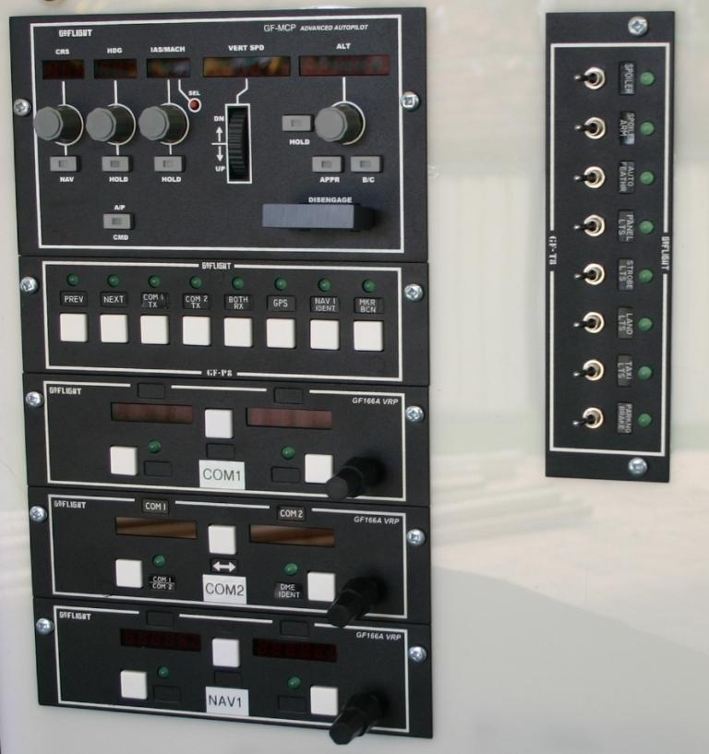

Figure 36 The GoFlight Radio Stack

The GoFlight modules are USB based, and do not have power connectors. This means you if are driving more than a couple of units you will need to use Powered USB hubs. I mounted the hubs behind the panel that houses the GoFlight equipment to reduce the number of cables connecting the panel to the rest of the pit.

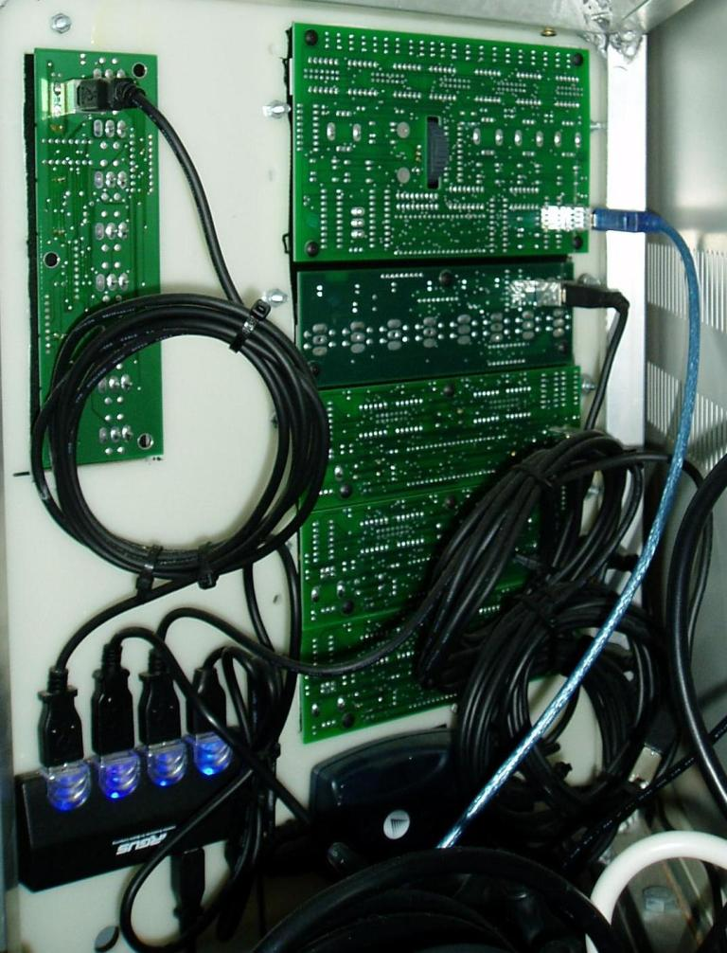

Figure 37 Behind the GoFlight Modules

In Dec 2005 Doyle released a full width Auto-pilot module, which has been added to my wishlist ☺

# The Throttle Assembly

Depending on the simulator I’m flying I’ll use the Precision Flight Control Quad assembly, the Cougar Throttle, or an old Thrustmaster throttle which is attached to a floor mounted Logitech stick. This assembly, like the Cougar stick, is attached to the pit to hold them in place.

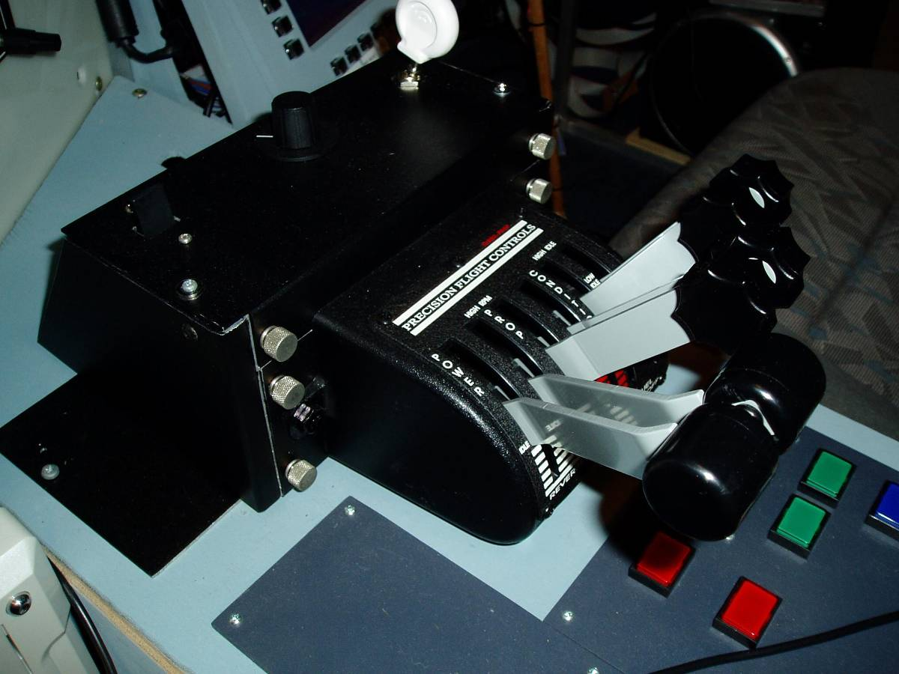

The PFC throttle assembly is a little different to what it is when it was purchased. The original box was too wide to sit on the sit panel of the pit, so an old Goflight chassis was called on to support the core of the throttle assembly. The PFC electronics are still in the PFC enclosure in the left had side of the pit.

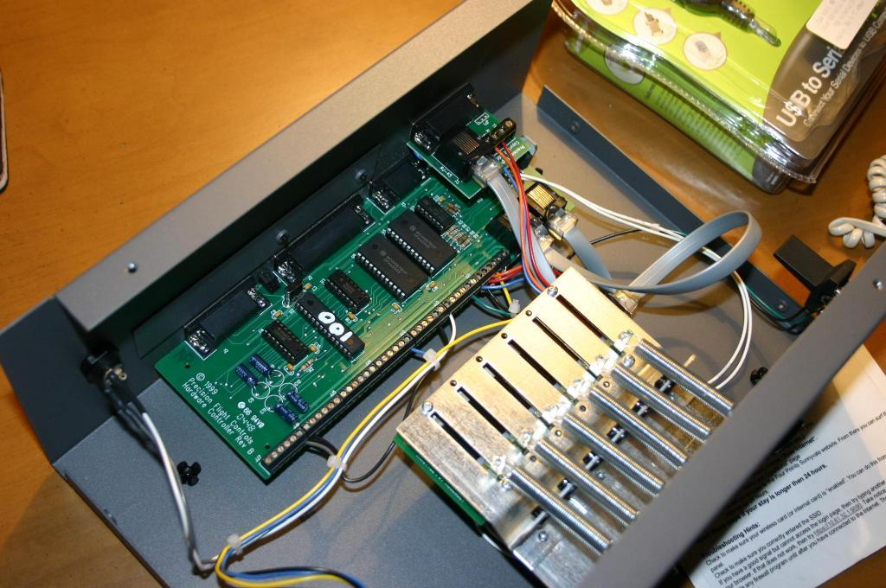

Figure 6 PFC before disassembly

One of the nice things about the PFC throttle is it has a nice solid feel, a side effect is that enclosure needs to be bolted to the pit, otherwise it will slide around. The throttle levers are interchangeable, I normally fly with the turbo prop levers, but also have the four engine Jet levers as well.

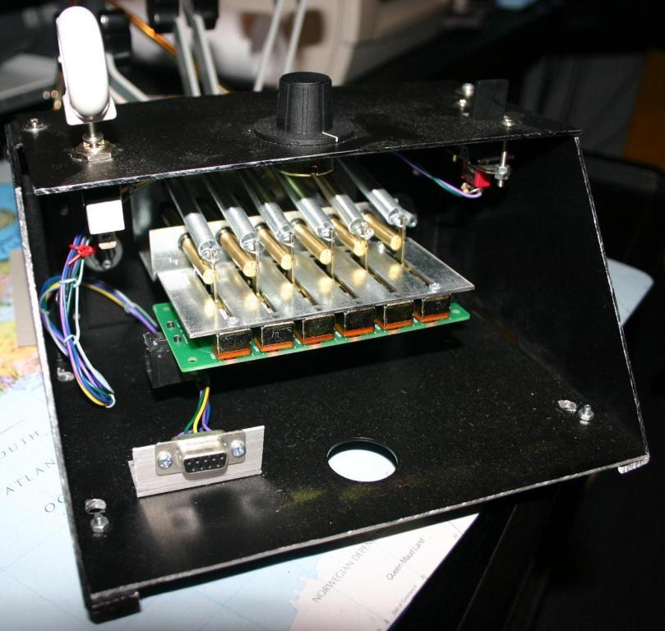

Figure 7 Back of Modified PFC Throttle Assembly

There are two connectors in the PFC throttle assembly. The DB9 for the switches and the RJ45 on the bottom of the slider PFC for sliders. The throttle levers drive the sliders via the brass rods seen the photo. Something I did not realise when I purchased the PFC throttle is that is does not present a standard Joystick interface, instead is presents a serial interface, which in turn communicates to FS200X via the Peter Dowson DLL (pfc.dll). If you are user a recent motherboard that does not have serial ports then you’ll also need a USB-to-Serial converter to attach the PFC Throttle to the computer.[2]

As the pfc.dll writes directly to FS200X it over-rides as keystroke inputs, so if you press the Gear-up keyboard sequence while the PFC Gear switch is in the down position, the gear starts to move up, but within a few milliseconds it returns to the down position.[3]

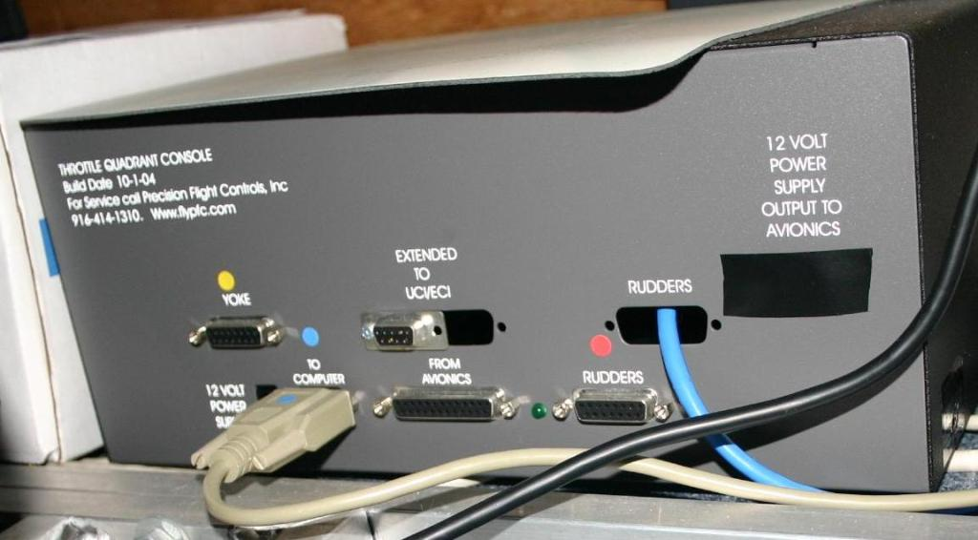

Figure 8 PFC control unit under left panel

I have now connected the sliders to the Beta-Innovations module so they can be viewed at standard Joystick axis for simulators other than FS200X. Whilst this means all of the PFC electronics are now longer used (bit of a waste….I know), I can now use the throttle assembly with any simulator that supports multiple controllers. As the Plasma module requires that all three pins of each potentiometer to be connected, the RJ45 on the PCB cannot be used. I simply soldered cables from an IDC socket to the pins of the pote This also addresses the issue of the PFC controller electronics overwriting the primary gear lever position.

The Beta Innovations Plasma provides both Joystick Analog and Pushbutton interfaces. There are logically two joystick interfaces provided, via separate 20 Pin IDC headers.

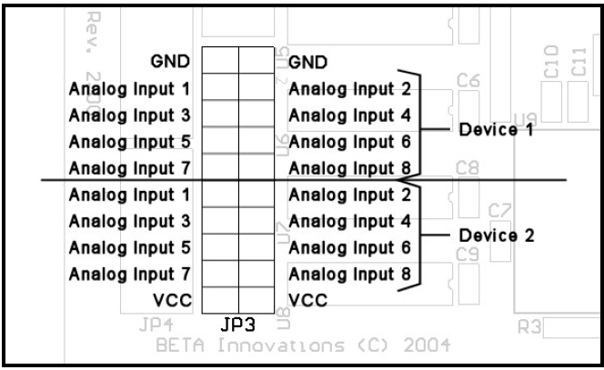

Figure 9 Analog Input for Plasma

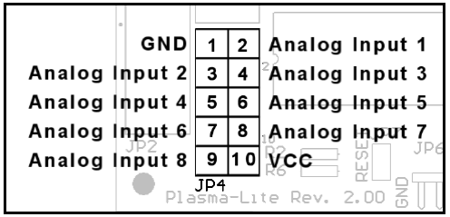

Figure 10 Analog inputs for Plasma-lite V2

The analog connector on the Plasma is plumbed to a distribution board in the Left Hand Side of the pit, where IDC headers connect to discrete modules.

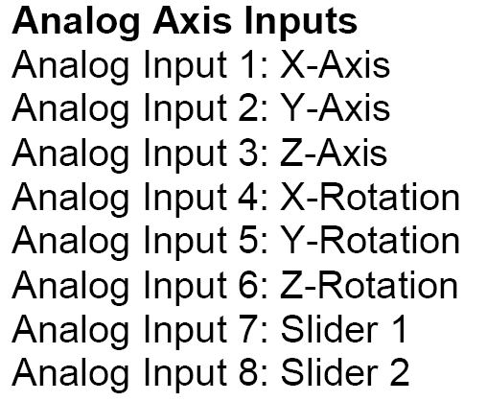

Under the Game Controllers control panel applet you get

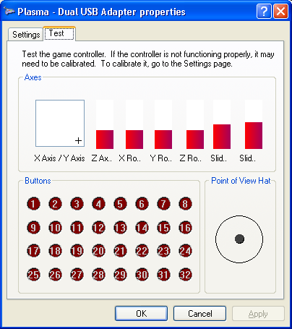

Currently the X/Y Axis have been left unused as I could be connecting the Simkits Flightstick to those interfaces. If I don’t they will be used for analog trim interfaces.

In the control Panel there are two entries for the one Plasma module.

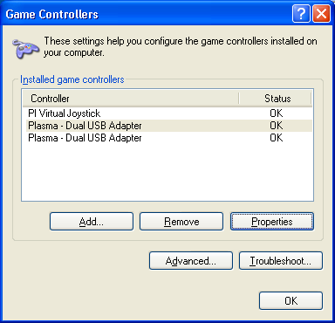

The Following axis are presented

|  |  |
| --- | --- |
| Control Panel Label | PFC Quadrant Mapping |

|  |  |
| --- | --- |
| Device 1 |  |

|  |  |
| --- | --- |
| X Axis |  |

|  |  |
| --- | --- |
| Y Axis |  |

|  |  |
| --- | --- |
| Z Axis | Left Throttle |

|  |  |
| --- | --- |
| X Rotation | Right Throttle |

|  |  |
| --- | --- |
| Y Rotation | Left Conditioner |

|  |  |
| --- | --- |
| Z Rotation | Right Conditioner |

|  |  |
| --- | --- |
| Slider 1 | Left Idle |

|  |  |
| --- | --- |
| Slider 2 | Right Idle |

|  |  |
| --- | --- |
|  |  |

|  |  |
| --- | --- |
| Device 2 |  |

|  |  |
| --- | --- |
| X Axis | Flight Stick X |

|  |  |
| --- | --- |
| Y Axis | Flight Stick Y |

|  |  |
| --- | --- |
| Z Axis | Rudder |

|  |  |
| --- | --- |
| X Rotation | Collective Throttle |

|  |  |
| --- | --- |
| Y Rotation | Collective Collective |

|  |  |
| --- | --- |
| Z Rotation |  |

|  |  |
| --- | --- |
| Slider 1 | Rudder Pedal Right Toe Brake |

|  |  |
| --- | --- |
| Slider 2 | Rudder Pedal Left Toe Brake |

|  |  |
| --- | --- |
|  |  |

When cabling potentiometers to the Plasma, all three pins must be connected. This is different to cheaper joysticks that typically only use two pins, Fortunately, the Simkits Collective has all three pins wired from the factory.

|  |
| --- |
| **Simkits Collective Pinouts** |

|  |  |
| --- | --- |
| Shield | Ground |

|  |  |
| --- | --- |
| Blue | Vcc |

|  |  |
| --- | --- |
| Yellow | Collective |

|  |  |
| --- | --- |
| White | Governor Switch (to gnd) |

|  |  |
| --- | --- |
| Red | Throttle |

|  |  |
| --- | --- |
|  |  |

The Gnd is on the RHS of the collective.

## Inputs on Plasma MM

|  |  |  |  |  |
| --- | --- | --- | --- | --- |
| Axis Name | Role | Min | Centre | Max |

|  |  |  |  |  |
| --- | --- | --- | --- | --- |
|  |  |  |  |  |

|  |  |  |  |  |
| --- | --- | --- | --- | --- |
| X Axis | X Axis | 680 | 828 | 929 |

|  |  |  |  |  |
| --- | --- | --- | --- | --- |
| Y Axis | Y Axis | 752 | 832 | 912 |

|  |  |  |  |  |
| --- | --- | --- | --- | --- |
| Z Axis | Rudder | 387 | 531 | 652 |

|  |  |  |  |  |
| --- | --- | --- | --- | --- |
| Z Rotation | Rudder Pedal Left Toe Brake | 12 | 18? | 931 |

|  |  |  |  |  |
| --- | --- | --- | --- | --- |
| Y Rotation | Rudder Pedal Right Toe Brake | 41 | 43? | 926 |

|  |  |  |  |  |
| --- | --- | --- | --- | --- |
| X Rotation | Cyclic Trim | 5 | N/A | 1018 |

|  |  |  |  |  |
| --- | --- | --- | --- | --- |
| Slider 1 | Collective Collective | 27 |  | 952 |

|  |  |  |  |  |
| --- | --- | --- | --- | --- |
| Slider 2 | Collective Throttle | 54 |  | 960 |

|  |  |  |  |  |
| --- | --- | --- | --- | --- |
|  |  |  |  |  |

Calibrate using comtrol panel first (to cover slider 2), and then tweak using DIView.

## 2007 Analog input rebuild

Had been trying to work out how to use different inputs on older Sims and also improve the resolution of the Simkits cyclic stick. After discovering the power of the Beta Inovations device manager which allows you to arbitrarily map different inputs to different windows Axis it was time for a rethink.

This also has other benefits as it’ll reduce the number of devices Fs2004 has to worry itself about. I had previously found FS2004 got confused with assignments and sensitivies as the number of devices grew:

Previously Had

1. Plasma V2-A
2. Plasma V2-B
3. Plasmalite
4. Cougar
5. Flight Stick
6. PI Virtual Stick from Xkeys

With the new setup should have

1. Plasma M2-1
2. Plasma M2-2
3. Cougar
4. Possibly the Plasma V2 for rotataries
5. PI Virtual Stick from Xkeys

Another FS2004 benefit is all config changes can be down using Device Manager, only likely issue is sensitity and zero point difference if swapping between PFC throttle and Collective, but this should be masked by using Aircraft Specific settings with FSUIPC.

Using MM2

|  |  |  |  |
| --- | --- | --- | --- |
| Input No | Role |  | X-Amp |

|  |  |  |  |
| --- | --- | --- | --- |
|  |  |  |  |

|  |  |  |  |
| --- | --- | --- | --- |
| 1 | Cyclic X Axis | X | Not needed slider travels full length |

|  |  |  |  |
| --- | --- | --- | --- |
| 2 | Cyclic Y Axis | Y | Not needed slider travels full length |

|  |  |  |  |
| --- | --- | --- | --- |
| 3 | Rudder | Z Axis | Possibly XAmp-1 |

|  |  |  |  |
| --- | --- | --- | --- |
| 4 | Left toe Brake |  |  |

|  |  |  |  |
| --- | --- | --- | --- |
| 5 | Right Toe Brake |  |  |

|  |  |  |  |
| --- | --- | --- | --- |
| 6 | Collective Throttle |  | Needed |

|  |  |  |  |
| --- | --- | --- | --- |
| 7 | Collective Collective | Slider | Needed |

|  |  |  |  |
| --- | --- | --- | --- |
| 8 | Trim wheel on Cycle | X RotAtion | Probably not needed |

|  |  |  |  |
| --- | --- | --- | --- |
|  |  |  |  |

|  |  |  |  |
| --- | --- | --- | --- |
| Input No | Role | X-Amp |  |

|  |  |  |  |
| --- | --- | --- | --- |
|  |  |  |  |

|  |  |  |  |
| --- | --- | --- | --- |
| 4 | PFC Throttle Left | Y Rotation | Not needed slider travels full length |

|  |  |  |  |
| --- | --- | --- | --- |
| 5 | PFC Throttle 2 | Z Rotation | Not needed slider travels full length |

|  |  |  |  |
| --- | --- | --- | --- |
| 1 | PFC Pitch 1 | Not needed slider travels full length |  |

|  |  |  |  |
| --- | --- | --- | --- |
| 2 | PFC Pitch 2 | Not needed slider travels full length |  |

|  |  |  |  |
| --- | --- | --- | --- |
| 3 | PFC Mixture 1 | Not needed slider travels full length |  |

|  |  |  |  |
| --- | --- | --- | --- |
| 4 | PFC Mixture 2 | Not needed slider travels full length |  |

|  |  |  |  |
| --- | --- | --- | --- |
| 5 | Rudder Pedal Left Toe Brake | Not needed slider travels full length |  |

|  |  |  |  |
| --- | --- | --- | --- |
| 6 | Rudder Pedal Right Toe Brake | Not needed slider travels full length |  |

|  |  |  |  |
| --- | --- | --- | --- |
| 7 | Rudder Trim | Hopefully not |  |

|  |  |  |  |
| --- | --- | --- | --- |
| 8 | Aleron Trim | Hopefully not. |  |

|  |  |  |  |
| --- | --- | --- | --- |
|  |  |  |  |

### Pinouts for the Cyclic Connector to MM2-1

|  |  |  |
| --- | --- | --- |
| 1 | Bottom Left Button |  |
| 2 |  |  |
| 3 | Hat Right |  |
| 4 | Top Left Button |  |
| 5 | **Hat Down** |  |
| 6 | Hat Left |  |
| 7 | Top Right Button |  |
| 8 | **Hat Up** |  |
| 9 |  |  |
| 10 | Bottom Right Buttom |  |
| 11 |  |  |
| 12 |  |  |
| 13 | Rudder |  |
| 14 | Left Toe Brake |  |
| 15 | Right Toe Brake |  |
| 16 | Cyclic Trim |  |
| 17 | Y Axis? |  |
| 18 | X Axis? |  |
| 19 | +5v |  |
| 20 | Gnd |  |

Pinouts for the Rudder 10 Pin Connector

|  |  |
| --- | --- |
| 1 | Rudder Assembly Gnd |
| 2 | Rudder Assembly + |
| 3 | Rudder Wiper |
| 4 | Left Toe Centre |
|  | Right Toe Centre |
|  |  |
|  |  |
|  |  |
|  |  |
|  |  |

Tuning the Axis

As the windows control panel isn’t necessarily the cleanest view of whats happening with an input, Logitechs DIView is a very useful diagnostic tool.

As a sanity test I tied both the X and Y axis to a common wiper, the linearity is very good. It’s important to start with a known set of conditions, so load page defaults using Device manager and save device. The start DIView (select the axis and enable raw view) and control panel. Intially when displaying raw values in calibration mode, all should display the same values.

DIview seems to like a scale of 0 to 65535, when means the raw output from the Plasma devices isn’t large on the raw scale as they only output 5 to 1018.

DIView doesn’t handle the two slider axis well at all, if adjust the collective, both slider axis move.

Another interesting side effect is that unused axis’s do bounce around

Once axis tweaking is enabled the raw values now move up to 65535 is the restricted range identified by the auto calibration. The non-raw values appear skweded until a cabliration is done. The raw values displayed in control panel now range up to 65535. After performing a windows calibration perform a rescan on DIview otherwise you may not be able to get to max values.

If tuning parameters are changed in DIvew then ensure you close and open the windows control panel to reflect the new settings.

Recorded Values from Flight Stick

|  |  |  |  |
| --- | --- | --- | --- |
|  | Min | Centre | Max |
| X Axis | 100 | 165 | 240 |
| Y Axis | 790 | 850 | 923 |
|  |  |  |  |

## Amplifying and Offset the Analog signal

As the potentiometer in the collective handle only moves a sixth of a turn, even the Plasma interface card isn’t able to present a large range of values to the simulator. To deal with this I built an amplifier which also provides the ability to zero the input as well. I also swapped the Ground and +5V pins on the collective pot as it originally output a range from approx 4.8V to 5V. My preference is to work with a low voltage and amplify with a small offset.

Operational Amplifiers are built for this task, but normally require a positive and negative rail, which isn’t present in my pit. The Analog Devices AD623AN is a single rail Instrumentation amp which is perfect for this role, as it also draws little current, an important consideration when you are sucking power from the Plasma boards.

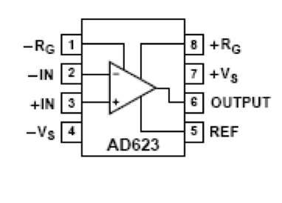

Figure 11 Pinout for AD623

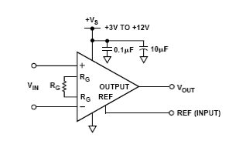

Figure 12 Circuit Diagram for Amplifier

The input to –IN (pin 2) is a 50K ohm multiturn trim potentiometer connected to the positive rail and ground. Rg is also a 50K ohm multiturn trim potentiometer.

Ref is tied to ground.

Amplifiers 2 and 3 are used for the Collective.

Currently Collective throttle maps to Y Rotation and Collective maps to Z Axis

Pinouts from Rudder Assembly

1 Positive for all pots

2 Negative for all pots

3 Rudder Wiper

4. Left Toe Brake Wiper – Z Rotation – 41 to 931

5. Right Toe Brake Wiper – Slider 2 – 77 to 1018

It currently appears that the rudder pedals and toe-brakes will not require amplification.

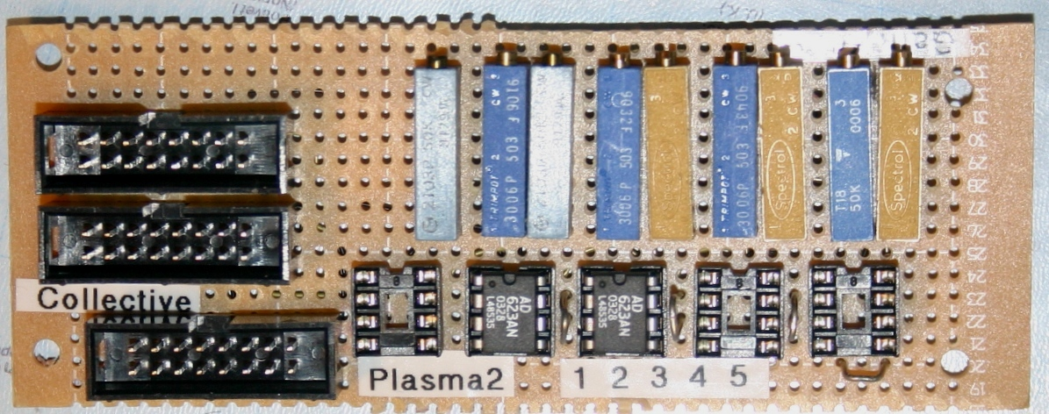

Figure 13 Analog Amplifier for Joysticks

# Calibration of the Analog Amplifiers

* Set the gain to max
* Stick to zero
* Adjust zero pot until output around 0.2V
* Turn stick to mid point
* Adjust gain to output of 2.5v
* Stick to max point. Wind off gain till output is seen to drop just below the rail.

# The Flight Stick

The flight stick from Simkits is a floor mounted joystick

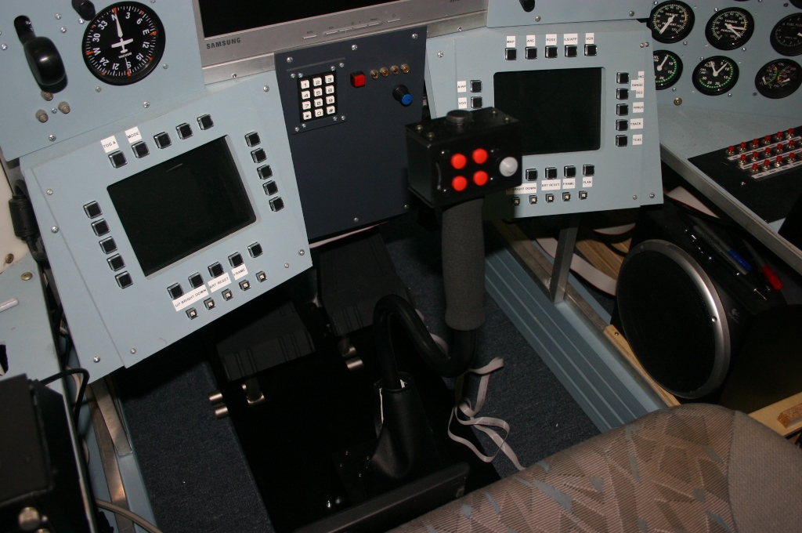

I have bolted it to the rudder pedals to firstly get the correct distance between stick and pedals and also to hold it in place.

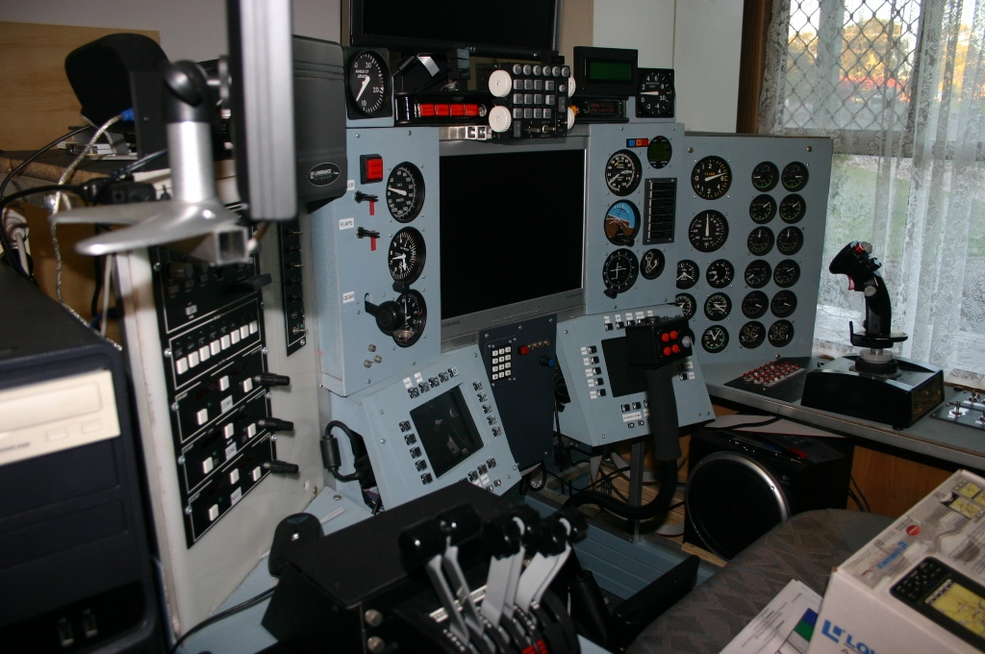

Figure 14 Flight Stick installed

# Tuning the Joystick Axis

As the Pit has multiple Joystick controllers there is an overlap of functions, specifically there is a class between the Throttle Quadrant and the Helicopter collective. I initially tried to manage this by tuning down sensitivities on unused axis’s, but had way too many mysterious engine failures for both helicopters and aircraft. Finally isolated the problem by looking in the virtual cockpit and seeing FS responding the tiniest movements on the unused throttles. Now I deselect the unused axis and haven’t had a mysterious engine failure since.[4]

Currently the Cougar doesn't seem to impact the other settings even when it remains connected.

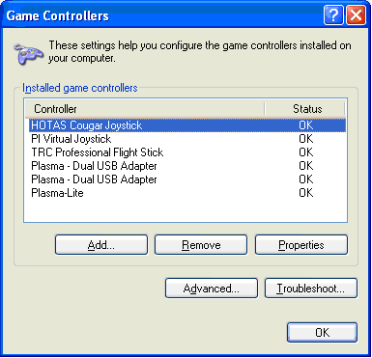

The First Plasma USB Adaptor holds the Throttle Quadrant

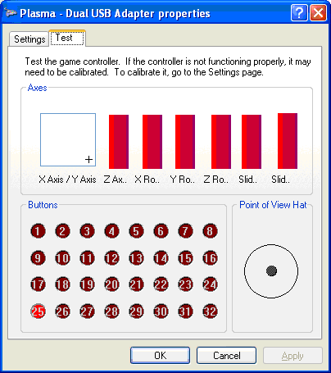

X/Y Axis not currently used

Z Axis - Left Engine Throttle

X Rotation - Right Engine Throttle

Y Rotation - Left Engine Prop

Z Rotation - Right Engine Prop

Slider 1 - Left Engine Conditioner - Fuel Cutoff

Slider 2 - right Engine Conditioner - Fuel Cutoff

Second Dual USB Adaptor Not Currently Used

Plasma-Lite

X/Y Axis not currently used

Z Axis - Rudder Pedals

X Rotation - Helicopter Collective

Y Rotation - Helicopter Throttle

Z Rotation - Left Toe Brake

Slider 1 - Currently Not Used

Slider 2 - Right Toe Brake

Flight Sim 2004

Assignments and Sensitivities for the Plasma-Lite

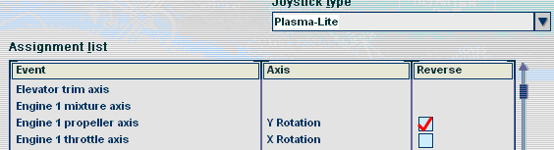



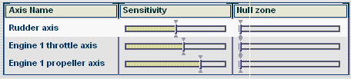

Plasma

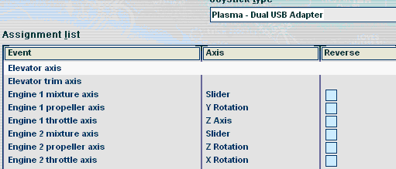

Note that sensitivities has been kept simple

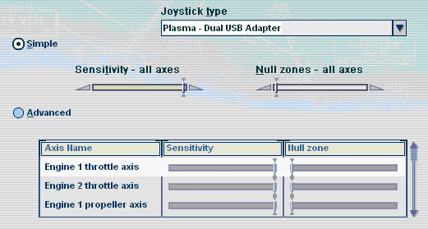

When flying the Beechcraft the Helicopter Throttle and Collective are deselected. Note when they are reselected, the Throttle maps to the Collective, and the Propeller maps to the Throttle on the collective.



When flying helicopters, Engine 1 Propeller and Throttle are deslected. The good news is the sensitivities is kept.



FSUIPC Settings

Aircraft Specific Settings have been used

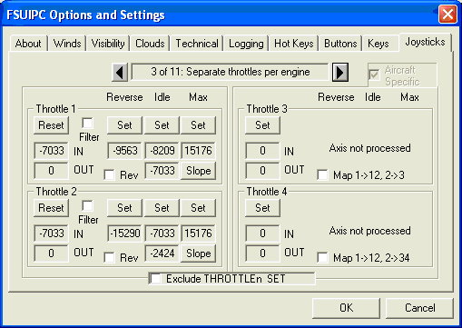

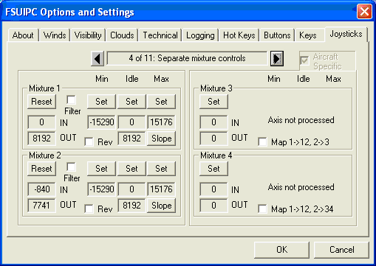

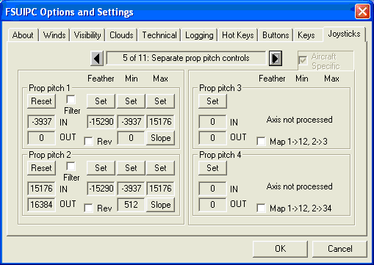

# Helicopter Inputs

In late 2007, the Gold Coast hosted an Australian Flight Sim Expo. A small company had a helicopter simulator that had a nice set of controls. They come from Flight Link in the US. Whilst they are expensive (USD$2522 inc shipping), they have a very real feel to them.

**Advanced Rotor Wing Package**;

G-Stick III Plus

1) Baseplate

4) Thumbscrews 10-32 x 3/8"

1) USB Cable

1) Installation Disk

1) Instruction Sheet

**Anti-Torque Pedals**

1) DB15 M/F Cable

2) Thumbscrews 10-32 x 3/4"

Collective with Twist Grip Throttle

1) DB15 M/F Cable

4) Thumbscrews 10-32 x 3/4"

1 1 0 1,685.00 1,685.00

**Seat & Base**

1) Seat Cover

4) 3/8-16 x 3/4" Hex Bolt

4) 3/8" Lock Washer

4) 3/8" Flat Washer

# Linking Multiple computers

As I don’t want three keyboards, and three mice in the cockpit I use a KVM to link the three computers to a common keyboard and mouse. Both the keyboard and mouse are wireless, meaning there are less cables to get tangled in the pit. The wireless sender sits on the top right of the pit. The video from the computers goes directly to the monitors.

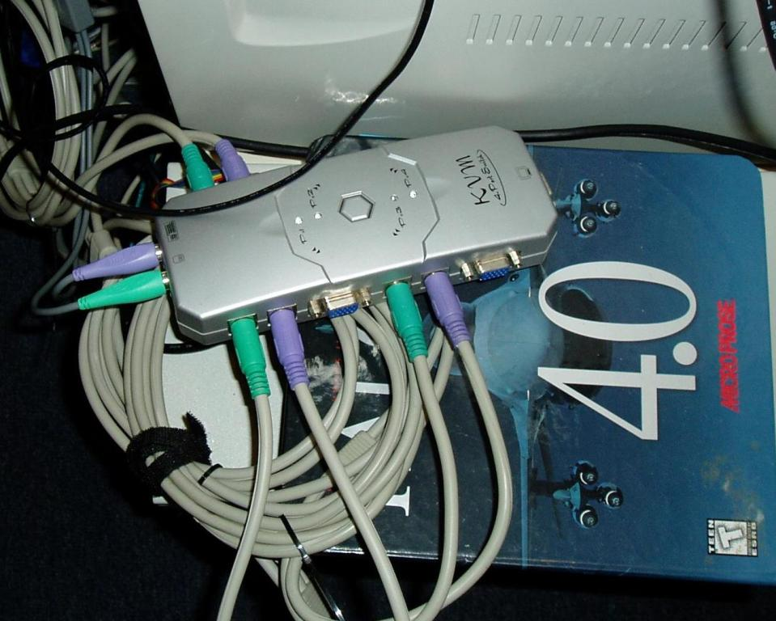

Figure 33 Close-up of KVM

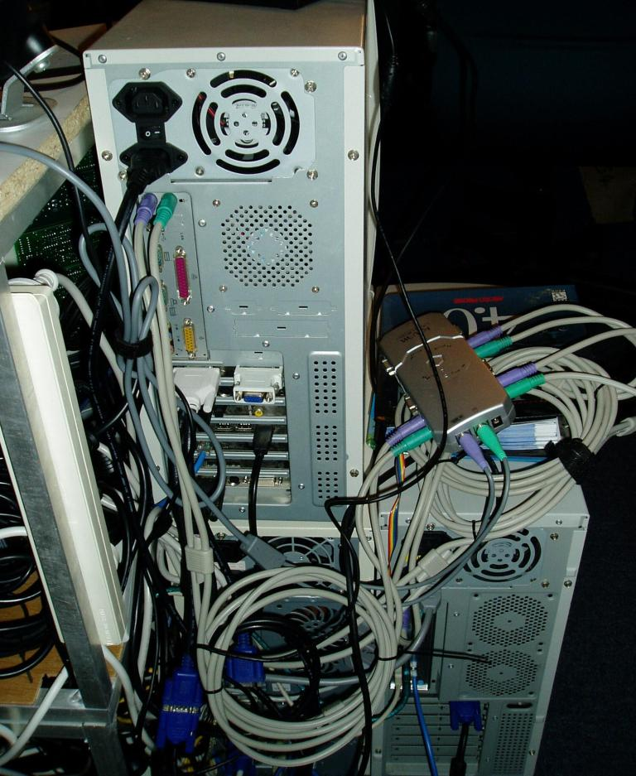

Figure 34 The three computers and KVM

The colored ribbon cable goes to the front panel of the pit where you are able to select the computer and see which computer is selected. A computer can also be selected from the wireless keyboard by pressing Scroll-Lock twice and then the number 1 to 4.

Unfortunately this conflicts with LOMAC, but is still real useful when cutting code and jumping between systems. One of the systems occasionally ‘gobbles’ the input (both mouse and keyboard), this can be a little distressing and half an hour of coding only to find the system has to be restarted before keyboard and mouse control are regained. Loosing half an hours programming is totally undesirable and is temporarily resolved by grabbing a USB mouse an getting a File-Save in before restarting.

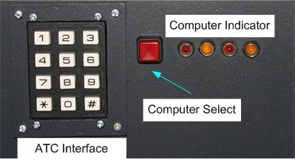

The Keypad has been included in the pit for Air Traffic Control communications. The ‘*’ key is to bring up ATC interaction, the numeric keys map to numeric digits (which is normally what is requested by the sim for ATC responses). The ‘#’ key is used to pause/resume the simulation.

# Touch Screens

I hadn’t been a big fan of touch screens as the whole reason for building the pit was to provide an immersive environment as possible, and I had felt that touch-screens were a little clumsy and required additional programming.

Guess I was wrong, as I fly different types of aircraft and simulators the touch screen provides a smooth way of displaying and getting input for aircraft or simulator specific commands.

One of the guys (under the tag of ZOLAC) on the Lockon forums (the ones hosted by Eagle Dynamics not UBISoft) wrote some code (Touchbuddy) that displays buttons and sends keystrokes to simulator, and can do so either from the local PC or a networked PC. Given this was one of the tasks I was planning to do with the MFD screens, I’m saving myself some pain and using the great work that has already been done.

I found two TouchScreen providers on EBay, both ended up supplying exactly the same units from Hong Kong. The 8 inch Touch Screens I ordered have a Native Resolution of 800*600 and can display 1024*768. A driver must be installed on the host PC, the Screen sends updates with a USB interface to the Host PC.

The two suppliers were “AV shoppe LTD” and “stivaskam”, despite my concerns about the name of the second supplier, goods where delivered from Hong Kong in 4 days, which had me pretty impressed. As of Oct 2006, AV shopper LTD appears to now longer be trading.

## Touch Screen Setup

The touch screen is currently running on the 3rd PC (Dell Server), primarily as it’s on the only unit with a spare video port.

Installation was pretty much as expected, using Win2000_XP_4.3.0.2412_Beta. As there are multiple screens (4) on this PC, I needed to go into the Calibration Utility

Right Click on Task Bar

Calibration utility

Display

Check Enable Multiple Monitors

Click on Screen 4

Operation Mode – Full Screen

Setting – Click on touch (button at bottom of screen), changed to Click on touch without moving cursor.

A shortcut – touchkit is also installed on the desktop.

## Touchbuddy Installation

Copied Touchbuddy-0.0.6-20060412.zip to c:\program files\touchbuddy

Extracted zip file to this directory

Found it placed files further down directory structured than I wanted so copied up

Started Touchbuddy.exe

Selected Local Mode

Selected Simple Layout

Dragged to Touch Screen Windows

Opened Notepad

Pressed the Fly Button on the touchscreen – Normal Button Press appears in Notepad.

## Touchbuddy Configuration

As touchbuddy sends the keystrokes to a window the window name must be specififed in the configuration file. For Falcon 4 AF the window name is “BFOps Falcon 4.0 Allied Force 3D Output”

Also the keystrokes are case sensitive, so “P” is Freeze whereas “p” is pause.

I found I also have to key the process “XKWdkApp.exe” using task manager before any application would receive keystrokes from Touchbuddy. Killing this process did not seem to adversely impact xkeys on the host system.

Creating a Profile for Falcon 4

Based the profile on LOMAC199-RUGG.

Did a global replace on

sendto = LOCK ON

sendto = BFOps Falcon 4.0 Allied Force 3D Output

and then started working through the keystrokes one by one

## Additional Configuration

Now using 1.02.

Touchbuddy takes the following command line parameters[5]

*' -m [local|client|server] -c <*.tbc>  
' "-m local" and "-m client" requires the -c option as well  
' server mode only requires the "-m server" option (no config required)  
' the -c option can be relative to where TouchBuddy is located*

## Running Touchbuddy

Originally Touchbuddy didn’t start on the 4th screen, even if the icon is clicked on the 4th screen. This meant Touchbuddy must be then be dragged to the 4th screen and then optionally maximized. This was resolved by making the touchbuddy screen the primary screen and removing the larger LCD as control functions can also be done using the small LCD.

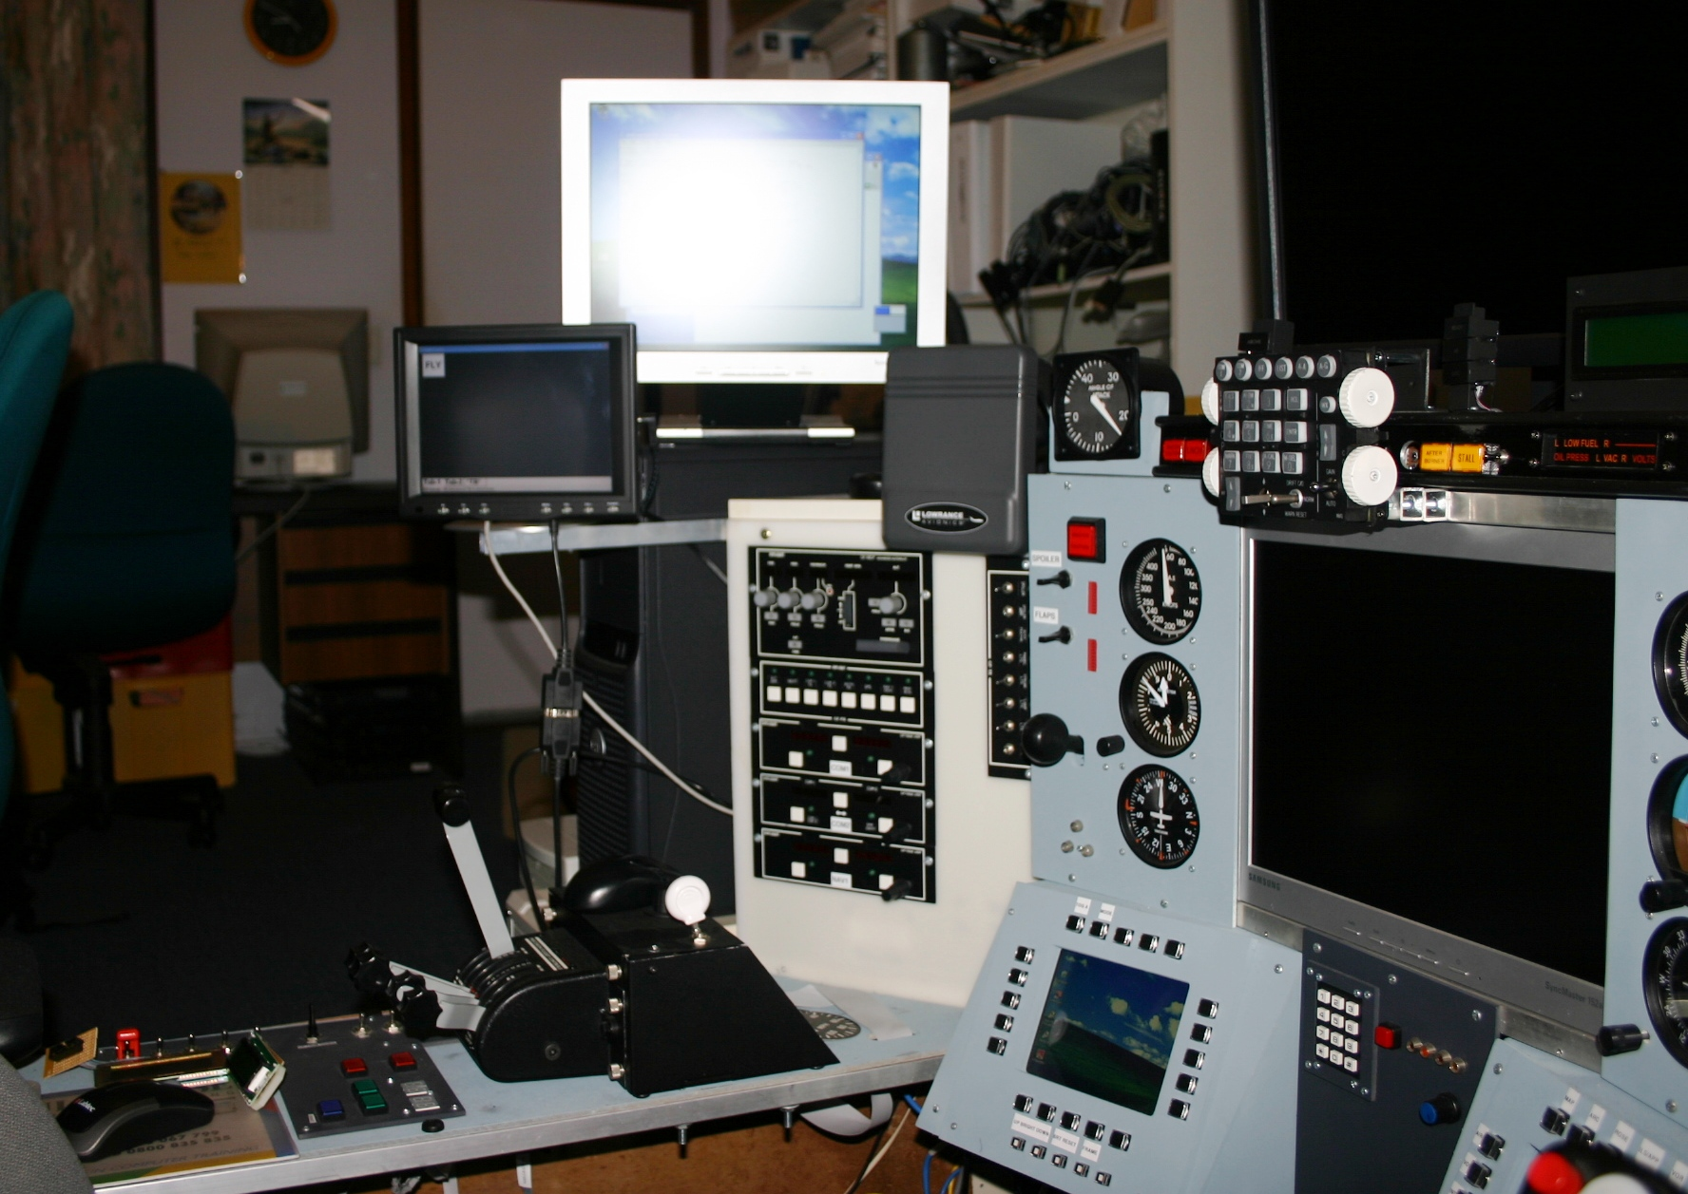

# Appendix

# Simulator Startup Procedures

As seen by the data-flow diagrams the simulator is neither a single computer nor a single program. The process of starting up the simulator depends on the aircraft being flown.

## Startup Procedure for FS2004

Connect the Secondary (supports MFDs) X-keys USB lead to the Third computer.

FS2004 has not been updated to the new shared memory module.

**1st PC**

* **Turn of PSU for Pit[6]**
* **Start TRCLink. Let TRC link Auto-zero altimeter before continuing, otherwise Altimeter performace will be jerky.**
* **Launch Keymapper S/w from BetaInnovations**
  + **Select untitled and press start emulator using new config.ksc**
* **If xkeys Macro Manager is not running start it**
  + **Select Layout of fs2004__April_1_2006.xk7.xk7**
* **Start FS2004**
  + **WideFS and GPSOut are FS modules and will automatically start**
  + **Goflight Modules should also automatically start**
  + **If using dual projectors**
    - **Views – New View – Cockpit**
    - **Right-Click – Undock View on new window**
    - **Drag to Left Screen and resize**
    - **View – View Options – Cockpit View01**
      * **Look-forward-Left**
      * **Zoom 0.75**
    - **Right Click Hide Window on Cockpit intstruments**
* **Check Throttle action**
* **If using San Francisco Scenery takes approx 5 minutes with a CPU load of 46-51%**
* **Dell Projector keystone set to 8**

**2nd PC**

* **Start WideFS (this should automatically connect to FS on the primary computer and IO Processes by clicking on StartFlightSim.bat. Let TRC link Auto-zero altimeter before continuing.**
* **Start FS2004 and General Purpose IO Processes (startflightsim.bat)**
  + **start /MIN C:\FSUIPC\WideFS\wideclient.exe**
  + **pause**
  + **cd C:\fs2002_vb**
  + **start /MIN SimPhidgetIOA.exe**
  + **start /MIN SimPhidgetIOB.exe**
  + **start /MIN SimPhidgetLedA.exe**
  + **start /MIN SimPhidgetLedB.exe**
  + **start /MIN SimPhidgetServo.exe**
  + **start /MIN FS2004Sender.exe**
  + **start /MIN FS2004Receiver.exe**
  + **start /MIN SimParallaxServo.exe**
  + **rem start /MIN SimDualStack.exe**
  + **pause**
* **Start Boeing EADI**

**3rd PC**

* **Start Wide FS**
  + **Open Task Manager and change the priority of the WideFS process to Above Normal.**
* **Start FreeFD ECIAS**
* **Start FreeFD ND**
* **Ensure Xkeys is running Sample Matrix xk7 file.**
* **Start MFD_Control application**

## Startup Procedure for Falcon 4

Connect the Secondary (supports MFDs) X-keys USB lead to the Primary computer.

The F4 environment is currently being migrated to the new code module.

1st PC

* Ensure Primary xkeys module is running Fs2004
* Ensure Secondary xkeys module is running Falcon4 MFD
* Ensure Beta Innovations Keyboard emulation is running Falon4 profile
* Start Touchbuddy Server
* Start TRC Custom Link (wait for Altimeter to Auto zero before continuing)
* Start Eagle 9 F4 GlassServer (versions 1.03)
* Start Falcon 4 AF (other versions are currently not supported)

2nd PC

* Start Eagle 9 F4 Glass Client
* Run Start_falcon4
  + start /MIN SimPhidgetIOA.exe
  + start /MIN SimPhidgetIOB.exe
  + start /MIN SimPhidgetLedA.exe
  + start /MIN SimPhidgetLedB.exe
  + start /MIN SimPhidgetServo.exe
  + start /MIN PTTRCLink.exe
  + start /MIN f4gpsout.exe
  + start /MIN Falcon42Pit.exe
  + start /MIN SimDualStack.exe
* Ensure GPS is plugged into Com1
* F4_GPSOut (Press run continuous)
  + Select the theatre you are planning to fly
* Start F4 Glass

3rd PC

* Start Eagle 9 F4 Glass Client
* Start Eagle 9 F4 Glass, ensure gauges are corrected positioned
* Start touchbuddy running Falcon4AF profile

## Startup Procedure for LOMAC

LOMAC is running the new code base which uses shared memory to improve update performance and reduce the impact of a task hang or crash

1st PC

* Click on Touchbuddy icon (automatically starts it in server mode)
* Start TRC Custom Link (takes TCP connection to drive Simkits) (allow gauges to settle before continuing
* Start LOMAC

2nd PC

* Start IO Utilities by clicking startlomac.bat
  + start /MIN SimPhidgetIOA.exe
  + start /MIN SimPhidgetIOB.exe
  + start /MIN SimPhidgetLedA.exe
  + start /MIN SimPhidgetLedB.exe
  + start /MIN SimPhidgetServo.exe
  + start /MIN PTTRCLink.exe
  + start /MIN LOMAC2Pit.exe
  + start /MIN LOMACGPSOUT.EXE
  + start /MIN SimDualStack.exe
* Start F4Glass

3rd PC

* TBD. Probably start custom application to monitor Weapons load or MFD client from Simmeters

# Installation and Configuration of the computers

Given hard disks can die at anytime, without warning I now keep a record of what versions of modules I am using to make recovery processes a little easier.

## FSUIPC and WideFS

|  |  |
| --- | --- |
| Was | Now |

|  |  |
| --- | --- |
| **1st PC** |  |

|  |  |
| --- | --- |
| FSUIPC 1 Oct 2004 3.4.0.0 | 3.5.3 1 Jan 2006 |

|  |  |
| --- | --- |
| Wide Server 16 April 2004 6.2.2.1 | 6.5.1.0 |

|  |  |
| --- | --- |
|  |  |

|  |  |
| --- | --- |
| **2nd PC** |  |

|  |  |
| --- | --- |
| Wideclient 6 Oct 2003 6.1.01 | 6.5.1.0? |

|  |  |
| --- | --- |
|  |  |

March 2006 - Upgraded FSUIPC and associated components primarily to enable the GPS to be driven off the second computer. WideClient uses TCP/IP, server is 10.1.1.16

### FSUIPC Post Upgrade Test Routine

1. Start Flight Simulator
2. Start Wide Client
3. Start FreeFD, verify ND, Boeing EADI, and ECAS
4. Start FS2004ToPit (reads information from FSUIPC and populates shared memory files)
5. Start SimPhidgetLedA, SimPhidgetLedB, SimPhidgetIO, SimPhidgetServo verify Leds change to match Generator switches and Parking Brake Status.
6. Start Flight Illusions DualStack driver and verify engine behaviour is correctly displayed.

## FreeFD Versions

|  |  |
| --- | --- |
| Module | Version |

|  |  |
| --- | --- |
|  |  |

|  |  |
| --- | --- |
| EADI | 0.8 |

|  |  |
| --- | --- |
| EICAS | 0.6 |

|  |  |
| --- | --- |
|  |  |

## Macro Manager

Xkeys 1.0.3.4

## Primary Computer

1. Install Windows XP SP2
2. Install Drivers for 7952
3. Install Matrox Triple Head to Go Drivers
4. Install Matrix Screen Saver – Test all projectors ok
5. Install FS2004 – Standard installation
6. Install LOMAC – Standard Installation
7. Install Winzip 8.1
8. Install Acrobat Reader
9. Install Ethereal
10. Install SysInterals Regmon and Filemon, Process Explorer, Portmon
11. Install GoFlight 2_22_06setup
12. Install xkeys Macro Works 29/4/2005 Version 1.2.14 (appears to autoload drivers
13. Install FSUIPC – copy FSUIPC to modules folder
    * Enter keys
    * Copy wideserver and ini file to modules
    * Copy gpsout and ini to modules, set port to widefs
14. Start FS2004 May need to start FS2004 in safe mode if previously running with projectors
15. Enter registration codes for FSUIPC and WideFs
16. Install Cougar Drivers and Software 3.HCO.2004
17. Start Cougar Control Panel to enable a default profile to be created
18. Install Foxy 4 and associated files
19. At this point device manager should list
    * One USB Com Port (for Dual Engine Stack)
    * Pibus with virtual Joystick, Keyboard, Mouse
    * TRC CCU and Multiboard
    * Thrustmaster Hotas Cougar in and out under USB Controllers
20. Game controllers should list
    * Thrustmaster HOTAS
    * PI Virtual Joystick
    * TRC Professional Flight Stick
    * Two Plasma Dual USB Adapters
    * Plasma-Lite
21. Now Configure Goflight Instruments using GF Config
    * Select each radio, assign Com1, Com2, and Nav 1, order correctly
    * Select Autopilot, select Set Defaults
    * Assign functions to Toggle and Push Buttons
22. Install TB Receiver
23. Install FS Whirlybirds
24. Install Megascenery USA Southern California
25. Install Megacity USA 2005 San Francisco
26. Install FS Falcon 2004
27. Install Chopper Havoc
28. Install FS Global
29. Install Commuter aircraft add-on (haven’t found it yet)
30. Install Helicopter add-on
31. Install NZ Scenery add-ons (Wellington, Auckland, Wanaka) (for details see PDF on CDROM, need to add scenery area in FS2004 by selecting folder).
32. Install NZ Mesh (NZ Mountains Raods and Rivers)
33. Calibrate Joysticks. Whilst things may look like nothing happens the calibration routines will work. Turn on raw data to see what is happening
34. copy xKeys and keyboard studio config files. Found earlier configs from Beta Innovation caused it not to recognized keystrokes. Have to rebuild file. Also found xkeys kept thinking matrix card was a foot controller. However it still seems to work ok.
35. Install touchbuddy and add shortcut to desktop
    * Installing version 1.0.1.20060712 to c:\tb
36. Change Joystick configurations in FS2004
    * Delete all button assignments for Plasma joysticks
    * Delete all Axis assignments for all joysticks aside from cougar.
    * Currently tuned down assignments for toe-brakes, could be due to it reversing axis assignment.

Install Lomac

1. Install 1.0 and then
2. Flamming Cliffs update
3. copy LUA file across

Install Falcon4

1. Install Lead Persuit
2. Install Hitiles Af
   1. HiTilesAF to copy and expand Textures out
   2. HiTilesAF_AlliedForce to select which season and to deselect when installing upgrades.
3. Install F4 Glass Enhanced Version 1.03
4. Install Free Falcon 3

## Second Computer

1. Install Visual Basic and VB SP5
2. Install TRC Multicontroller 1.5. Expand ZIP file to c:\install\trc\multi
   * Install Multicontroller Management S/W
3. Install TRC 3.4 and SDK 2.95 Driver 1.5. Expand files to c:\install\trc\ccu
4. Install Beta Innovations Device Manager 1.2.5.1
5. Install Beta Innovations Keyboard Studio 1.4.7
6. When connecting the USB lead prompted to install driver for CCU and Multicontroller
7. Install Dual Engine Cluster
8. Install the USB Com port driver (ont the lstest on web site, use USBPort subdirectory) FTDI 2/1/2002 1.0.2101.0
9. Launch MCLink, Device will appear and reappear
10. Launch TRCLink, Device will disappear and reappear.
11. Install Fs2004 noCD patch
12. Calibrate CCU Guages
    * Altimeter
    * Airpseed
    * VSI
    * Fuel
    * VOR
    * Heading
    * Clock
    * Warning Lights
13. Calibrate MC gauges (requires documentation on offsets)
    * Helicopter Turbine/Rotor
14. Install FreeFD, F4 Glass

## Third Computer

1. Install windows XP SP 2
2. All files copied from original Third Computer (if possible, if not core files copied from primary backup server)
3. Install Visual Basic 4
4. MSDN supplied with VB
5. Visual Basic Service Pack 5
6. Xkeys
   * Install Xkeys drivers, MacroWorks and MacroRecorder
   * Source Directory
     + \\10.1.1.2\d\oldburner\drivers\xkeys
     + Macro_Works_2004_06_21.zip
     + MWSetup (will prompt for driver files)
7. WideFS
   * Create FSUIPC Directory
   * Source Directory \\10.1.1.2\d\oldburner\toberecorded\Drivers\FSUIPC\FSUIPC 20060319
   * Copy WideClient.exe (6.5.1.0)
   * Copy WideClient.ini
   * Add the following to WideClient.ini
     + Usetcpip=yes
     + Servername=10.1.1.6
8. FreeFD
   * Install Freefd
   * Source Directory

\\10.1.1.2\d\oldburner\toberecorded\Games\FS2004\FreeFD

* + Source File

FreeFD_2003_23_23.zip

* + Create Desktop Shortcut to FreeFD ND
  + Create Desktop Shortcut to FreeFD EICAS

1. MFD Keys VB Project
   * Copy MFDControl directory C:\MFDControl
   * Create Shortcut on desktop
2. Keyboard Test Routine from FS2004_VB
3. F4 Glass
   * Install F4 Glass 1.03 Needed for Falcon4:AF 1.03
   * Source Directory
     + \\10.1.1.2\d\oldburner\Games\Falcon4\f4glass
   * Source File
     + F4Glass103Setup.exe
   * F4DM Client
   * On first startup will ask for IP Address of server 10.1.1.16, use UDP port 6668
   * Launch F4 Glass
   * Setup F4 Glass as per F4 Glass in MFD section of this document
4. Connect 2nd Xkeys USB interface
5. Test Xkeys
   * Launch Fs2004 on primary computer
   * Start WideFs
   * Start EICAS
   * Start ND
   * Start Macro Manager load MatrixSample.xk7
   * Start MFDControl
   * Set Focus on MFDControl
6. run Startup Proceedures and Test Falcon 4

run Startup Procedures and FS2004. ND and EICAS screens may have to be positioned

# Sources of Information Forums and Sites

There are many useful sites and forums out on the web. I frequent the following forums and sites.

|  |  |
| --- | --- |
| Viperpit | <http://www.viperpit.org/forum/> |

|  |  |
| --- | --- |
| Simkits | [http://www.simkits.com](http://www.simkits.com/) |

|  |  |
| --- | --- |
| Simkits Forum | <http://www.simkits.com/cgi-bin/forum/YaBB.cgi> |

|  |  |
| --- | --- |
| Flight Illusions | <http://members.chello.nl/p.leerentveld/> |

|  |  |
| --- | --- |
| Flight Illusions Forum | <http://forums.simflight.com/viewforum.php?f=209> |

|  |  |
| --- | --- |
| Frugals World | <http://forums.frugalsworld.com/vbb/forumdisplay.php?f=48> |

|  |  |
| --- | --- |
| Free Falcon | <http://www.freefalcon.com/content/content.php> |

|  |  |
| --- | --- |
| Lockon | <http://www.lockon.ru/> |

|  |  |
| --- | --- |
| Lockon Forum |  |

|  |  |
| --- | --- |
| Phidgets | <http://www.phidgets.com/> |

|  |  |
| --- | --- |
| Phidgets Forum | <http://www.phidgets.com/modules.php?op=modload&name=PNphpBB2&file=index> |

|  |  |
| --- | --- |
| Peter Dowsons – the writer of FSUIPC | <http://www.schiratti.com/dowson.html> |

# The Motion Platform

Well… this is on the radar, but not one that is purchased ‘off the shelf’ as they don’t start for less than US$15,000. I’m very seriously looking at the kit offering from Classic Flight ([info@classicflight.co.uk](mailto:info@classicflight.co.uk)) from the UK. They supply the interface cards and the code to interface between flight simulator and the motion platform. You need to add motors and controllers, and of course the platform itself. By the looks of it, 24Volt motors are the go, although the power supply requirements are steep, a typical platform has three 800watt motors… do the maths and work out how many amps that is at 24Volts.

I almost went down the hydraulics path, but simply don’t have the skills, or the willingness to have large amounts of hydraulic floating around my study. More to come..

# Safety in the pit

Given there is electricity flowing outside the confines of a computer, the pit is a place where you may need some form of fire fighting equipment (aka a fire extinguisher). I read of accounts where good beer has had to be used to fight a minor electrical fire in a pit, so getting a fire extinguisher was one of those things I was going to do. Halfway through a major renovation and after unplugging and plugging several USB devices while the juice was on…. I had a blonde moment and unplugged a servo while the power was on.

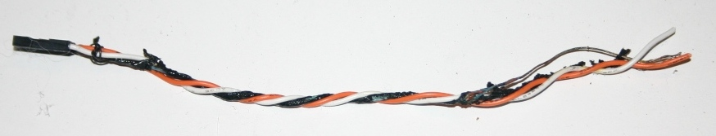

As can be seen from the photo, it didn’t end well. I was very lucky, aside from the obvious damage to the cable, lots of smoke, burns to my fingers trying to rip the cable out, the only other thing damaged was my ego.

But the lesson was learnt, unplug the pit from the wall when connecting or disconnecting anything that isn’t USB and have a fire extinguisher near-by, you never know when it may be useful.

# Wiring the pit

A quick count of switches, leds, and lamps shows that the pit has well over two hundred connections, and at least ten major electronic modules. Now given anyone of these modules may met an untimely end, I didn’t want to throw a soldering iron into the middle of a mass of cables whenever a module needed replacing or testing.

With the F16 Pit I put together some PCBs using WinQCad (hopefully will be of use to others someday). As the pit breaks down into three blocks, left middle and right there are three distribution panels which connect back to the electronics.

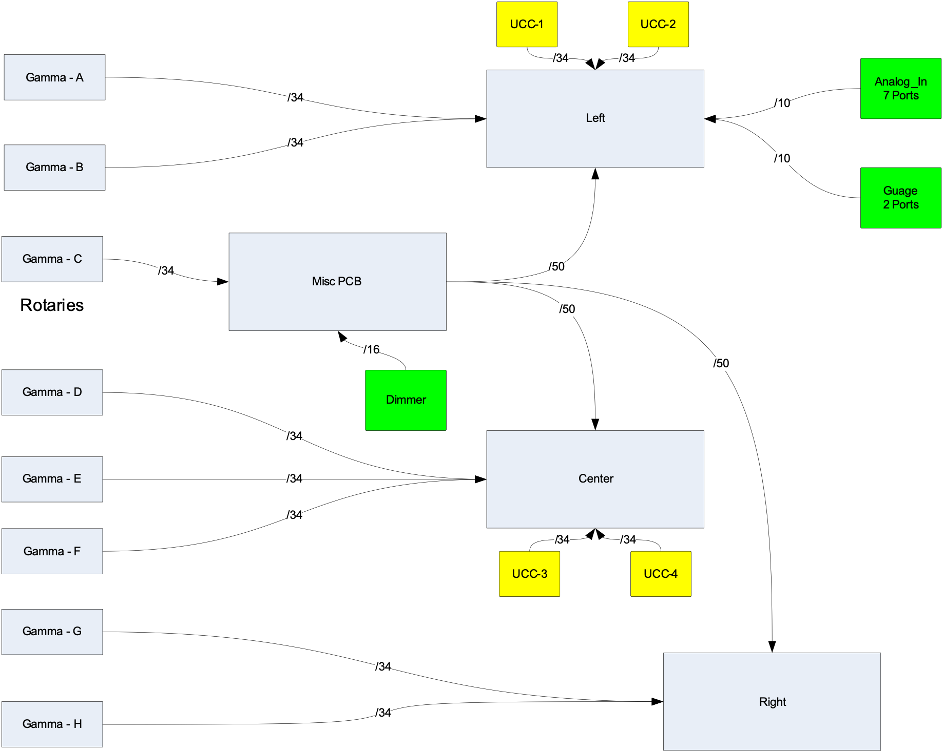

The Misc PCB provides a distribution point for the dimmer and rotary interface on the GammaRay.

Each Panel in the pit has a common PCB which provides connectivity to the GammaRay and UCC/ElectronFlux. The idea behind this is that only a single cable connects to the panel to the distribution PCB which in turn only has the minimal number of connectors back to the electronics. I’m planning to put all of the electronics in a single PC box/power supply simplying the layout of the electronics and power supplies.

### Back of Panel PCB

This is the building block of the pit, and has been designed to cover all of the panels aside from the MFDs which has a large number of connectors.

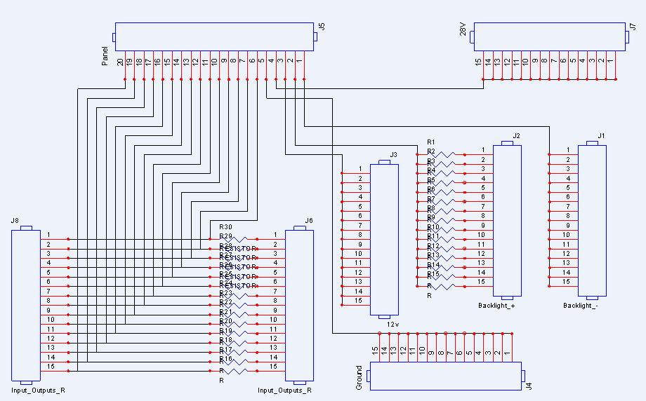

The PCB has 4 pins which 5 ports which are diedicated to the Backlight and power requirements. The remaining pins can either be inputs or outputs. The outputs can be driven via a resistor.

The distribution PCB is connected directly to the lighting controller, which has multiple channels. The first channel is for panel backlighting, the seond for NVG lighting of the front of the panels, the third for while flood lighting of the pit in general.

|  |  |
| --- | --- |
| Wire Colour | Wire Role |
|  |  |
| Light Blue | Backlight +ve |
| Dark Blue | Backlight -ve |
| Black | Ground |
| Yellow | Variable Voltages 28 to 12V for Lights and Leds |
| Purple | Return from lights –ve side going to output |
| Red | +12V |
| Green, crème, Brown, Orange, Gray, White | GammaRay Inputs |

The PCBs have thicker tracks for the Gnd, Fixed voltages, and the Dimmer rails. The dimmer rails are separated from the general inputs/outs by Gnd and general rails which should provide additional noise isolation.

## Wiring the JAY-EL switches

The Jay-el switches I scored were from an F4 simulator. To change the bulbs simply put your finger nails around the front legend and pull it out.

Photo Disassembled switch

Each Switch holds 4 bulbs rated at 28Volts, 2 across the top and two across the botton. Current draw at 28 is 40mA, 30mA at 16V. At 28V one bulb effectively lights the top or bottom of the switch. All four bulbs draw 160mA At lower voltages if becomes more clearly apparent that two bulbs are in each row. It did buy some Led ‘bulbs’ but found they had a much higher current draw than the filament bulbs, the 6 or so leds drew around 160mA.

Looking from the top of the switch ther are pins labeled 4, 3, C, 2, 1 (from back, left to right)

|  |  |
| --- | --- |
| Pin | Bulb Position |
|  |  |
| C | Common |
| 1 | Bottom Left |
| 2 | Top Left |
| 3 | Top Right |
| 4 | Bottom Right |

What I also noticed is the case casing does get a little warm when the lights are own. I briefly did think about trying to series the bulbs to reduce current draw and brightness a little and then realised they all anchor to a single common.

The switches from the F4 Simulator have the following legends

|  |  |  |  |  |
| --- | --- | --- | --- | --- |
| White Front Legend | F-16 Equiv | Top Lighted Text | Bottom Lighted Text | Lens Colour |
|  |  |  |  |  |
| SYS TEST | Yes | TEST (Green) | TEST (Green) | Clear |
| Diamond Shape |  |  |  | Black |
| ML RST | Yes |  |  | Red |
| SEARCH |  | SEARCH (Yellow) | SEARCH (Yellow) | Clear |
| MODE | Yes | PRIORITY (Yellow) | OPEN (Green) | Clear |
| POWER |  | PWR (Green) | PWR (Green) | Clear |
| RECORD |  | RECORD (Green) | RECORD (Green) | Clear |
| AAA DEF |  | AAA (Yellow) | DEFEAT (Yellow) | Clear |
| TGT SEP | YES | TARGET (Green) | SEPARATE(Green) | Clear |

The F16 TWP Stack looks like

|  |  |  |
| --- | --- | --- |
|  |  | HAND OFF (Record) |
|  | LAUNCH | MODE PRIORITY |
| Unknown/ Naval (AAA Def) | SYS TEST | TGT SEP |

The Green Highlighted text have a direct match to the F4 Legends, the Yellow will have to wait until someone makes some matching lenses.

The switch has six contact connectors at the back. Basically a left and right side.

The top connector is common, middle is Normally Open, bottom is normally closed.

Changing the lenses.

1. Remove the bulb assembly
2. There is a metal collar around the front with a couple of dimples, remove from front.
3. Underneath lthis should be a clear lens, the coloured lens, and another clear lens.
4. If the lens don’t simply dropout, remove a bulb and push them out fro the back.

The non-soldered switches

A few of the switches don’t have solder lugs, thought this was going to repsent some challenges, but has it turns out all is good. Used the following lugs (fro Dick Smith Electronics)

* + 5.3mm Ring Terminal Red
  + 3.2mm Spade Terminal Red
  + 4.3mm Spade Terminal Blue

## Earlier Versions

The earlier version of the pit just had electronics connected together. The black box in the background was the early housing for the xkeys module. Pretty much all of the electronics have been upgraded to later versions of Phidgets I/O controllers and the Version 2 of the Simkits CCU controller.

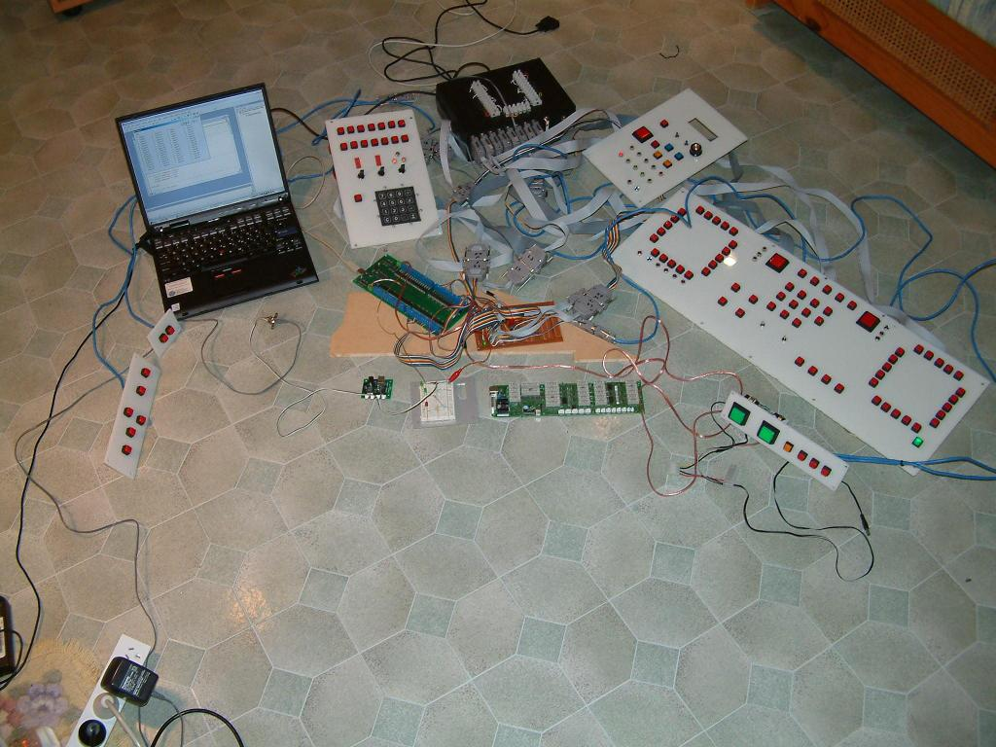

After using a set of IDC connectors for the xkeys interfaces, I also extended their use to providing an interconnect between the electronic modules and the panels containing the switches and indicators.

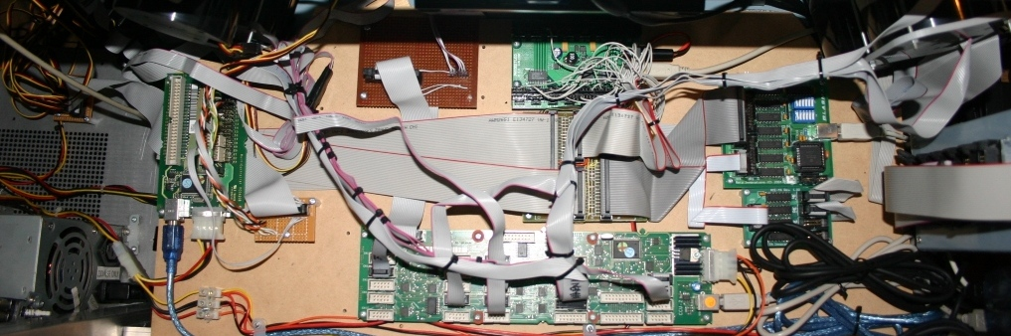

In the top shelf we have the CCUv2 from SimKits, the MCU from Simkits, a PhidgetsLed, and the Beta Innovations Plasma cards and expansion module. An interconnect module joins these units to the Panels around the pit. The keyboard input part is made up of the Plasma V2 and the button expansion kit. The Plasma has 16 Analog axis inputs.

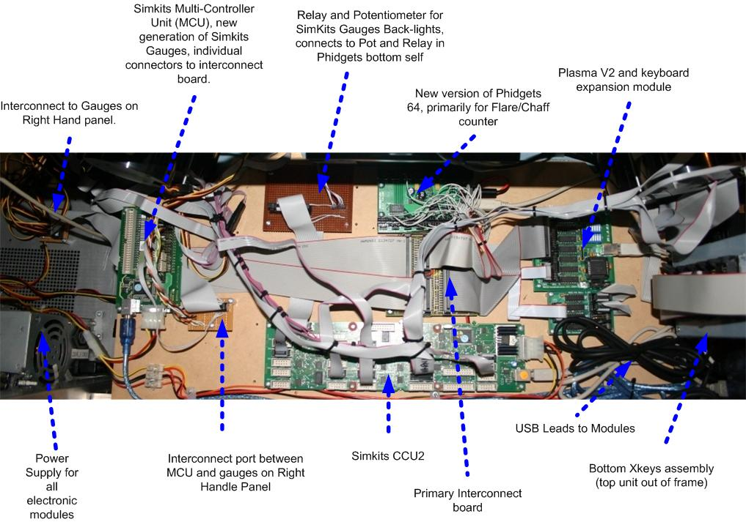

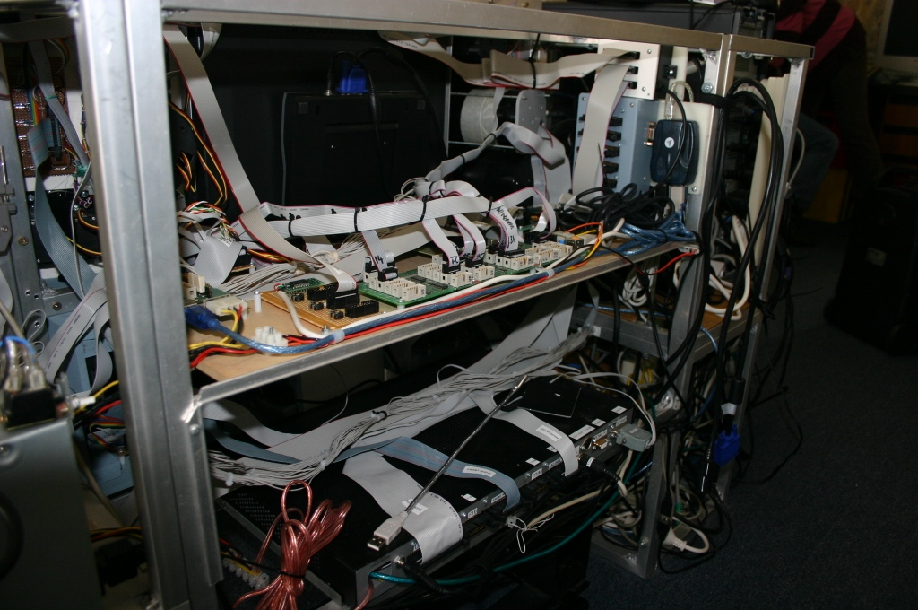

The inside of the bottom shelf is made up of Phidgets modules. Two 16 I/O modules, a 4 port servo module, and a Phidget Led 64 module (earlier version of the Phidget Led used in the upper shelf). The resistor array was used to provide back lighting for the button/lamps.

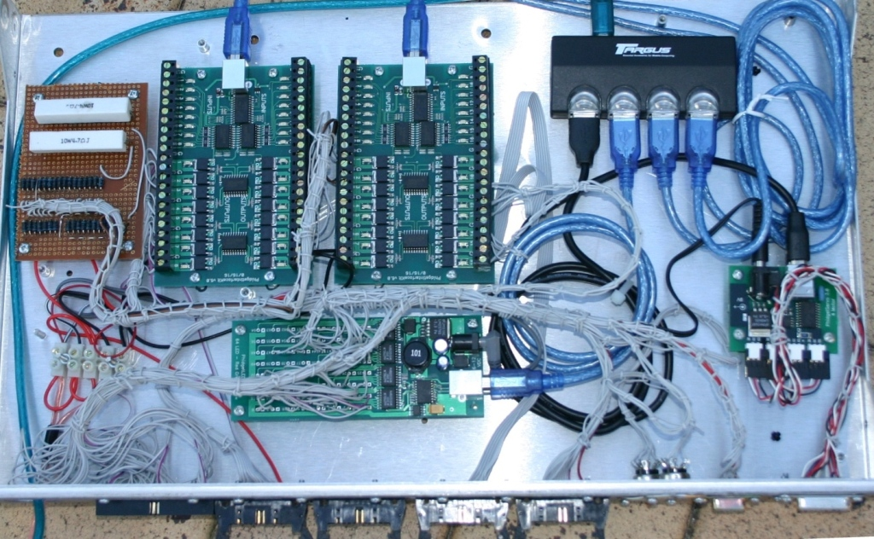

This unit is enclosed in a case to prevent anything from the upper self dropping into the bottom shelf electronics. .

The Interconnect board then connects to the Panels, which may also have a smaller distribution board. The Left Hand interconnect board will connect to the Seat Eject, using the servo style connector if possible. Currently looking at separating out the Led cabling from digital inputs are crosstalk is causing events to fire randomly… ie when they shouldn’t be firing.

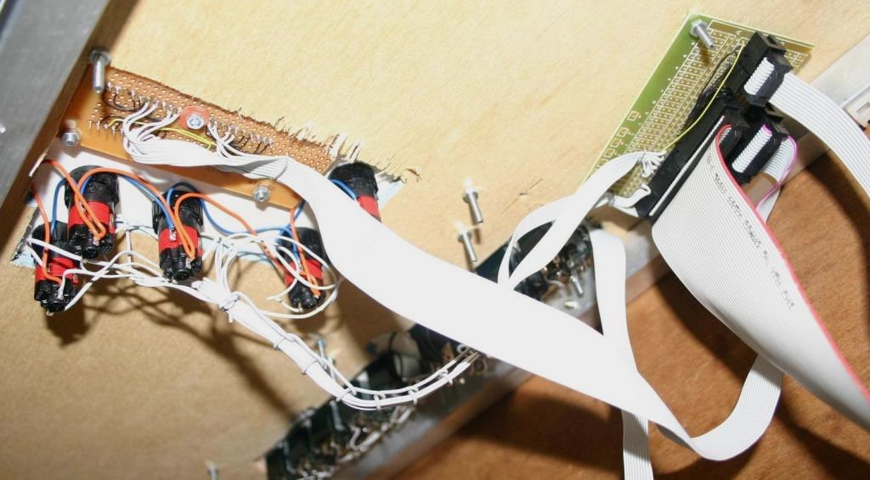

Figure 30 Underneath of Right Hand Panel

The top warning panel has the Simkits warning panel and some lighted buttons, they haven’t been rewired yet.

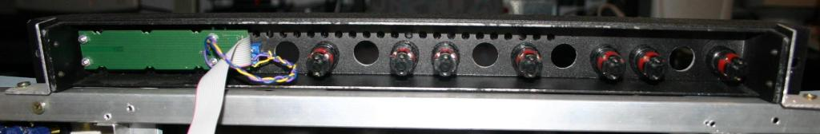

Figure 31 Back of Top Panel

UPDATE THIS PICTURE

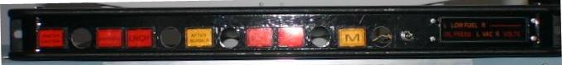

Back of right hand panel Simkits connections

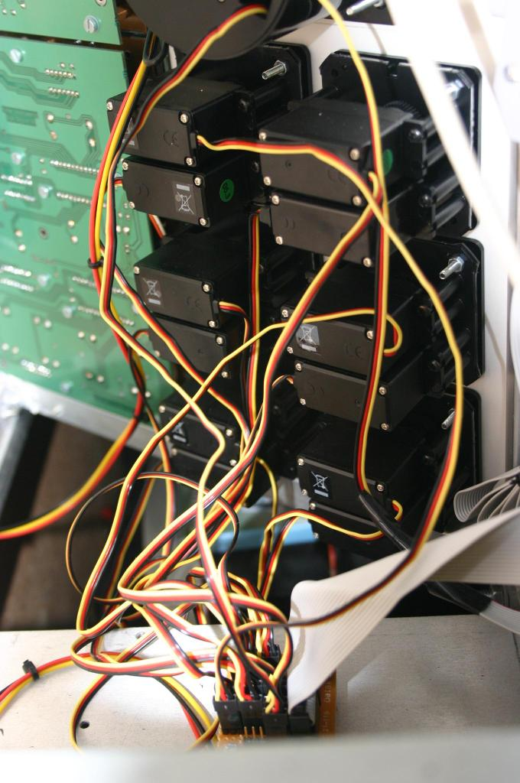

Figure 32 Back of Simkits Engine Gauges

Add shot of board with output from PhidgetServo

.

# Lighting the Pit

As I’m not lucky enough to have back-lit panels throughout the pit, I used an alternate approach, throwing light around the pit. Originally 8 Leds were used, four inside the pit on the left and right hand side panels, and four above and behind the pit. Why so many Leds? I wanted to avoid the touch effect where placing a hand in front of the beam blocks all light. By having a least two leds illuminating the panel from separate directions there is typically light being provided even with you move you hand to press a button or your head to look closer at an MFD.

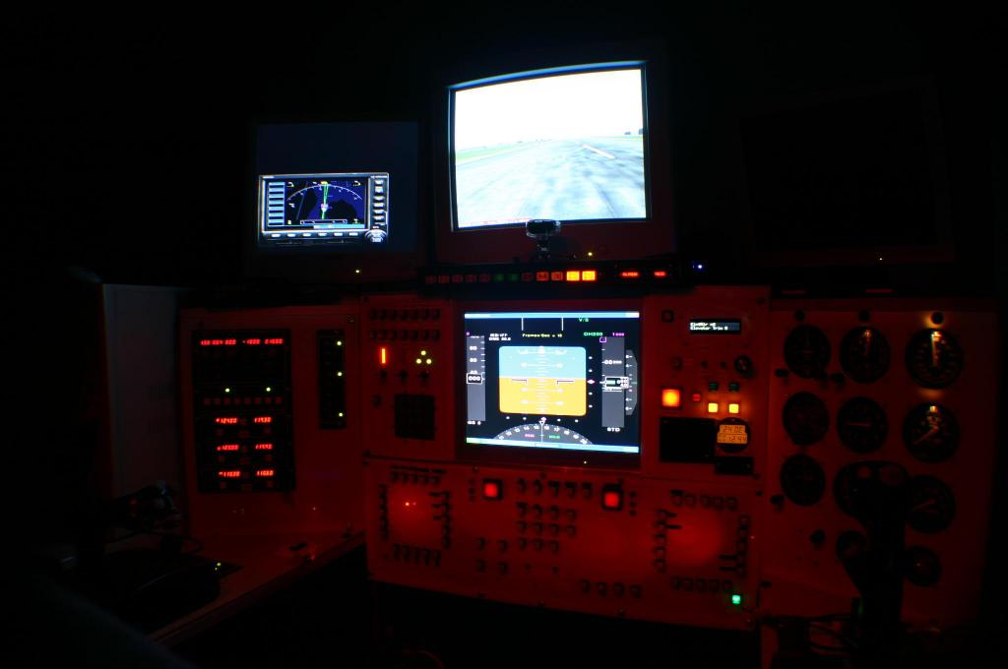

Figure 35 Night Lighting

Given the Leds were at different distances from the area they where illuminating a led lighting application was added to the pit.

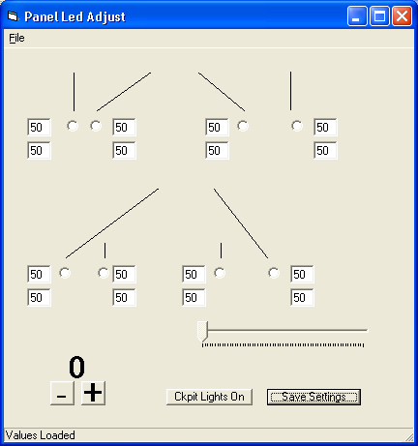

This allows the output of each led to be individually adjusted so the light across the panels was evenly distributed. The lights on the application are meant to be indicate where the leds output is being projected.

The smaller engine gauges from Simkits weren’t supplied with lighting bulbs, which didn’t bother me at first, but as the pit got close to its final shape the lack of light from the gauges needed to be addressed. The bulbs appear to be five volt and are driven from a common regulator. The maximum voltage across the bulbs is 3.85V. As a common regulator is used, and the current is low, I’m powering the gauges from a single connector on the CCUv2. A sanity check as far a loading goes something like, I have a maximum of 17 gauges that I’ll be lighting (15 given I had pulled the bulb out when assembling the VOR and attitude indicators), the CCUv2 board natively supports 23 bulbs, so I should be safe as far as load goes. If worse comes to worse I’ll simply take the output voltage and boost the current using a Darlington Pair.

# Approach Plates

Australian airports are available on the Internet for most Australian Airports (<http://www.airservicesaustralia.com/pilotcentre/aip/dap/AeroProcChartsTOC.htm>). For sometime I’ve had them in a folder, but have rarely used them as a large folder in the pit is a pain to handle.

We recently purchased a laminator which just made the approach plates a whole lot easier to use. The plates are printed on A4 but reduced to approximately 70%, placed back to back, and then laminated. To keep them all in place I used a paper punch three holes and then they are stored in a three ring binder.

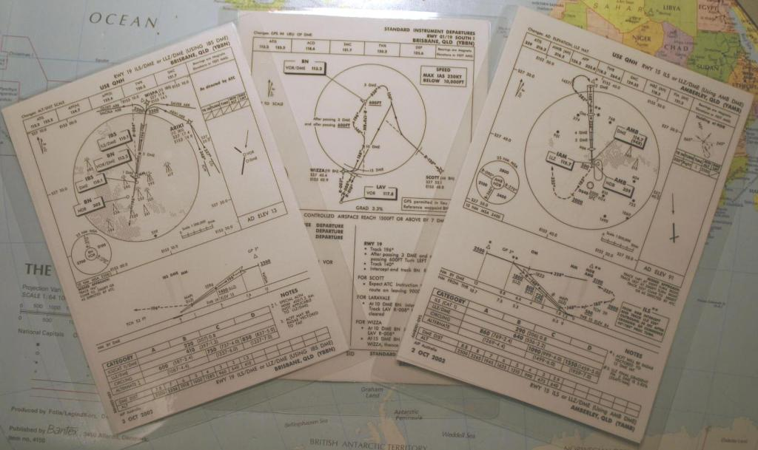

I doubt that frequencies for ILS and VOR change regularly, but to be sure I’ve saved the charts so they remain at the same date as FS. I found a new appreciation for the pilot’s workload when interacting with the tower, tuning Comm radios, and then working with the NAV radio and instruments. It certainly makes the flight sim experience much more immersive.

# Building the Frame

At the suggestion of a Sign Writing friend, the pit’s frame is built from Aluminum. Whilst it may not be as strong as steel, it doesn’t rust and it easy to work with. The only challenge was the requirement for a high current welder, which my friend had, so life was good ☺.

Before putting saw and welder to aluminum, a prototype using wood was made. After the measurements were sanity checked I sketched the frame up in Visio. About the only thing I’d change today is adding clearance for the pedals. The Thrustmaster pedals are very low profile compared to other pedals on the market today.

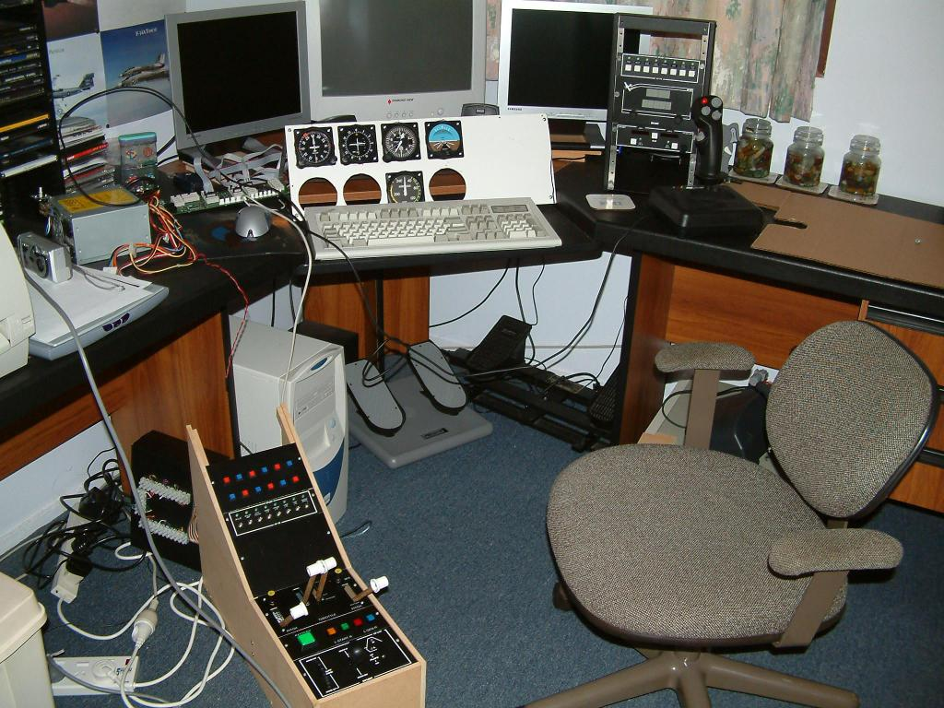

Figure 38 Bits and Pieces on the bench

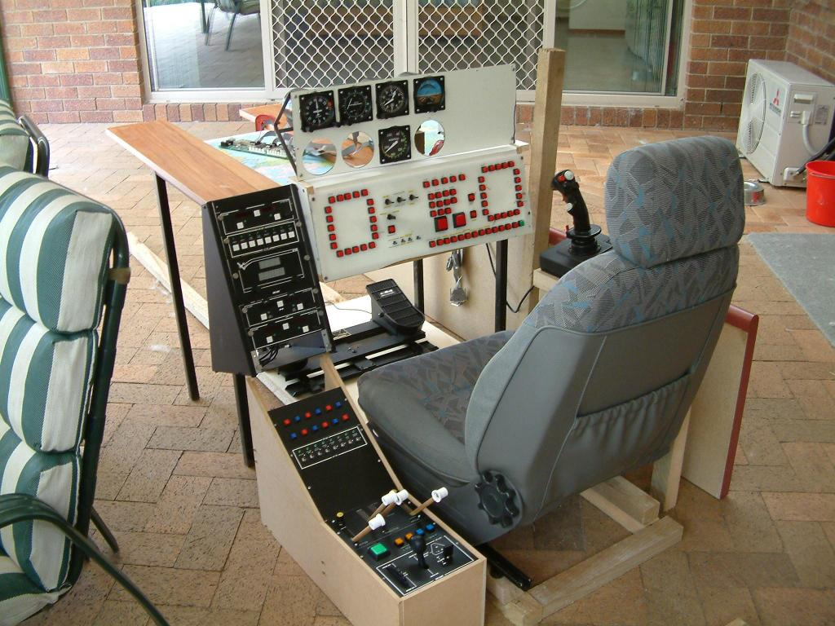

Figure 39 Got the car seat from the wreckers

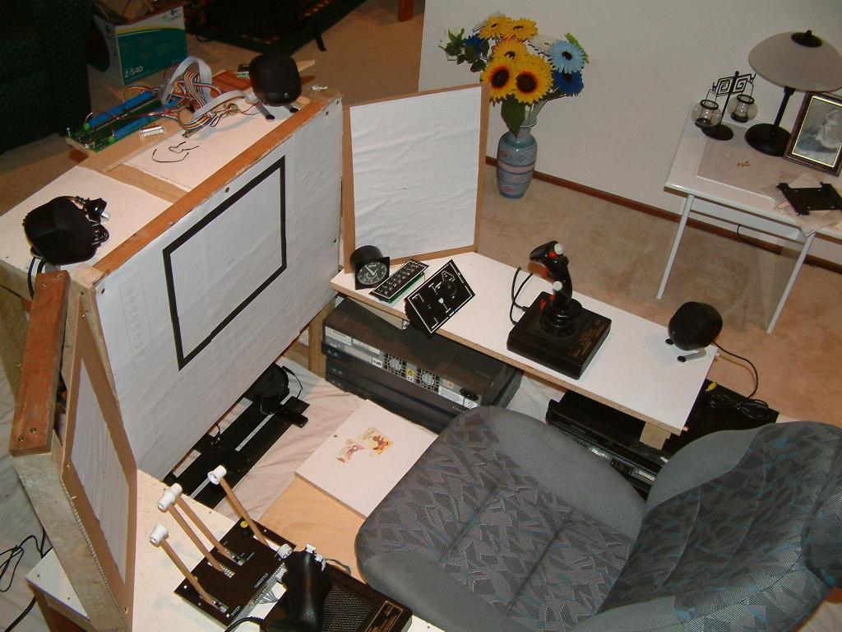

Figure 40 Little more detail

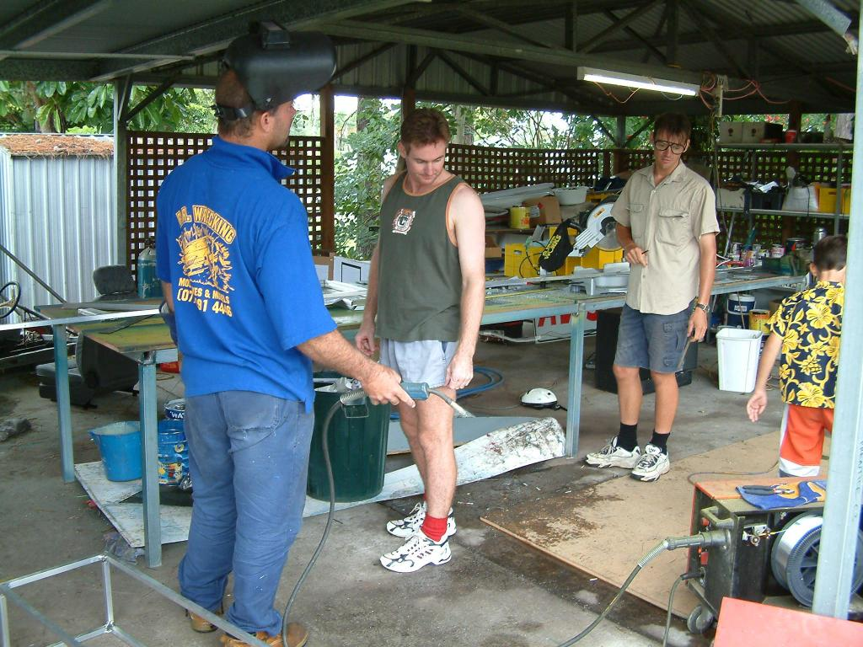

Figure 41 The boys starting the Frame

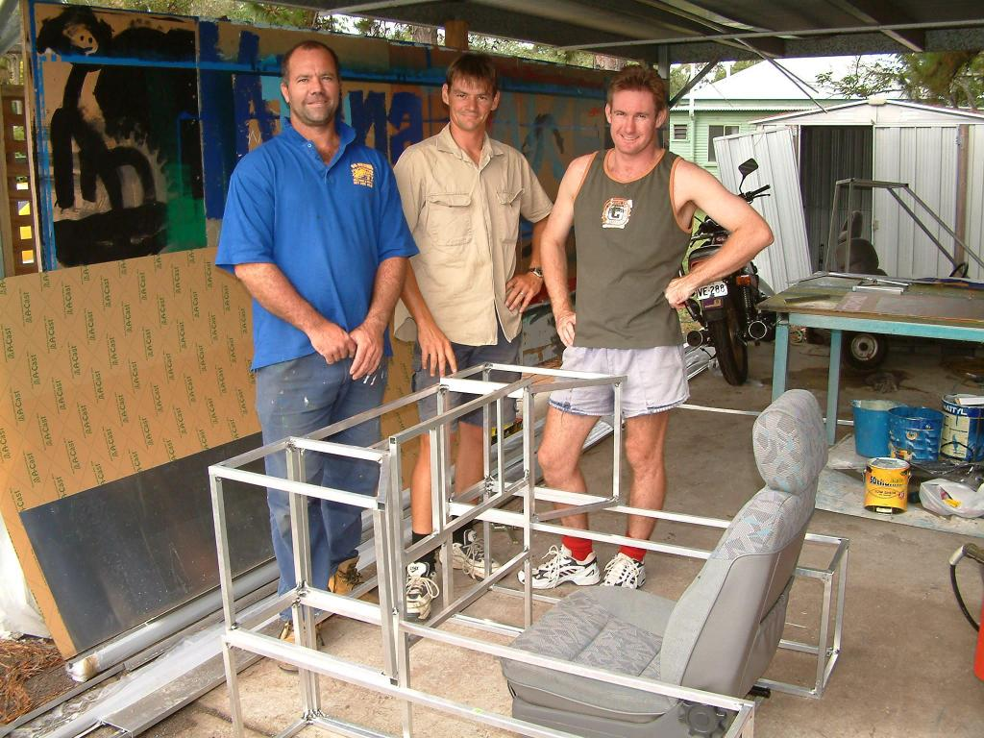

Figure 42 Frame complete time for a beer

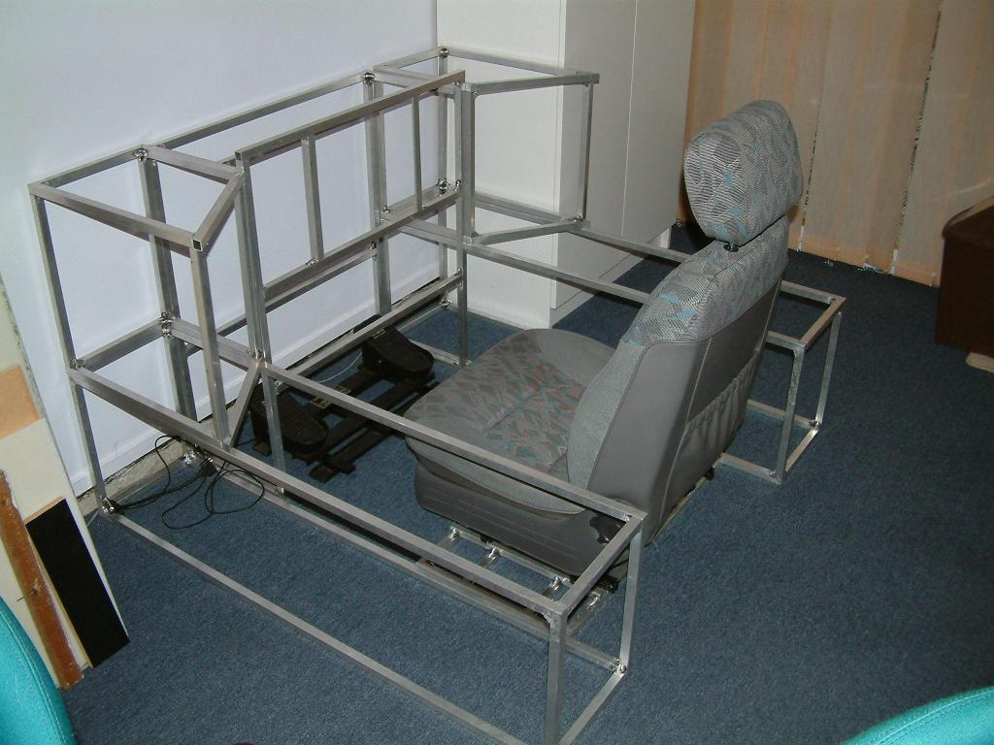

Figure 43 Just add the electronics

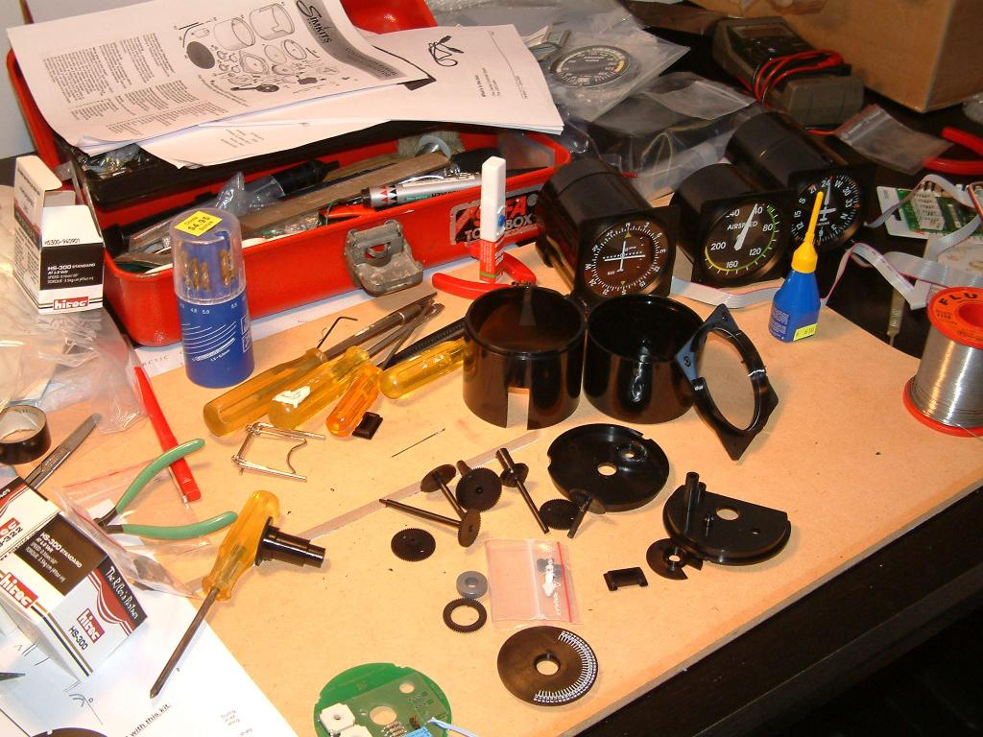

Figure 44 The Simkits Production Line

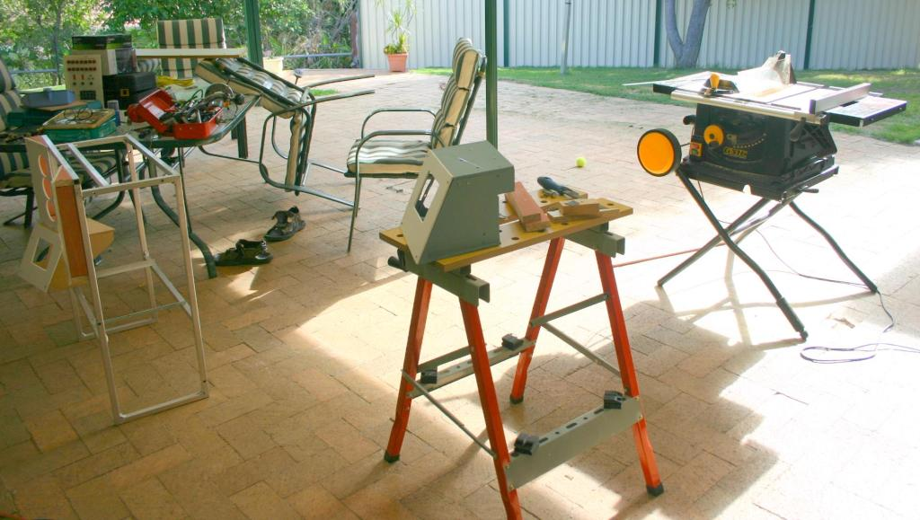

Figure 45 The MFD Workshop

# Creating the Panels

My panels are no where as flash as the panels created by Mike on Viperpit, functional I guess is one way to describe them. Most of the panels are built using the opaque plastic sheet used by sign writers. After drilling they are spray painted with an airbrush using Acrylic paint, Blue Blue by Solver paints.

For whatever reason Acrylic paints don’t come in a black as black as you can get with enamel. I used acrylic for most on the black panels but I’m now using enamel from a spray can. Whilst this may be more expensive there is less cleanup and the black dries real quick.

I had some fun trying to get the right effect on the Eject/Jettison warning panel. The goal was to hatch Yellow/Black. Initially I tried Yellow on black, what I soon discovered is that it takes a lot of yellow to cover black. With black on yellow only two coats are needed. The whole panel is painted yellow, and then I used masking tape to mask the lines I wanted to remain yellow. Only a couple of coast where applied, and not too heavily to reduce the amount of bleed under the edges of the masking tape. The black edges were tidied up by using a black DVD Marker pen.

# Creating this document

I primarily use Google’s Picasa for managing photos, but did find the Picture Manager included with Microsoft Office very useful for compressing and cropping pictures (don’t forget to press the Save button, as Picture Manager appears to complete the compress operation, but doesn’t automatically commit to disk. As most of the photos where originally taken with three to five megapixel cameras this document would have been huge without compressing the photos. A capability of Picasa I hadn’t used before was the auto-colour feature, this is real useful when a flash hasn’t been used and the lighting is provided by incandescent bulbs.

Another challenge faced was finding rouge ☺ photos that hadn’t been reduced in size, which had the document jumping in size by a couple of megabytes. I couldn’t find an easy way in Word to find the size of all embedded objects, however, by using the File-Save As a Web page, and then Select Web Page HTML as the type (default for my machine is Web Page Single File (MHT)). Once the exported, go to the File subdirectory and scan the list of exported files looking for large ones. Typically the files should be less than 100K.

When the document is exported as an HTML page from MS Word, it automatically creates a sub-directory to hold all of the images associated with the page. If an image is larger than 30K, Word will automatically shrink the image.

The labels on the photos where inserted using Visio by overlaying a non-transparent text box with 10 point font. Once the labels have been added the Visio document is exported as a JPEG file.

**Component Suppliers**

Without these guys cockpit building would be a pretty lonely hobby. Since 2003 there are been a number of suppliers adding products to what was previously a very small range of offerings.

The list is in no particular order, generally I’ve found all to offer good pre and post sales service.

|  |  |  |
| --- | --- | --- |
| Supplier |  | Pieces I’ve Used |

|  |  |  |
| --- | --- | --- |
| GOFLIGHT | Radio and autopilot modules. After I purchased the pre-built offerings, GoFlight added builders kits, giving the cockpit builder more flexibility in panel layouts.  All of the products have USB interfaces, and powered USB hubs are strongly recommended.  Doyle Nickless has done a great job of the interface into FS2004. He also provides an SDK and a utility to provide keystrokes.  Product Page  <http://www.goflightinc.com/>  Forums  <http://www.goflightinc.com/cgi-bin/ik/ikonboard.cgi> | 3 Radio Panels – COM1, COM2, NAV1, Autopilot, Toggle, Landing Gear |

|  |  |  |
| --- | --- | --- |
| Simkits | Pretty much all of the Simkits gauges are based on servos.  [www.simkits.com](http://www.simkits.com/) | CCUv2 (primary controller for driving the bulk of the gauges), Airspeed, altitimeter, Artifical Horizon, VSI, Heading, VOR. |

|  |  |  |
| --- | --- | --- |
| Phidgets | A great range of USB to almost anything devices. Chester has continued to expand the range of inputs and outs supports by this great cards. Provides drivers for a number of development languages including Visual Basic and Delphi. I had faced some challenges with Blue screens of death when using the earlier drivers, so much of my development is still done using Visual Basic  www.phidgets.com | 4 Port Servo, 2 * 16 I/O, Phidget LCD, Phidget Led 64, Phidget Text Led, |

|  |  |  |
| --- | --- | --- |
| Flight Illusions | More recent addition to the suppliers, nice quality, although they have had a couple of false starts. Still awaiting the Attitude indicator.  Drivers for FS2004. No public SDK.  <http://members.chello.nl/p.leerentveld/>  Contact: mark.verschaeren1@telenet.be | Dual Engine Stack |

|  |  |  |
| --- | --- | --- |
| Lowrance | Makers of real Aviation GPS. I chose the Airmap 2000C as it offered a NEMA input so I could drive it from the simulator. As I live in Australia the base map that was supplied with the unit covered Australian Airports, one day I’ll get the US Airports to the database.  <http://www.lowrance.com/Aviation/Products/AM2000C.asp> | Airmap 2000C |

|  |  |  |
| --- | --- | --- |
| Flight Deck Solutions | Pretty much the components super market for pit builders. Some nice options for annunicators, rotaries and knobs  <http://www.flightdecksolutions.com/>  Contact: pcos@flightdecksolutions.com | Annunciators |

|  |  |  |
| --- | --- | --- |
| X-Keys | One of the core parts of the pit, along with Beta Innovations provides the switch to keystroke translation. Primarily I use the Xkeys for momentary push buttons. Diodes are required if more than two switches are going to be pressed at any point in time.  http://www.xkeys.com/ | X-Keys Matrix |

|  |  |  |
| --- | --- | --- |
| Beta Innovations | The other half of the button to keystroke emulation for the pit. Excellent for using with toggle switches as diodes are not required.  http://www.betainnovations.com/ | Plasma-Lite V2  ACE-4X |

|  |  |  |
| --- | --- | --- |
| Parallax | Intelligent USB Servo controller. Replaced the Simkits MCU as Simkits did not offer an SDK. |  |

|  |  |  |
| --- | --- | --- |
| Thrustmaster | The all metal Cougar joystick and throttle, along with Rudder Pedals. | Joystick and Throttle |

|  |  |  |
| --- | --- | --- |
| Logitech | In addition to using the cougar I wanted a centre stick, which gives a totally different feel that a side stick. | Joystick, and wireless keyboard mouse. |

|  |  |  |
| --- | --- | --- |
| PC Range | Keyboard/Mouse/Video switching device. Given the pit requires several computers, I didn’t want three keyboards and three mice to argue with. This solves that problem, and was assembled in such a way that I get externalize the select button and status leds  Contact: [sales@pcrange.biz](mailto:sales@pcrange.biz)  www.pcrange.biz | 4 Port Keyboard, Mouse, Video switch |

|  |  |  |
| --- | --- | --- |
| Allied Electronics | Allied Electronics ([www.AlliedElec.com](http://www.AlliedElec.com/)). | Toggle Switches |

|  |  |  |
| --- | --- | --- |
| Matrox | The most common question I used to get, was our do I tie the three screens together? The great thing about the Matrox Parhelia was it did the work for you, and was supported in FS2004. Now days it just fast enough to drive Sims such as LOMAC, so it has been relegated to the central MFD. | Parhelia, three headed video card |

|  |  |  |
| --- | --- | --- |
| stivaskam | 8 Inch Touch Screens with Native Resolution of 800*600, support up to 1024*768. Considerably cheaper than the screens from TVS, but to be fair the screen from TVS are much more of an industrial feel, and a year or so older. |  |

|  |  |  |
| --- | --- | --- |
| TVS | Went looking long and hard for small LCD displays to use in the MFDs. Finding small displays is easy, finding ones with VGA inputs to maintain clarity was hard. These guys shipped from both Taiwan and the USA to Australia.  Contact: [yapid@tvs.com.tw](mailto:yapid@tvs.com.tw)  Or for the US  Contact: ahung@eversun.com | MFD 6.4” LCDs |

|  |  |  |
| --- | --- | --- |
| Jaycar and Dick Smith | The local electronics suppliers for the switches, IDC connectors, standoffs and prototype boards. | Miscellaneous |

|  |  |  |
| --- | --- | --- |
| Braemac | These are specialized switch suppliers  <http://www.braemac.com.au/Frame_locations.html>  Contact: phil@boughen.com.au | MFD Buttons and lighted switches |

|  |  |  |
| --- | --- | --- |
| Marsh Springs | Yeap, a spring manufacturer. I was unlikely enough, after ten years, to finally bust the main spring in my trusty old Thrustmaster pedals during a crosswind landing into Brisbane International. <http://www.marshsprings.com.au/>  Took the broken spring to them, and they made a brand new one. Brought a couple of others just in case brake another in ten years | Spring Manufacturer |

|  |  |  |
| --- | --- | --- |
| FreeFD | While not something you can buy, FreeFD is the software that drives the central display and the MFDs |  |

|  |  |  |
| --- | --- | --- |
| Eagle 9 | Donationware, used for provide gauges on a second computer. Whilst Erwin had written this for Falcon 4 I wrote an adaptor that enables Eagle 9 to also be used with LOMAC  http://www.eagle9.nl/ |  |

|  |  |  |
| --- | --- | --- |
| Zorlac | Touchbuddy – Freeware that provides an easy to use interface between a Touchscreen and pretty much any application. |  |

|  |  |  |
| --- | --- | --- |
| Peter Dowson | FSUIPC, probably the most prolifically used interface for Microsoft Flight Simulator. The interface is commonly used with hardware addons such as GoFlight, Simkits, FreeFd, and Flight Illusions. An option component is WideFS which enables you to obtain FS200X information on a second computer over a network  http://www.schiratti.com/dowson.html | FSUIPC |

|  |  |  |
| --- | --- | --- |
| Microsoft | FS2004 and Visual Basic |  |

|  |  |  |
| --- | --- | --- |
| Microprose | Falcon 4 and all of its derivatives | F4 BMS, and Falcon 4 AF |

|  |  |  |
| --- | --- | --- |
| Eagle Dynamics | The Flanker Series and Lockon Modern Air Combat (LOMAC), the Flamming Cliffs Addon  http://www.lockon.ru/ | LOMAC 1.1 |

|  |  |  |
| --- | --- | --- |
| Mitsibushui | High resolution Projector. I originally had a Sony which was 800*600 Native, upgraded to the Mitsibushi with a native resolution of 1024*768 |  |

|  |  |  |
| --- | --- | --- |
| Natural Point | Head tracking tool, pretty cool, but I’ve found you need plenty over CPU spare to make it seemless. The V4 of TrackIR integration into Lomac 1.2 looks nothing short of amazing  www.naturalpoint.com | TrackIR Pro |

|  |  |  |
| --- | --- | --- |
| Viperpit | Not a supplier as such but the place to hang out if you want to see what others are doing.  <http://www.viperpit.org/forum/> |  |

|  |  |  |
| --- | --- | --- |
| Frugals World | Also another great place to hang out and see whats happening in pit building as well as major Flight sims.  <http://forums.frugalsworld.com/vbb/forumdisplay.php?f=48> |  |

|  |  |  |
| --- | --- | --- |
| PC Aviator | Flight sims as well as add-ons  www.pcavaitor.com.au | LA and San Fran High-Res scenery |

# About the Builder

Well, I’m Peter Thomas, whose association with flight and electronics goes back to before I was 11. I was lucky enough to have a family friend who was an agricultural-pilot in a country town in New Zealand. After many flights in a Hiller UH-12 and a Bell Jet Ranger I was hooked. Whilst helicopters are still my favourite form of flight I did get a chance to take a Jet Fighter flight in an Ex-RNZAF Strike-Master.

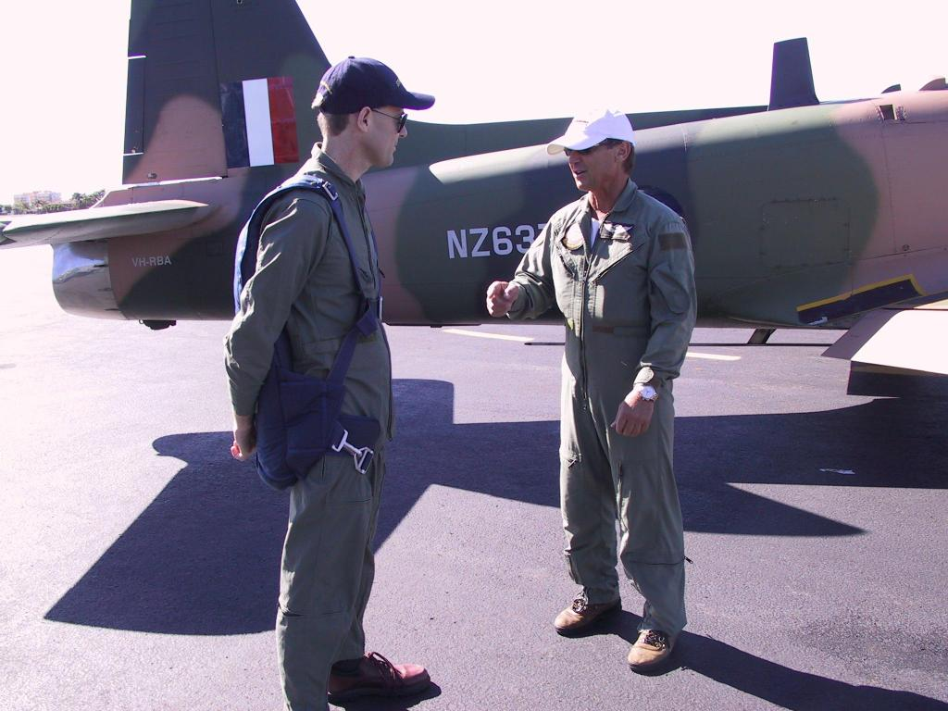

Figure 47 Preflight Briefing – if you gotta jump aim for the wing – yikes!

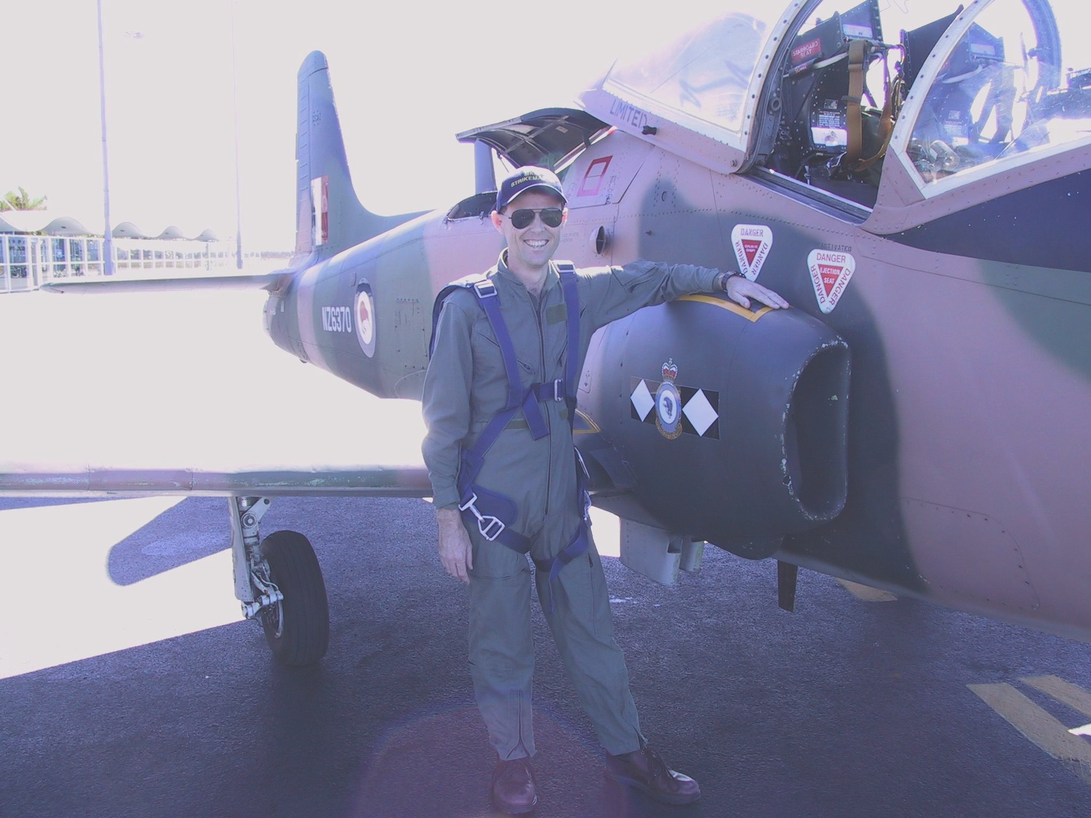

Figure 48 Finding something to lean on

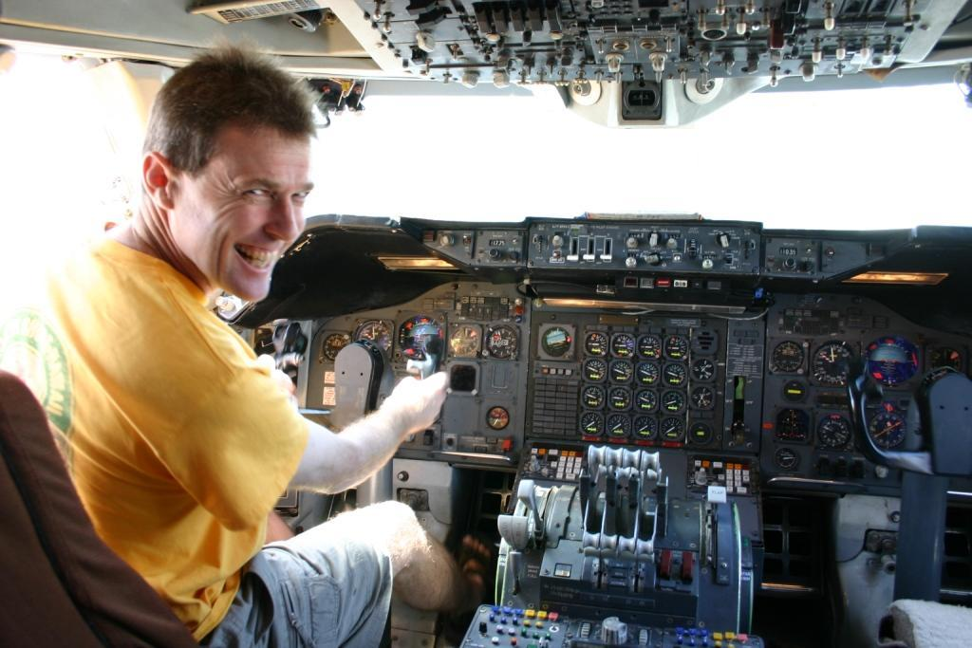

Figure 49 - At the pointy end of a real 747

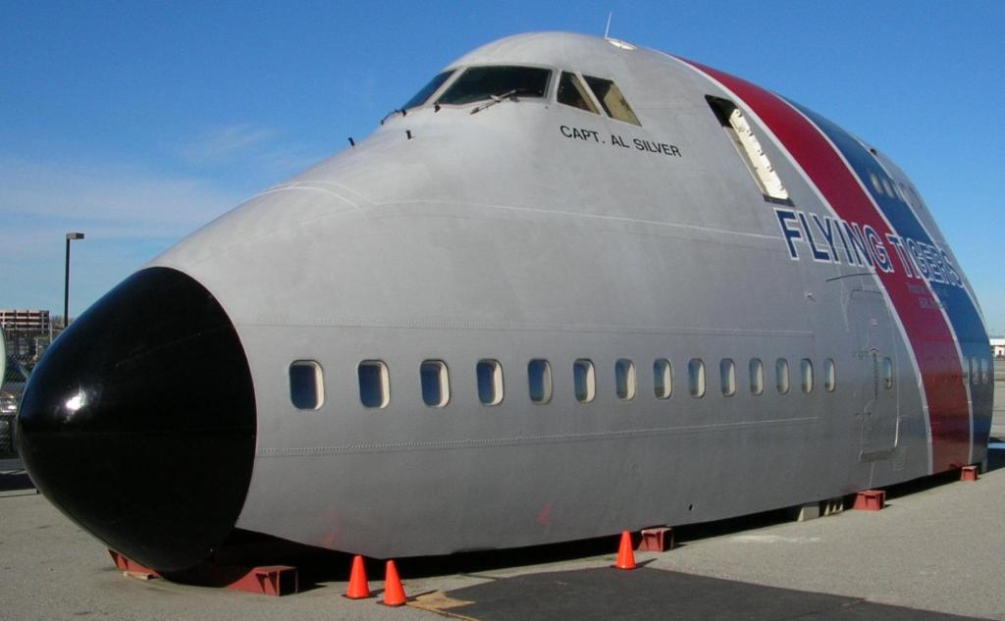

Figure 50 fortunately its at the Hiller Museum

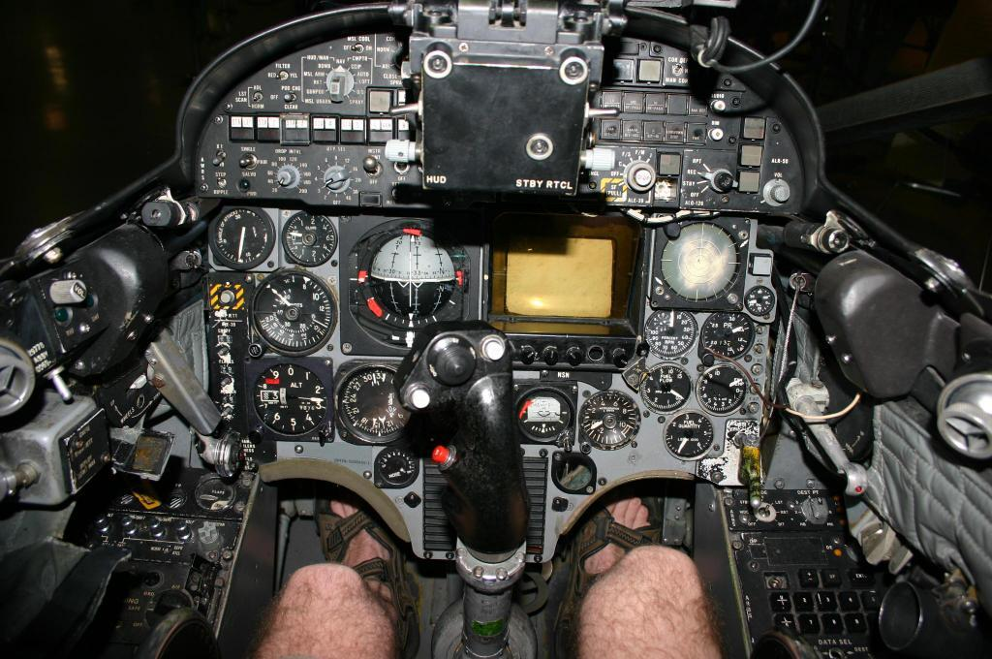

Figure 51 Inside a Sky Hawk – It’s a real squeeze - Hairy Legs and all

# Now If I had a Million Dollars

While in the USA I had the chance to get to Smithsonian Museum. They had a simulator room full of some very nice toys.

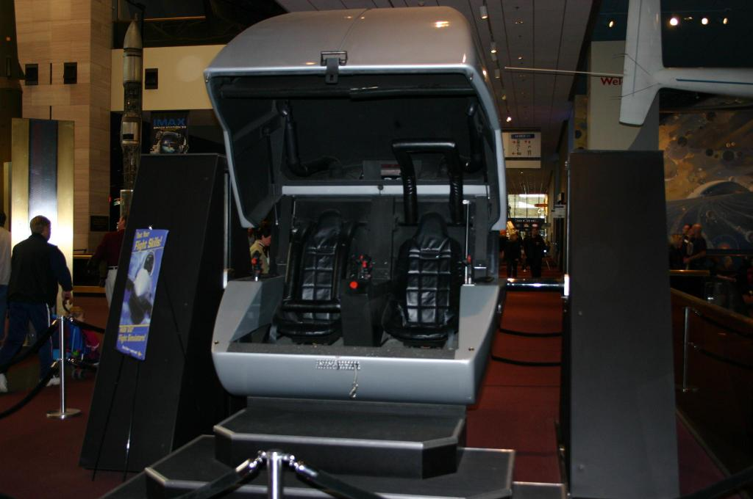

As can be seen in the photo you hop in, the lid closes, and off you go. The Sim engine didn’t have the fidelity I’d hoped for, but the movement of the sim more than made up for that. The image is projected onto a screen by a projector located above and behind the seats. The unit in this photo was not operational, but that wasn’t a problem as there is a whole hall of these simulators at the Smithsonian.

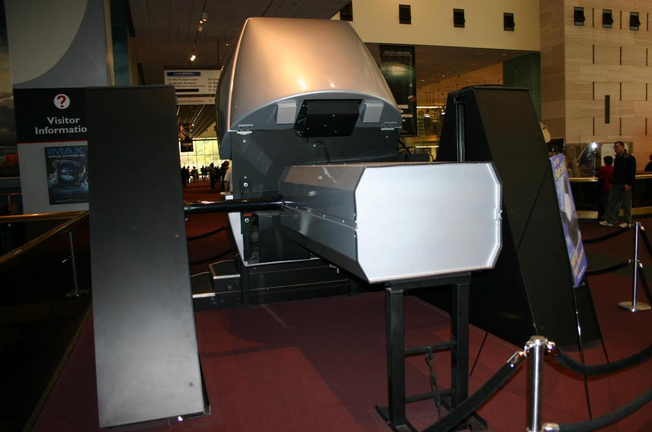

The front clam shell freely rotates, arm does a 180 degree roll, when flying the illusion is complete.

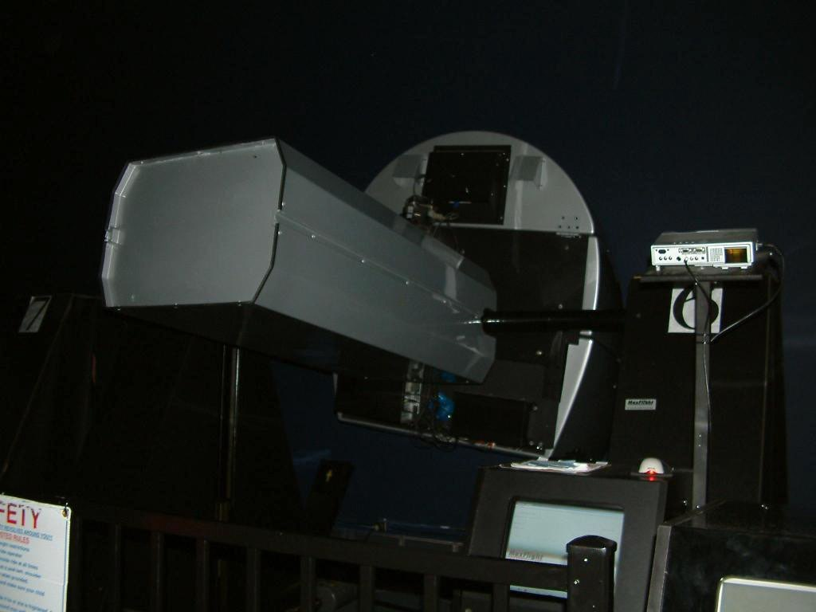

Figure 52 Over she goes

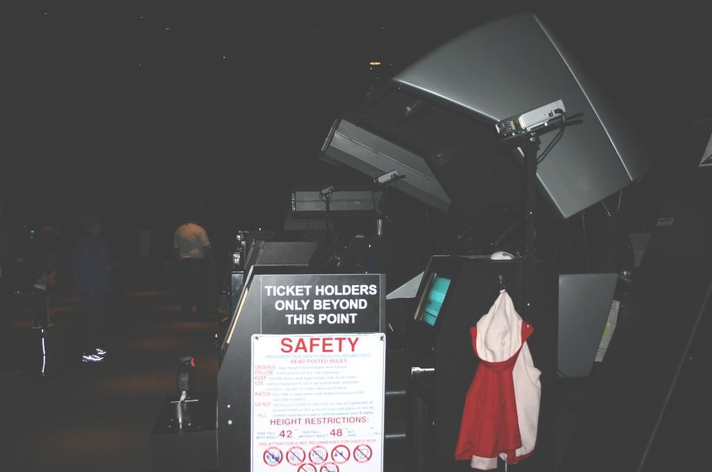

Figure 53 One of the rows of these fine sims

# Other Brisbane Pit Builders

Carl aka Scott Hendry – out on the Russel Island in the bay. <http://home.exetel.com.au/flightsim/archive.htm>

James Radvan aka Ruprecht

http://pitblog.radsy.com/

# Programming the simulator

As simulators provide programmatic interfaces, getting data from the simulator to the real world is relatively easy to do. The current generation of simulators expose a large number of values through different APIs, and some of them (eg FS2004 and LOMAC) offer the ability to programmatically set some values.

**Simulators and Supported Interfaces**

|  |  |  |
| --- | --- | --- |
| Simulator | Programmatic Interface | Remote Access (on another computer) |

|  |  |  |
| --- | --- | --- |
|  |  |  |

|  |  |  |
| --- | --- | --- |
| FS200X | Peter Dowson's FSUIPC | WideFS |

|  |  |  |
| --- | --- | --- |
| Falcon 4 | Shared Memory | Eagle9s F4 Glass, Simmeters |

|  |  |  |
| --- | --- | --- |
| il2 | Device Link | Native? |

|  |  |  |
| --- | --- | --- |
| Lomac | LUA | Via the LUA TCP interface |

**Components and Supported Simulators/Interfaces**

|  |  |  |
| --- | --- | --- |
| Component | FS200X Support | Generic SDK |

|  |  |  |
| --- | --- | --- |
|  |  |  |

|  |  |  |
| --- | --- | --- |
| GoFlight | Yes | Yes |

|  |  |  |
| --- | --- | --- |
| Simkits | Yes | Yes for CCU  No for MCU |

|  |  |  |
| --- | --- | --- |
| Beta Innovations | Yes | Yes |

|  |  |  |
| --- | --- | --- |
| Flight Illusions | Yes | No |

|  |  |  |
| --- | --- | --- |
| Phidgets | Indirectly | Yes |

**Digging Deeper – Falcon 4 Shared Memory**

I’ll start with Falcon 4 and the Programmatic interface it offers as this was the first sim I programmed against. Erwin’s Eagle 9 site (<http://www.eagle9.nl/>) is an excellent starting point, especially for VB programmers, it gave me enough information (and confidence) to start programming against simulators. Something to be aware of is that (at least with older releases of F4) is all of the shared memory may not be updated if you are running in simplified mode. I wasted a lot of time trying to work out why my code driving a DED wasn’t playing nicely, only to find it started working I switched to advanced avionics mode.

So what’s involved in getting information out of Falcon 4? Fundamentally not a lot.

The pseudo code looks like:

* Attempt to Open F4 Shared Memory Area (File name is FalconSharedMemoryArea)
* Set a Pointer to the Shared Memory Area
* Copy the Shared Memory Area to a local array
* Close the Handle
* Set the LEDs and Gauges as required

A little more than 5 lines of code is required to do this in practice.

As F4 is a living simulator with a couple of code trains you’ll first need to get the Data Structure for the version you are flying. There are at least(!) three that I know of:

1. The Standard Version i.e. 1.08US
2. F4 Allied Force
3. Free Falcon 3 (FF3)

Why different structures you may well ask? It’s all about adding new capabilities to the Sim, for example with FF3 support was adding for Dual Engine Aircraft, this pushed other exported values down the chain as the authors (quite correctly) kept both of the engine values together.

Once you’ve determined which data structure to use, then you may need to convert it to Visual Basic Format (if it hasn’t been done already).

The resulting data structure should look something like (I used this one for FF3):

Public Type FF3_FlightData

ShipNorth As Single ' Position of aircraft in North-South direction

ShipEast As Single ' Position of aircraft in East-West direction

ShipDown As Single ' Elevation of Aircraft

ShipNorthRate As Single ' Velocity of Aircraft in North-South direction(ft/sec)

ShipEastRate As Single ' Velocity of Aircraft in East-West direction (ft/sec)

ShipDownRate As Single ' Rate of Descent/Climb

alpha As Single ' Ownship Angle of Attack (Degrees)

beta As Single ' Ownship Beta (Degrees)

gamma As Single ' Ownship Gamma (Radians)

pitch As Single ' Ownship Pitch Angle (Radians)

roll As Single ' Ownship Roll Angle (Radians)

yaw As Single ' Ownship Yaw Angle (Radians)

' (can also be used as magnetic heading)

mach As Single ' Ownship Mach number (Mach)

kias As Single ' Ownship Indicated Airspeed (Knots)

vt As Single ' Ownship True Airspeed (Ft/Sec)

gs As Single ' Ownship G-Force (Gs)

windOffset As Single ' Wind delta to FPM (Radians)

nozzlePos As Single ' Ownship engine nozzle percent open (0-100)

NozzlePos2 As Single ' Ownship engine nozzle2 percent open (0-100)

' //TJL 01/14/04 Multi-engine

internalFuel As Single ' Ownship internal fuel (Lbs)

externalFuel As Single ' Ownship external fuel (Lbs)

fuelFlow As Single ' Ownship fuel flow (Lbs/Hour)

rpm As Single ' Ownship engine rpm (Percent 0-103)

RPM2 As Single ' Ownship engine rpm2 (Percent 0-103)

'//TJL 01/14/04 multi-engine

ftit As Single ' Ownship Forward Turbine Inlet Temp (Degrees C)

FTIT2 As Single ' Ownship Forward Turbine Inlet Temp2 (Degrees C)

'//TJL 01/14/04 multi-engine

gearPos As Single ' Ownship Gear position 0 = up, 1 = down;

speedBrake As Single ' Ownship speed brake position 0 = closed,

'1 = 60 Degrees open

epuFuel As Single ' Ownship EPU fuel (Percent 0-100)

oilPressure As Single ' Ownship Oil Pressure (Percent 0-100)

OilPressure2 As Single ' Ownship Oil Pressure2 (Percent 0-100)

'//TJL 01/14/04 Multi-engine

lightBits As Long ' Cockpit Indicator Lights, one bit per bulb. See enum

headPitch As Single ' Head pitch offset from design eye (radians)

headRoll As Single ' Head roll offset from design eye (radians)

headYaw As Single ' Head yaw offset from design eye (radians)

lightBits2 As Long ' Cockpit Indicator Lights, one bit per bulb. See enum

lightBits3 As Long ' Cockpit Indicator Lights, one bit per bulb. See enum

ChaffCount As Single ' Number of Chaff left

FlareCount As Single ' Number of Flare left

NoseGearPos As Single ' Position of the nose landinggear

LeftGearPos As Single ' Position of the left landinggear

RightGearPos As Single ' Position of the right landinggear

AdiIlsHorPos As Single ' Position of horizontal ILS bar

AdiIlsVerPos As Single ' Position of vertical ILS bar

fill_in As Single ' Placeholder 2004 11 26

courseState As Integer ' HSI_STA_CRS_STATE

headingState As Integer ' HSI_STA_HDG_STATE

totalStates As Integer ' HSI_STA_TOTAL_STATES ???

courseDeviation As Single' HSI_VAL_CRS_DEVIATION

desiredCourse As Single ' HSI_VAL_DESIRED_CRS

distanceToBeacon As Single' HSI_VAL_DISTANCE_TO_BEACON

bearingToBeacon As Single ' HSI_VAL_BEARING_TO_BEACON

currentHeading As Single ' HSI_VAL_CURRENT_HEADING

desiredHeading As Single ' HSI_VAL_DESIRED_HEADING

deviationLimit As Single ' HSI_VAL_DEV_LIMIT

halfDeviationLimit As Single ' HSI_VAL_HALF_DEV_LIMIT

localizerCourse As Single ' HSI_VAL_LOCALIZER_CRS

airbaseX As Single ' HSI_VAL_AIRBASE_X

airbaseY As Single ' HSI_VAL_AIRBASE_Y

totalValues As Single ' HSI_VAL_TOTAL_VALUES ???

TrimPitch As Single ' Value of trim in pitch axis, -0.5 to +0.5

TrimRoll As Single ' Value of trim in roll axis, -0.5 to +0.5

TrimYaw As Single ' Value of trim in yaw axis, -0.5 to +0.5

hsiBits As Integer ' HSI flags

DEDLines As String * 130 ' DED 6 * 26 usable chars

Invert As String * 130 ' DED 6 * 26 usable chars

PFLLines As String * 130 ' PFL 6 * 26 usable chars

PFLInvert As String * 130 ' PFL 6 * 26 usable chars

UFCTChan As Integer ' UFC TACAN Channel

AUXTChan As Integer ' AUX TACAN Channel

RWRObjectCount As Integer' Number of valid threat objects

RWRSymbol As Integer ' Type of threat

Bearing(20) As Single ' Bearing to threat (radians)

MissileActivity(20) As Single ' Missile is active or beam rider

MissileLaunch(20) As Single ' Missile is launched

Selected(20) As Single ' Threat is Selected

Lethality(20) As Single ' Lethal Range

FWDFuel As Single ' Forward Fuel Tank Quantity

AFTFuel As Single ' Aft Fuel Tank Quantity

TotalFuel As Single ' Total Fuel Tank Quantity

VersionNum As Integer ' Version of sh.mem file

End Type

What is defined in the data structure is really the offsets to values held in a shared memory area and the data type of the variable at that location. You could say the data structure is like a code book to determine where a value is, and how is it stored.

Unlike the early days of BASIC and MSDOS, you cannot blindly peek and poke just anywhere in the PCs memory. Windows now prevents one program from accessing another programs memory space, so how can you communicate between processes? Windows supports Shared Memory Files, much like a file on disk that can be read and written to by multiple programs, but it resides in memory. This means different Windows APIs must be used to access the data in the file, as Visual Basic doesn’t have an inbuilt statement to access a shared memory file.

So before we can use the Windows API to read the values we must declare it.

Public Declare Function OpenFileMapping Lib "kernel32" Alias "OpenFileMappingA" _

(ByVal dwDesiredAccess As Long, ByVal bInheritHandle As Long, _

ByVal lpName As String) As Long

Public Declare Function MapViewOfFile Lib "kernel32" (ByVal hFileMappingObject As Long, _

ByVal dwDesiredAccess As Long, ByVal dwFileOffsetHigh As Long, _

ByVal dwFileOffsetLow As Long, ByVal dwNumberOfBytesToMap As Long) As Long

Public Declare Sub CopyMemory Lib "kernel32" Alias "RtlMoveMemory" _

ByRef Destination As Any, ByRef Source As Any, ByVal numbytes As Long)

Declare Function UnmapViewOfFile& Lib "kernel32" (ByVal lpBaseAddress As Long)

The names for the APIs are reasonably self explanatory:

* OpenfileMapping opens a file handle to the memory mapped file
* MapViewOfFile gives you a pointer to the beginning of the memory
* CopyMemory copies memory from one location to another
* UnmapViewOfFile frees the memory used to map the file

The Code, without any error handling looks like:

**‘ Open the handle to the Memory mapped file**

SharedMemHandle = OpenFileMapping(4, True, "FalconSharedMemoryArea")

**‘ Set a pointer to the beginning of this memory mapped file**

SharedMemPointer = MapViewOfFile(SharedMemHandle, 4, 0, 0, 0)

**‘ Copy the Data in the shared memory file to the data structure in the program**

CopyMemory F4_FF3_Data, ByVal SharedMemPointer, Len(F4_FF3_Data)

**‘ Now we have the information we can do what we like**

Text1.text = F4_FF3_Data.kias

In a normal program we would had error checking to ensure we can successfully get the memory handle and copy the file. The code would be associated with a timer object than would fire say five to ten times a second. In all in Falcon 4 is pretty each to work with.

Another thing the pit builders may want to do is emulate Falcon 4. Basically it is the inverse of acting as an F4 client, instead of opening the file for reading, when emulating F4, you create the shared memory file, and populate the appropriate values. I used this approach to drive F4 Glass instruments from LOMAC.

**Digging Deeper FS2004**

The most common interface used to Flight Simulator 200X is FSUIPC, an interface written by Peter Dowson. Code Samples can be found in the SDK at <http://www.schiratti.com/dowson.html>.

The interface is simply to use, but underneath the covers FSUIPC is very different to Falcon 4 shared memory access.

**Building the custom code**

In earlier days I had used a single executable, but as the code and complexity have grown, timer based processes are not completing before the next event fires. Some the this may be due to latencies associated with FSUIPC Requests, my dodgy code ☺, and update latencies associated with Phidgets.

In an attempt to improve performance, I began storing state in the code. Whilst this helped with performance (I had previously queried the state of a Phidget device), it still didn’t fully solve the performance challenges I was seeing.

Given I was already reading and writing to Shared Memory Files for Falcon 4 and FSUIPC, I am now use Shared Memory files to communicate between the simulator and the different I/O components. This enables me to restart components without impacting the entire simulator.

Logically a feed either via Shared Memory, FSUIPC, or LUA will populate a shared memory file which is specific to the pit hardware. Different executables will read the shared memory file and update the I/O devices associated with that EXE, for example a specific PhidgetLed, or Phidget I/O. Additional sanity checks may be included in the Shared Memory files to verify the task has been completed, i.e. after setting the Led Bits update the Shared Memory state file.

# What is FS-Server

FS-Server is a program that will (not finished yet) provide an interface between simulators such as Falcon 4 and Lock On Modern Air Combat (LOMAC) and Hardware/Software solutions that use FSUIPC to communicate with Flight Simulator 2004. This enables you to use products such as Simkits, FreeFD, Flight Illusion gauges, and Goflight with other simulators.

## FS Server Code Change History

* + 1. Development started

2005-10-14 Ran into concurrency issue while testing against multiple instances of FreeFD, resolved with interim hack of Global Boolean.

2005-10-15 Completed early testing against FreeFD, start testing against SimKits and Flight Illusion.

2006-01-26 LOMAC LUA additions

2006-03.12 Added patching board for Joystick interface to Plasma V2. No longer require PFC external box. Noted some instability in FS9.1 for holdings button interface.

2006-03-19 Upgraded FSUIPC DLLs and extensions. FSUIPC.DLL was 3.4.0.0 now 3.5.3.0. Wide Client was 6.1.0.1 now ?.?.?. Wide Server was 6.2.2.1 now 6.5.1.0

Changed SimPhidgetIO code to measure time between cycles. Was seriously degrading after random period. Now code nulls Phidget Object, launches itself and terminates original instance. Worked well for 3 hours.

New Wideclient and GPSOut code supports driving GPS on remote computer. No longer need to move GPS between Primary and secondary computers.

Added Radar Altimeter interface (31E4 Radio altitude in metres * 65536, 4 bytes) and number of engines check (0AEC Number of Engines). Noted Rotor RPM interface has not changes with FSUIPC.

Got good results using Throttle as collective and Prop conditioner as turbine throttle.

2006-03-29 Noted that the landing light bits seem to be flipped after the upgraded. Landing Light indicator is on when landing lights are off. Chasing some stray characters in sim. Noted buttons 1, trim up, 8, and 9 saw jumping when switched on, this is generating stray characters. This appears to be due to crosstalk between the inputs to the Beta Innovations Plasma and the PhidgetLed output to the seven segment display. Time to separate out some of the cabling.

# Why Bother?

For me cockpit building started in Nov 2002 when I stumbled across the Goflight range of products. This started an ongoing cockpit building project (there is always another new widget just around the corner ☺) that used mostly off the shelf simulator cockpit components with some custom Software written to drive Phidgets devices that drive Servos, Leds, and Lights. Modifying my own code to support different Sims wasn’t too hard, and given Simkits provided an SDK for their CCU I was able to drive my simkits instruments. What I couldn’t do was drive the FreeFD instruments and the Flight Illusions engine stack I had recently purchased….. time to fix that!

Given most of the cockpit instruments are driven from MS Flight Simulator, and most support FSUIPC as the interface it is the obvious interface to write to.

Given the Flight Sims I fly are Falcon4 (FF3 and AF) and LOMAC, these are the ones I’m developing code for. For those that are interested I already have a LOMAC to Falcon 4 filter that enables the simmer to drive Eagle-9s gauges from LOMAC.

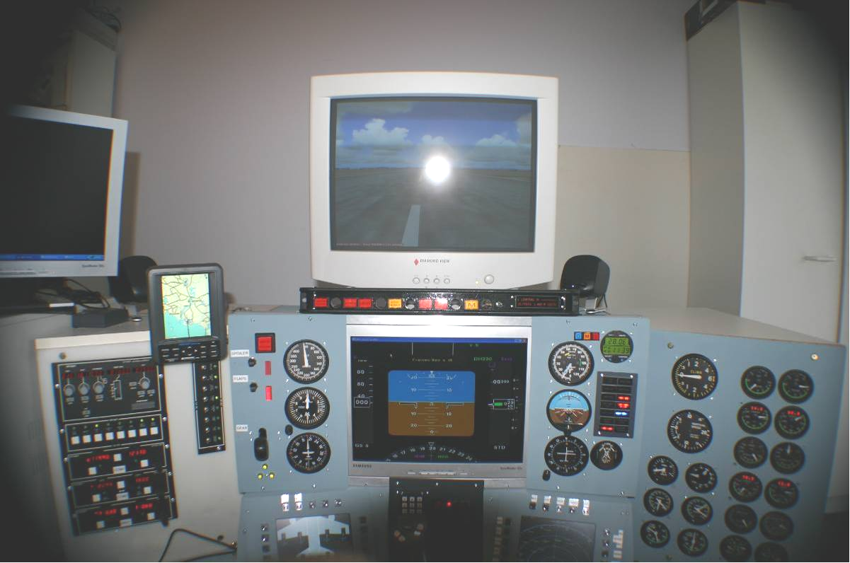

Photo 4 Front Pit Panels August 2005

# High Level Design

FS-Server will provide a North-bound interface to programs such as FreeFD and gauges such as Simkits and Flight Illusions. Due to the inherent challenges associated with Visual Basic and multi-threading I’m separating the FSUIPC replies from the data-sources from Falcon 4 and LOMAC, a simple shared memory file will be used to provide communications vehicle between the input programs and the output mode of FS-Server. Then if unsolicited update arrived from Lomac during a reply phase for FSUIPC I won’t be hit with reentrancy issues.

# Understanding FSUIPC

Pete Dowson, the author of FSUIPC, has provided the Flight sim community with an SDK (<http://www.schiratti.com/dowson.html>), this was used as the reference to code against. As my day job is a Systems Engineer, not a programmer, I work in Visual Basic which when used with the Windows API allows you to most things… one thing I think I’ve walked into is a challenge is reentrancy. When doing development testing I tested against a single instance of FreeFD, and then found I was getting weird results when testing against three instances of FreeFD (EADI, EICAS, and ND). So for the moment, one of the ‘known issues’ is FS-Server will result ‘0s’ if it gets a second request while processing a request.

Before launching into the details of how FSUIPC works, it is important to understand that FSUIPC uses much more than a single Shared Memory file like Falcon 4, it also uses Atoms and Windows Messages, allowing multiple programs to both read and write to Flight Simulator.

The documentation refers to hex offsets, most of the debugging tools in this code provide both hex and decimal offsets.

Requests made via FSUIPC are made up of atomic blocks, that is a single FSUIPC request is usually made up of multiple offset requests.

A FSUIPC request will usually contain Offset Requests for:

* &H3304 (13060) FSUIPC Version (4 bytes)
* &H3308 (13064) FS Version (FS2002 = 6)
* &H330A (13066) Standardised Result should be 0xFADE

A FSUIPC Request can contain both Read and Write constructs, the Read_Header is a 1, the Write_Header is a 2

|  |  |
| --- | --- |
| Read Request | Write Request |

|  |
| --- |
| (All these are long 4 bytes) |

|  |  |
| --- | --- |
| Read_hdr (1) | Write_Hdr |

|  |  |
| --- | --- |
| dw_ID | dw_ID |

|  |  |
| --- | --- |
| Offset | Offset |

|  |  |
| --- | --- |
| nBytes | nBytes |

|  |  |
| --- | --- |
| pDest |  |

Building a request is not a single command, but a series of commands, a typical request would be enacted by:

|  |  |
| --- | --- |
| FSUIPC_READ | Build  Request  Array |

|  |  |
| --- | --- |
| FSUIPC_READ |  |

|  |  |
| --- | --- |
| FSUIPC_WRITE |  |

|  |  |
| --- | --- |
| FSUIPC_PROCESS | Actually Send Request |

The library uses the variables m_pView& and m_pNext&. The process request adds an all 0’s record as the terminator.

After the request make pNext=pView

Read Pseudo Code

* Copy 4 bytes to determine R/W m_pNext
* Copy Header_record (note m_pNext hasn’t moved forward yet
* Move Pointer Forward the length of the header record
* Get the length of the returned data from pHdrr.nbytes
* Copy the returned value i.e. the request we asked for to the target variable which was originally asked for
* Increment Pointer forward the length of the bytes of the response
* Move to the next record

M_pView& - assigned to mapview of file, this is shared mempointer in former code speak.

## Global Variables

m_hWnd& FS window handle

m_msg& ID of registered Window Message

m_atom Global atom of file mapping object

m_hMap Handle of file mapping object

m_pView& Pointer to view of file mapping object

m_pNext next ‘space’ pointer

In FSUIPC Process – pdw is integer

After doing a read m_pNexy = Mapview Next

Copy contents pointed to a mapnext to PDW

This gives the datatype/question being asked for Read or Write

If pdw = 0 then we have reached the end of the request array

As each block segment is read it is read into a pHdrR (read header) or write header.

Move pointer to next block to be read

Read and Write Bytes now writing value to memory location of variable

In early testing I assumes all test values where longs (bytes) to simplify test program, this meant all requests really had to be longs, other Request Headers will become out of sequence. As code developed a full case statement of included to remove this dangerous assumption.

## Values used by FreeFD

Looks like airspeed uses all

02B4, o2B8, 02BC, but it seems like the last value set wins. These settings look more like Knots * 128

02C4 Barber Pole speed is where the ‘red line’ appears, ie max airspeed.

0570 Altitude moves purple arrow on LHS of altitude bar.

Apparent SDK document error Aircraft on ground at 0366 is a byte not an integer

May be an issue with heading 7CC, this is more to do with how the heading is calculated, found similar issue with things that are more like two longs that need to be split and recalculated.

Use offset 574 for altitude

Boolean

07FC

07DC

07D0

07C8

07BC

4 Byte

02B4 A/S

02B8 TAS

02BC IAS

02C4 Barber Pole

3324 alt not correct

0578 Pitch 88,000,000 give 400 this is the clue for fixing heading

2 Byte

0330 not correct follows pressure

8 byte

0564 Lat

0560

056C Long

0568

# Lat/Long Conversion

LAT formula = *90/(10001750)

LONG formula = *360/(65536*65536)

YBNE Brisbane 27 Degrees 20.09 South

-3040525

153 Degrees 06.59 East

1826361101

Long X-Axis Lat Y-Axis

# Distributing FS Information Between Computers

Given the simplicity LOMAC and LUA to export data from the simulation to other computers, I decided to use the same approach for my code with FS2004. The ultimate intend is to have a small lightweight program on the primary computer extrcting information from FSUIPC. The extracted information can then be easily delivered to other computers using UDP.

This overcomes one of the self induced problems of poor performance from FSUIPC reads. My initial built an FSUIPC request and then issued an FSUIPC process directive. This when combined with buffering associated with WideFS resulted in average performance as each request bothered FS, so instead of FS getting a single block of work to do, it had lots of smaller blocks of wok to process. What I should have done was build multiple reads and then issue an FSUIPC process directive. This is the approach used with the new code FS2004Sender and FS2004Receiver.

As the name suggests FS2004Sender reads data from FS2004, and then sends the data to other computers using FS2004Receiver. FS2004Receiver populates the memory mapped files used by the physical IO devices such as PhidgetLed and PhidgetIO.

FS2004

Sender

FS2004

FS2004

Receiver

SimPhidgetIO

SimParallaxServo

FSUIPC

UDP

Memory-Mapped Files

The over the wire format will be the same as used with LUA export, variable will be:

1. Separated with semicolons
2. Variable names are unquoted and appear after the semicolon, and
3. Data values are quoted with double quotes.

This approach allows for variable length fields. I am currently no overly concerned re the data payload exceeding 1500 bytes as LOMAC code showed the OS automatically fragments and reassembles large UDP packets.

The interval between updates being sent will be around 100mS, enough to provide smooth updates without overloading the processor. I am hoping the sending code be happy to attach to the second core of the primary computer as FS2004 and FSX do not appear to effectively use both cores.

The UDP Receive port will be 8083.

**Development Tips**

## Generating the Lookup Tables

As FSUIPC supports over 1023 offsets, typing in all of the possible values in a case statement was not something I really wanted to do. This was ultimately done by

1. Copying the offsets table from the FSUIPC SDK document into Excel
2. Running a quick cleanup in Excel
3. Importing the Data into Access
4. Running procedures against the database to generate code for the Data_Type declaration, the Case Statement, and the Data_Structure initialization.

## Data Type Creation

Dim i As Integer

Dim hexwrkstr As String

Dim wrkstr

wrkstr = "Public Type FSUIPC_MASTER_TYPE" & Chr(13)

For i = 0 To 2000

If Source_Data(i).Offset <> "" Then

hexwrkstr = "&H" & Source_Data(i).Offset

Select Case Source_Data(i).Size

Case 1

wrkstr = wrkstr & " x" & Source_Data(i).Offset & " AS Byte "

wrkstr = wrkstr & " ' " & Mid(Source_Data(i).Use, 1, 80) & Chr(13)

Case 2

wrkstr = wrkstr & " x" & Source_Data(i).Offset & " AS Integer "

wrkstr = wrkstr & " ' " & Mid(Source_Data(i).Use, 1, 80) & Chr(13)

Case 4

wrkstr = wrkstr & " x" & Source_Data(i).Offset & " AS long "

wrkstr = wrkstr & " ' " & Mid(Source_Data(i).Use, 1, 80) & Chr(13)

Case 6

wrkstr = wrkstr & " x" & Source_Data(i).Offset & " AS long "

wrkstr = wrkstr & " ' " & Mid(Source_Data(i).Use, 1, 80) & Chr(13)

Case 8

wrkstr = wrkstr & " x" & Source_Data(i).Offset & " AS long "

wrkstr = wrkstr & " ' " & Mid(Source_Data(i).Use, 1, 80) & Chr(13)

Case Else

wrkstr = wrkstr & " x" & Source_Data(i).Offset & " AS long "

wrkstr = wrkstr & " ' " & Mid(Source_Data(i).Use, 1, 80) & Chr(13)

End Select

End If ' Source Data not blank

Next i

wrkstr = wrkstr & "end type" & Chr(13)

Clipboard.Clear

Clipboard.SetText wrkstr

## Case Statement Creation

Dim i As Integer

Dim hexwrkstr

Dim wrkstr As String

wrkstr = ""

For i = 0 To 2000

If Source_Data(i).Offset <> "" Then

hexwrkstr = "&H" & Source_Data(i).Offset

Select Case Source_Data(i).Size

Case 1

wrkstr = wrkstr & "Case &H" & Source_Data(i).Offset & " ' " & CInt(hexwrkstr) & "/" & Source_Data(i).Size & Chr(13)

wrkstr = wrkstr & " ' " & Mid(Source_Data(i).Use, 1, 80) & Chr(13)

wrkstr = wrkstr & " Data_Size = 1" & Chr(13)

wrkstr = wrkstr & " Return_Data_1.Data = FSUIPC_MASTER_DATA.x" & Source_Data(i).Offset & Chr(13)

'wrkstr = wrkstr & " warning_str = hexwrkstr & ""/"" & cint(hexwrkstr) & "" Size "" & Source_Data(i).size " & Chr(13)

wrkstr = wrkstr & " Log_Warning(Source_Data(i).Offset)" & Chr(13)

Case 2

wrkstr = wrkstr & "Case &H" & Source_Data(i).Offset & " ' " & CInt(hexwrkstr) & "/" & Source_Data(i).Size & Chr(13)

wrkstr = wrkstr & " ' " & Mid(Source_Data(i).Use, 1, 80) & Chr(13)

wrkstr = wrkstr & " Data_Size = 2" & Chr(13)

wrkstr = wrkstr & " Return_Data_2.Data = FSUIPC_MASTER_DATA.x" & Source_Data(i).Offset & Chr(13)

'wrkstr = wrkstr & " warning_str = hexwrkstr & ""/"" & cint(hexwrkstr) & "" Size "" & Source_Data(i).size " & Chr(13)

wrkstr = wrkstr & " Log_Warning(Source_Data(i).Offset)" & Chr(13)

Case 4

wrkstr = wrkstr & "Case &H" & Source_Data(i).Offset & " ' " & CInt(hexwrkstr) & "/" & Source_Data(i).Size & Chr(13)

wrkstr = wrkstr & " ' " & Mid(Source_Data(i).Use, 1, 80) & Chr(13)

wrkstr = wrkstr & " Data_Size = 4" & Chr(13)

wrkstr = wrkstr & " Return_Data_4.Data = FSUIPC_MASTER_DATA.x" & Source_Data(i).Offset & Chr(13)

'wrkstr = wrkstr & " warning_str = hexwrkstr & ""/"" & cint(hexwrkstr) & "" Size "" & Source_Data(i).size " & Chr(13)

wrkstr = wrkstr & " Log_Warning(Source_Data(i).Offset)" & Chr(13)

Case 6

wrkstr = wrkstr & "Case &H" & Source_Data(i).Offset & " ' " & CInt(hexwrkstr) & "/" & Source_Data(i).Size & Chr(13)

wrkstr = wrkstr & " ' " & Mid(Source_Data(i).Use, 1, 80) & Chr(13)

wrkstr = wrkstr & " Data_Size = 6" & Chr(13)

wrkstr = wrkstr & " Return_Data_6.Data = FSUIPC_MASTER_DATA.x" & Source_Data(i).Offset & Chr(13)

'wrkstr = wrkstr & " warning_str = hexwrkstr & ""/"" & cint(hexwrkstr) & "" Size "" & Source_Data(i).size " & Chr(13)

wrkstr = wrkstr & " Log_Warning(Source_Data(i).Offset)" & Chr(13)

Case 8

wrkstr = wrkstr & "Case &H" & Source_Data(i).Offset & " ' " & CInt(hexwrkstr) & "/" & Source_Data(i).Size & Chr(13)

wrkstr = wrkstr & " ' " & Mid(Source_Data(i).Use, 1, 80) & Chr(13)

wrkstr = wrkstr & " Data_Size = 8" & Chr(13)

wrkstr = wrkstr & " Return_Data_8.Data = FSUIPC_MASTER_DATA.x" & Source_Data(i).Offset & Chr(13)

'wrkstr = wrkstr & " warning_str = hexwrkstr & ""/"" & cint(hexwrkstr) & "" Size "" & Source_Data(i).size " & Chr(13)

wrkstr = wrkstr & " Log_Warning(Source_Data(i).Offset)" & Chr(13)

Case Else

wrkstr = wrkstr & "Case &H" & Source_Data(i).Offset & " ' " & CInt(hexwrkstr) & "/" & Source_Data(i).Size & Chr(13)

wrkstr = wrkstr & " ' " & Mid(Source_Data(i).Use, 1, 80) & Chr(13)

wrkstr = wrkstr & " Data_Size = 99" & Chr(13)

wrkstr = wrkstr & " Return_Data_99.Data = FSUIPC_MASTER_DATA.x" & Source_Data(i).Offset & Chr(13)

' wrkstr = wrkstr & " warning_str = hexwrkstr & ""/"" & cint(hexwrkstr) & "" Size "" & Source_Data(i).size " & Chr(13)

wrkstr = wrkstr & " Log_Warning(Source_Data(i).Offset)" & Chr(13)

End Select

End If ' Source Data not blank

Next i

Clipboard.Clear

Clipboard.SetText wrkstr

## Master Variable Initialisation

Dim i As Integer

Dim hexwrkstr As String

Dim wrkstr

wrkstr = "with FSUIPC_MASTER_TYPE" & Chr(13)

For i = 0 To 2000

If Source_Data(i).Offset <> "" Then

hexwrkstr = "&H" & Source_Data(i).Offset

Select Case Source_Data(i).Size

Case 1

wrkstr = wrkstr & " .x" & Source_Data(i).Offset & "= 1 "

wrkstr = wrkstr & " ' " & Mid(Source_Data(i).Use, 1, 80) & Chr(13)

Case 2

wrkstr = wrkstr & " .x" & Source_Data(i).Offset & "= 1 "

wrkstr = wrkstr & " ' " & Mid(Source_Data(i).Use, 1, 80) & Chr(13)

Case 4

wrkstr = wrkstr & " .x" & Source_Data(i).Offset & "= 1 "

wrkstr = wrkstr & " ' " & Mid(Source_Data(i).Use, 1, 80) & Chr(13)

Case 6

wrkstr = wrkstr & " .x" & Source_Data(i).Offset & "= 1 "

wrkstr = wrkstr & " ' " & Mid(Source_Data(i).Use, 1, 80) & Chr(13)

Case 8

wrkstr = wrkstr & " .x" & Source_Data(i).Offset & "= 1 "

wrkstr = wrkstr & " ' " & Mid(Source_Data(i).Use, 1, 80) & Chr(13)

Case Else

wrkstr = wrkstr & " .x" & Source_Data(i).Offset & "= 1 "

wrkstr = wrkstr & " ' " & Mid(Source_Data(i).Use, 1, 80) & Chr(13)

End Select

End If ' Source Data not blank

Next i

wrkstr = wrkstr & "end with " & Chr(13)

Clipboard.Clear

Clipboard.SetText wrkstr

## Database Structure

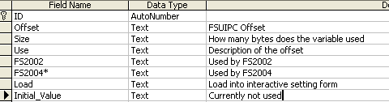

# Challenges encountered

FSUIPC Versions – I was initially just using the example of 1.998 without thinking too much, FreeFD doesn’t care too much, but Simkits is fussy both about FSUIPC versions and Flight sim versions.

|  |  |  |  |  |
| --- | --- | --- | --- | --- |
| 3304 | 4 | FSUIPC version number:  The HIWORD (i.e. bytes 3306-7) gives the main version as BCD x 1000: e.g. 0x1998 for 1.998  The LOWORD (bytes 3304-5) gives the Interim build letter: 0=none, 1-26=a-z: e.g. 0x0005 = 'e' | **Ok** | **Ok** |
| 3308 | 2 | FS version, as determined by FSUIPC: Currently only one of these:  1 = FS98  2 = FS2000  3 = CFS2  4 = CFS1  5 = reserved  6 = FS2002  7 = FS2004 “A Century of Flight”  *(see also bit 1 in offset 3302 above)* | **Ok** | **Ok** |

# Known Issues

## Unable to process multiple requests concurrently

Pretty sure this is a reentrancy issue with Visual Basic. For the moment I track state with a global Boolean and simply ’ack’ the FSUIPC request without setting any values. This may be fixed by going to Delphi. The problem area is in the Function call that is handled when a message is received by window. As memory is allocated the function call needs to be ‘answered’ and memory returned.

A partial work-around I have used is setting the FreeFD (or whatever requestors are in action) to a low priority using Windows Task Manager (Select Program – Right-Click-Goto Process, Right Click on the Process, Set Priority – Low), and ensure FS-Server is running at a higher Priority. This reduces the frequency of collisions, in a test run, I was loosing around 20Meg of RAM per hour

## Discovery of Offsets Use by other products

As I didn’t want to spend time writing code to support offsets that are not used by the tools in my Pit I included logging capability in the FS-Server. This is used to discover which offsets are used by which tool. Essentially the code walks through the primary data structure looking for Offsets which have been flagged as referenced (Source_Data(i).Referenced). If an offset has been referenced it is added to the List2 listbox.

Me.List2.Clear

Dim i

Dim wrkstr

For i = 0 To 2000

If Source_Data(i).Referenced = True Then

wrkstr = "&H" & Source_Data(i).Offset

frm_FSServer_Main.List2.AddItem Source_Data(i).Offset & " (" & CInt(wrkstr) & ") " & Source_Data(i).Use

End If

Next i

The values of listbox2 are copied to the clip when the Edit-Copy is selected.

Dim wrkstr As String

Dim i As Integer

wrkstr = ""

For i = 0 To Me.List2.ListCount - 1

wrkstr = wrkstr & Me.List2.List(i) & vbCr

Next i

Clipboard.Clear

Clipboard.SetText wrkstr

# Inter-process and Inter-machine communication

As can be seen by the very capable FSUIPC interface, communicating between processes on the same PC can be complex. For the bulk of my code I am using Shared Memory Files, as they are very efficient and can easily pass data structures. The simplicity does come at a cost as data structures have to be synchronized across programs.

As the Simkits SDK mandated the use of TCP, I had continued to use TCP to communicate between processes on different PCs. One of the reasons for this was concern about packets becoming larger than 1500 bytes, exceeding the MTU. This turned out to be a non-issue as the OS auto-magically fragments and reassembles the packets.

A benefit of using UDP is that is it stateless. This means either the Server or Client can be restarted without impacting the other. UDP is also used for LOMAC LUA, and doesn’t require the Nagle algorithm to be bypassed.

As complex data structures are not easily passed using the Winsock control, values are passed using single quotes and commas. Whilst this does add overhead, a side benefit is there is a measure of independence from the server and client. New values can be exported without immediately impacting on the client.

|  |  |
| --- | --- |
| Receiving Application | Port Used |

|  |  |
| --- | --- |
|  |  |

|  |  |
| --- | --- |
| TRC Custom Link | 1927 |

|  |  |
| --- | --- |
| Lomac2F4Glass | 8080 |

|  |  |
| --- | --- |
| DualStack | 8081 |

|  |  |
| --- | --- |
| In use by Unknown | 8082 |

|  |  |
| --- | --- |
| FS2004Receiver | 8083 |

I have also started to use machine names instead of hard coding addresses. The LUA script looks for guagepc to send data.

Todo: Modify Senders to do a host lookup, removing hard coded IP Addresses.

# To Time or not to time

One of the design considerations was how to synchronize or deliver data from the simulator to different presentation devices from different manufacturers. Earlier versions of the cockpit code were monolithic, in that a single request was made of the simulator, and data was fed to the devices as part of the request loop, or by timers.

As some of the devices took a while to respond to requests they slowed down the entire program. Given multi-threading is not always the easiest of things to do in Visual Basic I have opted to use Shared Memory to communicate between processes. This still left room for a timer conflict, where the timer event associated with data collection could fire during the timer event for delivering data to a consumer.

After trying a several approaches the communication model used in the simulator is partially event driven and partially polling.

The first goal was to get data from the simulator (either timer event or receipt of data packet) and doing as little as possible transform the data into the Shared Memory files for other presentation processes. As writing to a Shared Memory file is a very quick process, the data receipt process should complete before the next packet is received from the simulator. There is a maximum of one timer event on the primary simulator program.

Other programs then read the information from their respective shared memory files and output the data to gauges, Leds and Lights. If one of these applications should fail, it doesn’t (normally!!) impact on other applications.

# The Shared Memory Programs

These programs provide the interface between the simulator and the Shared Memory programs. The reason for adding a layer of abstraction is that it allow new simulators to be supported by only changing the core code – not having to worry about the quirks of each of the physical interfaces.

There are three programs in use as of March 07

* Falcon 4 - Falcon42Pit
* FS2004 – FS2004Sender.exe & FS2004Receiver.exe
* LOMAC - LOMAC2Pit.exe

The FS2004 is broken into a sender and receiver module, if required the sender module can be hosted on the PS running the simulator is WideFS overhead becomes an issue.

The GPS code has been given different treatment, this is mainly historical, and could be rolled int the Falcon and LOMAC code. It hasn’t yet, mainly as it ain’t really broken. FS2004 uses the native GPS interface provided as part of FSUIPC.

Starting to program with Vc++

When using Leos SDK need DDK (now known was WDK). Used Server2003 DDK

Point VC++ include directories to DDK include directory.

# Batch Files to Launch IO Code

***FS2004***

***start /MIN C:\FSUIPC\WideFS\wideclient.exe***

***pause***

***cd C:\fs2002_vb***

***start /MIN SimPhidgetIOA.exe***

***start /MIN SimPhidgetIOB.exe***

***start /MIN SimPhidgetLedA.exe***

***start /MIN SimPhidgetLedB.exe***

***start /MIN SimPhidgetServo.exe***

***start /MIN FS2004Sender.exe***

***start /MIN FS2004Receiver.exe***

***start /MIN SimParallaxServo.exe***

***rem start /MIN SimDualStack.exe***

***pause***

Falcon4

start /MIN SimPhidgetIOA.exe

start /MIN SimPhidgetIOB.exe

start /MIN SimPhidgetLedA.exe

start /MIN SimPhidgetLedB.exe

start /MIN SimPhidgetServo.exe

start /MIN PTTRCLink.exe

start /MIN f4gpsout.exe

start /MIN Falcon42Pit.exe

start /MIN SimDualStack.exe

# The Physical IO Programs

These separate programs separate the logical interfacing of the simulator to the physical devices in the simulator. The net result being it is easier to:

* identify ‘rogue’ code and device drivers,
* add other simulators without doing a massive monolithic update
* restart individual modules without impacting on the simulator interface. This was a major issue in the earlier days when I used TCP has the LUA transport with Lomac.

The programs are started through a batch file which also minimises them on startup.

For a diagrammatic view of how these modules interconnect refer to “More on Programming the Pit” on page 83

In March 07 added a common field to the Shared Memory files which indicates whether aircraft power is available or not. When the field indicates that power is not available all lights should be off, with the single exception of the Canopy light on the PhidgetsIO card. This light provides enough light to get in and out of the pit when the aircraft is ‘powered down’ Currently this really only has relevance to FS2004 as neither Falcon4 or Lockon export bus voltages.

## Shared Memory - SimDualStack.vbp

Drives the Flight Illusions Dual Engine Stack via a virtual serial port.. Completely replaces the code provided by Flight Illusions as it provides better safeties (less likely to bend needles when chaging aircraft from a Beechcraft to a F16), is now the same code irrespective of the simulation used, backlights when panel lights are on.

Shared Memory File Name: *PTDualEngineSharedMemoryArea*

The VB Project and executable files are:

1. SimDualStack.vbp SimDualStack.exe

*Public Type DualStackDataStructure*

*PanelLights As Boolean*

*PowerAvailable As Boolean*

*ITTLeft As Double ' 1200*

*TorqueLeft As Double ' 120*

*PropRPMLeft As Double ' 2000*

*TurbineLeft As Double ' 110*

*FuelFlowLeft As Double ' 800*

*OilTempLeft As Double ' 140*

*OilPressLeft As Double ' 200*

*ITTRight As Double ' 1200*

*TorqueRight As Double ' 120*

*PropRPMRight As Double ' 2000*

*TurbineRight As Double ' 110*

*FuelFlowRight As Double ' 800*

*OilTempRight As Double ' 140*

*OilPressRight As Double ' 200*

*ControlBits As Double*

*End Type*

**Change History**

* None.

## Shared Memory - SimParallaxServo

Drives the Parallax USB board. This board has a little more intelligences than the Phidget Servo card is that you can instruct it to move to a certain position at a certain rate. The G_Force, AOA, and Radar_Altitude are currently not used, but are held for when the PhidgetServo card is retired.

Shared Memory File Name: *PTParallaxServoSharedMemoryArea*

The VB Project and executable files are:

SimParallaxServo.vbp SimParallaxServo.exe

*Public Type Type_Parallax_Servo*

*G_Force As Single ' G Force -3 to 8*

*AOA As Single ' Angle Of Attack 0 to 43*

*Radar_Altitude As Single ' Radar Altitude 0 to 1500*

*Flaps As Single ' Flaps 0 to 40*

*Bus_Amps As Single ' Bus Amps -30 to 30*

*Bus_Volts As Single ' Bus Volts - 0 to 34 There was a -99 show power off*

*Left_Fuel As Single ' Left Fuel -99 to 100 -99 Indicates power off*

*Centre_Fuel As Single ' Centre Fuel -99 to 100 ' -99 Indicates Power off*

*Right_Fuel As Single ' Right Fuel -99 to 100 -99 Indicates Power off*

*Seconds As Single*

*Helicopter_Turbine As Single ' Helicopter Turbine 0 to 120*

*Helicopter_Rotor As Single ' Helicopter Rotor 0 to 120*

*End Type*

**Change History**

* Added Helicopter values to finally replace the Simkits MCU. March 07.

## Shared Memory – PhidgetIOA and PhigdetIOB

Is used to drive the two 16 Port Phidget I/O cards. These cards typically drive incandescent bulbs and relays for toggling cockpit lights. If the loop takes longer than 23mS to complete, the program spawns another instance of itself and then terminates. This helped address Phidget hanging issues.

Shared Memory File Name: *PTPhidgetIOSharedMemoryArea*

The VB Project and executable files are:

1. SimPhidgetIOA.vbp SimPhidgetIOA.exe SerialNumber = 2377
2. SimPhidgetIOB.vbp SimPhidgetIOB.exe

*Public Type Type_Phidget_IO*

*BackLight As Boolean*

*SimKitsBackLight As Boolean*

*ICPBacklight As Boolean*

*MasterCautionLeft As Boolean*

*TLConfig As Boolean*

*MasterCautionTop As Boolean*

*InnerMarker As Boolean*

*MiddleMarker As Boolean*

*OuterMarker As Boolean*

*Launch As Boolean*

*FLCSFault As Boolean*

*AfterBurner As Boolean*

*Avionics As Boolean*

*Stall As Boolean*

*NavigationLights As Boolean*

*CockpitLight As Boolean*

*PowerAvailable As Boolean*

*End Type*

**Change History**

* Split PhidgetIO into two separate EXEs to isolate root cause of hangs. This hangs become apparent when the CPU is under load and there are two Phiddget devices being hit from the same executable. Feb 07.
* Added Nav and Cockpit lights Feb 07.
* Added PowerAvailable March 07.

## Shared Memory PhidgetLedA

Is used to drive one of the 64 Port PhidgetLed cards. While most of the flags are pretty self explantatory as Booleans, some are worthy of an explanation.

* FlapsPosition – an integer (0 to 10). This indicates the number of bars that should be lit in the flaps position indicator.
* BrakesPosition - an integer (0 to 10). This indicates the number of bars that should be lit in the brakes position indicator.
* StrobeLights – activates a timer which flashes a white led to emulate a strobe.
* PowerAvailable – If no power is available all leds should be off.
* Left/Middle/Right Gear – Integer indicating whether Gear Led should be Out, Yellow or Green.

Shared Memory File Name: *PTPhidgetLed1SharedMemoryArea*

The VB Project and executable files are:

1. SimPhidgetLedA.vbp SimPhidgetLedA.exe SerialNumber=2300

*Public Type Type_PhidgetLed1*

*LeftFire As Boolean*

*RightFire As Boolean*

*LeftOil As Boolean*

*RightOil As Boolean*

*LeftGen As Boolean*

*RightGen As Boolean*

*LeftFuelValve As Boolean*

*RightFuelValve As Boolean*

*LeftStart As Boolean*

*RightStart As Boolean*

*CanopyOpen As Boolean*

*RotorRPMLow As Boolean*

*ParkBrake As Boolean*

*LandingLights As Boolean*

*FlapsPosition As Integer ' Flaps Position 0 Off 10 all down*

*SpeedBrakesPosition As Integer ' Brakes Position 0 Off 10 all on*

*LeftGear As Integer ' 1=Up 2=Moving 3=Down*

*RightGear As Integer ' 1=Up 2=Moving 3=Down*

*MiddleGear As Integer ' 1=Up 2=Moving 3=Down*

*CockpitLeds As Boolean*

*AOA_ON As Boolean*

*AOA_ABOVE As Boolean*

*AOA_BELOW As Boolean*

*ICP_Ready As Boolean*

*ICP_AR_NWS As Boolean*

*ICP_DISC As Boolean*

*StrobeLights As Boolean*

*PowerAvailable As Boolean*

*End Type*

**Change History**

Added Strobe Feb 07.

Added PowerAvailable March 07.

## Shared Memory PhidgetLedB

Is used to drive the other 64 Port PhidgetLed card. This program does a little more work than PhidgetLedA as it also has to convert digits to individual elements on the Chaff and Flare seven segment displays. If the Chaffcount or Flarecount fields are set to 100 then the corresponding display is switched off.

Shared Memory File Name: *PTPhidgetLed2SharedMemoryArea*

The VB Project and executable files are:

1. SimPhidgetLedB.vbp SimPhidgetLedB.exe SerialNumber=10860

*Public Type TypePhidgetLed2*

*Chaffcount As Integer ' 0 to 99*

*Flarecount As Integer ' 0 to 99*

*AvionicsOn As Boolean*

*BatteryOn As Boolean*

*PowerAvailable As Boolean*

*End Type*

**Change History**

Added PowerAvailable March 07

## Shared Memory PhidgetServo

Is used to drive the 4 Port Phidget Servo. Ultimately will be replaced with Parallax code once it stabilizes and cables are rerun.

Shared Memory File Name: *PTPhidgetServoSharedMemoryArea*

The VB Project and executable files are:

1. SimPhidgetServo.vbp SimPhidgetServo.exe SerialNumber=1170

*Public Type Type_Phidget_Servo*

*G_Force As Single*

*AOA As Single*

*Radar_Altitude As Single*

*Unassigned As Single*

*End Type*

**Change History**

None

## Shared Memory LCDText

Is used to drive the usbMicro LCD interface module.

Shared Memory File Name: *PTLCDSharedMemoryArea*

The VB Project and executable files are:

1. SimUsbLcd.vbp SimUsbLcd.exe

The sharedmemory file is flat, supporting 40 characters.

**Change History**

None

## PTTRCLink

Reads shared memory file and sends information to TRC (aka Simkits) SDK receiving program over the network. This needs to be tidied up to the same format as the other Physical IO programs.

Shared Memory File Name: *TRCSharedMemoryArea*

The VB Project and executable files are:

1. PTTRCLink.vbp PTTRCLink.exe

*Public Type TRCLinkData*

*Alti_Height As Single*

*Airspeed As Single*

*VerticalSpeed As Single*

*Attitude_Pitch As Single*

*Attitude_Bank As Single*

*Heading_Compass As Single*

*Left_Fuel As Single*

*Right_Fuel As Single*

*Engine_Fault As Single*

*Warning_Left_Fuel As Boolean*

*Warning_Right_Fuel As Boolean*

*Warning_Elec_Fault As Boolean*

*Chaff_Count As Single*

*Flare_Count As Single*

*Eng_1_RPM As Single*

*Eng_2_RPM As Single*

*TotalFuel As Single*

*fuelFlow As Single*

*UFCTChan As Integer*

*AUXTChan As Integer*

*bearingToBeacon As Integer*

*desiredCourse As Integer ' HSI_VAL_DESIRED_CRS*

*distanceToBeacon As Integer ' HSI_VAL_DISTANCE_TO_BEACON*

*PlaceHolder As Integer*

*End Type*

**Change History**

None

## Debugging and Monitoring Code

Before moving to the timer based module I measured the following on Lomac2F4Glass.

|  |  |  |  |
| --- | --- | --- | --- |
| PPS | Frame Per Sec | CPU | Window State |

|  |  |  |  |
| --- | --- | --- | --- |
|  |  |  |  |

|  |  |  |  |
| --- | --- | --- | --- |
| 140 | 70 | 35% | Focused |

|  |  |  |  |
| --- | --- | --- | --- |
| 80 | 40 | 20% | Focused |

|  |  |  |  |
| --- | --- | --- | --- |
| 20 | 10 | 7.4% | Focused |

|  |  |  |  |
| --- | --- | --- | --- |
| 20 | 10 | 3.3 | Minimised |

|  |  |  |  |
| --- | --- | --- | --- |
|  |  |  |  |

As can be seen the number of Packets per second does have a real impact on CPU of the PC running Lomac2F4Glass. Much of the CPU is due to the large updates being drawn as the input string is displayed on the screen. Of course this will not be needed in the final release of the code.

# Phidgets Performance

As I wanted large LED displays for Chaff and Flare, I could not use the PhidgetTextLed (and it wasn’t released when I started that part of the project). Something I wanted to quantify, now that device updates are separated from simulator Updates, was how fast can I drive the PhidgetLed. This will ultimately determine how quickly timer events are fired to get updates from the shared memory file.

There are four seven segment displays to indicate the remaining number of Chaff and Flares. As the displays are driven led by led, this means there are 28 updates to perform each cycle.

The code was simply a for-next loop that displayed a number from 0 to 9999. Given the multiplier of 28, this means there are 280,000 operations to be performed during the code run. I was also interested in the impact of adding DoEvents on completion time.

|  |  |  |  |  |  |
| --- | --- | --- | --- | --- | --- |
| Test | Description | Time | Ops/  Sec | Digits/  Sec | Group/  Sec |
| 1 | No DoEvents | 285 Sec | 982 | 140 | 35 |
| 2 | DoEvents between character updates | 286 Sec | 979 | 139 | 34.75 |
| 3 | DoEvents between element updates (40-50% CPU) | 290 Sec | 965 | 137 | 34.25 |
|  |  |  |  |  |  |

These results suggest a regular sprinkling of DoEvents has only a minimal impact on update performance of Phidget Devices while considerably benefiting other applications on the PC. It also suggests a frequency of 10 updates per second is a reasonable compromise better refresh rates and a hit on the CPU.

# Overall Performance with Multiple Programs

With multiple programs running on the Phidget PC (C1.7G), the base CPU Load is 20%.

The running programs during the test routine where

|  |  |
| --- | --- |
| Program Name | Events / Sec |

|  |  |
| --- | --- |
| SimPhidgetServo |  |

|  |  |
| --- | --- |
| SimPhidgetLedA | 5 |

|  |  |
| --- | --- |
| SimPhidgetLedB | 5 |

|  |  |
| --- | --- |
| SimPhidgetIO |  |

|  |  |
| --- | --- |
| DualStackTx |  |

|  |  |
| --- | --- |
| PTsTRCLink |  |

|  |  |
| --- | --- |
| CockpitTest |  |

During longer term soak testing both the PhidgetIO and PhidgetServo programs encountered stability issues. They appears to be for different reasons, the PhidgetIO was hitting what looked to be like an automation error, whereas the PhidgetServo was getting invalid number messages. These issues were dealt with by adding on error resume next statements to the timer code.

A more interesting challenge was that after 20 minutes of soaking the PhidgetsIO code started to take 3 seconds between updates. That is the last update label only updated every three seconds. The PC was running at the normal CPU levels of 20%. Of interest was the GPSCode also exited. No dialog boxes seen on screen. When the program was focused, the timed updates went back to second updates, thus suggesting Windows was starving PhidgetIO of CPU resources. Even while focused noticed that the updates irregularly dropped back to ten seconds. During the period of soak testing the PhidgetLeds never missed a beat.

On a Similar note was TRCCustom running very slowly on the Primary computer. Once RealPlayer was stopped, TRCCustom immediately began to run smooth. TRCLink performance and stability issues have been largely dealt with by waiting for Altimeter to settle before launching FS2004.

# Working with LCD Displays

Having added the ICP to the pit it was time to get an LCD going. I’d purchased a cheap LCD from Modtronix (4*20)[7], and then tried to use the Native LCD driver with the usbMicro[8] adaptor. For whatever reason I couldn’t get the LCD to initialize correctly using the calls supplied with the usbMicro adaptor. However once the LCD is initialized I could use the embedded calls which run at least 50% faster than manually banging the lead.

Given I only write to the LCDs (as opposed to reading and writing), it should be possible to configure up common R/W, RS, and data leads, leaving the E lead as the unique lead. This reduces the number of USB devices required to support multiple displays and hopefully doesn’t adversely impact performance as it is unlikely that all LCDs will require changing in a single cycle.

I’m also planning to hold a copy of the strings displayed by the LCD, do a string compare in memory, and only the deltas to the LCD, this should assist in performance. Perhaps once a minute doing a complete rewrite to the LCD modules,

The diagram below is from the usbMicro site.

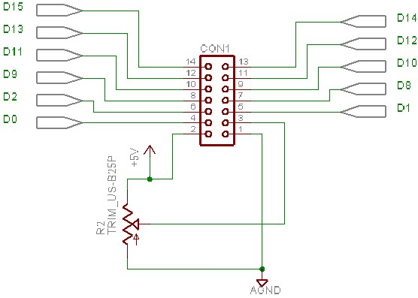

A very useful site is <http://www.myke.com/lcd.htm>.

| **Pins** | **Description** | **usbMicro** | **16 Way Header Pinout** |
| --- | --- | --- | --- |
| 1 | Ground | 9 | 1 |
| 2 | Vcc | 14 | 2 |
| 3 | Contrast Voltage | From Pot | 3 |
| 4 | "R/S" _Instruction/Register Select | 1 | 4 |
| 5 | "R/W" _Read/Write LCD Registers | 2 | 5 |
| 6 | "E" Clock | 3, 4 24 (Port A 2,3,4) | 6 |
| 7 - 14 | Data I/O Pin 0 | 5 | 7 |
| 8 | Data I/O Pin 1 | 20 | 8 |
| 9 | Data I/O Pin 2 | 6 | 9 |
| 10 | Data I/O Pin 3 | 19 | 10 |
| 11 | Data I/O Pin 4 | 7 | 11 |
| 12 | Data I/O Pin 5 | 18 | 12 |
| 13 | Data I/O Pin 6 | 8 | 13 |
| 14 | Data I/O Pin 7 | 17 | 14 |
| Backlight A |  |  | 15 |
| Backlight K |  |  | 16 |

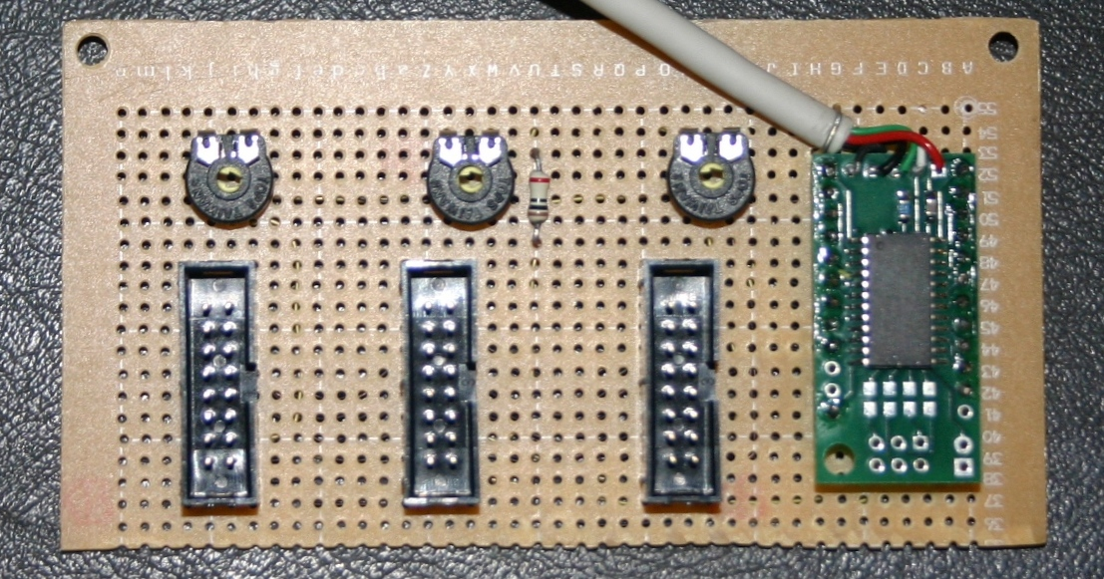

This board is able to drive three LCDs, currently only middle connector supplies power to the backlight. The usbMicro chip provides an API to write characters, prior to using he API the module needs to be programmed with which of the I/O pins should be use for RS, RW and E. The plan is to change which pin is designated as the E pin to drive the different displays.

The trim-pots are used to adjust the contrast of the LCD modules.

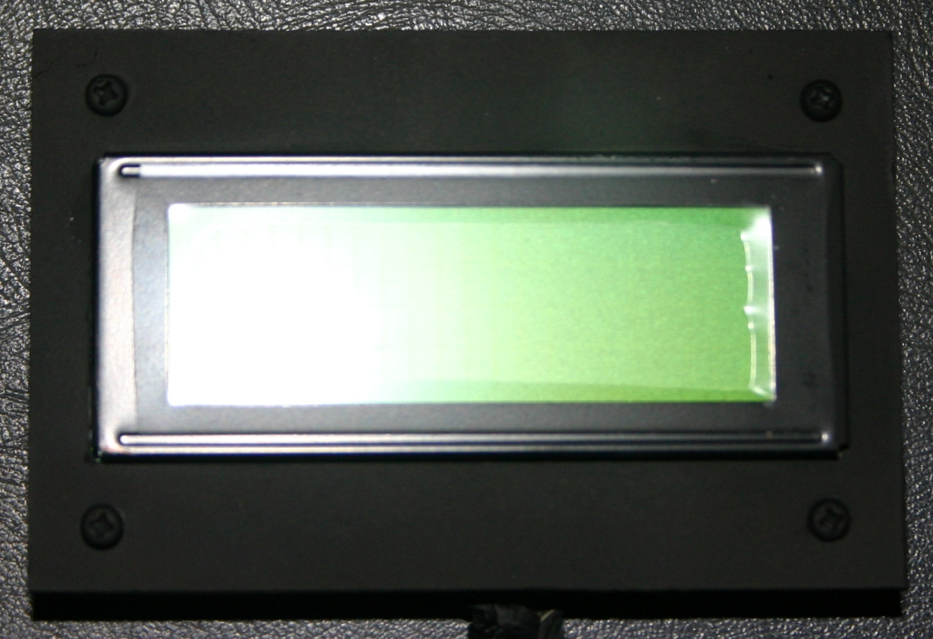

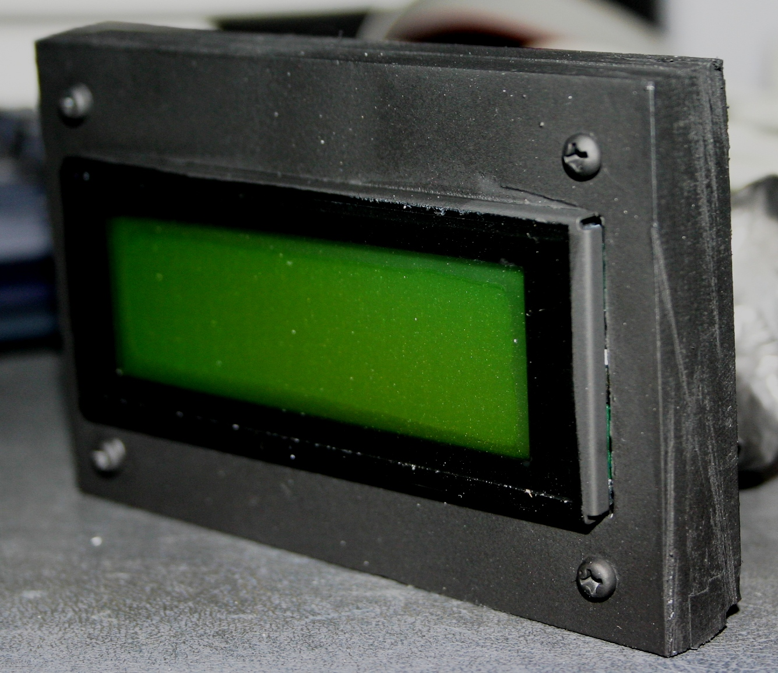

| **RS** | **R/W** | **D7** | **D6** | **D5** | **D4** | **D3** | **D2** | **D1** | **D0** | **Instruction/Description** |
| --- | --- | --- | --- | --- | --- | --- | --- | --- | --- | --- |
| 4 | 5 | 14 | 13 | 12 | 11 | 10 | 9 | 8 | 7 | Pins |
| 0 | 0 | 0 | 0 | 0 | 0 | 0 | 0 | 0 | 1 | Clear Display |
| 0 | 0 | 0 | 0 | 0 | 0 | 0 | 0 | 1 | * | Return Cursor and LCD to Home Position |
| 0 | 0 | 0 | 0 | 0 | 0 | 0 | 1 | ID | S | Set Cursor Move Direction |
| 0 | 0 | 0 | 0 | 0 | 0 | 1 | D | C | B | Enable Display/Cursor |
| 0 | 0 | 0 | 0 | 0 | 1 | SC | RL | * | * | Move Cursor/Shift Display |
| 0 | 0 | 0 | 0 | 1 | DL | N | F | * | * | Set Interface Length |
| 0 | 0 | 0 | 1 | A | A | A | A | A | A | Move Cursor into CGRAM |
| 0 | 0 | 1 | A | A | A | A | A | A | A | Move Cursor to Display |
| 0 | 1 | BF | * | * | * | * | * | * | * | Poll the "Busy Flag" |
| 1 | 0 | D | D | D | D | D | D | D | D | Write a Character to the Display at the Current Cursor Position |
| 1 | 1 | D | D | D | D | D | D | D | D | Read the Character on the Display at the Current Cursor Position |

The bit descriptions for the different commands are:

"*" - Not Used/Ignored. This bit can be either "1" or "0"

**Set Cursor Move Direction:**

ID - Increment the Cursor After Each Byte Written to Display if Set

S - Shift Display when Byte Written to Display

**Enable Display/Cursor**

D - Turn Display On(1)/Off(0)

C - Turn Cursor On(1)/Off(0)

B - Cursor Blink On(1)/Off(0)

**Move Cursor/Shift Display**

SC - Display Shift On(1)/Off(0)

RL - Direction of Shift Right(1)/Left(0)

**Set Interface Length**

DL - Set Data Interface Length 8(1)/4(0)

N - Number of Display Lines 1(0)/2(1)

F - Character Font 5x10(1)/5x7(0)

**Poll the "Busy Flag"**

BF - This bit is set while the LCD is processing

**Move Cursor to CGRAM/Display**

A - Address

**Read/Write ASCII to the Display**

D - Data

The connections for the usbMicro 421 are

|  |  |
| --- | --- |
| **Pin** | **U421 Signal** |
| **1** | PA.0 - Port A bit 0 |
| **2** | PA.1 - Port A bit 1 |
| **3** | PA.2 - Port A bit 2 |
| **4** | PA.3 - Port A bit 3 |
| **5** | PB.0 - Port B bit 0 |
| **6** | PB.2 - Port B bit 2 |
| **7** | PB.4 - Port B bit 4 |
| **8** | PB.6 - Port B bit 6 |
| **9** | **Ground** |
| **10** | No Connect |
| **11** | No Connect |
| **12** | Do not use |
| **13** | No Connect |
| **14** | **+5V (USB)** |
| **15** | USB D- (already connected to the USB cable) |
| **16** | USB D+ (already connected to the USB cable) |
| **17** | PB.7 - Port B bit 7 |
| **18** | PB.5 - Port B bit 5 |
| **19** | PB.3 - Port B bit 3 |
| **20** | PB.1 - Port B bit 1 |
| **21** | PA.7 - Port A bit 7 (or SPI SCK) |
| **22** | PA.6 - Port A bit 6 (or SPI MISO) |
| **23** | PA.5 - Port A bit 5 (or SPI MOSI) |
| **24** | PA.4 - Port A bit 4 (or SPI SS [when in slave mode]) |

Once the LCD is initialized with manual code the follow APIs are called.

***USBm_InitLCD 0, &H10, &H12***

Use PA0 for RS, PA1 for RW, and PA3 for E. Port B is the byte wide interface used to send data to the LCD. This API is more about getting the microUSB device configured as opposed to getting the LCD initialized.

***USBm_LCDCmd 0, &H39***

Send commands, as opposed to data to the LCD

***USBm_LCDData 0, &31***

Send data to the LCD to be written.

## Manual Initialisation of LCD

|  |  |
| --- | --- |
| USBm_DirectionA 0, &HFF, &HFF |  |
| USBm_DirectionB 0, &HFF, &HFF |  |
|  |  |
| ' Get Control Leads into shape |  |
| USBm_ResetBit 0, E_ChipEnableLead |  |
| USBm_ResetBit 0, RSLead |  |
| USBm_ResetBit 0, RWLead |  |
|  |  |
| ' Initialisation Sequence using 8 not 4 bits |  |
| SendCharToLCD &H30 |  |
|  |  |
| ' Send three times |  |
| ToggleELead |  |
| ToggleELead |  |
| ToggleELead |  |
|  |  |
| ' Display Off |  |
| SendCharToLCD &H39 |  |
| ToggleELead |  |
|  |  |
| 'Enable Cursor |  |
| SendCharToLCD &HF |  |
| ToggleELead |  |
|  |  |
| 'Clear Display |  |
| SendCharToLCD &H1 |  |
| ToggleELead |  |
|  |  |
|  |  |
| ' Now can write data to screen |  |
| ' Usually RW is zero |  |
| USBm_SetBit 0, RSLead |  |
| USBm_ResetBit 0, RWLead |  |
|  |  |
| SendCharToLCD Asc("o") |  |
| ToggleELead |  |

## Interfacing the LCD to Falcon 4

Given the LCD I’ve purchased only has 4 lines and 20 characters, and the Falcon 4 DED is 6 lines by 25 characters (130 total) there is going to have to be some crunching of the data to make it fit.

As it is not uncommon to see blank lines in the display, the code will work from the bottom-up, removing blank lines. If all lines are populated then the bottom two will be lost.

Something also to be resolved is if the cursor should be left on after an update, for example if the pilot is updating a field, the cursor is important. Without any specific modifications the cursor sits in the top left hand corner after an update.

As the display is also smaller than the real DED, a check will be made for leading and trailing spaces.

Also given it takes a finite amount of time to update the LCD, from the eye its looks like the usbMicro takes 800mS to refresh 80 characters.

Ultimately I plan to get an LCD that better matches the unit in the F16, these units have been a little rare. Good news is that the conversion between the current and higher resolution unit should be relatively painless as the usbMicro device doesn’t manage text, it simply passes the characters and control strings to the LCD.

As it turned out, what is really needed is a graphical LCD, which don’t automatically have character generators on-board, so there is going to be some bit banging required to make it work.

The unit I purchased from LCDModkit is a graphical unit without a character generator. Some significant differences are found when comparing this unit to the text units I’ve been working with thus far:

1. The contrast appears to mandate the use of the negative voltage generated by the LCD module. (pin 17). Previously I had simply used 0 to 5 volts, now it looks like the external pins of the potentiometer need to be connected to ground and pin 17 as per the following diagram.

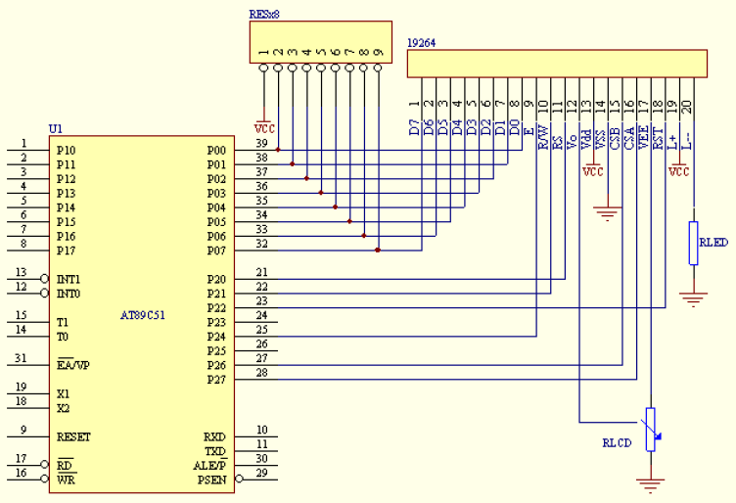

Figure 54 Graphical LCD circuit diagram

1. The graphical display actually has three separate controllers. This means that there needs to be three lots of initialisation.
2. There is a separate reset pin (18), which could be tied to ping 2.
3. The display size is measured in dots, and is 192 dots wide by 64 dots high. Product code LKG-192064-42. Other codes JHD19264A 020628
4. The controller is a KS0108B

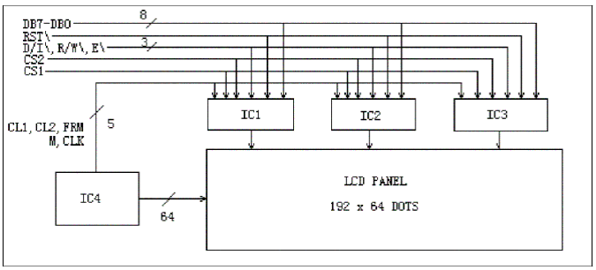

Figure 55 Logical diagram of Graphical LCD Module

Doing the maths

Six lines in Falcon gives 64/6 = 10 rows of dots per character (with 4 rows spare) and

25 Characters in Falcon gives 192/25 = 7 columns per character (with 17 columns spare). Looks sort of hopeful as documentation refers to 6*8 font sizes for other controllers, although further on the document refers to 5*7 characters in a 8*8 cell which basically means I’ll have a single pixel between characters.

The KS0108B has the following commands

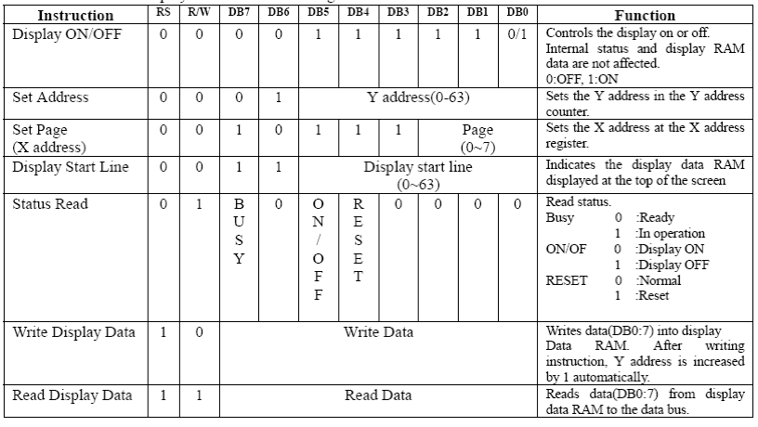

Figure 56 FS0108B Command set

Now the good news is Leo from Beta Innovations has already done the hard work, so the Interface to Falcon 4 is already done. As it reads the Falcon 4 Shared Memory File this can be used for the other simulators (LOMAC and FS2004).

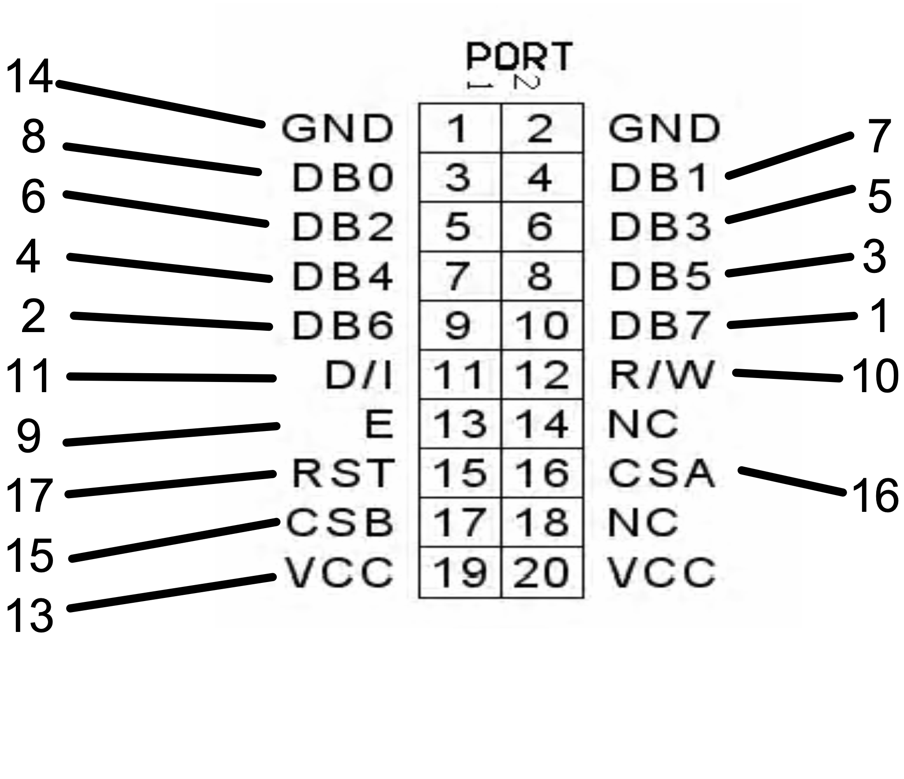

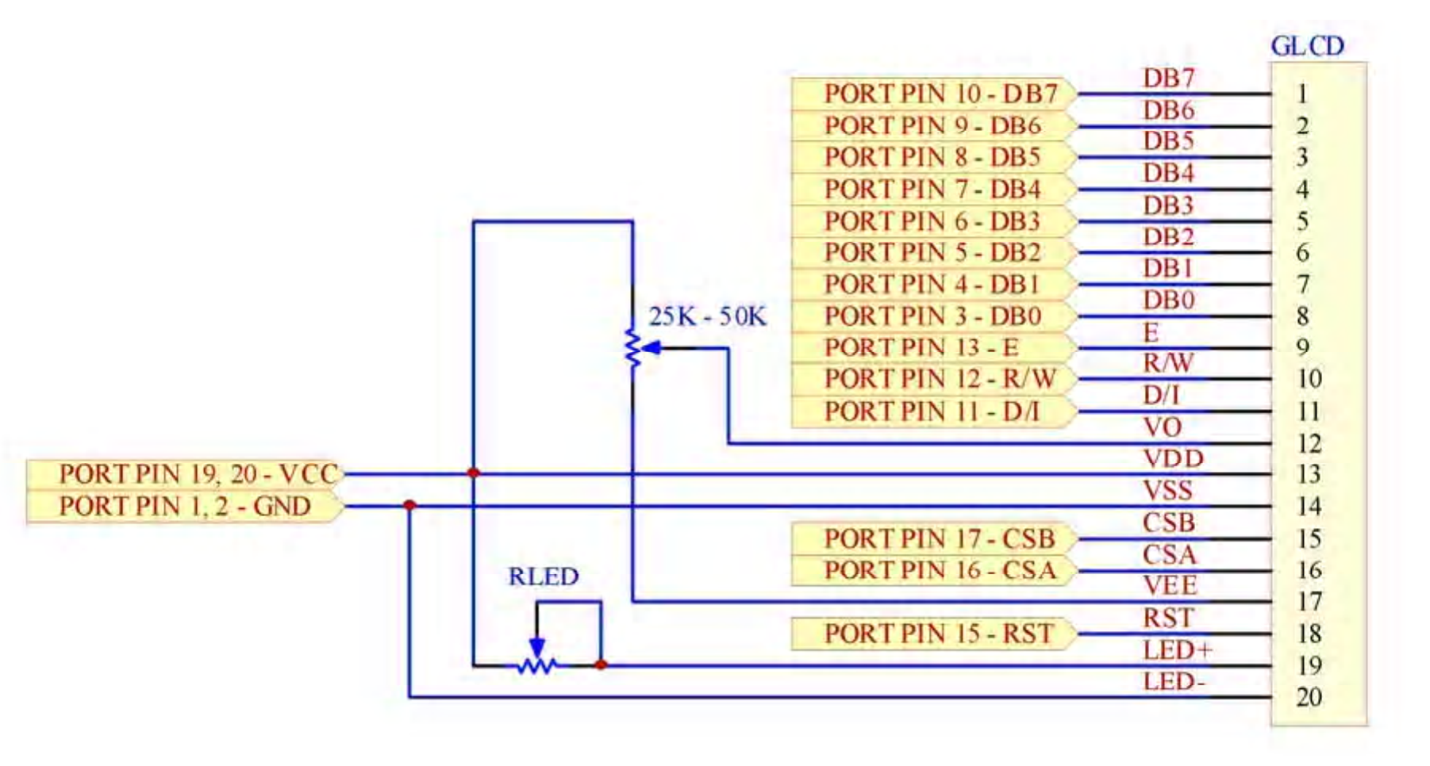

# Modifying a Real VOR

I scored a couple of ARC VORs from ebay. As they come from the real thing thought it’ll be an interesting challenge to interface them to the simulator.

The first VOR had Glideslope needle and a motor to drive the heading dial.

The Motor draws 12mA to 25mA, and whilst it spins from 2V to 6V, 3V is a nice compromise between speed and noise.

The needles are extremely sensitive and will fully deflect on a low ohms scale with a digital multimeter.

I replaced the synchro with an Absolute encoder from [www.digitalusa.com](http://www.digitalusa.com/). This was one of the few absolute encoders that could fit inside the synchro case (wanted that way to ensure aligned of the existing gear assembly).

Phidgets Output can drive motor through BC547, cannot drive 5v relay directly

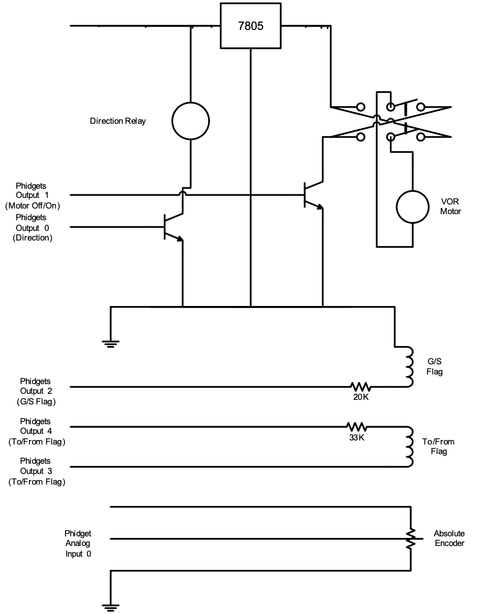

If the motor is switched off, it takes 24 steps (1000 steps in 360 degrees) to stop. Desired position 810 (point at which motor is switched off), stops at position 832 to 834. If the motor is reversed the desired stop point becomes 999, is stops at 981 to 975. The max value received from the encoder when powered from Phidgets was 995.

To prevent overrun the motor is slowed when it is 50 steps away, and further reduced when it is 10 steps away. It is slowed by performing crude pulse width modulation using timers in Visual Basic.

## Visual Basic Code To Drive Motor

Two timers, are used in the program, timer1 is used to determine how long the motor should be ‘pulsed’ for as the dial nears the desired location (pulse times range from 1 to 5mS). The Second timer fires 20 times a second (50mS). The second timer event contains the core code, which is activated when the Phidgets I/O controller is attached and the OBS button is pressed in.

***Const DirectionRelay = 0***

***Const MotorPower = 1***

***Const GlideSlopeFlag = 2***

***Const ToFromFlagA = 3***

***Const ToFromFlagB = 4***

***Const Clockwise = False***

***Const CounterClockwise = True***

***Const OpenRelay = False***

***Const MaxReturnedValue = 995***

***iDesiredValue = IFKit.SensorValue(5)***

***iCurrentValue = IFKit.SensorValue(4)***

***' Deal with special cases***

***' First max value returned from rotational sensor is 995***

***If iDesiredValue > MaxReturnedValue Then***

***iDesiredValue = MaxReturnedValue***

***End If***

***iDelta = iDesiredValue - iCurrentValue***

***TextLCD.DisplayString(0) = iDesiredValue & " - " & iCurrentValue***

***If Abs(iDelta) > 500 Then***

***' There is more than 180 degrees difference reverse path***

***iDelta = iDelta * -1***

***End If***

***If Abs(iDelta) > 990 Then***

***' Deal with floating around the zero mark***

***iDelta = Int(iDelta * 0.01)***

***TextLCD.DisplayString(1) = iDelta***

***End If***

***If Abs(iDelta) < 5 Then***

***IFKit.OutputState(MotorPower) = False***

***IFKit.OutputState(ToFromFlagA) = False***

***IFKit.OutputState(ToFromFlagB) = False***

***IFKit.OutputState(DirectionRelay) = OpenRelay***

***IFKit.OutputState(GlideSlopeFlag) = False***

***Exit Sub***

***End If***

***If iDelta > 0 Then***

***IFKit.OutputState(ToFromFlagA) = False***

***IFKit.OutputState(ToFromFlagB) = True***

***Else***

***IFKit.OutputState(ToFromFlagA) = True***

***IFKit.OutputState(ToFromFlagB) = False***

***End If***

***IFKit.OutputState(GlideSlopeFlag) = True***

***If Abs(iDelta) < 50 Then***

***If iDelta > 0 Then***

***IFKit.OutputState(DirectionRelay) = Clockwise***

***Else***

***IFKit.OutputState(DirectionRelay) = CounterClockwise***

***End If***

***' If we are real close to the desired position reduce speed***

***If Abs(iDelta) < 20 Then***

***' Real close to final position***

***Me.Timer1.Interval = 1***

***Else***

***' Close to Final Position***

***Me.Timer1.Interval = 5***

***End If***

***IFKit.OutputState(MotorPower) = True***

***Me.Timer1.Enabled = True***

***Exit Sub***

***Else***

***If iDelta > 0 Then***

***IFKit.OutputState(DirectionRelay) = Clockwise***

***Else***

***IFKit.OutputState(DirectionRelay) = CounterClockwise***

***End If***

***IFKit.OutputState(MotorPower) = True***

***End If***

## Determining the Dial Position using potentiometers.

One of the VORs natively used potentiometers for tracking heading. The four outputs give the following resistance values.

Determining the position:

1. Read all four inputs
2. Determine which input is the lowest (to a restricted precision). If there is a tie break then the angle must be exactly halfway between the two lowest readings
3. Determine which input is the next lowest. This reduces the possible range of angles to at 90 degree range, with expected resistances to be between 0Ω and 1300 Ω.
4. A ratio of resistances is used to calculate the position, e.g. both 1300 then half way between. This approach holds true even with working around the 0 values, although there is a greater likelihood of error as both of the neighboring axis approach 2000 Ω.

This translates to:

Ratio=Lowest Value /(Lowest Value + Next Lowest Value)

Degrees= Nearest Zero Point +/- Ratio*90º

The formula tests well against the measured data:

|  |  |  |  |  |  |
| --- | --- | --- | --- | --- | --- |
| Lowest Reading | Next Lowest | Ratio | Calculated Angle | Desired Angle | Error |
| 0.93 | 1.36 | 0.406114 | 126.5502 | 120 | 105% |
| 0.83 | 1.66 | 0.333333 | 150 | 150 | 100% |
| 0.88 | 1.35 | 0.394619 | 215.5157 | 210 | 103% |
| 0.86 | 1.37 | 0.38565 | 304.7085 | 300 | 102% |
| 0.85 | 1.39 | 0.379464 | 325.8482 | 330 | 99% |
| 0.85 | 1.42 | 0.374449 | 33.70044 | 30 | 112% |

Yes there are more mathematical correct values to resolve this, but approximately a straight line gives good results.

Driving the VOR Flags

Based on these a 50K resistor can be used with 5Vs to move the To/From flag. A current of 0.1mA does the trick. Full deflection of meter is 0.15mA, around 30K with a 4.5V supply. The ILS To/From Flag moves happy with 0.15mA, the Glideslope Flag moves at 0.25mA.

FSUIPC values

|  |  |  |  |  |
| --- | --- | --- | --- | --- |
| 0C48 | 1 | NAV1 Localiser Needle: –127 left to +127 right | **Ok** | **Ok** |
| 0C49 | 1 | NAV1 Glideslope Needle: –127 up to +127 down | **Ok** | **Ok** |
| 0C4A | 1 | NAV1 Back Course flags:  0 BC available  1 Localiser tuned in  2 On Back Course (?)  7 Station active (even if no BC) | **Ok** |  |
| 0C4B | 1 | NAV1 To/From flag: 0=not active, 1=To, 2=From | **Ok** | **Ok** |
| 0C4C | 1 | NAV1 GS flag: TRUE if GS alive | **Ok** | **Ok** |
| 0C4D | 1 | NAV1 code flags, bits used as follows:   1. DME available 2. TACAN 3. Voice available 4. No signal available 5. DME transmitter at GS transmitter 6. No back course 7. GS available 8. This is a localiser (else it’s a VOR)   *[FS2002+, Not yet tested]* |  |  |
| 0C4E | 2 | NAV1 OBS setting (degrees, 0–359) | **Ok** | **Ok** |
| 0C50 | 2 | NAV1 radial ( *360/65536 for degrees) | **Ok** | **Ok** |

|  |  |  |  |  |
| --- | --- | --- | --- | --- |
| 0C59 | 1 | NAV2 Localiser Needle: –127 left to +127 right | **Ok** | **Ok** |
| 0C5A | 1 | NAV2 Back Course flags:  0 BC available  1 Localiser tuned in  2 On Back Course (?)  7 Station active (even if no BC) | **Ok** | **Ok** |
| 0C5B | 1 | NAV2 To/From flag: 0=not active, 1=To, 2=From | **Ok** | **Ok** |
| 0C5E | 2 | NAV2 OBS setting (degrees, 0–359) | **Ok** | **Ok** |
| 0C60 | 2 | NAV2 radial ( *360/65536 for degrees) | **Ok** | **Ok** |
| 0C62 | 4 | NAV2 signal strength:  For Localisers, seems to be either 0 or 256  For VORs varies from 0 to over 1,000,000 when really close! |  |  |
| 0C6A | 2 | ADF1: relative bearing to NDB ( *360/65536 for degrees, –ve left, +ve right) | **Ok** | **Ok** |
| 0C6C | 2 | ADF1: dial bearing, where adjustable (in degrees, 1–360) | **Ok** | **Ok** |
| 0C6E | 1 | NAV2 Glideslope Needle: –127 up to +127 down [FS2002+] | **Ok** | **Ok** |
| 0C6F | 1 | NAV2 GS flag: TRUE if GS alive [FS2002+] | **Ok** | **Ok** |
| 0C70 | 1 | NAV2 code flags, bits used as follows:   1. DME available 2. TACAN 3. Voice available 4. No signal available 5. DME transmitter at GS transmitter 6. No back course 7. GS available 8. This is a localiser (else it’s a VOR)   *[FS2002+, Not yet tested]* |  |  |

# Driving the Analog Meters

Deflecting flags is relatively easy, a single ended flag such as Glide-Slope (GS) uses a single output, a three position flag such as To/Off/From uses two digital ports. What is more complicated is the needles on VOR1/VOR2. If the needle fully deflects at 0.150mA then a 33K ohm resister with a 5V supply can cause full deflection. The question then becomes how do we provide bipolar incremental outputs? Fully let’s deal with the easy use case, the Centered needle. This is achieved by simply setting both outputs to 0V.

Given there can be two VORs (1 and 2), with one having Glide-Slope capabilities means that 6 analog outputs are required. Given neither Phidgets or Beta Innovations have a card with 6 Analog outputs then two choices are available.

1. Six AD converters, using either 60 pins or 30 pings with Dual AD.
2. One AD converter with some form of Sample and Hold. Assume 8 port sample and hold (3 Bits for address, 1 bit for sample), and 8 bits (less is needed, say 4 bits give 16 values)

**Pin-outs for the VOR/ILS**

|  |  |
| --- | --- |
| Grey/Orange-White | ARC |
| Blue/Red | BC |
| Purple/Black | NAV To/From |
| Yellow/White | GS |
| Green/Black | ILS Needle |

# Servo Interface

The Parallax USB card can drive 16 Servos, providing a virtual serial interface to write to. It is able to smooth transitions, reducing the programmers workload as you can simply ask it to position a servo and give it a time to get their.

One minor frustration is the power supply requirements. The documentation suggests 4.75 to 7 volts will do. I tried running it directly off a 5V computer PSU, only to find it didn’t want to play (even though the output voltage was 5.20V). It is currently running off a 9V unregulated Plug pack (measured power supply input was 8.2V).

***The following chapter has now been made largely redundant as I now use the Parallax controller, which does the ‘smoothing’ itself***

As Simkits and Flight Illusions do not make all of the gauges I want, the Phidgets 4 Port Servo card is still in use. The gauges I wanted were

* Radar Altimeter
* G-Force
* Angle of Attack

When setting up the servos using the Phidgets card I did find the zero and maximum positions differed from the Simkits CCUv2. This meant the needles had to be repositioned.

To smooth out gauge readings I attempt to not jump directly from one value to another as this gives severe jitter. During development I used a graphtest routine to determine the believability of different timer values.

Using

For I = 1 to time delay

Update Servo Position

Doevents

Next i

A time delay of 1000 gave good results. An additional factor was I was updating four servos during the loop, thus when calculating loop times needed to include latency of the servo update and the 1000 DoEvents.

With a step of 0.01, the DoEvents code had no visible impact. A scaling of 0.1 still gives a smooth action.

If the servo is below min motor position, the needle goes no further and the servo buzzes. Not buzz noted when the servo was set to max motor position.

**Code Notes on Update_Servo_Pos**

* Fires 20 times a second
* Every second time gets a value from shared memory
* Reads value to desired servo pos
* If desired servo pos = current pos then exit sub
* Else if desired pos > current pos then increment current pos by servo inc value and set servo pos
* Else decrement current os by servo dec value and check to see if we haven’t jumped above or below desired value.

10 = GForce 3

20 = Gforce 2.5

Outrange = 20 – 10 ie the delta

- number of seps between min and max of interest

- going to give proportional delta

Delta between values = 3 – 2.5

Servo pos = delta between values as a percentage

3 – 2.75 = 0.25

0.25/ 3.25 = 0.25/5 = 50%

50% * (max-min) + min = servo pos

|  |
| --- |
| Servo Motor Positions |

|  |  |  |  |
| --- | --- | --- | --- |
|  |  | Min | Max |

|  |  |  |  |
| --- | --- | --- | --- |
| Servo(0) | GForce | 28 | 180 |

|  |  |  |  |
| --- | --- | --- | --- |
| Servo(1) | AOA | 30 | 180 |

|  |  |  |  |
| --- | --- | --- | --- |
| Servo(2) | Radar Alt | 32 | 180 |

|  |  |  |  |
| --- | --- | --- | --- |
| Servo(3) | Not used |  |  |

Gauge Reference Points

|  |  |  |
| --- | --- | --- |
| G-Force | AOA | Radar Alt |

|  |  |  |
| --- | --- | --- |
|  |  |  |

|  |  |  |
| --- | --- | --- |
| -3 | 0 | 0 |

|  |  |  |
| --- | --- | --- |
| -2 | 5 | 20 |

|  |  |  |
| --- | --- | --- |
| -1 | 10 | 40 |

|  |  |  |
| --- | --- | --- |
| 0 | 15 | 60 |

|  |  |  |
| --- | --- | --- |
| 1 | 20 | 80 |

|  |  |  |
| --- | --- | --- |
| 2 | 25 | 100 |

|  |  |  |
| --- | --- | --- |
| 3 | 30 | 150 |

|  |  |  |
| --- | --- | --- |
| 4 | 35 | 300 |

|  |  |  |
| --- | --- | --- |
| 5 | 40 | 600 |

|  |  |  |
| --- | --- | --- |
| 6 | 43 | 100 |

|  |  |  |
| --- | --- | --- |
| 7 |  | 1500 |

|  |  |  |
| --- | --- | --- |
| 8 |  |  |

|  |  |  |
| --- | --- | --- |
|  |  |  |

# More on Programming the Pit

As there is no standard interface for simulators the cockpit code has to be adaptable, adjusting to each of the different simulators. Obviously each of the Sims runs on the primary computer.

The follow diagrams show the data flow between the computers.

Falcon 4

**Falcon 4**

Simkits CCUv2

*TRC SDK*

*Over NW Link*

F4 Glass Server

*Shared Memory*

F4 Glass Client

*NW Link to 2nd PC*

*NW Link to 3rdd PC*

F4 Glass on MFDs

*Shared Memory*

*Serial Port on 2nd PC*

FS2002_VB

*F4 Shared Memory*

*Output to Phidget LEDs, I/O 16 * 2*

*Phidget Servo*

2nd PC

3rd PC

1st PC

GPS

F4 Glass Client

F4 Glass on MFDs

FS2004

FreeFD ND

Flight Illusions

Engine Stack

**FS2004**

GoFlight Modules

Simkits CCUv2

*TRC Driver*

Simkits MCUv2

*MCU Driver*

Wide FS

GPS Out

*WideFS-GPSSOut*

*Flight Illusions Driver*

*FSUIPC*

Wide client

Wide client

*NW Link to 2nd PC*

*NW Link to 3rdd PC*

*FSUIPC*

FreeFD EICAS

*FSUIPC*

FreeFD EADI

*FSUIPC*

FS2002_VB

*FSUIPC*

*Output to Phidget LEDs, I/O 16 * 2*

*Phidget Servo*

2nd PC

3rd PC

1st PC

LOMAC

1.1

**LOMAC**

LUA2

F4Glass

*NW Link to 2nd PC. Data exported over UDP from LUA*

*(to 8080)*

LOMACGPSout

F4 Glass

2nd PC

1st PC

*Shared Memory File*

*“PTLomacSharedMemoryArea”*

*Shared Memory File*

*“FalconSharedMemoryArea”*

GPS

*RS232 from COM5*

*"19200,N,8,1"*

*NEMA*

TRC_Custom_Link

DualStack_TX

*UDP Data Link for Dual Engine Stack*

*(to 8081)*

DualStack_RX

PTTRC

_Link

*TCP Link to Simkits TRC Custom Link*

*(to 1972)*

*Shared Memory File*

*“TRCSharedMemoryArea”*

*Shared Memory File*

*“PTDualEngineSharedMemoryArea”*

***Add Shared Memory for PhidgetLED, PhidgetIO and PhidgetServo***

Lock-On

Fs2002_VB

Simkits SDK

F4 Glass

**Lock-On Modern Air Combat**

**Primary PC**

*LUA Export over NW to 2nd PC*

*F4 shared memory file on 2nd PC*

**Second PC**

*Simkits SDK over Network*

**Second PC**

**Primary PC**

GPS

*Serial Port*

Button Press on XKeys

MFD-Control

EICAS

ND

**Keyboard Flow on third computer for FS 2004**

# USB Connectivity

## Primary Computer

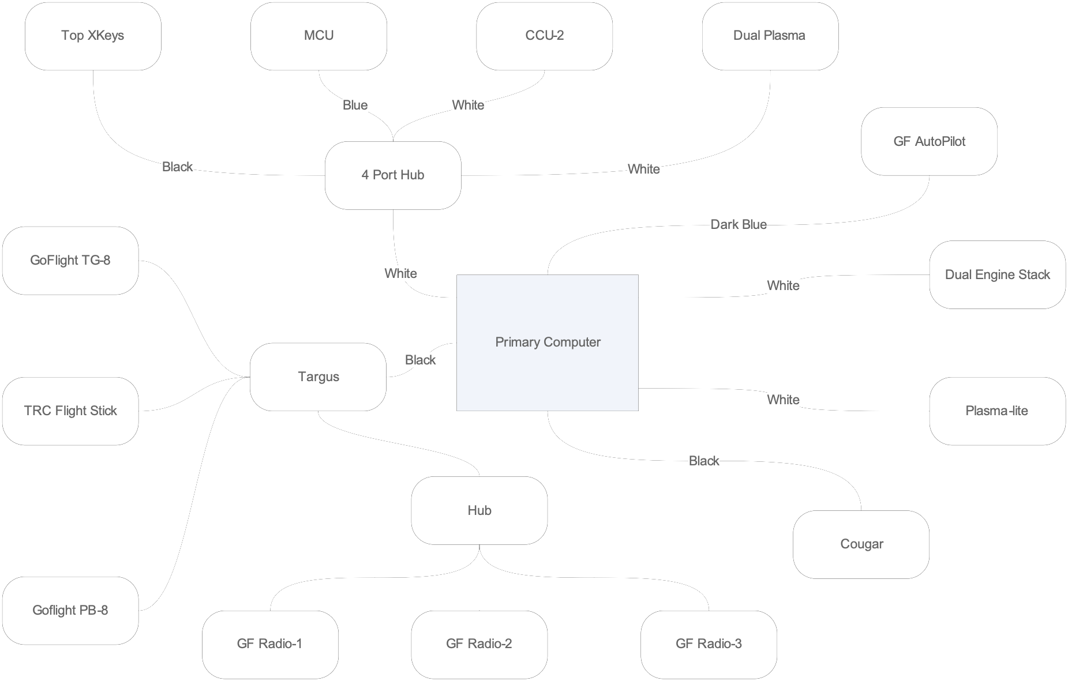

Primary Computer USB Connectivity 1

# Finding other aircraft

If you rarely fly multi-player, one of the challenges I found is finding your team mates. I know there are some very nicely ATC programs out there (which still may well be the right answer..), and if I can find one for both F4 and Lomac then this program probably won’t get created.

With all of the sims I fly I can get positional output. It should then be possible to either multicast or broadcast out the position of your aircraft. If each person on the lan is running a program which collects this information you can then provide heading and distance information to your flying partners. Initially this will be presented as digits, and perhaps later graphically.

# System Performance Comparisons

After purchasing a Dell PowerEdge that had PCI Express slot…which doesn’t take ordinary PCI Express cards (well I guess it is supposed to be a server), I looked at how the different systems I had running performed. I used an older version of PCMark 2002 and 2001 3DMarks. The reason for using an older test is the newer tests didn’t want to look at the older video cards. The results are in here more for historical information than any thing else.

|  |  |  |  |  |
| --- | --- | --- | --- | --- |
|  | CPU | Memory | Hard Disk | 2001 3D Marks |

|  |  |  |  |  |
| --- | --- | --- | --- | --- |
|  |  |  |  |  |

|  |  |  |  |  |
| --- | --- | --- | --- | --- |
| PC1 | 6664 | 7345 | 1101 | 9479 |

|  |  |  |  |  |
| --- | --- | --- | --- | --- |
| PC2 | 4431 | 3637 | 691 | 3598 |

|  |  |  |  |  |
| --- | --- | --- | --- | --- |
| PC3 | 3488 | 2286 | N/A | N/A |

|  |  |  |  |  |
| --- | --- | --- | --- | --- |
| Dell5100 | 6744 | 16244 | 1352 | 5043 |

|  |  |  |  |  |
| --- | --- | --- | --- | --- |
| Burner | 3907 | 3083 | 199 | Insufficient RAM |

|  |  |  |  |  |
| --- | --- | --- | --- | --- |
| Middle | 5455 | 4880 | 942 | 8228 |

|  |  |  |  |  |
| --- | --- | --- | --- | --- |
| PowerEdge | 5911 | 10279 | 1479 | 4408 |

|  |  |  |  |  |
| --- | --- | --- | --- | --- |
| Dell 9150 | 7504 | 18065 | 1390 | 24820 |

|  |  |  |  |  |
| --- | --- | --- | --- | --- |
|  |  |  |  |  |

# Lock-on Modern Air Combat 1.11 LUA Export

LOMAC exporting capabilities were considerably enhanced in 1.1. The LUA scripting language enables you to easily export data values from LOMAC to a file or across the network. I had written a utility to receive the data exported from LOMAC and massage it to a Falcon 4 shared memory file, enabling the use of Eagle 9’s F4 Glass with LOMAC.

Not all of the exported parameters are updated for all aircraft. For example the Hydraulic Pressure appears to be updated for the newer modules such as the SU25 but not for the A10 or Eagle.

The options displayed by F4 Glass are:

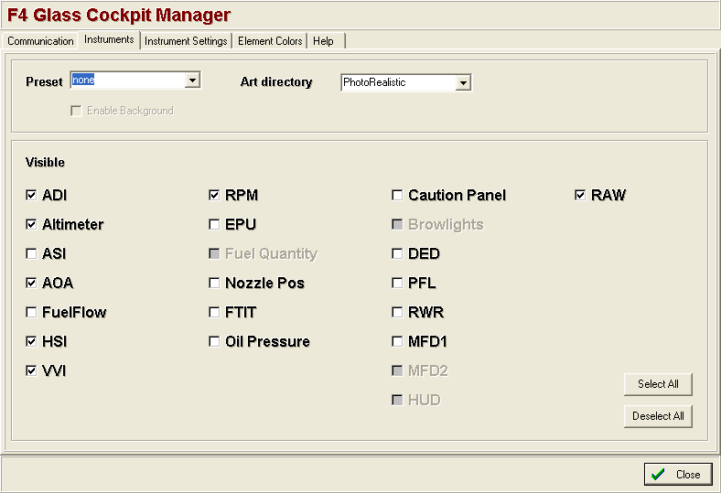

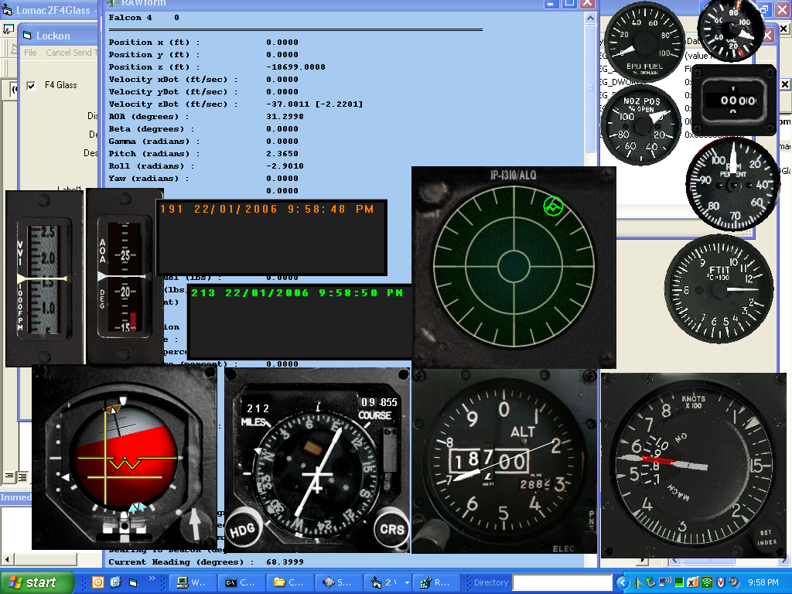

A little imagination is needed for mapping from LOMAC to F4 Glass

EPU Fuel – Internal Fuel

Oil – Hydraulic Pressure

Fuel Flow - ?

Nozzle Position – External Fuel ?

PFL – Weapon select

DDL – Current Position

|  |  |
| --- | --- |
| F4 Glass | Available in 1.11 LUA Export |

|  |  |
| --- | --- |
|  |  |

|  |  |
| --- | --- |
| ADI | Pitch Yaw Roll Needles |

|  |  |
| --- | --- |
| Altimeter | Both Baro and Radar |

|  |  |
| --- | --- |
| ASI | Airspeed |

|  |  |
| --- | --- |
| AOA | Angle of Attack |

|  |  |
| --- | --- |
| Fuel Flow | Not Available |

|  |  |
| --- | --- |
| HSI | Yaw and distance to next waypoint |

|  |  |
| --- | --- |
| VVI | Vertical Velocity |

|  |  |
| --- | --- |
| RPM | Engine RPM |

|  |  |
| --- | --- |
| EPU | Not Available |

|  |  |
| --- | --- |
| Nozzle Pos | Not Available |

|  |  |
| --- | --- |
| FTIT | Engine Temperature |

|  |  |
| --- | --- |
| Oil Pressure | Hydraulic Pressure |

|  |  |
| --- | --- |
| Caution Panel | See Below |

|  |  |
| --- | --- |
| DED | Pylon Information? |

|  |  |
| --- | --- |
| PFL | Course Information? |

|  |  |
| --- | --- |
| RWR | TWS |

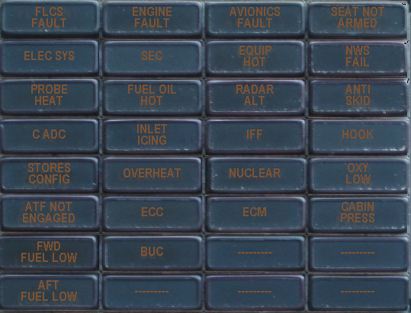

|  |  |
| --- | --- |
| F4 Glass | LOMAC Indicators |

|  |  |
| --- | --- |
|  |  |

|  |  |
| --- | --- |
| FLCS Fault |  |

|  |  |
| --- | --- |
| Engine Fault | LeftEngineFailure |

|  |  |
| --- | --- |
| Avionics Fault |  |

|  |  |
| --- | --- |
| Seat Not Armed |  |

|  |  |
| --- | --- |
| Elec Sys |  |

|  |  |
| --- | --- |
| Sec |  |

|  |  |
| --- | --- |
| Equip Hot |  |

|  |  |
| --- | --- |
| NWS Fail |  |

|  |  |
| --- | --- |
| Probe Heat |  |

|  |  |
| --- | --- |
| Fuel Oil Hot |  |

|  |  |
| --- | --- |
| Radar Alt | RadarFailure |

|  |  |
| --- | --- |
| Anti Skid |  |

|  |  |
| --- | --- |
| CADC |  |

|  |  |
| --- | --- |
| Inlet Icing |  |

|  |  |
| --- | --- |
| IFF |  |

|  |  |
| --- | --- |
| Hook |  |

|  |  |
| --- | --- |
| Store Config |  |

|  |  |
| --- | --- |
| Overheat |  |

|  |  |
| --- | --- |
| Nuclear |  |

|  |  |
| --- | --- |
| Oxy Low |  |

|  |  |
| --- | --- |
| ATF Not Engaged |  |

|  |  |
| --- | --- |
| ECC |  |

|  |  |
| --- | --- |
| ECM | ECMFailure |

|  |  |
| --- | --- |
| Cabin Press | CanopyOpen |

|  |  |
| --- | --- |
| FWD Fuel Low |  |

|  |  |
| --- | --- |
| BUC |  |

|  |  |
| --- | --- |
| Aft Fuel Low |  |

LOMAC 1.0 supported the export of:

|  |  |
| --- | --- |
| Airspeed | LoGetIndicatedAirSpeed |

|  |  |
| --- | --- |
| Altitude | LoGetAltitudeAboveSeaLevel  LoGetAltitudeAboveGroundLevel |

|  |  |
| --- | --- |
| Vertical Speed | LoGetVerticalVelocity |

|  |  |
| --- | --- |
| Airspeed | LoGetIndicatedAirSpeed |

|  |  |
| --- | --- |
| Pitch | LoGetADIPitchBankYaw |

|  |  |
| --- | --- |
| G Force | LoGetAccelerationUnits |

|  |  |
| --- | --- |
| Bank | LoGetADIPitchBankYaw |

|  |  |
| --- | --- |
| Yaw (heading) | LoGetADIPitchBankYaw |

|  |  |
| --- | --- |
| Start Time | LoGetMissionStartTime |

|  |  |
| --- | --- |
| Model Time | LoGetModelTime |

|  |  |
| --- | --- |
| Pilot Name | LoGetPilotName |

LOMAC 1.1 Provides much more, in addition to basic aircraft information, we now get Engine Status, Warning Indicators, Threats, Aircraft Position, Payload Information.

An important capability of the scripting engine is the ability to export either after every frame or in fixed intervals. Initially I was exporting every frame, but this did overload the code receiving the UDP packets. Using the Timer option ended up being much smarter. Now I only export every 100mS.

**Engine Status**

In LOMAC 1.1 we get engine RPM, Temperature, Hydraulic, Pressure and Internal/External fuel quantities.

*LoGetEngineInfo() -- (args - 0 ,results = table)*

*engineinfo =*

*{*

*RPM = {left, right},(%)*

*Temperature = { left, right}, (Celcium degrees)*

*HydraulicPressure = {left ,right}, kg per square centimeter*

*fuel_internal -- fuel quantity internal tanks kg*

*fuel_external -- fuel quantity external tanks kg*

*}*

**Warning Indicators**

This list was generated by the following LUA script fragment. One of the benefits of this approach is that when additional parameters are added the script does not have to change as it will enumerate all possible values.

local MCPDisplay = LoGetMCPState()

if MCPDisplay then

for i_MCP,MCPVal in MCPDisplay do

if MCPVal then

b = string.format("%s = True", i_MCP)

else

b = string.format("%s = False", i_MCP)

end

c = string.format("%s %s", a, b)

a = c

end

end

|  |  |  |
| --- | --- | --- |
| LOMAC Export Name | F4 Glass Mapping | Physical Cockpit Indicator |

|  |  |  |
| --- | --- | --- |
|  |  |  |

|  |  |  |
| --- | --- | --- |
| RightTailPlaneFailure |  |  |

|  |  |  |
| --- | --- | --- |
| EOSFailure |  |  |

|  |  |  |
| --- | --- | --- |
| ECMFailure | ECM |  |

|  |  |  |
| --- | --- | --- |
| RightAileronFailure |  |  |

|  |  |  |
| --- | --- | --- |
| MasterWarning |  | Master Warning |

|  |  |  |
| --- | --- | --- |
| RightEngineFailure |  |  |

|  |  |  |
| --- | --- | --- |
| CannonFailure |  |  |

|  |  |  |
| --- | --- | --- |
| MLWSFailure |  |  |

|  |  |  |
| --- | --- | --- |
| ACSFailure (autopilot) |  |  |

|  |  |  |
| --- | --- | --- |
| RadarFailure | Radar Alt |  |

|  |  |  |
| --- | --- | --- |
| HelmetFailure |  |  |

|  |  |  |
| --- | --- | --- |
| HUDFailure |  |  |

|  |  |  |
| --- | --- | --- |
| LeftMainPumpFailure |  |  |

|  |  |  |
| --- | --- | --- |
| RightWingPumpFailure |  |  |

|  |  |  |
| --- | --- | --- |
| LeftWingPumpFailure |  |  |

|  |  |  |
| --- | --- | --- |
| MFDFailure |  |  |

|  |  |  |
| --- | --- | --- |
| RWSFailure |  |  |

|  |  |  |
| --- | --- | --- |
| GearFailure |  |  |

|  |  |  |
| --- | --- | --- |
| HydraulicsFailure |  |  |

|  |  |  |
| --- | --- | --- |
| AutopilotFailure = True |  |  |

|  |  |  |
| --- | --- | --- |
| FuelTankDamage |  |  |

|  |  |  |
| --- | --- | --- |
| LeftAileronFailure |  |  |

|  |  |  |
| --- | --- | --- |
| CanopyOpen | Cabin Press |  |

|  |  |  |
| --- | --- | --- |
| RightMainPumpFailure |  |  |

|  |  |  |
| --- | --- | --- |
| StallSignalization |  | Stall |

|  |  |  |
| --- | --- | --- |
| LeftEngineFailure | Engine Fault |  |

|  |  |  |
| --- | --- | --- |
| AutopilotOn |  | Autopilot Engaged |

|  |  |  |
| --- | --- | --- |
| LeftTailPlaneFailure |  |  |

**Aircraft Position**

Something I had really been waiting for was the ability to drive an external GPS. Getting the position of your aircraft from LOMAC is a two step process. First we get our Plane, and then ask for the position of the plane with that information.

MyPlane = LoGetObjectById(LoGetPlayerPlaneId())

Lat = MyPlane.LatLongAlt.Lat

LongPos = MyPlane.LatLongAlt.Long

The coordinates are returned in decimal format. The component after the decimal point is the Minutes/Seconds which must be converted before being sent to the GPS

Lat=44.936181107631, Long=35.264056474911

The GetObjectById(LoGetPlayerPlaneId()) function can also return

Name =

Type =

Subtype =

Country =

Coalition =

LatLongAlt = { Lat = , Long = , Alt = }

Heading =

For more information see the section of Driving the GPS from LOMAC.

Todo: Something which is useful to determine what type of aircraft is being flown. Given this is not given by GetObjectById function, and it is not desirable to be enumerating the entire world for every frame up, the model time value to be used to enumerate the world in the first second. Once this information is held the Lomac2F4Glass program can determine appropriate scaling for gauges such as VSI and Engine RPM.

**Payload Information**

LOMAC is one of the very few simulators that exports information about weapon loads. The following LUA script fragment gives

*if stations then*

*b = string.format("Current = %d \n",stations.CurrentStation)*

*d = string.format("%s",c)*

*c = string.format("%s %s",d,b)*

*for i_st,st in pairs (stations.Stations) do*

*local name = LoGetNameByType(st.weapon.level1 ,st.weapon.level2, st.weapon.level3,st.weapon.level4);*

*if name then*

*b = string.format(" weapon = %s , count = %d \n",name,st.count)*

*else*

*b = string.format(" weapon = {%d,%d,%d,%d} ,count = %d \n", st.weapon.level1, st.weapon.level2, st.weapon.level3, st.weapon.level4,st.count)*

*end*

*d = string.format("%s",c)*

*c = string.format("%s %s",d,b)*

*end*

*end*

Resulting information for F15 Eagle

weapon = AIM-120C , count = 1

weapon = AIM-120C , count = 1

weapon = {0,0,0,0} ,count = 0

weapon = {0,0,0,0} ,count = 0

weapon = AIM-9M , count = 1

weapon = AIM-9M , count = 1

weapon = AIM-7M , count = 1

weapon = AIM-7M , count = 1

weapon = AIM-7M , count = 1

weapon = AIM-7M , count = 1

weapon = fuel tank 1000 gal , count = 1

**Threat Status**

Like Falcon 4, TWS information is exported. As with the Warning Indicators, the information is not held in a fixed array, instead it is returned as a variable size table.

*local TWS = LoGetTWSInfo()*

*if TWS then*

*local TWSMode = TWS.Mode*

*b = string.format("Current Mode=%s", TWSMode)*

*d = string.format("%s",c)*

*c = string.format("%s %s",d,b)*

*for i_em,em in pairs (TWS.Emitters) do*

*-- local name = LoGetNameByType(st.weapon.level1,st.weapon.level2,st.weapon.level3,st.weapon.level4);*

*-- if name then*

*-- b = string.format(" weapon = %s , count = %d \n",name,st.count)*

*-- else*

*-- b = string.format(" weapon = {%d,%d,%d,%d} ,count = %d \n", st.weapon.level1,st.weapon.level2,st.weapon.level3,st.weapon.level4,st.count)*

*-- end*

*b = string.format("Az=%f, Type=%s, Signal=%s",em.Azimuth,em.Type.level1, em.SignalType)*

*d = string.format("%s",c)*

*c = string.format("%s %s",d,b)*

*end*

*b = string.format("Target Found")*

*end*

This returns the following for a single threat.

Current Mode=0 Az=0.857360, Type=1, Signal=scan

The TSW Table has the following constructs.

*LoGetTWSInfo() -- return Threat Warning System status (result the table )*

*result_of_LoGetTWSInfo =*

*{*

*Mode = , -- current mode (0 - all ,1 - lock only,2 - launch only*

*Emitters = {table of emitters}*

*}*

*emitter_table =*

*{*

*ID =, -- world ID*

*Type = {level1,level2,level3,level4}, -- world database classification of emitter*

*Power =, -- power of signal*

*Azimuth =,*

*Priority =,-- priority of emitter (int)*

*SignalType =, -- string with vlues: "scan" ,"lock", missile_radio_guided","track_while_scan";*

*}*

I assumes the Threat Type maps to the values found further down the LUA file

*Object types:*

*Air = 1 (Subtypes: Airplane = 1, Helicopter = 2)*

*Ground = 2 (Subtypes: Moving = 8, Standing = 9, Tank = 17, SAM = 16)*

*Navy = 3 (Subtypes: Ship = 12)*

*Weapon = 4 (Subtypes: Missile = 4, Bomb = 5, Shell = 6, Rocket = 7)*

*Static = 5 (Subtypes: Airdrome = 13)*

Or it is more likely to be provided by

*local name = LoGetNameByType(st.weapon.level1,st.weapon.level2,st.weapon.level3,st.weapon.level4);*

When converting this information to Falcon 4 Shared Memory the translation must be terminated after 39 values as this is all the space available.

The fields for F4 AF are

|  |  |
| --- | --- |
| Field | Description |

|  |  |
| --- | --- |
| RWRObjectCount As Long | Number of valid threat object |

|  |  |
| --- | --- |
| RWRSymbol(39) As Long | Type of threat |

|  |  |
| --- | --- |
| Bearing(39) As Single | Bearing to threat (radians) |

|  |  |
| --- | --- |
| MissileActivity(39) As Long | Missile is active or beam rider |

|  |  |
| --- | --- |
| MissileLaunch(39) As Long | Missile is launched |

|  |  |
| --- | --- |
| Selected(39) As Long | Threat is Selected |

|  |  |
| --- | --- |
| Lethality(39) As Single | Lethal Range |

The fields exported from LOMAC are

|  |  |
| --- | --- |
| **Field Name** |  |

|  |  |
| --- | --- |
|  |  |

|  |  |
| --- | --- |
| **Em.id (world ID)** |  |

|  |  |
| --- | --- |
| **Em.Power Power of Signal** |  |

|  |  |
| --- | --- |
| **em.Azimuth** |  |

|  |  |
| --- | --- |
| **Em.Priority** |  |

|  |  |
| --- | --- |
| **em.Type.level1 (world database classification if emitter)** |  |

|  |  |
| --- | --- |
| **em.SignalType** |  |

|  |  |
| --- | --- |
| **st.weapon.level1,st.weapon.level2,st.weapon.level3,st.weapon.level4** |  |

**Other Values used**

LoGetAngleOfAttack()

LoGetControlPanel_HSI()

LoGetGlideDeviation()[9]

LoGetSideDeviation()

LoGetSlipBallPosition()[10]

LOMAC 1.02 Readme includes the following information of the TWS.

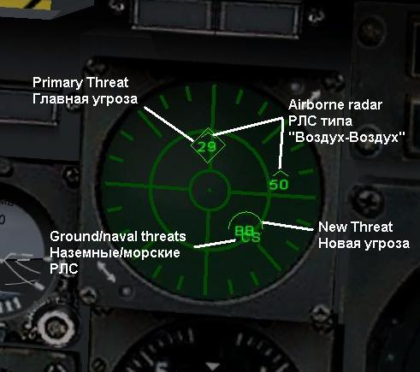

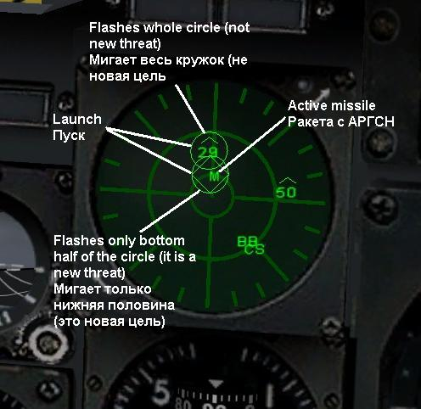

# Driving the GPS from LOMAC

As LOMAC needs every bit of CPU it can get, I’ve attached the GPS to a second computer which is also running F4 Glass.

The Lowrance Airmap 2000 is configured to receive NEMA sentences on the serial port.

The Settings are

* System Setup
* Communications Port
  + Baud Rate = 19200
  + NEMA Input = Checked
  + NEMA GPS Input = checked
  + NEMA Output = Not checked
  + Configure NEMA
    - GLL = Not checked
    - RMC and RMB = Checked
    - GGA = Not Checked
    - GSA and GSV = Checked
    - APB = Not Checked
  + Mangnavox DGPS = Not checked
  + Starlink DGPS = Not Checked

I spent some time chasing a problem where the Altitude bar was flashing on the GPS, after chasing my tail thinking the problem was checksum related, turned out I was not sending a third sentence containing the Satellite information.

In addition to researching NEMA sentences on the net I also used the PortMonitor utility from SysInternals[11] to see what GPSOut was sending from Flight Sim 2004.

# Working with Serial Ports and Visual Basic

Given the Flight Illusions Flight Simulator Driver appears to be written in Visual Basic I thought I should try VB writing to the Virtual USB Serial Port to drive the Dual Engine Stack.

Initially the upgrade rate was a couple of refreshes per second, which is pretty average. After some investigation, found the opening and closing of the Communication Port was time intensive. By pulling the open/close off the communication port up into the form load/unload the update performance jumped to better than 20 updates per second.

Todo: Update the GPS code to only open/close the communications port during form load/unload.

Todo: Provide a user option to select the communication port the GPS/Engine Stack is attached to. This is not an issue with the 1st and 2nd PCs, but does present a challenge when testing code on an IBM laptop which does not have any built in serial ports.

During December of 2006 I moved the Simkits CCU/MCU and the Flight Illusions stack to the second PC. Given both Simkits and Flight Illusions use FSUIPC for their native drivers, WideFS can be used to communicate back to the primary computer. The benefit of this approach is it is easier to write my own interfaces to these instruments. One of the challenges I did face is a conflict on serial port usage.

|  |  |
| --- | --- |
| Comm Port | Description |
|  |  |
| Com1 | Physical Serial Port for GPS |
| Com2 |  |
| Com3 | Flight Illusions (must use this port) |
| Com4 | Parallax Servo |

# Driving the Flight Illusion Dual Engine Gauges

As mentioned above Flight Illusions has not published an SDK to drive their gauges. The have however, been kind enough to provide the low level packet format for sending information to the gauges.

The data is send via a virtual communications port which must be configured to 38400, n, 8, 1. 38400 bps, no parity, 8 bits, 1 stop bit.

|  |
| --- |
| Flight Illusions Offsets |

|  |
| --- |
| Const StartFlagPos = 1 |

|  |
| --- |
| Const ITTLeftHigh = 2 |

|  |
| --- |
| Const ITTLeftLow = 3 |

|  |
| --- |
| Const TorqueLeftHigh = 4 |

|  |
| --- |
| Const TorqueLeftLow = 5 |

|  |
| --- |
| Const PropRPMLeftHigh = 6 |

|  |
| --- |
| Const PropRPMLeftLow = 7 |

|  |
| --- |
| Const TurbineLeftHigh = 22 |

|  |
| --- |
| Const TurbineLeftLow = 23 |

|  |
| --- |
| Const FuelFlowLeftHigh = 8 |

|  |
| --- |
| Const FuelFlowLeftLow = 9 |

|  |
| --- |
| Const OilTempLeftHigh = 12 |

|  |
| --- |
| Const OilTempLeftLow = 13 |

|  |
| --- |
| Const OilPressLeftHigh = 14 |

|  |
| --- |
| Const OilPressLeftLow = 15 |

|  |
| --- |
| Const ITTRightHigh = 16 |

|  |
| --- |
| Const ITTRightLow = 17 |

|  |
| --- |
| Const TorqueRightHigh = 18 |

|  |
| --- |
| Const TorqueRightLow = 19 |

|  |
| --- |
| Const PropRPMRightHigh = 20 |

|  |
| --- |
| Const PropRPMRightLow = 21 |

|  |
| --- |
| Const TurbineRightHigh = 10 |

|  |
| --- |
| Const TurbineRightLow = 11 |

|  |
| --- |
| Const FuelFlowRightHigh = 24 |

|  |
| --- |
| Const FuelFlowRightLow = 25 |

|  |
| --- |
| Const OilTempRightHigh = 26 |

|  |
| --- |
| Const OilTempRightLow = 27 |

|  |
| --- |
| Const OilPressRightHigh = 28 |

|  |
| --- |
| Const OilPressRightLow = 29 |

|  |
| --- |
| Const Terminator1 = 39 |

|  |
| --- |
| Const Terminator2 = 40 |

|  |
| --- |
|  |

|  |
| --- |
| Const TerminatorCheckValue = &HAA |

|  |
| --- |
| Const StartFlag = "F" |

|  |
| --- |
|  |

' Byte38: Control byte

' bit 7: Light control 0=off 1=on

' bit 6: Blanking Diplays 0=off 1=on

40 Byte packets are sent to the controller, and must start with “F” and finish with two bytes of “&HAA”. The packet is built by created a 40 byte string populated with Nulls, and then placing data values at the appropriate offsets. As mentioned earlier the Communications port is not opened and closed for each update as this process introduces considerable latency.

Data is passed to the DualGuage code in the format of

‘ValueName=Value’,

There are no spaces around the ‘=’ and the data set must terminate in ‘’,’, including the final data set.

The code to update the gauges looks something like:

***Main***

rxTurbineLeft = Format(GetVal(s, "LeftRPM", "0"), "00.00")

ToSendToGuage.TurbineLeftHigh = Int(rxTurbineLeft / 10)

ToSendToGuage.TurbineLeftLow = (rxTurbineLeft - (Int(rxTurbineLeft / 10) * 10)) * 25.4

TorqueLeft = Format(rxTurbineLeft, "00.00")

Mid(ComBufferXmit, TurbineLeftHigh, 1) = Chr$(ToSendToGuage.TurbineLeftHigh)

Mid(ComBufferXmit, TurbineLeftLow, 1) = Chr$(ToSendToGuage.TurbineLeftLow)

***GetVal function***

If strToSearch = "" Or valueToFind = "" Then

GetVal = valueIfNotFound

Exit Function

End If

strStartPos = InStr(strToSearch, "'" & valueToFind & "=")

If strStartPos = 0 Then

GetVal = valueIfNotFound

End If

' Now add the len of the name and allow for =

strStartPos = strStartPos + Len(valueToFind) + 2

strEndPos = InStr(strStartPos, strToSearch, "',")

If strStartPos = 0 Or strEndPos = 0 Then

GetVal = valueIfNotFound

End If

GetVal = Mid$(strToSearch, strStartPos, strEndPos - strStartPos)

Driving the displays requires a little more work, this code will be turned into a routine, instead of being repeated for each of the 4 displays.

If rxTurbineLeft < 100 Then

byte1 = Mid$(rxTurbineLeft, 4, 1) And &HF

byte1 = (byte1 + 1) * 16

byte1 = byte1 Or &HB 'code for dot

Mid$(ComBufferXmit, 30, 1) = Chr$(byte1)

byte1 = Mid$(rxTurbineLeft, 2, 1) And &HF

byte2 = Mid$(rxTurbineLeft, 1, 1) And &HF

byte1 = ((byte1 + 1) * 16) + byte2 + 1

Mid$(ComBufferXmit, 31, 1) = Chr$(byte1)

Else

byte1 = Mid$(rxTurbineLeft, 1, 1) And &HF

byte2 = Mid$(rxTurbineLeft, 2, 1) And &HF

byte1 = ((byte2 + 1) * 16) + byte1 + 1

Mid$(ComBufferXmit, 31, 1) = Chr$(byte1)

byte1 = Mid$(rxTurbineLeft, 3, 1) And &HF

byte1 = byte1 + 1

byte1 = byte1 Or &HB0 'first digit = blank/space

Mid$(ComBufferXmit, 30, 1) = Chr$(byte1)

End If

The Backlight and Display values are controlled by software as well

' Byte38: Control byte

' bit 7: Light control 0=off 1=on

' bit 6: Blanking Diplays 0=off 1=on

The following code turns both on

*Mid(ComBufferXmit, 38, 1) = Chr$(&H1)*

# Programming the Seven Segment displays

As I wanted large displays for the Chaff and Flare counters I did not want to use the smaller seven segment displays supplied by Phidgets. As making a real doh about using common anode or cathode its now time to program up the displays.

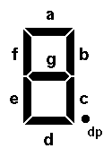

No real black magic was required here, aside from some thought on how to make the code clean and maintainable. Seven Arrays are created, each array have 4 entries. These are used to make the somewhat random port I’ve wired the segments up to the PhidgetLed.

# An Analog Clock

Whilst I can use the Simkits Digital Clock to display the time, it doesn’t provide the at-a-glance assessment of time you get from looking at an analog clock face. A USB to small LCD screen from ww.4dsystems.com.com offers some interesting possibilities. The microLCD or uLCD can be purchased from Dontronics ([www.dontronics.com.au](http://www.dontronics.com.au/)) (you may also need the USB-to-Serial converter).

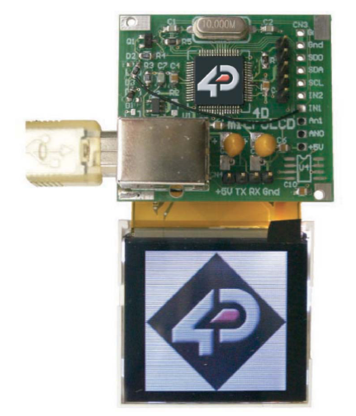

After some scratching of my head I realised the clock is relatively easy to code by using some high school maths, SINs and COSINs are used to determine the where the ends of the hands should be located.

Communication to the module is done using commands output to a virtual USB serial port (similar to the way you communicate to the Flight Illusions Dual Engine Stack). Commands are acknowledged with an <ACK> (06), this can be used to gate the rate commands are send to the unit. After sending a command I enter a doevents loop until a character is returned from the uLCD (currently I don’t check the response... just expect all to be good ☺).

I explored erasing the screen between updates, but found the unit didn’t respond quickly enough. I use Static variables to keep track of the last time written to the screen and plan to use shared memory files to communicate the time to analog clock. The Static variables enable me to write over the last locations the hands where, even if time is being accelerated.

The uLCD also requires a graceful shutdown to prevent possible damage to the LCD through skewed power supply rails.

**Code Initialisation** (each step waits for an acknowledgement from the uLCD, should consider adding a counter as a safety valve if the uLCD doesn’t respond)

* Send Powerup sequence to LCD
* Erase LCD Screen
* Turn on backlight
* Set Background Colour
* Enable Screen Update Flag

**Timer-A Code** (fires every 100mS – to be reviewed)

* Check statics to see if they have been written, if not assign to current time
* If the Shared Memory File exists read the time from the Simulator else
* Add a second and then check if minutes and hours need updating.
* Enable Timer-B

**Timer-B Code** (fires every 300mS to be reviewed)

* Read Hour, Minute, Second variables that been set by Timer-A code.
* If the Hour, Minute, Second are the same as the last reading exit the routine
* Erase the last Hour, Minute, Second Hands
* Calculate and Draw the Hour Hand (allowing for intra-hour movement)
* Calculate and Draw the Minute Hand
* Calculate and Draw the Second
* Save the values just written to Static Variables

The lcd module is mounted onto a Simkits small faceplate, and is held in place with hot glue.

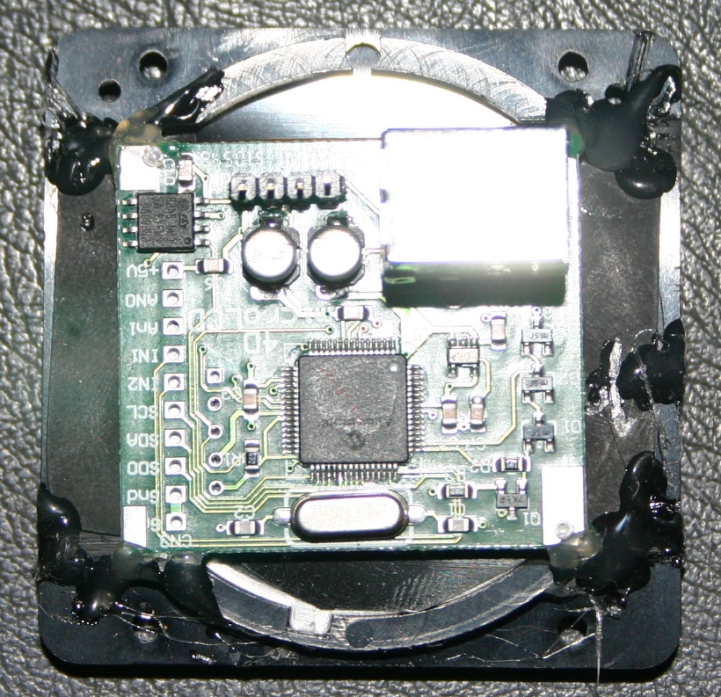

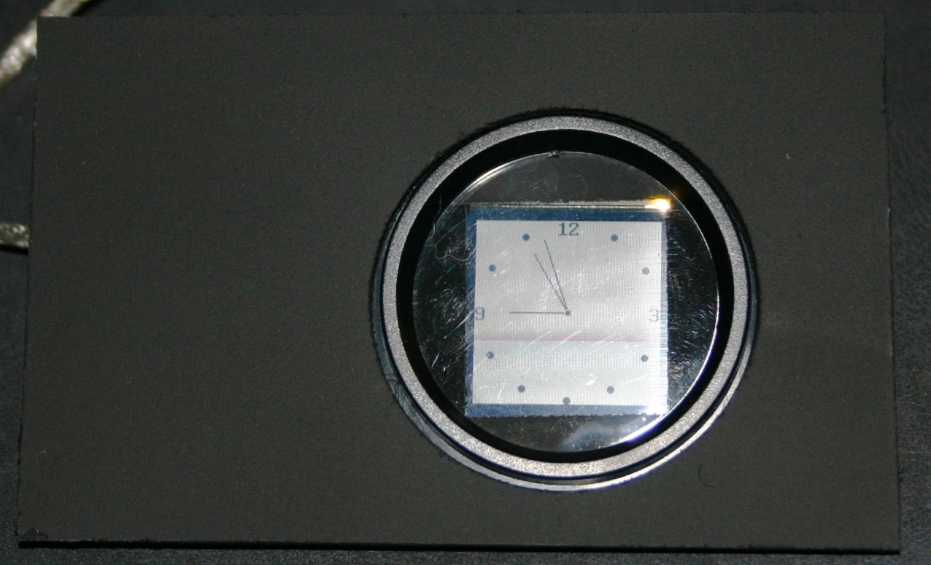

# Magnetic Switches

While trolling one of the Viperpit threads, found reference to the engine starter switch which is held in place magnetically. Current is applied until the JFS light extinguishes, which is nicely presented as one of the light bits.

These switches appear on EBay for around US$70. The coil is rated at 28 Volts, I found is still holds nicely at 12Volts drawing around 18mA.

# Mapping the output devices to the simulators

As different simulators focus on different capabilities, the information available to pit builders varies considerably. Flight Simulator through the FSUIPC interface pretty much exports everything bar the kitchen sink, aside from anything to do with weapons selection and target information. LOMAC on the other hand exports lots of information regarding the weapons and targets, but only a small amount of information on aircraft status (i.e. no information on gear, flaps, or speed brakes). Falcon 4 is somewhere in-between LOMAC and FS2004.

Another consideration is the simulators export information in different values, it could be feet vs meters or degrees vs radians. In the late 2005/2006 redesign I now normalize information which is then passed to shared memory files for the output devices to read.

The following table maps physical output devices to Simulators and there current development status in the pit.

|  |  |
| --- | --- |
| Colour | Status |

|  |  |
| --- | --- |
| Green | Complete |

|  |  |
| --- | --- |
| Blue | Completed in old code but not refreshed to shared memory |

|  |  |
| --- | --- |
| Yellow | To be developed |

|  |  |
| --- | --- |
| Red | Not physically wired |

|  |  |
| --- | --- |
| Gray | Status to be determined |

|  |  |
| --- | --- |
| Black | Information not available from Simulator |

|  |  |  |  |  |
| --- | --- | --- | --- | --- |
| Gauge Name | Panel | FS2004 | F4 | LOMAC |

|  |  |  |  |  |
| --- | --- | --- | --- | --- |
| No Of Engines | Hidden | 2796 |  |  |

|  |  |  |  |  |
| --- | --- | --- | --- | --- |
| Master Warning | Front Left |  |  |  |

|  |  |  |  |  |
| --- | --- | --- | --- | --- |
| Airspeed | Front Left | 02BC |  | Airspeed |

|  |  |  |  |  |
| --- | --- | --- | --- | --- |
| Altimeter | Front Left | 0570 |  | Altimeter |

|  |  |  |  |  |
| --- | --- | --- | --- | --- |
| Heading Indicator | Front Left | 0580 |  | Heading Ind |

|  |  |  |  |  |
| --- | --- | --- | --- | --- |
| Flap Indicator | Front Left | 3036 |  |  |

|  |  |  |  |  |
| --- | --- | --- | --- | --- |
| Air Brakes Indicator | Front Left | 3024 |  |  |

|  |  |  |  |  |
| --- | --- | --- | --- | --- |
| Gear Left | Front Left | 3060 |  |  |

|  |  |  |  |  |
| --- | --- | --- | --- | --- |
| Gear Centre | Front Left | 3052 |  |  |

|  |  |  |  |  |
| --- | --- | --- | --- | --- |
| Gear Right | Front Left | 3056 |  |  |

|  |  |  |  |  |
| --- | --- | --- | --- | --- |
| Stall Warning | TBA | 876 |  |  |

|  |  |  |  |  |
| --- | --- | --- | --- | --- |
| Helicopter Rotor | Front Right | 0908 |  |  |

|  |  |  |  |  |
| --- | --- | --- | --- | --- |
| Helicopter Turbine | Front Right | 08F4 |  |  |

|  |  |  |  |  |
| --- | --- | --- | --- | --- |
| Clock Local Time | Front Right | 0238 023B |  |  |

|  |  |  |  |  |
| --- | --- | --- | --- | --- |
| Clock Outside Temperature | Front Right | 0E8C |  |  |

|  |  |  |  |  |
| --- | --- | --- | --- | --- |
| Clock Battery Voltage | Front Right | 3102? |  |  |

|  |  |  |  |  |
| --- | --- | --- | --- | --- |
| Attitude Indicator | Front Right | 2F70 2F78 |  |  |

|  |  |  |  |  |
| --- | --- | --- | --- | --- |
| VOR | Front Right | 0C48, OC49 0C4B, OC4C |  |  |

|  |  |  |  |  |
| --- | --- | --- | --- | --- |
| Fuel Gauge Left | Front Right | 0B7C |  | Fuel Internal. Needs to be proportioned to aircraft |

|  |  |  |  |  |
| --- | --- | --- | --- | --- |
| Fuel Gauge Right | Front Right | 0B94 |  | Fuel External. Needs to be proportioned to aircraft |

|  |  |  |  |  |
| --- | --- | --- | --- | --- |
| Outer Marker | Front Right | 0BB0 |  |  |

|  |  |  |  |  |
| --- | --- | --- | --- | --- |
| Middle Marker | Front Right | 0BAE |  |  |

|  |  |  |  |  |
| --- | --- | --- | --- | --- |
| Inner Marker | Front Right | 0BAC |  |  |

|  |  |  |  |  |
| --- | --- | --- | --- | --- |
| Left Fire | Front Right | 3366 |  | Left Engine Failure |

|  |  |  |  |  |
| --- | --- | --- | --- | --- |
| Right Fire | Front Right | 3366 |  | Right Engine Failure |

|  |  |  |  |  |
| --- | --- | --- | --- | --- |
| Left Oil | Front Right | 2234 |  | Left Hyd Press |

|  |  |  |  |  |
| --- | --- | --- | --- | --- |
| Right Oil | Front Right | 2386 |  | Right Hyd Press |

|  |  |  |  |  |
| --- | --- | --- | --- | --- |
| Left Gen | Front Right | 15228 |  |  |

|  |  |  |  |  |
| --- | --- | --- | --- | --- |
| Right Gen | Front Right | 15036 |  |  |

|  |  |  |  |  |
| --- | --- | --- | --- | --- |
| Fuel Valve Left | Front Right | 3590 |  |  |

|  |  |  |  |  |
| --- | --- | --- | --- | --- |
| Fuel Valve Right | Front Right | 3594 |  |  |

|  |  |  |  |  |
| --- | --- | --- | --- | --- |
| Left Start | Front Right | 2194 |  |  |

|  |  |  |  |  |
| --- | --- | --- | --- | --- |
| Right Start | Front Right | 2346 |  |  |

|  |  |  |  |  |
| --- | --- | --- | --- | --- |
| Canopy Open | Front Right | 13159 |  | Canopy? |

|  |  |  |  |  |
| --- | --- | --- | --- | --- |
| Rotor RPM Low | Front Right | 2312 |  |  |

|  |  |  |  |  |
| --- | --- | --- | --- | --- |
| Park Brake | Front Right | 3016 |  |  |

|  |  |  |  |  |
| --- | --- | --- | --- | --- |
| Landing Lights | Front Right | 3340 |  |  |

|  |  |  |  |  |
| --- | --- | --- | --- | --- |
|  |  |  |  |  |

|  |  |  |  |  |
| --- | --- | --- | --- | --- |
| VSI | Far Right | 02C8 |  |  |

|  |  |  |  |  |
| --- | --- | --- | --- | --- |
| Radar Altimeter | Far Right | 31E4 |  |  |

|  |  |  |  |  |
| --- | --- | --- | --- | --- |
| Left Fuel | Far Right | 0B7C |  |  |

|  |  |  |  |  |
| --- | --- | --- | --- | --- |
| Right Fuel |  | 0B94 |  |  |

|  |  |  |  |  |
| --- | --- | --- | --- | --- |
| Flaps Position | Far Right | 0BE0 |  |  |

|  |  |  |  |  |
| --- | --- | --- | --- | --- |
| Centre Fuel | Far Right | 0B74 |  |  |

|  |  |  |  |  |
| --- | --- | --- | --- | --- |
| Bus Volts | Far Right | 2824 |  |  |

|  |  |  |  |  |
| --- | --- | --- | --- | --- |
| Bus Amps | Far Right | 2840 |  |  |

|  |  |  |  |  |
| --- | --- | --- | --- | --- |
|  |  |  |  |  |

|  |  |  |  |  |
| --- | --- | --- | --- | --- |
| ITT Left | Far Right | 2038 |  | Left Oil Pressure ITT? |

|  |  |  |  |  |
| --- | --- | --- | --- | --- |
| ITT Right | Far Right | 2138 |  | Right Oil Pressure |

|  |  |  |  |  |
| --- | --- | --- | --- | --- |
| Torque Left | Far Right | 2028 |  |  |

|  |  |  |  |  |
| --- | --- | --- | --- | --- |
| Torque Right | Far Right | 2128 |  |  |

|  |  |  |  |  |
| --- | --- | --- | --- | --- |
| Prop RPM Left | Far Right | 2400 |  |  |

|  |  |  |  |  |
| --- | --- | --- | --- | --- |
| Prop RPM Right | Far Right | 2500 |  |  |

|  |  |  |  |  |
| --- | --- | --- | --- | --- |
| Turbine RPM Left | Far Right | 2000 |  | Turbine RPM Left |

|  |  |  |  |  |
| --- | --- | --- | --- | --- |
| Turbine RPM right | Far Right | 2100 |  | Turbine RPM Right |

|  |  |  |  |  |
| --- | --- | --- | --- | --- |
| Fuel Flow Left | Far Right | 2060 |  |  |

|  |  |  |  |  |
| --- | --- | --- | --- | --- |
| Fuel Flow Right | Far Right | 2160 |  |  |

|  |  |  |  |  |
| --- | --- | --- | --- | --- |
| Oil Temp Left | Far Right | 08B8 |  |  |

|  |  |  |  |  |
| --- | --- | --- | --- | --- |
| Oil Pressure Left | Far Right | 08BA |  |  |

|  |  |  |  |  |
| --- | --- | --- | --- | --- |
| Oil Temp Right | Far Right | 0950 |  |  |

|  |  |  |  |  |
| --- | --- | --- | --- | --- |
| Oil Pressure Right | Far Right | 0952 |  |  |

|  |  |  |  |  |
| --- | --- | --- | --- | --- |
| Remaining Chaff | Left Side |  |  |  |

|  |  |  |  |  |
| --- | --- | --- | --- | --- |
| Remain Flares | Left Side |  |  |  |

|  |  |  |  |  |
| --- | --- | --- | --- | --- |
| Avionics | Right Side | 12547 |  |  |

|  |  |  |  |  |
| --- | --- | --- | --- | --- |
| Battery | Right Side | 12546 |  |  |

|  |  |  |  |  |
| --- | --- | --- | --- | --- |
| Flight Illusions Backlight | Front Right | 0280 |  |  |

|  |  |  |  |  |
| --- | --- | --- | --- | --- |
| Simkits Backlight | All |  |  |  |

|  |  |  |  |  |
| --- | --- | --- | --- | --- |
| Cockpit Lights | All |  |  |  |

|  |  |  |  |  |
| --- | --- | --- | --- | --- |
|  |  |  |  |  |

|  |  |  |  |  |
| --- | --- | --- | --- | --- |
| Master Warn | Top |  |  |  |

|  |  |  |  |  |
| --- | --- | --- | --- | --- |
| ?? | Top |  |  |  |

|  |  |  |  |  |
| --- | --- | --- | --- | --- |
| Launch | Top |  |  |  |

|  |  |  |  |  |
| --- | --- | --- | --- | --- |
| Afterburner | Top |  |  |  |

|  |  |  |  |  |
| --- | --- | --- | --- | --- |
| T/L Config | Top |  |  |  |

|  |  |  |  |  |
| --- | --- | --- | --- | --- |
| FLCS | Top |  |  |  |

|  |  |  |  |  |
| --- | --- | --- | --- | --- |
| Middle | Top |  |  |  |

|  |  |  |  |  |
| --- | --- | --- | --- | --- |
| Angle of Attack | Top | 11BA |  |  |

|  |  |  |  |  |
| --- | --- | --- | --- | --- |
| G Force | Top | 11BE |  |  |

|  |  |  |  |  |
| --- | --- | --- | --- | --- |
| Left Low Fuel | Top |  |  |  |

|  |  |  |  |  |
| --- | --- | --- | --- | --- |
| Right Low Fuel | Top |  |  |  |

|  |  |  |  |  |
| --- | --- | --- | --- | --- |
| Oil Pressure | Top |  |  |  |

|  |  |  |  |  |
| --- | --- | --- | --- | --- |
| L Vacum | Top |  |  |  |

|  |  |  |  |  |
| --- | --- | --- | --- | --- |
| R Vacum | Top |  |  |  |

|  |  |  |  |  |
| --- | --- | --- | --- | --- |
| Volts | Top |  |  |  |

|  |  |  |  |  |
| --- | --- | --- | --- | --- |
| Leds on buttons at bottom of MFD | Bottom Middle |  |  |  |

|  |  |  |  |  |
| --- | --- | --- | --- | --- |
| GoFlight Outputs | Far Left |  |  |  |

|  |  |  |  |  |
| --- | --- | --- | --- | --- |
| Lowrance GPS | External |  |  |  |

Separate to the indicators above, a weapons status screen will be developed that will run in one of the MFDs. It’ll show Weapon Selected, remaining rounds, and then list all weapons and remaining rounds.

# Button Mappings

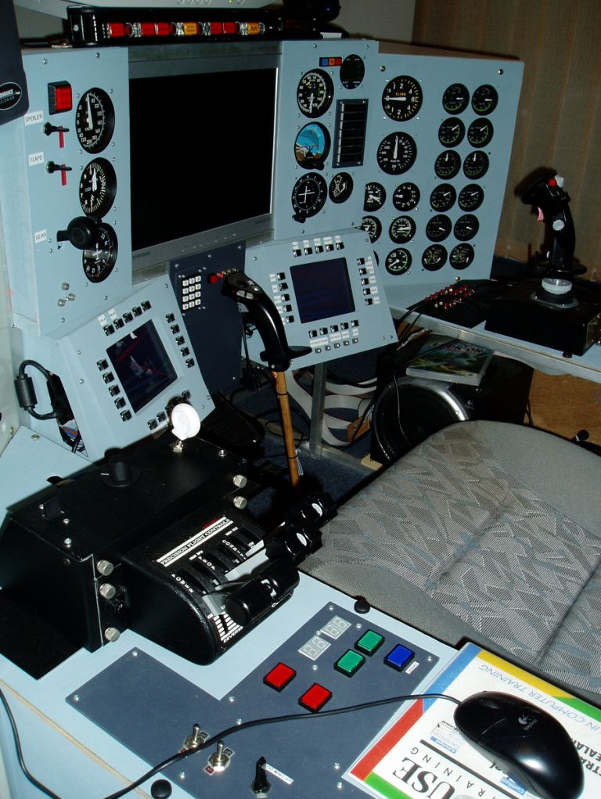

Figure 57

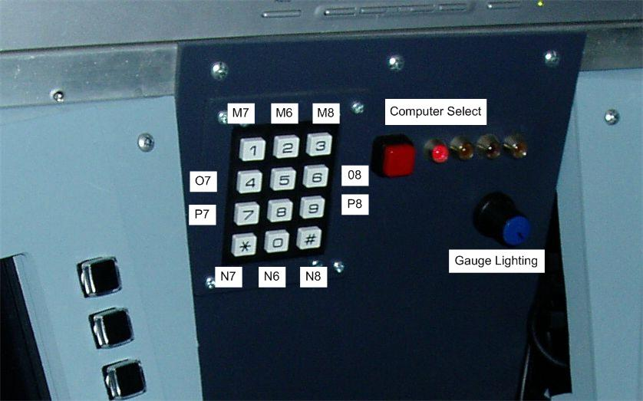

Figure 58 Centre Mid Panel Key Maps

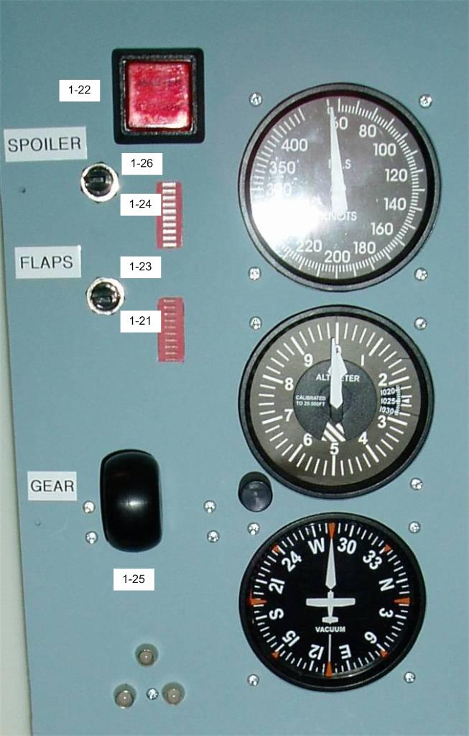

Figure 59 Front Left Panel Key Maps

The Gear lever was hijacked from my Goflight module.

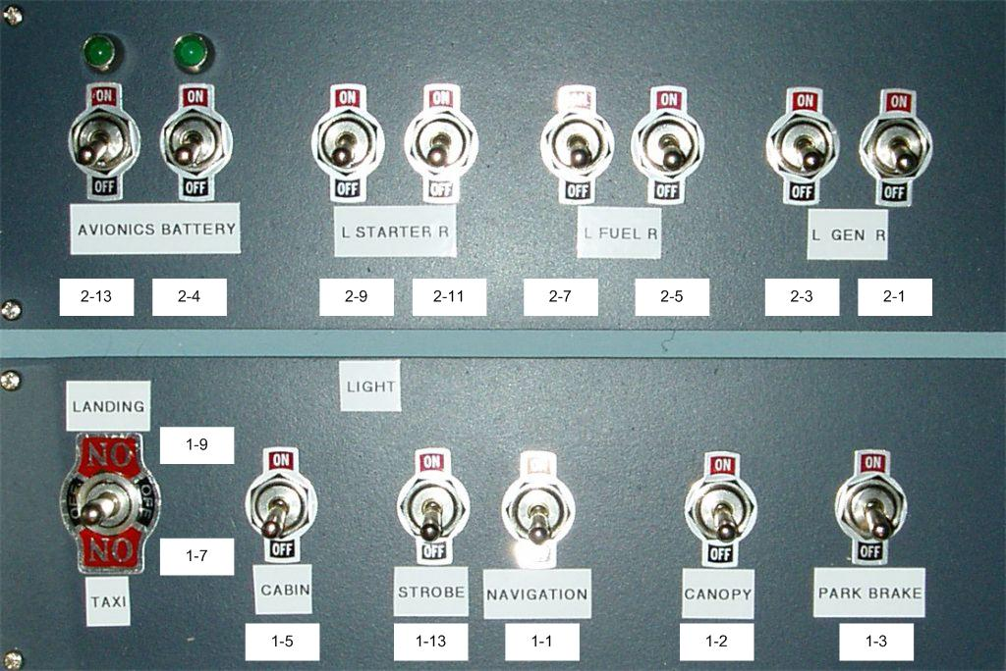

Figure 60 Avionics Key Maps

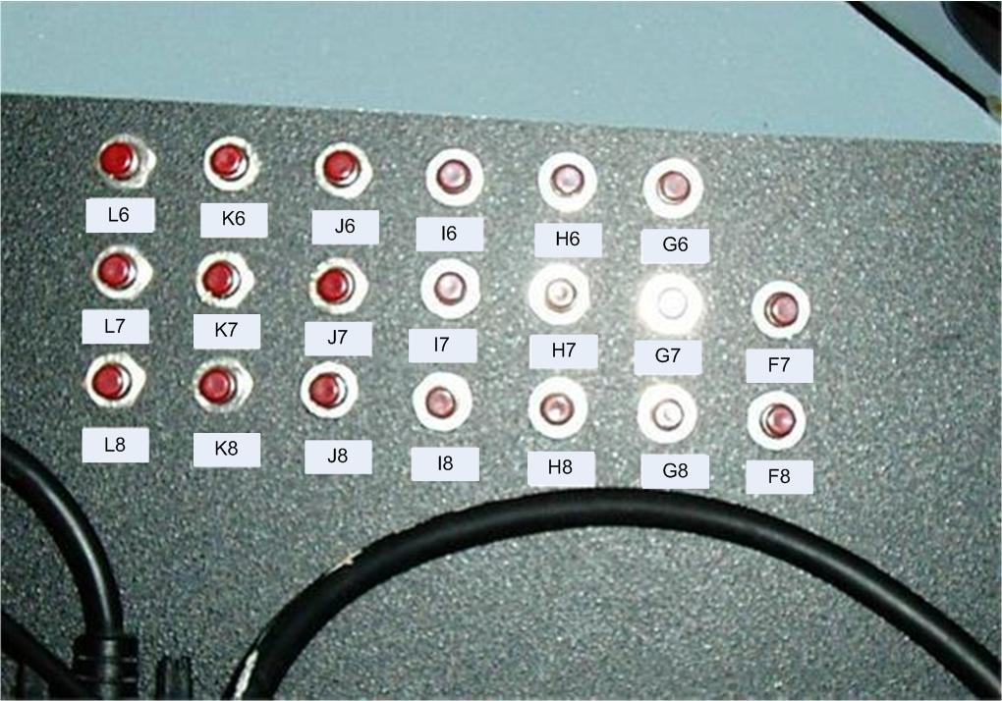

Figure 61 Toggle Panel Key Maps

This panel has been built to deal with simulators that only offer a toggle action keystroke. For example Lights-On and Lights-Off all too often maps to a single keystroke such as ‘L’. If the toggle switch is in the incorrect position at the start of the simulation, then toggling the switch will turn the lights on and off, but the switch will always be in the wrong position. The array of smaller push buttons is there to deal with this challenge. Basically the smaller buttons map to a toggle switch, so it a toggle switch is in the incorrect position, press the smaller button to toggle the action.

Ultimately this problem should be resolved by the simulator offering toggle keystrokes for all actions, much like Falcon 4 has done.

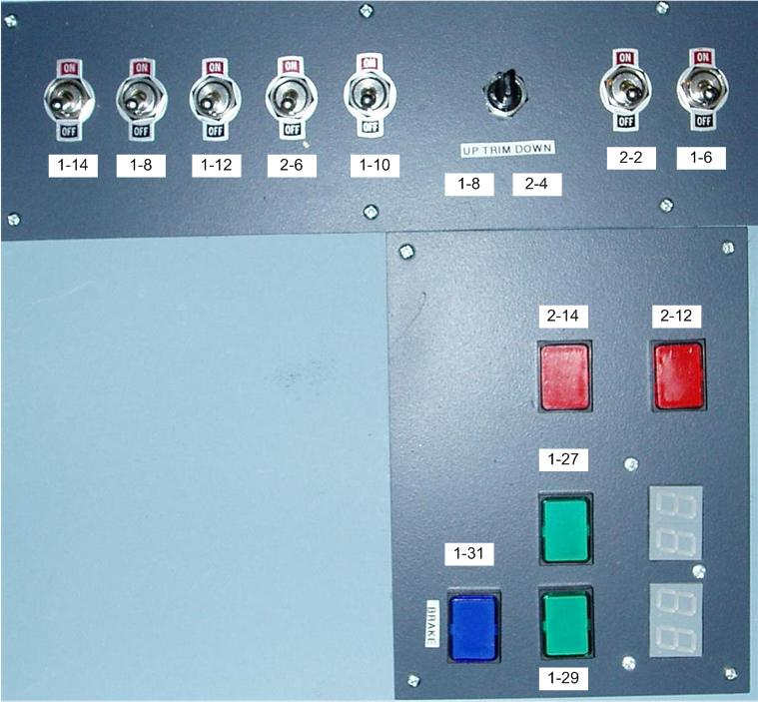

Figure 62 Flare Chaff Panel Key Maps

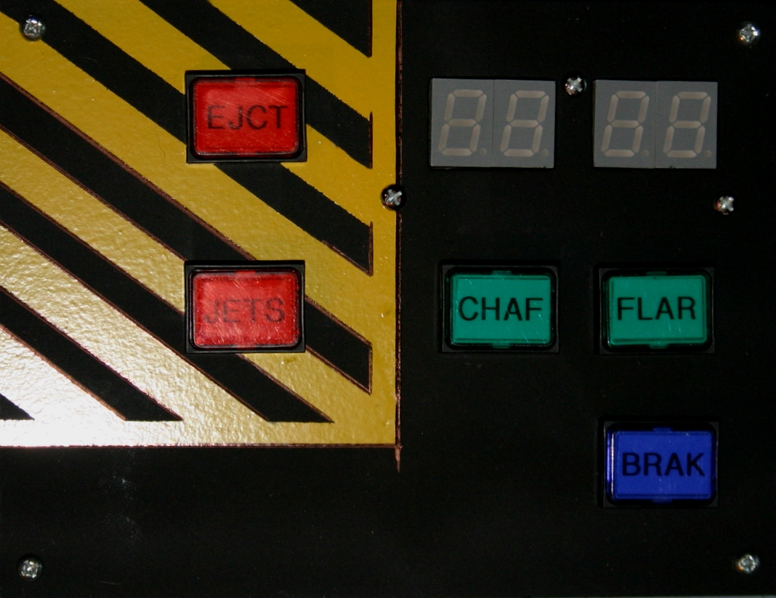

Figure 63 Updated Chaff Flare Panel

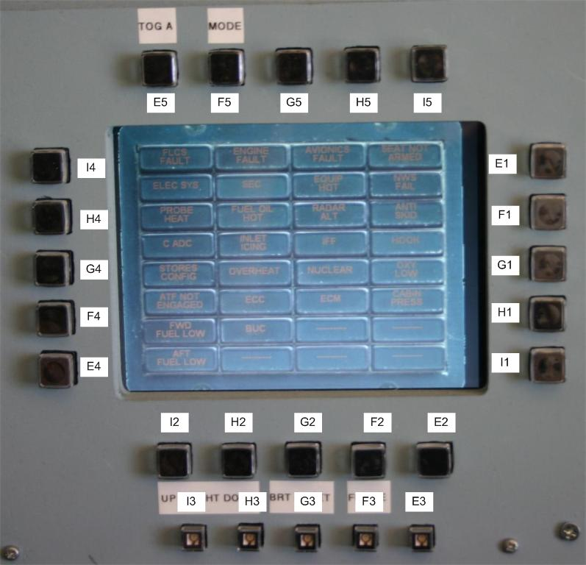

Figure 64 Left MFD Key Maps – to be updated

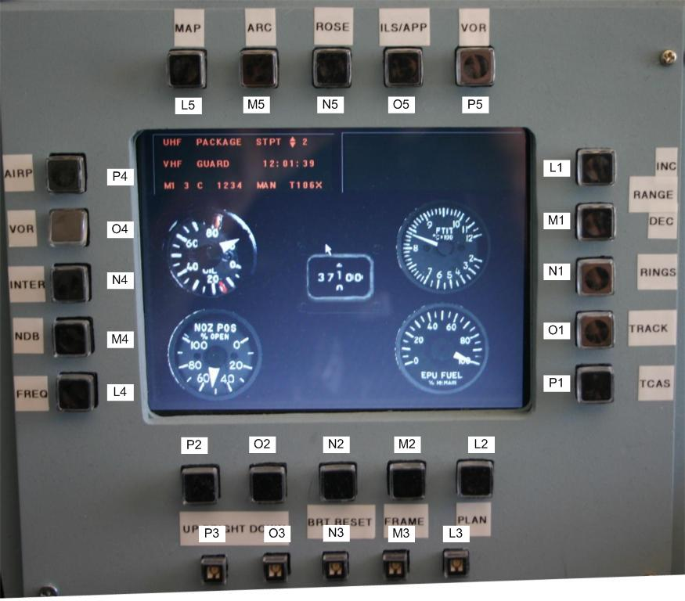

Figure 65 Right MFD Key Maps

## ICP

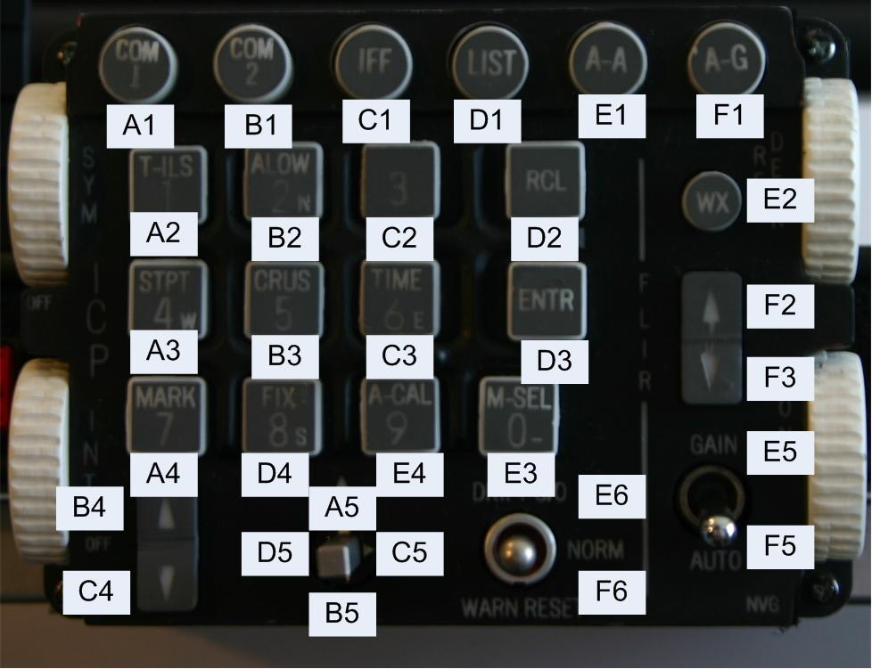

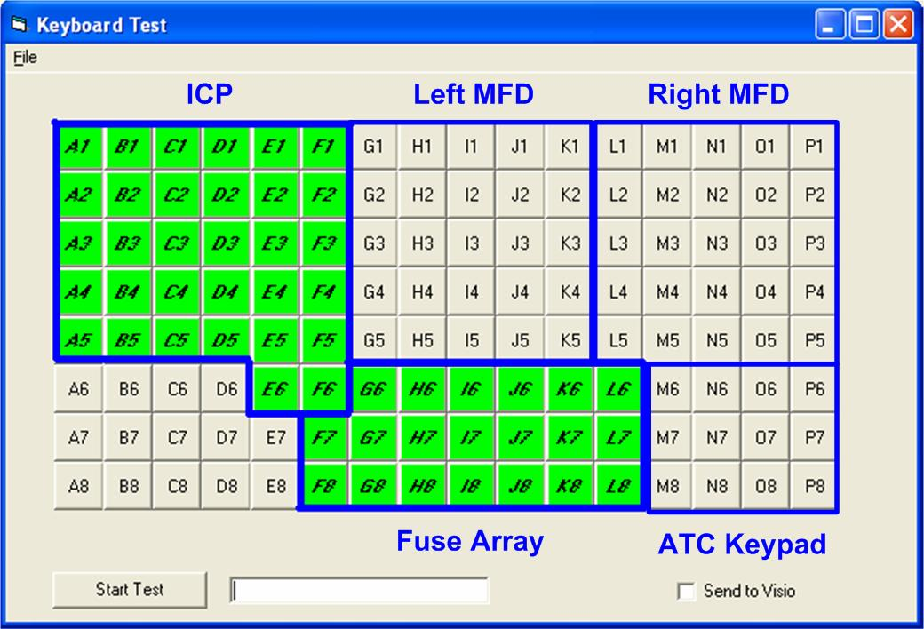

Mike (Kabar03) and Jay (Crease-Guard) from Viperpit have put together a very nice ICP.

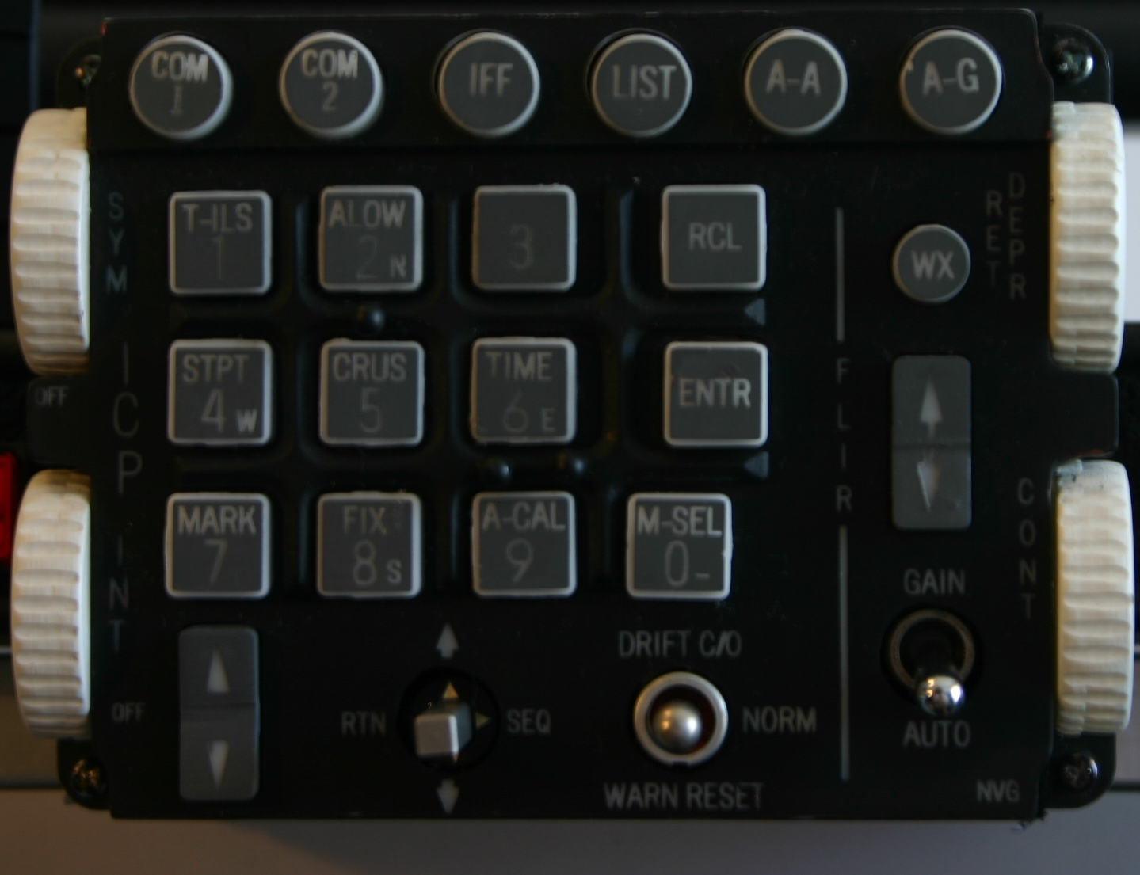

It also is backlit, does require 24V, so I added an adjustable plug-pack from Dick Smith Electronics.

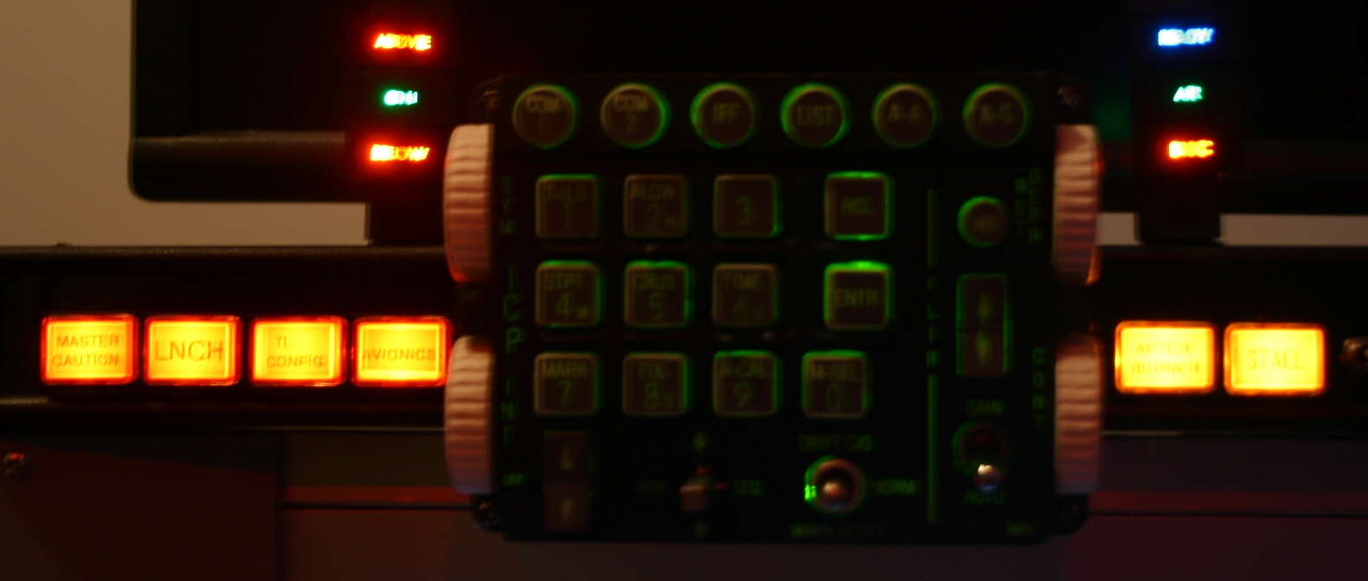

I had been searching for some toggle switches that didn’t look or feel cheap. These can be found at Allied Electronics ([www.AlliedElec.com](http://www.AlliedElec.com/)). The switch models I’m using include:

* 676-3240 7101TZQE
* 676-3245 7103TZQE
* 676-3250 7105TZQE

# Button Mappings

|  |  |  |  |  |
| --- | --- | --- | --- | --- |
| Description | Tag | FS2004 | F4 | LOMAC |

|  |  |  |  |  |
| --- | --- | --- | --- | --- |
|  |  |  |  |  |

|  |
| --- |
| File Names |

|  |  |  |  |  |
| --- | --- | --- | --- | --- |
| X-Keys Macroworks |  |  |  |  |

|  |  |  |  |  |
| --- | --- | --- | --- | --- |
| Plasma Keyboard Studio |  | New Config.ksc |  |  |

|  |  |  |  |  |
| --- | --- | --- | --- | --- |
|  |  |  |  |  |

|  |
| --- |
| Top Left Hand |

|  |  |  |  |  |
| --- | --- | --- | --- | --- |
| Master Warning | 1-22 |  |  | Shift-N |

|  |  |  |  |  |
| --- | --- | --- | --- | --- |
| Spoiler Up | 1-26 | Shift-Ctrl-Z |  | Ctrl-B |

|  |  |  |  |  |
| --- | --- | --- | --- | --- |
| Spoiler Down | 1-24 | Shift-Ctrl-X |  | Shift-B |

|  |  |  |  |  |
| --- | --- | --- | --- | --- |
| Flaps Up | 1-23 | F8 |  | Ctrl-F |

|  |  |  |  |  |
| --- | --- | --- | --- | --- |
| Flaps Down | 1-21 | F7 |  | Shift-F |

|  |  |  |  |  |
| --- | --- | --- | --- | --- |
| Gear | 1-25 Press | Ctrl-G |  | Ctrl-G |

|  |  |  |  |  |
| --- | --- | --- | --- | --- |
|  | Release | Shift-G |  | Shit-G |

|  |  |  |  |  |
| --- | --- | --- | --- | --- |
|  |  |  |  |  |

|  |
| --- |
| ICP |

|  |  |  |  |  |
| --- | --- | --- | --- | --- |
| COM1 | A1 |  |  |  |

|  |  |  |  |  |
| --- | --- | --- | --- | --- |
| COM2 | B1 |  |  |  |

|  |  |  |  |  |
| --- | --- | --- | --- | --- |
| IFF | C1 |  |  |  |

|  |  |  |  |  |
| --- | --- | --- | --- | --- |
| LIST | D1 |  |  |  |

|  |  |  |  |  |
| --- | --- | --- | --- | --- |
| A-A | E1 |  |  |  |

|  |  |  |  |  |
| --- | --- | --- | --- | --- |
| A-G | F1 |  |  |  |

|  |  |  |  |  |
| --- | --- | --- | --- | --- |
| 1 T-ILS | A2 |  |  |  |

|  |  |  |  |  |
| --- | --- | --- | --- | --- |
| 2 ALLOW | B2 |  |  |  |

|  |  |  |  |  |
| --- | --- | --- | --- | --- |
| 3 | C2 |  |  |  |

|  |  |  |  |  |
| --- | --- | --- | --- | --- |
| RCL | D2 |  |  |  |

|  |  |  |  |  |
| --- | --- | --- | --- | --- |
| 4 STPT | A3 |  |  |  |

|  |  |  |  |  |
| --- | --- | --- | --- | --- |
| 5 CRUS | B3 |  |  |  |

|  |  |  |  |  |
| --- | --- | --- | --- | --- |
| 6 TIME | C3 |  |  |  |

|  |  |  |  |  |
| --- | --- | --- | --- | --- |
| ENTR | D3 |  |  |  |

|  |  |  |  |  |
| --- | --- | --- | --- | --- |
| 7 MARK | A4 |  |  |  |

|  |  |  |  |  |
| --- | --- | --- | --- | --- |
| 8 FIX | D4 |  |  |  |

|  |  |  |  |  |
| --- | --- | --- | --- | --- |
| 9 A-CAL | E4 |  |  |  |

|  |  |  |  |  |
| --- | --- | --- | --- | --- |
| 0 M-SEL | E3 |  |  |  |

|  |  |  |  |  |
| --- | --- | --- | --- | --- |
| WX | E2 |  |  |  |

|  |  |  |  |  |
| --- | --- | --- | --- | --- |
| FLIR UP | F2 |  |  |  |

|  |  |  |  |  |
| --- | --- | --- | --- | --- |
| FLIR DOWN | F3 |  |  |  |

|  |  |  |  |  |
| --- | --- | --- | --- | --- |
| GAIN | E5 |  |  |  |

|  |  |  |  |  |
| --- | --- | --- | --- | --- |
| AUTO | F5 |  |  |  |

|  |  |  |  |  |
| --- | --- | --- | --- | --- |
| DRIFT C/0 | E6 |  |  |  |

|  |  |  |  |  |
| --- | --- | --- | --- | --- |
| WARN RESET | F6 |  |  |  |

|  |  |  |  |  |
| --- | --- | --- | --- | --- |
| OTTO-UP | A5 |  |  |  |

|  |  |  |  |  |
| --- | --- | --- | --- | --- |
| OTTO-DN | B5 |  |  |  |

|  |  |  |  |  |
| --- | --- | --- | --- | --- |
| OTTO-SEQ | C5 |  |  |  |

|  |  |  |  |  |
| --- | --- | --- | --- | --- |
| OTTO-RTN | D5 |  |  |  |

|  |  |  |  |  |
| --- | --- | --- | --- | --- |
| INT-UP | B4 |  |  |  |

|  |  |  |  |  |
| --- | --- | --- | --- | --- |
| INT-DOWN | C4 |  |  |  |

|  |  |  |  |  |
| --- | --- | --- | --- | --- |
| All Warning Buttons | F4 |  |  |  |

|  |  |  |  |  |
| --- | --- | --- | --- | --- |
|  |  |  |  |  |

|  |
| --- |
| Bottom Middle Keypad |

|  |  |  |  |  |
| --- | --- | --- | --- | --- |
| 1 | M7 | 1 |  | 1 |

|  |  |  |  |  |
| --- | --- | --- | --- | --- |
| 2 | M6 | 2 |  | 2 |

|  |  |  |  |  |
| --- | --- | --- | --- | --- |
| 3 | M8 | 3 |  | 3 |

|  |  |  |  |  |
| --- | --- | --- | --- | --- |
| 4 | 07 | 4 |  | 4 |

|  |  |  |  |  |
| --- | --- | --- | --- | --- |
| 5 | O6 | 5 |  | 5 |

|  |  |  |  |  |
| --- | --- | --- | --- | --- |
| 6 | O8 | 6 |  | 6 |

|  |  |  |  |  |
| --- | --- | --- | --- | --- |
| 7 | P7 | 7 |  | 7 |

|  |  |  |  |  |
| --- | --- | --- | --- | --- |
| 8 | P6 | 8 |  | 8 |

|  |  |  |  |  |
| --- | --- | --- | --- | --- |
| 9 | P8 | 9 |  | 9 |

|  |  |  |  |  |
| --- | --- | --- | --- | --- |
| 0 | N6 | 0 |  | 0 |

|  |  |  |  |  |
| --- | --- | --- | --- | --- |
| * | N7 |  |  |  |

|  |  |  |  |  |
| --- | --- | --- | --- | --- |
| # | N8 |  |  |  |

|  |  |  |  |  |
| --- | --- | --- | --- | --- |
|  |  |  |  |  |

|  |
| --- |
| Far Right |

|  |  |  |  |  |
| --- | --- | --- | --- | --- |
| Avionics | 2-13 Press | Ctrl-K |  | Shift-L |

|  |  |  |  |  |
| --- | --- | --- | --- | --- |
|  | Release | Ctrl-K |  |  |

|  |  |  |  |  |
| --- | --- | --- | --- | --- |
| Battery | 2-4 Press | Shift-M |  | Shift-L |

|  |  |  |  |  |
| --- | --- | --- | --- | --- |
|  |  | Shift-M |  |  |

|  |  |  |  |  |
| --- | --- | --- | --- | --- |
| L-Starter | 2-9 Press | Ctrl-Shift-M |  | RWin-Alt-Home |

|  |  |  |  |  |
| --- | --- | --- | --- | --- |
|  | Release | Ctrl-Shift-M |  |  |

|  |  |  |  |  |
| --- | --- | --- | --- | --- |
| R-Starter | 2-11 Press | Shift-Ctrl-, |  | RWin-Shift-Home |

|  |  |  |  |  |
| --- | --- | --- | --- | --- |
|  | Release | Shift-Ctrl-, |  |  |

|  |  |  |  |  |
| --- | --- | --- | --- | --- |
| L-Fuel | 2-7 Press | Shift-Ctrl-. |  | RWin-Alt-End |

|  |  |  |  |  |
| --- | --- | --- | --- | --- |
|  | Release | Shift-Ctrl-. |  |  |

|  |  |  |  |  |
| --- | --- | --- | --- | --- |
| R-Fuel | 2-5 Press | Shift-Ctrl-/ |  |  |

|  |  |  |  |  |
| --- | --- | --- | --- | --- |
|  | Release | Shift-Ctrl-/ |  |  |

|  |  |  |  |  |
| --- | --- | --- | --- | --- |
| L-Gen | 2-3 Press | Shift-Ctrl-[ |  | N/A |

|  |  |  |  |  |
| --- | --- | --- | --- | --- |
|  | Release | Shift-Ctrl-[ |  |  |

|  |  |  |  |  |
| --- | --- | --- | --- | --- |
| R-Gen | 2-1 Press | Shift-Ctrl-T |  | N/A |

|  |  |  |  |  |
| --- | --- | --- | --- | --- |
|  | Release | Shift-Ctrl-T |  |  |

|  |  |  |  |  |
| --- | --- | --- | --- | --- |
| Landing-Lights | 1-9 Press | Ctrl-L |  | Alt-L |

|  |  |  |  |  |
| --- | --- | --- | --- | --- |
|  | Release | Ctrl-L |  | Alt-L |

|  |  |  |  |  |
| --- | --- | --- | --- | --- |
| Taxi-Lights | 1-7 Press | Shift-Ctrl-N |  | Alt-L |

|  |  |  |  |  |
| --- | --- | --- | --- | --- |
|  | Release | Shift-Ctrl-N |  | Alt-L |

|  |  |  |  |  |
| --- | --- | --- | --- | --- |
| Cabin-Lights | 1-5 Press | Shift-L |  | L |

|  |  |  |  |  |
| --- | --- | --- | --- | --- |
|  | Release | Shift-L |  | L |

|  |  |  |  |  |
| --- | --- | --- | --- | --- |
| Strobe-Lights | 1-13 Press | O |  | N/A |

|  |  |  |  |  |
| --- | --- | --- | --- | --- |
|  | Release | O |  | N/A |

|  |  |  |  |  |
| --- | --- | --- | --- | --- |
| Navigation-Lights | 1-1 Press | Shift-Ctrl-F |  | N/A |

|  |  |  |  |  |
| --- | --- | --- | --- | --- |
|  | Release | Shift-Ctrl-F |  | N/A |

|  |  |  |  |  |
| --- | --- | --- | --- | --- |
| Canopy | 1-2 Press | Shift-E 1 |  | Ctrl-C |

|  |  |  |  |  |
| --- | --- | --- | --- | --- |
|  | Release | Shift-E 1 |  | Ctrl-C |

|  |  |  |  |  |
| --- | --- | --- | --- | --- |
| Parking-Brake | 1-3 Press | Ctl-. |  |  |

|  |  |  |  |  |
| --- | --- | --- | --- | --- |
|  | Release | . |  |  |

|  |  |  |  |  |
| --- | --- | --- | --- | --- |
|  |  |  |  |  |

|  |
| --- |
| Toggle Array |

|  |  |  |  |  |
| --- | --- | --- | --- | --- |
| Gear - Tog | L6 |  |  | G |

|  |  |  |  |  |
| --- | --- | --- | --- | --- |
| Parkbrake - Tog | K6 |  |  |  |

|  |  |  |  |  |
| --- | --- | --- | --- | --- |
| Canopy - Tog | J6 |  |  | Ctrl-C |

|  |  |  |  |  |
| --- | --- | --- | --- | --- |
| Land-L - Tog | I6 |  |  | Alt-L |

|  |  |  |  |  |
| --- | --- | --- | --- | --- |
| Taxi-L - Tog | H6 |  |  | Alt-L |

|  |  |  |  |  |
| --- | --- | --- | --- | --- |
| Cabin-L - Tog | G6 |  |  | L |

|  |  |  |  |  |
| --- | --- | --- | --- | --- |
| Avionics - Tog | L7 |  |  | Shift-L |

|  |  |  |  |  |
| --- | --- | --- | --- | --- |
| Battery - Tog | K7 |  |  | Shift-L |

|  |  |  |  |  |
| --- | --- | --- | --- | --- |
| L-Starter - Tog | J7 |  |  |  |

|  |  |  |  |  |
| --- | --- | --- | --- | --- |
| R-Starter - Tog | I7 |  |  |  |

|  |  |  |  |  |
| --- | --- | --- | --- | --- |
| L-Fuel-V -Tog | H7 |  |  |  |

|  |  |  |  |  |
| --- | --- | --- | --- | --- |
| R-Fuel-V - Tog | G7 |  |  |  |

|  |  |  |  |  |
| --- | --- | --- | --- | --- |
|  | F7 |  |  |  |

|  |  |  |  |  |
| --- | --- | --- | --- | --- |
| L-Gen - Tog | L8 |  |  |  |

|  |  |  |  |  |
| --- | --- | --- | --- | --- |
| R-Gen - Tog | K8 |  |  |  |

|  |  |  |  |  |
| --- | --- | --- | --- | --- |
| Nav-L - Tog | J8 |  |  | L |

|  |  |  |  |  |
| --- | --- | --- | --- | --- |
| Strobe-L - Tog | I8 |  |  |  |

|  |  |  |  |  |
| --- | --- | --- | --- | --- |
| Autopilot – Tog | H8 |  |  | A |

|  |  |  |  |  |
| --- | --- | --- | --- | --- |
|  | G8 |  |  |  |

|  |  |  |  |  |
| --- | --- | --- | --- | --- |
|  | F8 |  |  |  |

|  |  |  |  |  |
| --- | --- | --- | --- | --- |
|  |  |  |  |  |

|  |
| --- |
| Bottom Left |

|  |  |  |  |  |
| --- | --- | --- | --- | --- |
| Master Arm | 1-14 |  |  | Alt-Space |

|  |  |  |  |  |
| --- | --- | --- | --- | --- |
| Record Track | 1-8 |  |  | Ctrl-R |

|  |  |  |  |  |
| --- | --- | --- | --- | --- |
| Smoke | 1-12 |  |  | T |

|  |  |  |  |  |
| --- | --- | --- | --- | --- |
|  | 2-6 |  |  |  |

|  |  |  |  |  |
| --- | --- | --- | --- | --- |
|  | 1-10 |  |  |  |

|  |  |  |  |  |
| --- | --- | --- | --- | --- |
| Trim Up | 1-8 |  |  | Ctrl-; |

|  |  |  |  |  |
| --- | --- | --- | --- | --- |
| Trim Down | 2-4 |  |  | Ctrl. |

|  |  |  |  |  |
| --- | --- | --- | --- | --- |
| Trim Reset | 2-2 |  |  | Ctrl-T |

|  |  |  |  |  |
| --- | --- | --- | --- | --- |
| Autopilot | 1-6 |  |  | A |

|  |  |  |  |  |
| --- | --- | --- | --- | --- |
|  |  |  |  |  |

|  |
| --- |
| Chaff Flare |

|  |  |  |  |  |
| --- | --- | --- | --- | --- |
| Dump Ext Stores | 2-12 |  |  | Ctrl-W Alt-R |

|  |  |  |  |  |
| --- | --- | --- | --- | --- |
| Eject | 2-14 |  |  | Ctrl-E-E-E |

|  |  |  |  |  |
| --- | --- | --- | --- | --- |
| Chaff | 1-27 |  |  | Insert |

|  |  |  |  |  |
| --- | --- | --- | --- | --- |
| Flare | 1-29 |  |  | Delete |

|  |  |  |  |  |
| --- | --- | --- | --- | --- |
| Ground Brakes | 1-31 |  |  | W |

|  |  |  |  |  |
| --- | --- | --- | --- | --- |
|  |  |  |  |  |

# Key layout summary

When assigning keys to panels, I’ve tried to keep them in groups. This reduces ‘orphaned’ keycodes and makes allocation for new modules much easier.

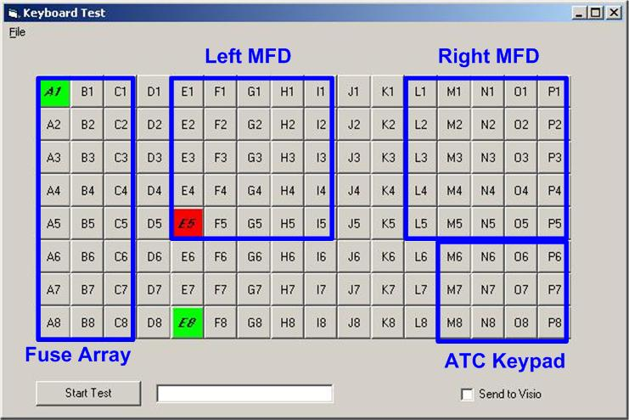

# Xkeys Pinouts

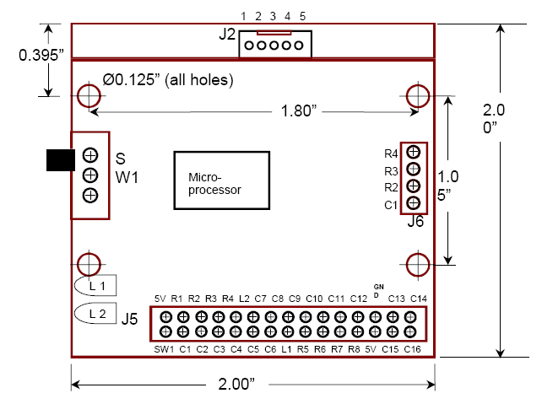

Switch Matrix Header Connection

|  |  |
| --- | --- |
| 1 SW1 Programming Switch | 16 C14 Column 14 of the matrix |

|  |  |
| --- | --- |
| 2 C1 Column 1 of the matrix | 17 C13 Column 13 of the matrix |

|  |  |
| --- | --- |
| 3 C2 Column 2 of the matrix | 18 GND Ground |

|  |  |
| --- | --- |
| 4 C3 Column 3 of the matrix | 19 C12 Column 12 of the matrix |

|  |  |
| --- | --- |
| 5 C4 Column 4 of the matrix | 20 C11 Column 11 of the matrix |

|  |  |
| --- | --- |
| 6 C5 Column 5 of the matrix | 21 C10 Column 10 of the matrix |

|  |  |
| --- | --- |
| 7 C6 Column 6 of the matrix | 22 C9 Column 9 of the matrix |

|  |  |
| --- | --- |
| 8 L2 LED 2 (red layer indicator) | 23 C8 Column 8 of the matrix |

|  |  |
| --- | --- |
| 9 R5 Row 5 of the matrix | 24 C7 Column 7 of the matrix |

|  |  |
| --- | --- |
| 10 R6 Row 6 of the matrix | 25 L1 LED 1 (Green Layer Indicator) |

|  |  |
| --- | --- |
| 11 R7 Row 7 of the matrix | 26 R4 Row 4 of the matrix |

|  |  |
| --- | --- |
| 12 R8 Row 8 of the matrix | 27 R3 Row 3 of the matrix |

|  |  |
| --- | --- |
| 13 5V 5 Volt Source (provided by USB connection) | 28 R2 Row 2 of the matrix |

|  |  |
| --- | --- |
| 14 C15 Column 15 of the matrix | 29 R1 Row 1 of the matrix |

|  |  |
| --- | --- |
| 15 C16 Column 16 of the matrix | 30 5V 5 Volt source (from USB connection) |

|  |  |
| --- | --- |
|  |  |

## Key Labels for the Button Array

The role of the button is primarily to act as a ‘toggle farm’ should a physical toggle switch start in an incorrect position. The following table was printed, laminated, sliced and then held in position using the switch nuts.

|  |  |  |  |  |  |  |
| --- | --- | --- | --- | --- | --- | --- |
| Gear | ParkBrake | Canopy | Land-L | Taxi-L | Cabin-L |  |

|  |  |  |  |  |  |  |
| --- | --- | --- | --- | --- | --- | --- |
| Avionics | Battery | L-Starter | R-Starter | L-Fuel-V | R-Fuel-V |  |

|  |  |  |  |  |  |  |
| --- | --- | --- | --- | --- | --- | --- |
| L-Gen | R-Gen | Nav-L | Strobe-L |  |  |  |

The table width was permanently set to 14.1CM (which maps to a column width of 1.96cm), and the columns evenly spaced using Table – Autofit – Distribute Columns evenly.

# LEDs and Lights

Phidget LED and I/O devices control the cockpit lights, leds, and servos. These devices are driven by Visual Basic.

|  |  |  |
| --- | --- | --- |
| Phidget | Serial Number | Version |

|  |  |  |
| --- | --- | --- |
| Phidget I/O 16 | 2375 | 6 |

|  |  |  |
| --- | --- | --- |
|  | 2377 | 6 |

|  |  |  |
| --- | --- | --- |
| Phidget Led | 10860 | 2 |

|  |  |  |
| --- | --- | --- |
|  | 2300 | 1.01 |

|  |  |  |
| --- | --- | --- |
| Servo | 1170 | 3 |

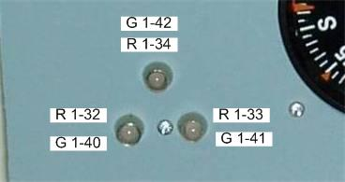

Figure 66 Landing Gear LEDs

The three gear indicators are multi-color, Green, Red, and Yellow. Whilst not necessarily totally realistic, I indicate Yellow for when each of the wheels are in transit, and Green for fully locked down. Red is not used. Both FS2004 and Falcon 4 indicate gear position in degrees, enabling you to determine whether the gear is up, down, or in transit.

There is a trick to driving multi-color Leds from PhidgetLed, they need to run off opposite sides of a ‘common bus’. For my unit you’ll see they are eight ports apart. You cannot connect the legs of the led to sequential ports.

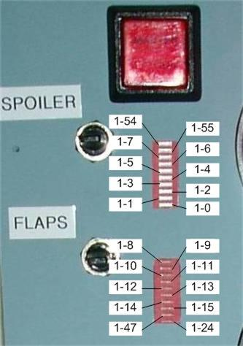

Figure 67 Front Left Panel

The front left panel has two bargraphs that indicate Airbrake and Flap positions.

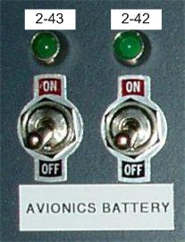

Figure 68 Avionics Panel

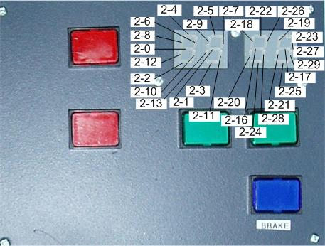

Figure 69 Chaff and Flare Panel

When building the chaff and flare panel I did make the mistake of assuming the leds needed to be common Anode… only to find they need to be common Cathode (or vice-versa..need to check).

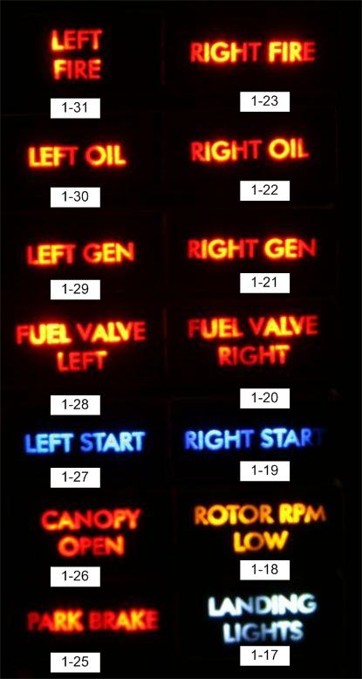

Figure 70 Led Numbering for warning panel

|  |  |  |
| --- | --- | --- |
| Port | I/O Card 1 | I/O Card 2 |

|  |  |  |
| --- | --- | --- |
| 0 | Unused |  |

|  |  |  |
| --- | --- | --- |
| 1 | Backlight (all on including ICP) |  |

|  |  |  |
| --- | --- | --- |
| 2 | Unused | ICP Backlight |

|  |  |  |
| --- | --- | --- |
| 3 | Backlight for Simkits Gauges | Master Caution (EB) |

|  |  |  |
| --- | --- | --- |
| 4 | Unused | Inner Marker |

|  |  |  |
| --- | --- | --- |
| 5 | Unused | Outer Marker |

|  |  |  |
| --- | --- | --- |
| 6 | Unused | Middle Marker |

|  |  |  |
| --- | --- | --- |
| 7 | Master Caution Left Panel |  |

|  |  |  |
| --- | --- | --- |
| 8 | Cockpit Light (bulb) |  |

|  |  |  |
| --- | --- | --- |
| 9 | Navigation Lights (left and right) | T/L Config (EB) |

|  |  |  |
| --- | --- | --- |
| 10 | Unused | After Burner (EB) |

|  |  |  |
| --- | --- | --- |
| 11 | Unused | Avionics (EB) |

|  |  |  |
| --- | --- | --- |
| 12 | Unused |  |

|  |  |  |
| --- | --- | --- |
| 13 | Unused | Launch (EB) |

|  |  |  |
| --- | --- | --- |
| 14 | Unused |  |

|  |  |  |
| --- | --- | --- |
| 15 | Unused | Stall (EB) |

|  |  |  |
| --- | --- | --- |
|  |  |  |

|  |  |  |
| --- | --- | --- |
| Port | Phidget Led 1 | Phidget Led 2 |

|  |  |  |
| --- | --- | --- |
| 0 | Spoiler - 10 | Chaff Seven Segment |

|  |  |  |
| --- | --- | --- |
| 1 | Spoiler – 9 | Chaff Seven Segment |

|  |  |  |
| --- | --- | --- |
| 2 | Spoiler – 8 | Chaff Seven Segment |

|  |  |  |
| --- | --- | --- |
| 3 | Spoiler – 7 | Chaff Seven Segment |

|  |  |  |
| --- | --- | --- |
| 4 | Spoiler – 6 | Chaff Seven Segment |

|  |  |  |
| --- | --- | --- |
| 5 | Spoiler – 5 | Chaff Seven Segment |

|  |  |  |
| --- | --- | --- |
| 6 | Spoiler – 4 | Chaff Seven Segment |

|  |  |  |
| --- | --- | --- |
| 7 | Spoiler – 3 | Chaff Seven Segment |

|  |  |  |
| --- | --- | --- |
| 8 | Flaps – 1 | Chaff Seven Segment |

|  |  |  |
| --- | --- | --- |
| 9 | Flaps – 2 | Chaff Seven Segment |

|  |  |  |
| --- | --- | --- |
| 10 | Flaps – 3 | Chaff Seven Segment |

|  |  |  |
| --- | --- | --- |
| 11 | Flaps – 4 | Chaff Seven Segment |

|  |  |  |
| --- | --- | --- |
| 12 | Flaps – 5 | Chaff Seven Segment |

|  |  |  |
| --- | --- | --- |
| 13 | Flaps – 6 | Chaff Seven Segment |

|  |  |  |
| --- | --- | --- |
| 14 | Flaps – 7 |  |

|  |  |  |
| --- | --- | --- |
| 15 | Flaps – 8 |  |

|  |  |  |
| --- | --- | --- |
| 16 |  | Flare Seven Segment |

|  |  |  |
| --- | --- | --- |
| 17 | Warn – Landing Lights | Flare Seven Segment |

|  |  |  |
| --- | --- | --- |
| 18 | Warn – Rotor RPM Low | Flare Seven Segment |

|  |  |  |
| --- | --- | --- |
| 19 | Warn – Right Start | Flare Seven Segment |

|  |  |  |
| --- | --- | --- |
| 20 | Warn – Fuel Valve Right | Flare Seven Segment |

|  |  |  |
| --- | --- | --- |
| 21 | Warn – Right Gen | Flare Seven Segment |

|  |  |  |
| --- | --- | --- |
| 22 | Warn – Right Oil | Flare Seven Segment |

|  |  |  |
| --- | --- | --- |
| 23 | Warn – Right Fire | Flare Seven Segment |

|  |  |  |
| --- | --- | --- |
| 24 | Flaps -10 | Flare Seven Segment |

|  |  |  |
| --- | --- | --- |
| 25 | Warn – Park Brake | Flare Seven Segment |

|  |  |  |
| --- | --- | --- |
| 26 | Warn – Canopy Open | Flare Seven Segment |

|  |  |  |
| --- | --- | --- |
| 27 | Warn – Left Start | Flare Seven Segment |

|  |  |  |
| --- | --- | --- |
| 28 | Warn – Fuel Valve Left | Flare Seven Segment |

|  |  |  |
| --- | --- | --- |
| 29 | Warn – Left Gen | Flare Seven Segment |

|  |  |  |
| --- | --- | --- |
| 30 | Warn – Left Oil |  |

|  |  |  |
| --- | --- | --- |
| 31 | Warn – Left Fire |  |

|  |  |  |
| --- | --- | --- |
| 32 | Gear – Left – Red |  |

|  |  |  |
| --- | --- | --- |
| 33 | Gear – Right – Red |  |

|  |  |  |
| --- | --- | --- |
| 34 | Gear – Top – Red |  |

|  |  |  |
| --- | --- | --- |
| 35 |  |  |

|  |  |  |
| --- | --- | --- |
| 36 |  |  |

|  |  |  |
| --- | --- | --- |
| 37 |  |  |

|  |  |  |
| --- | --- | --- |
| 38 |  |  |

|  |  |  |
| --- | --- | --- |
| 39 |  |  |

|  |  |  |
| --- | --- | --- |
| 40 | Gear – Left – Green |  |

|  |  |  |
| --- | --- | --- |
| 41 | Gear – Right - Green |  |

|  |  |  |
| --- | --- | --- |
| 42 | Gear – Top - Green | Battery |

|  |  |  |
| --- | --- | --- |
| 43 | Back-Leds Top Right | Avionics |

|  |  |  |
| --- | --- | --- |
| 44 | Back-Leds Top Left |  |

|  |  |  |
| --- | --- | --- |
| 45 | Back-Leds Top Mid Left |  |

|  |  |  |
| --- | --- | --- |
| 46 | Back-Leds Top Mid Right |  |

|  |  |  |
| --- | --- | --- |
| 47 | Flaps – 9 |  |

|  |  |  |
| --- | --- | --- |
| 48 |  |  |

|  |  |  |
| --- | --- | --- |
| 49 |  |  |

|  |  |  |
| --- | --- | --- |
| 50 |  |  |

|  |  |  |
| --- | --- | --- |
| 51 |  |  |

|  |  |  |
| --- | --- | --- |
| 52 |  |  |

|  |  |  |
| --- | --- | --- |
| 53 |  |  |

|  |  |  |
| --- | --- | --- |
| 54 | Spoiler – 1 |  |

|  |  |  |
| --- | --- | --- |
| 55 | Spoiler – 2 |  |

|  |  |  |
| --- | --- | --- |
| 56 | AOA-Above |  |

|  |  |  |
| --- | --- | --- |
| 57 | ICP-Disc |  |

|  |  |  |
| --- | --- | --- |
| 58 | ICP-AR/NWS |  |

|  |  |  |
| --- | --- | --- |
| 59 | ICP-Ready |  |

|  |  |  |
| --- | --- | --- |
| 60 | AOA-Below |  |

|  |  |  |
| --- | --- | --- |
| 61 | AOA-On |  |

|  |  |  |
| --- | --- | --- |
| 62 |  |  |

|  |  |  |
| --- | --- | --- |
| 63 | Strobe Light |  |

# Attitude Indicator Pinouts

Sourced form <http://members.chello.nl/m.waterloo/f4b-panel.html>

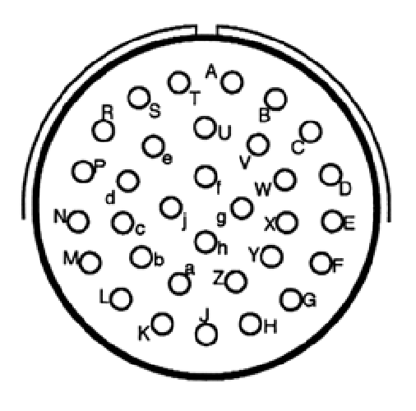

This is the Lear Siegler Inc. (Instrument Division, Grand Rapids, Michigan, USA) ARU-11/A Artificial Director Indicator (ADI). It is similar in appearance and electrical connections as the ID-1144/AJB-7 ADI. It sits in the center of the main panel and receives signals from remote units. The heading, pitch and roll can be moved using synchros when wired. Pin connections are: A=Ground, B=115 V- 400 Hz, F=Heading-x, G=Heading-y, H=Heading-z, J=Glide-slope-flag+, K=Glide-slope-flag-,

P=rate-gyroscope-power-warning-flag+, R= rate-gyroscope-power-warning-flag-,

S=glideslope-pointer+ , T=glideslope-pointer-,

U=vert-ptr-flag+, V=vert-ptr-flag-, W=horiz-ptr-, X=horiz-ptr+, Y=vert-ptr-, Z=vert-prt+, a=pitch-x, b=pitch-y, c=pitch-z, d=roll-x, e=roll-y, f=roll-z, g=lighting (5 V), h=lighting (GND), C,D,E,L,M,N and j not used.

# ICP Wiring Diagram

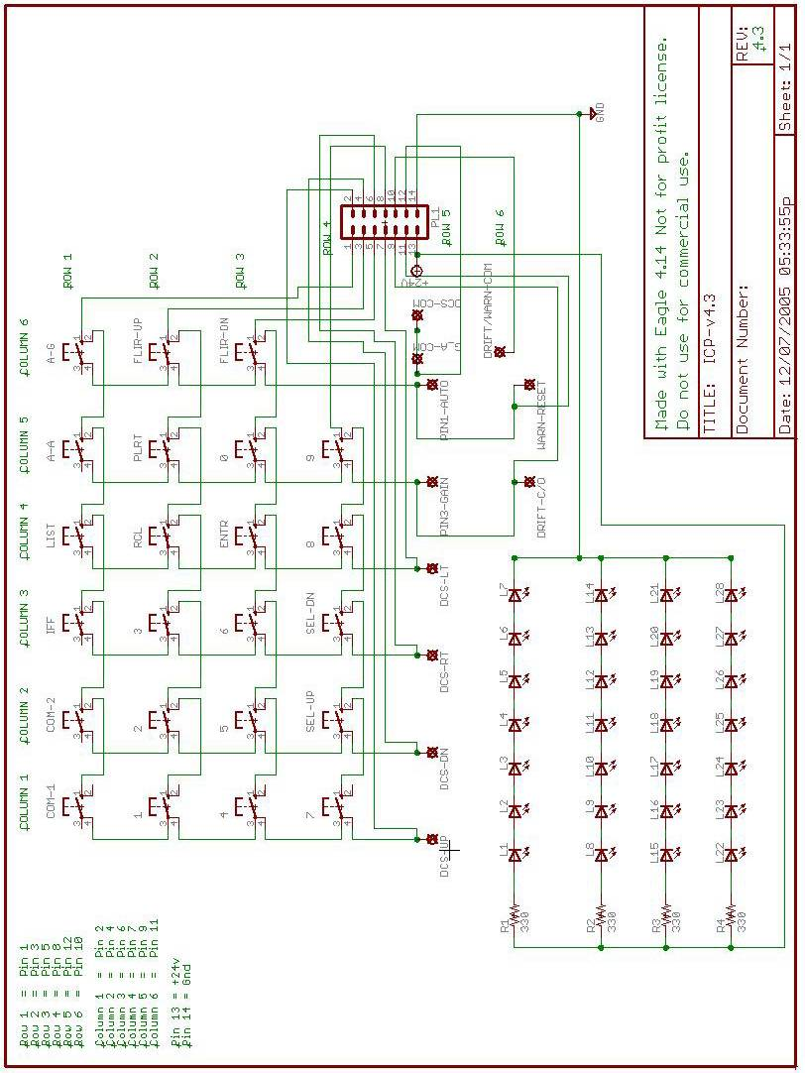

**LCD Writing Pseudo Code**

The Falcon 4 array is five lines of 26 characters. Given a null (chr(0)) is found at the end positions (25, 26, 51, 52, 77, 78, 103, 104, 129, 130) the effective line length is 24 characters.

.

## Read From shared Memory

Initialise LCD

Erase Static Array (i.e. set to space (30)

Write “Waiting for Falcon 4 startup” to line 2 of static array)

Attempt to open shared memory file for writing

If able to open then read each char from shared memory array

End if

***wrkstr = ""***

***bolFirstLineBlank = True***

***bolsecondLineBlank = True***

***bolThirdLineBlank = True***

***bolForthLineBlank = True***

***bolFifthLineBlank = True***

***For i = 1 To Len(F4_FF3_Data.DEDLines)***

***wrkchr = Mid(s, i, 1)***

***If wrkchr <> Chr(32) And wrkchr <> Chr(0) Then***

***Select Case i***

***Case 1 To 24***

***bolFirstLineBlank = False***

***Case 27 To 50***

***bolsecondLineBlank = False***

***Case 53 To 76***

***bolThirdLineBlank = False***

***Case 79 To 102***

***bolForthLineBlank = False***

***Case 105 To 128***

***bolFifthLineBlank = False***

***Case Else***

***' do nothing***

***End Select***

***End If***

***Next i***

***'If bolFirstLineBlank = False Then MsgBox "1st line has text"***

***'If bolsecondLineBlank = False Then MsgBox "2nd line has text"***

***'If bolThirdLineBlank = False Then MsgBox "3rd line has text"***

***'If bolForthLineBlank = False Then MsgBox "4th line has text"***

***'If bolFifthLineBlank = False Then MsgBox "5th line has text"***

***' Now need to make some decisions about what line gets drawn where***

***' First if the fifth line is blank then no smarts needed***

***' If the fifth line isn't blank then check to see if either***

***' the third or forth lines are blank***

***' if the forth line is blank then draw the fifth line there***

***' if the forth line isn't blank but the third is the draw line***

***' four on line three and line five on line four***

***WriteForthLineToThirdLine = False***

***WriteFifthLineToForthLine = False***

***If Not bolFifthLineBlank Then***

***If bolForthLineBlank Then***

***WriteFifthLineToForthLine = True***

***Else***

***If bolThirdLineBlank Then***

***WriteForthLineToThirdLine = True***

***WriteFifthLineToForthLine = True***

***End If***

***End If***

***End If***

***MsgBox "test mode"***

***'WriteForthLineToThirdLine = True***

***'WriteFifthLineToForthLine = True***

***' Draw the first two lines***

***' As the LCD only has 80 characters, blank it out***

***lcdlinelen = 25***

***F4DEDLineLen = 26***

***wrkstr = Space(130)***

***For i = 1 To 130***

***Select Case i***

***Case 25, 26, 51, 52, 77, 78, 103, 104, 129, 130***

***' Do nothing these are the end of lines with nulls***

***Case Else***

***' Work out what line we are drawing***

***LineBeingDrawn = Int((i - 1) / F4DEDLineLen)***

***wrkstrPos = lcdlinelen * LineBeingDrawn + i Mod F4DEDLineLen***

***' See if the characters or more right than the***

***' 20 characters we have on the 20*4 LCD***

***If i Mod F4DEDLineLen < lcdlinelen Then***

***' Remember Line Being Drawn starts at 0***

***If LineBeingDrawn = 2 And WriteForthLineToThirdLine Then***

***tmpstr = Mid(F4_FF3_Data.DEDLines, i + F4DEDLineLen, 1)***

***ElseIf LineBeingDrawn = 3 And WriteFifthLineToForthLine Then***

***tmpstr = Mid(F4_FF3_Data.DEDLines, i + F4DEDLineLen, 1)***

***Else***

***tmpstr = Mid(F4_FF3_Data.DEDLines, i, 1)***

***End If***

***' Where are we writing to***

***wrkstrPos = lcdlinelen * LineBeingDrawn + i Mod F4DEDLineLen***

***If tmpstr <> Chr(0) Then***

***Mid(wrkstr, wrkstrPos, 1) = tmpstr***

***Else***

***wrkstr = wrkstr & Chr(13)***

***' MsgBox "Null @ " & i***

***End If***

***End If***

***End Select***

***Next i***

***Text3.Text = Mid(wrkstr, 1, lcdlinelen) & Chr(13) & Chr(10) & _***

***Mid(wrkstr, lcdlinelen + 1, lcdlinelen) & Chr(13) & Chr(10) & _***

***Mid(wrkstr, 2 * lcdlinelen + 1, lcdlinelen) & Chr(13) & Chr(10) & _***

***Mid(wrkstr, 3 * lcdlinelen + 1, lcdlinelen) & Chr(13) & Chr(10) & _***

***Mid(wrkstr, 4 * lcdlinelen + 1, lcdlinelen) & Chr(13) & Chr(10)***

## Write from Shared Memory to LCD

If able to open file

For each character position that is less than position 78

If character at this position is different to that of the static array

Write new character to LCd

Update static array with new character

End if

Next character less than position 78

Set All_Characters_Blank_Flag

For each character than is between 78 and 104

If character is not blank then reset All_Characters_Blank_Flag

If character at this position is different to that of static

Next character between 78 and 104

If All_Characters_Blank_Flag is still true then lets copy the 5th line.

For each character on line 5

‘ then lets see if anything is not blank on line five

If character on line 5 is different to corresponding character on

Line 4 in the static array then

Write new character to LCD on line 4

Update Static Array on line 4

End character on line 5 is different

Next Character on line 5

End if All_Character_Blank_Flag is true

Else

Erase display

Write unable to connect to LCD Write routine

End if

# LCD Pinout for Graphical LCD

|  |  |  |  |
| --- | --- | --- | --- |
| ***Pin Number*** | ***Symbol*** | ***Level*** | ***Description*** |
| **1** | **DB7** | **H/L** | **Data bit 7** |
| **2** | **DB6** | **H/L** | **Data bit 6** |
| **3** | **DB5** | **H/L** | **Data bit 5** |
| **4** | **DB4** | **H/L** | **Data bit 4** |
| **5** | **DB3** | **H/L** | **Data bit 3** |
| **6** | **DB2** | **H/L** | **Data bit 2** |
| **7** | **DB1** | **H/L** | **Data bit 1** |
| **8** | **DB0** | **H/L** | **Data bit 0** |
| **9** | **E** | **H, H**→**L** | **H : Chip enable, H**→**L : Data write into or read from** |
| **10** | **R/W** | **H/L** | **Read/Write select signal** |
| **11** | **RS** | **H/L** | **Data (H) and command (L) register** |
| **12** | **VO** | **Var. V** | **Contrast adjustment by different voltage** |
| **13** | **VDD** | **5.0 V** | **Supply voltage for logic** |
| **14** | **VSS** | **0 V** | Ground |
| **15** | **CS2** | **H/L** | **Chip select signal for left screen, 00** |
| **16** | **CS1** | **H/L** | **Middle screen, 01, right screen, 10** |
| **17** | **VEE** | **-10.0 V** | **Output from built in –ve voltage generator** |
| **18** | **RES** | **L**→**H** | **Reset the system ( Keep at 1 after reset )** |
| **19** | **LED+** | **3.8 – 4.2 V** | **LED Cathode, Setting depend on light intensity** |
| **20** | **LED-** | **0 V** | **LED Anode** |

# Planning the F16 Pit

The pit is based on learnings from the pit general purpose pit and Viperpit.org, a great source of information for F16 pit builders.

I wanted to improve the documentation of the new pit by using PCBs, then there should be little doubt as to what track goes where. Designing the PCB meant careful checking and rechecking before sending the GEBER files off to the manufacturer. The PCB design program I use is WinQCard (v37), which translates the circuit diagram into a PCB layout with auto-routing. It is sold by the number of holes it supports, which meant a trade off between the cost of paying for a larger pin count version of winQCad versus getting several boards prototyped. I opted for the 1000 pin version which still meant multiple PCBs would have to be built.

The initial run was the PCBs that sit on the back of each panel. The PCBs are double sided and silk screened. Four PCBs per sheet where specified, cost for 10 boards (including tooling and shipping) was US$101 from www.ourpcb.com

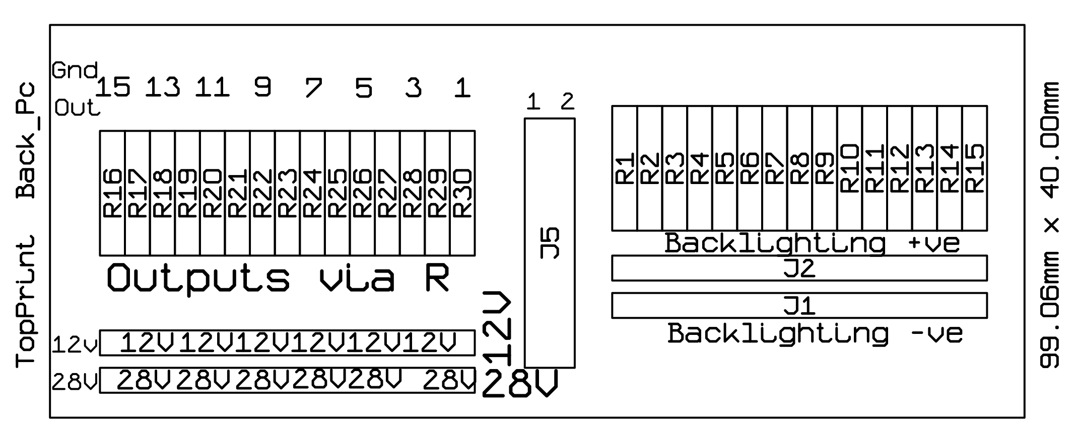

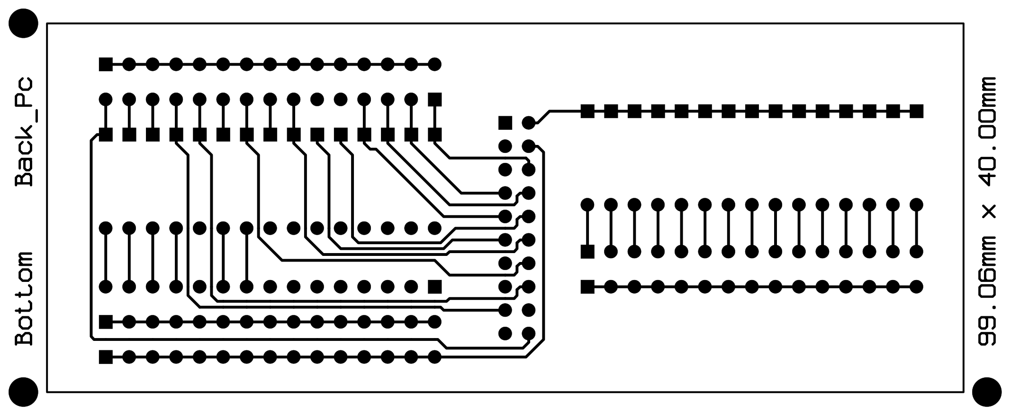

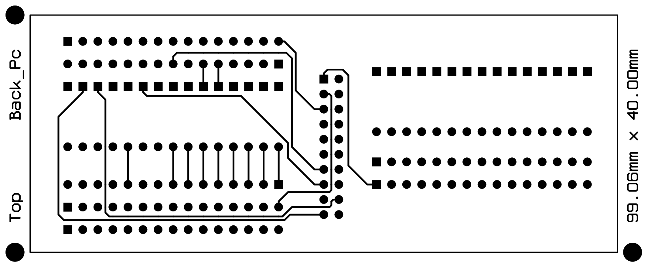

The larger PCBs too a little longer with the following checks:

* Compare data from the F16Callback spreadsheet on Viperpit against pictures of the F16 pit and Mike’s panels.
* Only buttons with Call backs where wired
* All panels were given provision for backlighting.
* One port on the GammaRay was left for used with rotary switches which is shared amongst all three panels.
* Output information from Olivers UCC Manual

Another decision point is where to split the PCBs. The drawings provided by Jason provide the answer. There needs to be three panels, with the split between the gear and misc panels.

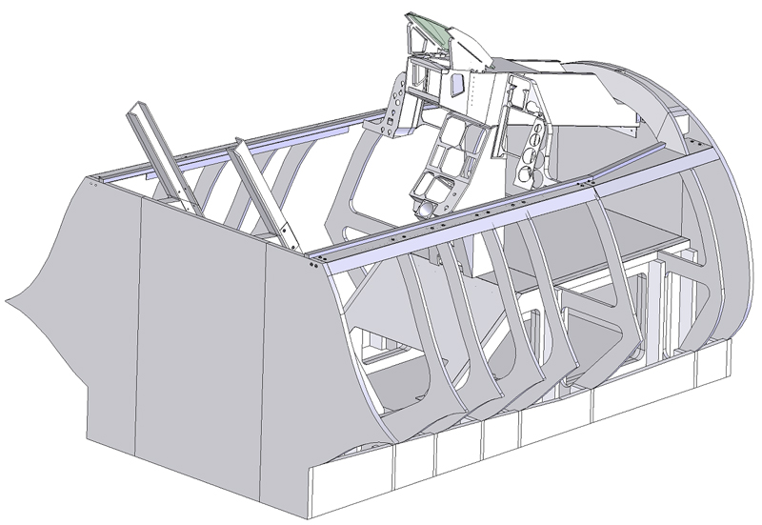

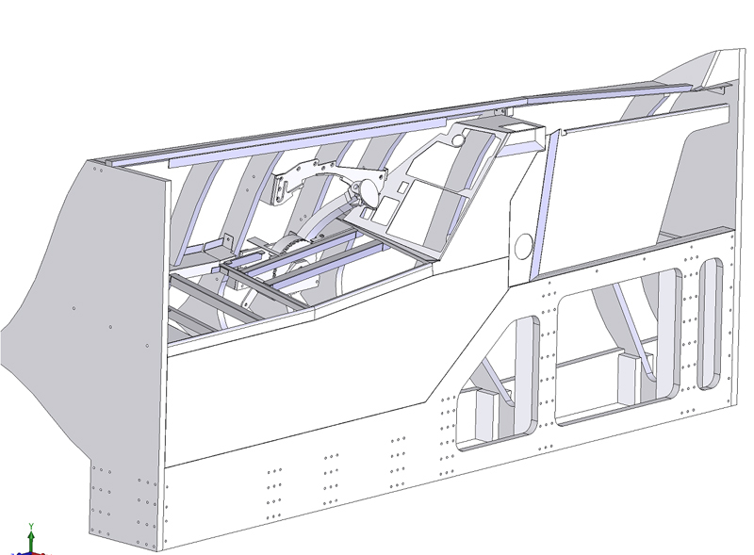

## Backlighting

Although I built a prototype using PWM, the dimmer from Flight Data Systems (<http://fdatasystems.com/LC_40.htm>) offered multiple zones, which maps nicely into what can be used inside the F16 pit. Whilst PWM is electrically noisier than a linear regulator it is much more efficient, and enables you to use different number of leds in columns without impacting on the balance of light output as the voltage is dropped when occurs when a linear regulator is used.

Something I’m still looking at is which voltage to use to drive the backlights. I have plenty of current available with an ordinary PC power supply, but that also means more current flowing to each of the boards. There are something like 539 Leds used for backlighting alone. If the leds are wired in a series of three, then 180 s columns of leds need to be lit. If each column draws 20mA, then the total current draw is 3.6Amps. If a higher voltage is used, allowing 6 leds per column then the current is halved to 1.8Amps. The LC40 lighting system supports 1.5Amps per channel which gives around 16mA per column which should provide more than adequate light levels.

My thoughts is to use multiple channels to provide different light levels for

1. Backlighting NVG (Night vision Green)
2. Flood lighting NVG (to augment backlight when flying)
3. Bright Red/White to flood the pit when getting in and out

I intend to wire the lights so they are aware of voltage levels in the simulation, so lights can be managed by master battery switches. As the sim doesn’t expose Panel light status the switch will be directly used.

I also like the Bright/Dim switch on the lighting controller, which is represented on the lighting panel in the pit.

# Pinouts for the PCBs

Mid_PCBs Bill of Material 23-May-07

----------------------------------------------------------------------------

Qty Product/Value Package Reference Designators

----------------------------------------------------------------------------

1 0.01uF 2PIN::H/200/200 C3

1 0.1uF 2PIN::H/200/200 C4

4 CAPACITOR 2PIN::V/200/400 C1-C2 C5-C6

----------------------------------------------------------------------------

2 DIODE 2PIN::H/400/100 D4-D5

1 LED 2PIN::H/200/100 D6

3 LED 2PIN::V/100/200 D1-D3

----------------------------------------------------------------------------

1 ACESII CON-HDR::2x5 J15

1 Analog_In CON-HDR::2x5 J27

1 Anti-G CON-HDR::2x5 J5

1 Audio CON-HDR::2x10 J31

1 Audio_2 CON-HDR::2x5 J11

1 Aux_Comm CON-HDR::2x8 J7

1 Aux_Comm_Channel CON-HDR::2x8 J8

1 AVTR CON-HDR::2x5 J16

1 Cen_Misc_Services CON-HDR::2x10 J39

1 Center_Pwr CON-HDR::2x5 J35

1 Centre_Pwr CON-HDR::2x5 J2

1 CMDS CON-HDR::2x10 J23

1 CMDS_Display CON-HDR::2x5 J21

1 ECM CON-HDR::2x5 J14

2 EFlux_Out CON-HDR::2x10 J19 J33

1 Elect CON-HDR::2x8 J17

1 EPU CON-HDR::2x5 J10

1 Ext_Light CON-HDR::2x8 J9

1 Flt_Control CON-HDR::2x5 J4

1 Fuel CON-HDR::2x8 J6

1 Gamma_Ray_V2_A CON-HDR::2x17 J18

1 Gamma_Ray_V2_B CON-HDR::2x17 J32

1 Gamma_Ray_V2_C CON-HDR::2x17 J40

1 Gear CON-HDR::2x10 J29

1 Guage_In CON-HDR::2x5 J26

1 Jet_Start CON-HDR::2x5 J13

1 Left_Cabin CON-HDR::2x5 J28

2 Left_Misc_Services CON-HDR::2x17 J25 J41

1 Left_Pwr CON-HDR::2x5 J34

1 Lighting_Controller CON-HDR::2x8 J42

1 Man_pitch CON-HDR::2x5 J3

1 Man_Trim CON-HDR::2x10 J30

1 Right_Misc_Services CON-HDR::2x10 J38

1 Right_Pwr CON-HDR::2x5 J36

2 Spare CON-HDR::2x10 J43-J44

1 Spare_Pwr CON-HDR::2x5 J37

1 Test CON-HDR::2x5 J12

1 Threat_Wrn_Aux CON-HDR::2x8 J22

1 UCC_Out_1 CON-HDR::2x17 J1

1 UCC_Out_2 CON-HDR::2x17 J20

1 UHF CON-HDR::2x5 J24

----------------------------------------------------------------------------

1 MOSFET_N TO::218 Q1

----------------------------------------------------------------------------

1 1K 2PIN::H/400/100 R5

1 47R 2PIN::H/400/100 R7

1 50K POT::TA_Circ300 R4

1 120 2PIN::H/200/100 R6

1 R_12V 2PIN::H/400/100 R2

1 R_28V 2PIN::H/400/100 R3

1 R_Bklight 2PIN::H/400/100 R1

----------------------------------------------------------------------------

1 LMC555 DIP::8D400Y300 U1

----------------------------------------------------------------------------

Totals: Elements=65 Pins=800 Nets=188

Right_PCB Bill of Material 24-May-07

----------------------------------------------------------------------------

Qty Product/Value Package Reference Designators

----------------------------------------------------------------------------

4 CAPACITOR 2PIN::V/200/400 C1-C4

----------------------------------------------------------------------------

6 LED 2PIN::V/100/200 D1-D6

----------------------------------------------------------------------------

1 Air_Cond CON-HDR::2x5 J34

1 Anti_Ice CON-HDR::2x5 J31

1 Avoinic_Pwr CON-HDR::2x10 J24

1 Cen_Misc_Services CON-HDR::2x10 J18

1 Center_Pwr CON-HDR::2x5 J1

1 DTU CON-HDR::2x5 J25

2 EFlux_Out CON-HDR::2x10 J10 J15

1 Eyebrow_L CON-HDR::2x5 J16

1 Eyebrow_R CON-HDR::2x5 J11

1 Fuel_Qty_Select CON-HDR::2x8 J12

1 Gamma_Ray_V2_D CON-HDR::2x17 J2

1 Gamma_Ray_V2_E CON-HDR::2x17 J13

1 Gamma_Ray_V2_F CON-HDR::2x17 J20

1 Gamma_Ray_V2_G CON-HDR::2x17 J22

1 Gamma_Ray_V2_H CON-HDR::2x17 J36

1 HIS CON-HDR::2x5 J5

1 Hud_Control CON-HDR::2x10 J29

1 Indexer_L CON-HDR::2x5 J8

1 Indexer_R CON-HDR::2x5 J9

1 Inst CON-HDR::2x8 J4

1 KY_58 CON-HDR::2x5 J30

1 Left_MFD CON-HDR::2x17 J3

1 Lighting CON-HDR::2x8 J27

1 Master_Zeroise CON-HDR::2x5 J33

1 Misc CON-HDR::2x10 J17

1 Nuclear_Consent CON-HDR::2x5 J28

1 OBOGS CON-HDR::2x5 J32

1 Ox_Reg CON-HDR::2x5 J26

1 Right_MFD CON-HDR::2x17 J6

1 Right_Misc_Services CON-HDR::2x10 J35

1 Right_Pwr CON-HDR::2x5 J21

1 Sensor_Pwr CON-HDR::2x5 J23

2 Spare CON-HDR::2x10 J37-J38

1 Threat_Wrn_Prime CON-HDR::2x8 J19

1 UCC_Out_3 CON-HDR::2x17 J7

1 UCC_Out_4 CON-HDR::2x17 J14

----------------------------------------------------------------------------

2 R_12V 2PIN::H/400/100 R2 R5

2 R_28V 2PIN::H/400/100 R3 R6

2 R_Bklight 2PIN::H/400/100 R1 R4

----------------------------------------------------------------------------

Totals: Elements=54 Pins=742 Nets=169

# Falcon 4 Allied Forces Shared Memory format

Shared Memory format as of 23 October 2005

|  |  |
| --- | --- |
| Value | Falcon 4 Allied Forces Description |

|  |  |
| --- | --- |
| ShipNorth As Single | Position of aircraft in North-South direction |

|  |  |
| --- | --- |
| ShipEast As Single | Position of aircraft in East-West direction |

|  |  |
| --- | --- |
| ShipDown As Single | Elevation of Aircraft |

|  |  |
| --- | --- |
| ShipNorthRate As Single | Velocity of Aircraft in North-South direction(ft/sec) |

|  |  |
| --- | --- |
| ShipEastRate As Single | Velocity of Aircraft in East-West direction (ft/sec) |

|  |  |
| --- | --- |
| ShipDownRate As Single | Rate of Descent/Climb |

|  |  |
| --- | --- |
| alpha As Single | Ownship Angle of Attack (Degrees) |

|  |  |
| --- | --- |
| beta As Single | Ownship Beta (Degrees) |

|  |  |
| --- | --- |
| gamma As Single | Ownship Gamma (Radians) |

|  |  |
| --- | --- |
| pitch As Single | Ownship Pitch Angle (Radians) |

|  |  |
| --- | --- |
| roll As Single | Ownship Roll Angle (Radians) |

|  |  |
| --- | --- |
| yaw As Single | Ownship Yaw Angle (Radians) (can also be used as magnetic heading) |

|  |  |
| --- | --- |
| mach As Single | Ownship Mach number (Mach) |

|  |  |
| --- | --- |
| kias As Single | Ownship Indicated Airspeed (Knots) |

|  |  |
| --- | --- |
| vt As Single | Ownship True Airspeed (Ft/Sec) |

|  |  |
| --- | --- |
| gs As Single | Ownship G-Force (Gs) |

|  |  |
| --- | --- |
| windOffset As Single | Wind delta to FPM (Radians) |

|  |  |
| --- | --- |
| nozzlePos As Single | Ownship engine nozzle percent open (0-100) |

|  |  |
| --- | --- |
| internalFuel As Single | Ownship internal fuel (Lbs) |

|  |  |
| --- | --- |
| externalFuel As Single | Ownship external fuel (Lbs) |

|  |  |
| --- | --- |
| fuelFlow As Single | Ownship fuel flow (Lbs/Hour) |

|  |  |
| --- | --- |
| rpm As Single | Ownship engine rpm (Percent 0-103) |

|  |  |
| --- | --- |
| ftit As Single | Ownship Forward Turbine Inlet Temp (Degrees C) |

|  |  |
| --- | --- |
| gearPos As Single | Ownship Gear position 0 = up, 1 = down; |

|  |  |
| --- | --- |
| speedBrake As Single | Ownship speed brake position 0 = closed, 1 = 60 Degrees open |

|  |  |
| --- | --- |
| epuFuel As Single | Ownship EPU fuel (Percent 0-100) |

|  |  |
| --- | --- |
| oilPressure As Single | Ownship Oil Pressure (Percent 0-100) |

|  |  |
| --- | --- |
| lightBits As Long | Cockpit Indicator Lights, one bit per bulb. See enum |

|  |  |
| --- | --- |
| headPitch As Single | Head pitch offset from design eye (radians) |

|  |  |
| --- | --- |
| headRoll As Single | Head roll offset from design eye (radians) |

|  |  |
| --- | --- |
| headYaw As Single | Head yaw offset from design eye (radians) |

|  |  |
| --- | --- |
| lightBits2 As Long | Cockpit Indicator Lights, one bit per bulb. See enum |

|  |  |
| --- | --- |
| lightBits3 As Long | Cockpit Indicator Lights, one bit per bulb. See enum |

|  |  |
| --- | --- |
| ChaffCount As Single | Number of Chaff left |

|  |  |
| --- | --- |
| FlareCount As Single | Number of Flare left |

|  |  |
| --- | --- |
| NoseGearPos As Single | Position of the nose landinggear |

|  |  |
| --- | --- |
| LeftGearPos As Single | Position of the left landinggear |

|  |  |
| --- | --- |
| RightGearPos As Single | Position of the right landinggear |

|  |  |
| --- | --- |
| AdiIlsHorPos As Single | Position of horizontal ILS bar |

|  |  |
| --- | --- |
| AdiIlsVerPos As Single | Position of vertical ILS bar |

|  |  |
| --- | --- |
| fill_in As Single | Placeholder 2004 11 26 |

|  |  |
| --- | --- |
| courseState As Integer | HSI_STA_CRS_STATE |

|  |  |
| --- | --- |
| headingState As Integer | HSI_STA_HDG_STATE |

|  |  |
| --- | --- |
| totalStates As Integer | HSI_STA_TOTAL_STATES ??? |

|  |  |
| --- | --- |
| courseDeviation As Single | HSI_VAL_CRS_DEVIATION |

|  |  |
| --- | --- |
| desiredCourse As Single | HSI_VAL_DESIRED_CRS |

|  |  |
| --- | --- |
| distanceToBeacon As Single | HSI_VAL_DISTANCE_TO_BEACON |

|  |  |
| --- | --- |
| bearingToBeacon As Single | HSI_VAL_BEARING_TO_BEACON |

|  |  |
| --- | --- |
| currentHeading As Single | HSI_VAL_CURRENT_HEADING |

|  |  |
| --- | --- |
| desiredHeading As Single | HSI_VAL_DESIRED_HEADING |

|  |  |
| --- | --- |
| deviationLimit As Single | HSI_VAL_DEV_LIMIT |

|  |  |
| --- | --- |
| halfDeviationLimit As Single | HSI_VAL_HALF_DEV_LIMIT |

|  |  |
| --- | --- |
| localizerCourse As Single | HSI_VAL_LOCALIZER_CRS |

|  |  |
| --- | --- |
| airbaseX As Single | HSI_VAL_AIRBASE_X |

|  |  |
| --- | --- |
| airbaseY As Single | HSI_VAL_AIRBASE_Y |

|  |  |
| --- | --- |
| totalValues As Single | HSI_VAL_TOTAL_VALUES ??? |

|  |  |
| --- | --- |
| TrimPitch As Single | Value of trim in pitch axis, -0.5 to +0.5 |

|  |  |
| --- | --- |
| TrimRoll As Single | Value of trim in roll axis, -0.5 to +0.5 |

|  |  |
| --- | --- |
| TrimYaw As Single | Value of trim in yaw axis, -0.5 to +0.5 |

|  |  |
| --- | --- |
| hsiBits As Long | HSI flags |

|  |  |
| --- | --- |
| DEDLines As String * 130 | DED 6 * 26 usable chars |

|  |  |
| --- | --- |
| Invert As String * 130 | DED 6 * 26 usable chars |

|  |  |
| --- | --- |
| PFLLines As String * 130 | PFL 6 * 26 usable chars |

|  |  |
| --- | --- |
| PFLInvert As String * 130 | PFL 6 * 26 usable chars |

|  |  |
| --- | --- |
| UFCTChan As Single | UFC TACAN Channel |

|  |  |
| --- | --- |
| AUXTChan As Single | AUX TACAN Channel |

|  |  |
| --- | --- |
| RWRObjectCount As Long | Number of valid threat object |

|  |  |
| --- | --- |
| RWRSymbol(39) As Long | Type of threat |

|  |  |
| --- | --- |
| Bearing(39) As Single | Bearing to threat (radians) |

|  |  |
| --- | --- |
| MissileActivity(39) As Long | Missile is active or beam rider |

|  |  |
| --- | --- |
| MissileLaunch(39) As Long | Missile is launched |

|  |  |
| --- | --- |
| Selected(39) As Long | Threat is Selected |

|  |  |
| --- | --- |
| Lethality(39) As Single | Lethal Range |

|  |  |
| --- | --- |
| NewDetection(39) As Long | New for F4 |

|  |  |
| --- | --- |
| FWDFuel As Single | Forward Fuel Tank Quantity |

|  |  |
| --- | --- |
| AFTFuel As Single | Aft Fuel Tank Quantity |

|  |  |
| --- | --- |
| TotalFuel As Single | Total Fuel Tank Quantity |

|  |  |
| --- | --- |
| VersionNum As Integer | Version of sh.mem file |

|  |  |
| --- | --- |
| Light Bit | Description |

|  |  |
| --- | --- |
| lightBit(1)=&H1 | MasterCaution |

|  |  |
| --- | --- |
| lightBit(2)=&H2 | TF |

|  |  |
| --- | --- |
| lightBit(3)=&H4 | OBS |

|  |  |
| --- | --- |
| lightBit(4)=&H8 | ALT |

|  |  |
| --- | --- |
| lightBit(5)=&H20 | ENG_FIRE |

|  |  |
| --- | --- |
| lightBit(6)=&H40 | CONFIG |

|  |  |
| --- | --- |
| lightBit(7)=&H80 | HYD |

|  |  |
| --- | --- |
| lightBit(8)=&H100 | OIL |

|  |  |
| --- | --- |
| lightBit(9)=&H200 | DUAL |

|  |  |
| --- | --- |
| lightBit(10)=&H400 | CAN |

|  |  |
| --- | --- |
| lightBit(11)=&H800 | T_L_CFG |

|  |  |
| --- | --- |
| lightBit(12)=&H1000 | AOAAbove |

|  |  |
| --- | --- |
| lightBit(13)=&H2000 | AOAOn |

|  |  |
| --- | --- |
| lightBit(14)=&H4000 | AOABelow |

|  |  |
| --- | --- |
| lightBit(15)=&H8000 | RefuelRDY |

|  |  |
| --- | --- |
| lightBit(16)=&H10000 | RefuelAR |

|  |  |
| --- | --- |
| lightBit(17)=&H20000 | RefuelDSC |

|  |  |
| --- | --- |
| lightBit(18)=&H40000 | FltControlSys |

|  |  |
| --- | --- |
| lightBit(19)=&H80000 | LEFlaps |

|  |  |
| --- | --- |
| lightBit(20)=&H100000 | EngineFault |

|  |  |
| --- | --- |
| lightBit(21)=&H200000 | Overheat |

|  |  |
| --- | --- |
| lightBit(22)=&H400000 | FuelLow |

|  |  |
| --- | --- |
| lightBit(23)=&H800000 | Avionics |

|  |  |
| --- | --- |
| lightBit(24)=&H1000000 | RadarAlt |

|  |  |
| --- | --- |
| lightBit(25)=&H2000000 | IFF |

|  |  |
| --- | --- |
| lightBit(26)=&H4000000 | ECM |

|  |  |
| --- | --- |
| lightBit(27)=&H8000000 | Hook |

|  |  |
| --- | --- |
| lightBit(28)=&H10000000 | NWSFail |

|  |  |
| --- | --- |
| lightBit(29)=&H20000000 | CabinPress |

|  |  |
| --- | --- |
| lightBit2(1)=&H1 | HandOff |

|  |  |
| --- | --- |
| lightBit2(2)=&H2 | launch |

|  |  |
| --- | --- |
| lightBit2(3)=&H4 | PriMode |

|  |  |
| --- | --- |
| lightBit2(4)=&H8 | Naval |

|  |  |
| --- | --- |
| lightBit2(5)=&H10 | Unk |

|  |  |
| --- | --- |
| lightBit2(6)=&H20 | TgtSep |

|  |  |
| --- | --- |
| lightBit2(7)=&H1000 | AuxSrch |

|  |  |
| --- | --- |
| lightBit2(8)=&H2000 | AuxAct |

|  |  |
| --- | --- |
| lightBit2(9)=&H4000 | AuxLow |

|  |  |
| --- | --- |
| lightBit2(10)=&H8000 | AuxPwr |

|  |  |
| --- | --- |
| lightBit2(11)=&H10000 | EcmPwr |

|  |  |
| --- | --- |
| lightBit2(12)=&H20000 | EcmFail |

|  |  |
| --- | --- |
| lightBit2(13)=&H40000 | FwdFuelLow |

|  |  |
| --- | --- |
| lightBit2(14)=&H80000 | AftFuelLow |

|  |  |
| --- | --- |
| lightBit2(15)=&H100000 | EPUOn |

|  |  |
| --- | --- |
| lightBit2(16)=&H200000 | JFSOn |

|  |  |
| --- | --- |
| lightBit2(17)=&H400000 | SEC |

|  |  |
| --- | --- |
| lightBit2(18)=&H800000 | OXY_LOW |

|  |  |
| --- | --- |
| lightBit2(19)=&H1000000 | PROBEHEAT |

|  |  |
| --- | --- |
| lightBit2(20)=&H2000000 | SEAT_ARM |

|  |  |
| --- | --- |
| lightBit2(21)=&H4000000 | BUC |

|  |  |
| --- | --- |
| lightBit2(22)=&H8000000 | FUEL_OIL_HOT |

|  |  |
| --- | --- |
| lightBit2(23)=&H10000000 | ANTI_SKID |

|  |  |
| --- | --- |
| lightBit2(24)=&H20000000 | TFR_ENGAGED |

|  |  |
| --- | --- |
| lightBit2(25)=&H40000000 | GEARHANDLE |

|  |  |
| --- | --- |
| lightBit3(1)=&H1 | Flcspmg |

|  |  |
| --- | --- |
| lightBit3(2)=&H2 | MainGen |

|  |  |
| --- | --- |
| lightBit3(3)=&H4 | StbyGen |

|  |  |
| --- | --- |
| lightBit3(4)=&H8 | EPUGen |

|  |  |
| --- | --- |
| lightBit3(5)=&H10 | EPUpmg |

|  |  |
| --- | --- |
| lightBit3(6)=&H20 | ToFlcs |

|  |  |
| --- | --- |
| lightBit3(7)=&H40 | FlcsRly |

|  |  |
| --- | --- |
| lightBit3(8)=&H80 | BatFail |

|  |  |
| --- | --- |
| lightBit3(9)=&H100 | Hydrazine |

|  |  |
| --- | --- |
| lightBit3(10)=&H200 | Air |

|  |  |
| --- | --- |
| lightBit3(11)=&H400 | Elec_Fault |

|  |  |
| --- | --- |
| lightBit3(12)=&H800 | Lef_Fault |

|  |  |
| --- | --- |
|  |  |

|  |  |
| --- | --- |
| hsiBit(1)=&H1 | HSITOTrue |

|  |  |
| --- | --- |
| hsiBit(2)=&H2 | HSIILSWARN |

|  |  |
| --- | --- |
| hsiBit(3)=&H4 | HSICRSWARN |

|  |  |
| --- | --- |
| hsiBit(4)=&H8 | HSIFLAGINIT |

|  |  |
| --- | --- |
| hsiBit(5)=&H10 | HSITotalFlags(?) |

|  |  |
| --- | --- |
| hsiBit(6)=&H20 | ADIOFFFlag |

|  |  |
| --- | --- |
| hsiBit(7)=&H40 | ADIAUXFlag |

|  |  |
| --- | --- |
| hsiBit(8)=&H80 | ADIGSFlag |

|  |  |
| --- | --- |
| hsiBit(9)=&H100 | ADILOCFlag |

|  |  |
| --- | --- |
| hsiBit(10)=&H200 | ADIOFFFlag |

|  |  |
| --- | --- |
| hsiBit(11)=&H400 | HSIOFFFlag |

|  |  |
| --- | --- |
| hsiBit(12)=&H800 | VVIOFFFlag |

|  |  |
| --- | --- |
| hsiBit(13)=&H1000 | AOAOFFFlag |

|  |  |
| --- | --- |
| hsiBit(14)=&H2000 | AVTRLight |

|  |  |
| --- | --- |
|  |  |

# FSUIPC Offsets utilisation by product

## Flight Illusion Dual Engine Stack

|  |
| --- |
| 0280 (640) Lights: this operates the NAV lights, plus, on FS2000, the TAXI, PANEL and WING lights. For separate switches on FS2000 (and CFS2?) see offset 0D0C |

|  |
| --- |
| 08B8 (2232) Engine 1 Oil temperature, 16384 = 140 C. |

|  |
| --- |
| 08BA (2234) Engine 1 Oil pressure, 16384 = 55 psi. Not that in some FS2000 aircraft (the B777) this can exceed the 16-bit capacity of this location. FSUIPC limits it to fit, i.e.65535 = 220 psi |

|  |
| --- |
| 0950 (2384) Engine 2 Oil temperature, 16384 = 140 C. |

|  |
| --- |
| 0952 (2386) Engine 2 Oil pressure, 16384 = 55 psi. Not that in some FS2000 aircraft (the B777) this can exceed the 16-bit capacity of this location. FSUIPC limits it to fit, i.e.65535 = 220 psi |

|  |
| --- |
| 2000 (8192) Turbine Engine 1 N1 value (%) as a double (FLOAT64). This is for jets and turboprops-it has no meaning on reciprocating prop aircraft. |

|  |
| --- |
| 2028 (8232) Turbine Engine 1 max torque fraction (range 0.0-1.0) as a double (FLOAT64). (Only tested on turboprops). |

|  |
| --- |
| 2038 (8248) Turbine Engine 1 ITT (interstage turbine temperature) in degrees Rankine, as a double (FLOAT64). This is for jets and turboprops. |

|  |
| --- |
| 2060 (8288) Turbine Engine 1 fuel flow (pounds per hour) as a double (FLOAT64). This is for jets and turboprops. |

|  |
| --- |
| 2100 (8448) Turbine Engine 2 N1 value (%) as a double (FLOAT64). This is for jets and turboprops-it has no meaning on reciprocating prop aircraft. |

|  |
| --- |
| 2128 (8488) Turbine Engine 2 max torque fraction (range 0.0-1.0) as a double (FLOAT64). (Only tested on turboprops). |

|  |
| --- |
| 2138 (8504) Turbine Engine 2 ITT (interstage turbine temperature) in degrees Rankine, as a double (FLOAT64). This is for jets and turboprops. |

|  |
| --- |
| 2160 (8544) Turbine Engine 2 fuel flow (pounds per hour) as a double (FLOAT64). This is for jets and turboprops. |

|  |
| --- |
| 2400 (9216) Propeller 1 RPM as a double (FLOAT64). This value is for props and turboprops and is negative for counter-rotating propellers. |

|  |
| --- |
| 2500 (9472) Propeller 2 RPM as a double (FLOAT64). This value is for props and turboprops and is negative for counter-rotating propellers. |

## FreeFD EADI

|  |
| --- |
| 02A0 (672) Magnetic variation (signed, -ve = West). For degrees *360/65536. Convert True headings to Magnetic by subtracting this value, Magnetic headings to True by adding this value. |

|  |
| --- |
| 02B4 (692) GS: Ground Speed, as 65536*metres/sec. Not updated in Slew mode! |

|  |
| --- |
| 02B8 (696) TAS: True Air Speed, as knots * 128 |

|  |
| --- |
| 02BC (700) IAS: Indicated Air Speed, as knots * 128 |

|  |
| --- |
| 02C4 (708) Barber pole airspeed, as knots * 128 |

|  |
| --- |
| 02C8 (712) Vertical speed, signed, as 256 * metres/sec. For the more usual ft/min you need to apply the conversion *60*3.28084/256 |

|  |
| --- |
| 0330 (816) Altimeter pressure setting ("Kollsman" window). As millibars (hectoPascals) * 16 |

|  |
| --- |
| 0350 (848) NAV1 frequency, 4 digits in BCD format. A frequency of 113.45 is represented by 0x1345. The leading 1 is assumed. (See also offset 0388) |

|  |
| --- |
| 0366 (870) Aircraft on ground flag (0=airborne, 1=on ground). Not updated in Slew mode. (should be byte not integer |

|  |
| --- |
| 036E (878) Turn co-ordinator ball position (slip and skid). -128 is extreme left, +127 is extreme right, 0 is balanced. |

|  |
| --- |
| 0570 (1392) Altitude, in metres and fractional metres. The units are in the high 32-bit integer (at 0574) and the fractional part is in the low 32-bit integer (at 0570). [Can be written to move aircraft: in FS2002 only in slew or pause states] |

|  |
| --- |
| 0574 (1396) Altitude, in metres and fractional metres. The units are in the high 32-bit integer (at 0574) and the fractional part is in the low 32-bit integer (at 0570). [Can be written to move aircraft: in FS2002 only in slew or pause states] |

|  |
| --- |
| 0578 (1400) Pitch, *360/(65536*65536) for degrees. 0=level, -ve=pitch up, +ve=pitch down |

|  |
| --- |
| 057C (1404) Bank, *360/(65536*65536) for degrees. 0=level, -ve=bank right, +ve=bank left |

|  |
| --- |
| 0580 (1408) Heading, *360/(65536*65536) for degrees TRUE. |

|  |
| --- |
| 07BC (1980) Autopilot Master switch |

|  |
| --- |
| 07C4 (1988) Autopilot NAV1 lock |

|  |
| --- |
| 07C8 (1992) Autopilot heading lock |

|  |
| --- |
| 07CC (1996) Autopilot heading value, as degrees*65536/360 |

|  |
| --- |
| 07D0 (2000) Autopilot altitude lock |

|  |
| --- |
| 07D4 (2004) Autopilot altitude value, as metres*65536 |

|  |
| --- |
| 07DC (2012) Autopilot airspeed hold |

|  |
| --- |
| 07E2 (2018) Autopilot airspeed value, in knots |

|  |
| --- |
| 07E4 (2020) Autopilot mach hold |

|  |
| --- |
| 07E8 (2024) Autopilot mach value, as Mach*65536 |

|  |
| --- |
| 07F2 (2034) Autopilot vertical speed value, as ft/min |

|  |
| --- |
| 07FC (2044) Autopilot GlideSlope hold |

|  |
| --- |
| 0800 (2048) Autopilot Approach hold. |

|  |
| --- |
| 0810 (2064) Autothrottle Arm |

|  |
| --- |
| 0842 (2114) Vertical speed in metres per minute, but with -ve for UP, +ve for DOWN. Multiply by 3.28084 and reverse the sign for the normal fpm measure. This works even in slew mode (except in FS2002). |

|  |
| --- |
| 0870 (2160) NAV1 ILS localiser inverse runway heading if VOR1 is ILS. Convert to degrees by *360/65536. This is 180 degrees different to the direction of flight to follow the localiser. |

|  |
| --- |
| 0894 (2196) Engine 1 combustion flag (TRUE if engine firing) |

|  |
| --- |
| 092C (2348) Engine 2 combustion flag (TRUE if engine firing) |

|  |
| --- |
| 09C4 (2500) Engine 3 combustion flag (TRUE if engine firing) |

|  |
| --- |
| 0A5C (2652) Engine 4 combustion flag (TRUE if engine firing) |

|  |
| --- |
| 0AEC (2796) Number of Engines |

|  |
| --- |
| 0AF4 (2804) Fuel weight as pounds per gallon * 256 |

|  |
| --- |
| 0B4C (2892) Ground altitude (metres). See 0020 for more accuracy. |

|  |
| --- |
| 0B74 (2932) Fuel: centre tank level, % * 128 * 65536 |

|  |
| --- |
| 0B78 (2936) Fuel: centre tank capacity: US Gallons (see also offsets 1244- for extra FS2k/CFS2 fuel tanks) |

|  |
| --- |
| 0B7C (2940) Fuel: left main tank level, % * 128 * 65536 |

|  |
| --- |
| 0B80 (2944) Fuel: left main tank capacity: US Gallons |

|  |
| --- |
| 0B84 (2948) Fuel: left aux tank level, % * 128 * 65536 |

|  |
| --- |
| 0B88 (2952) Fuel: left aux tank capacity: US Gallons |

|  |
| --- |
| 0B94 (2964) Fuel: right main tank level, % * 128 * 65536 |

|  |
| --- |
| 0B98 (2968) Fuel: right main tank capacity: US Gallons |

|  |
| --- |
| 0B9C (2972) Fuel: right aux tank level, % * 128 * 65536 |

|  |
| --- |
| 0BA0 (2976) Fuel: right aux tank capacity: US Gallons |

|  |
| --- |
| 0BAC (2988) Inner Marker: activated when TRUE |

|  |
| --- |
| 0BAE (2990) Middle Marker: activated when TRUE |

|  |
| --- |
| 0BB0 (2992) Outer Marker: activated when TRUE |

|  |
| --- |
| 0BB2 (2994) Elevator control input: -16383 to +16383 |

|  |
| --- |
| 0BB6 (2998) Aileron control input: -16383 to +16383 |

|  |
| --- |
| 0BDC (3036) Flaps control, 0=up, 16383=full. The "notches" for different aircraft are spaced equally across this range: calculate the increment by 16383/(number of positions-1), ignoring fractions. See also offset 3BFA below. |

|  |
| --- |
| 0C29 (3113) DME1 distance as character string, either "nn.n" or "nnn." (when > 99.9 nm). The 5th character may be a zero or a space. Don't rely on it. |

|  |
| --- |
| 0C48 (3144) NAV1 Localiser Needle: -127 left to +127 right |

|  |
| --- |
| 0C49 (3145) NAV1 Glideslope Needle: -127 up to +127 down |

|  |
| --- |
| 0E8C (3724) Outside Air Temperature (OAT), degrees C * 256 |

|  |
| --- |
| 0E90 (3728) Ambient wind speed (at aircraft) in knots |

|  |
| --- |
| 0E92 (3730) Ambient wind direction (at aircraft), *360/65536 to get degrees Magnetic or True. |

|  |
| --- |
| 0F48 (3912) Pressure (QNH) as millibars (hectoPascals) *16. |

|  |
| --- |
| 2EE0 (12000) Flight Director Active, control and indicator. 1=active, 0=inactive. [FS2000-FS2004 only] |

|  |
| --- |
| 2EE8 (12008) Flight director pitch value, in degrees. Double floating point format, only when FD is active. [FS2000-FS2004 only] |

|  |
| --- |
| 2EF0 (12016) Flight director bank value, in degrees. Double floating point format, right is negative, left positive. [FS2000-FS2004 only] |

|  |
| --- |
| 3000 (12288) VOR1 IDENTITY (string supplied: 6 bytes including zero terminator) |

|  |
| --- |
| 3080 (12416) Roll acceleration in radians/sec/sec relative to the body axes (see Note at end of table). This is in double floating point format (FLOAT64). [FS2000 and later] |

|  |
| --- |
| 3300 (13056) [FS2k, CFS2 and FS98, as applicable] |

|  |
| --- |
| 3324 (13092) This is the altimeter reading in feet (or metres, if the user is running with the preference for altitudes in metres), as a 32-bit signed integer. Please check offset 0C18 to determine when metres are used (0C18 contains '2'). |

## FreeFD ECAS

|  |
| --- |
| 036D (877) Overspeed warning (0=no, 1=overspeed) |

|  |
| --- |
| 07BC (1980) Autopilot Master switch |

|  |
| --- |
| 0810 (2064) Autothrottle Arm |

|  |
| --- |
| 088C (2188) ENGINE 1 values, as detailed below |

|  |
| --- |
| 0892 (2194) Engine 1 Starter switch position (Magnetos), |

|  |
| --- |
| 0894 (2196) Engine 1 combustion flag (TRUE if engine firing) |

|  |
| --- |
| 0896 (2198) Engine 1 Jet N2 as 0 - 16384 (100%). This also appears to be the Turbine RPM % for proper helo models (and now also for the FS2004 Robinson model and derivatives) |

|  |
| --- |
| 0898 (2200) Engine 1 Jet N1 as 0 - 16384 (100%), or Prop RPM (derive RPM by multiplying this value by the RPM Scaler (see 08C8) and dividing by 65536). Note that Prop RPM is signed and negative for counter-rotating propellers. |

|  |
| --- |
| 08B8 (2232) Engine 1 Oil temperature, 16384 = 140 C. |

|  |
| --- |
| 08BA (2234) Engine 1 Oil pressure, 16384 = 55 psi. Not that in some FS2000 aircraft (the B777) this can exceed the 16-bit capacity of this location. FSUIPC limits it to fit, i.e.65535 = 220 psi |

|  |
| --- |
| 08BC (2236) Engine 1 Pressure Ratio (where calculated): 16384 = 1.60 |

|  |
| --- |
| 08BE (2238) Engine 1 EGT, 16384 = 860 C. [Note that for Props this value is not actually correct. For FS2004 at least you will get the correct value from 3B70. In FS2004 the value here has been derived by FSUIPC to be compatible with FS2002 et cetera] |

|  |
| --- |
| 08D0 (2256) Engine 1 Oil Quantity: 16384 = 100% On FS2000 FSUIPC usually has to derive this from a leakage value as it isn't provided directly. |

|  |
| --- |
| 08D4 (2260) Engine 1 Vibration: 16384 = 5.0. This is a relative measure of amplitude from the sensors on the engine which when too high is an indication of a problem. The value at which you should be concerned varies according to aircraft and engine. |

|  |
| --- |
| 08D8 (2264) Engine 1 Hydraulic pressure: appears to be 4*psi |

|  |
| --- |
| 08DC (2268) Engine 1 Hydraulic quantity: 16384 = 100% |

|  |
| --- |
| 0918 (2328) Engine 1 Fuel Flow Pounds per Hour, as floating point double (FLOAT64) |

|  |
| --- |
| 0924 (2340) Engine 2 Throttle lever, -4096 to +16384 |

|  |
| --- |
| 092A (2346) Engine 2 Starter switch position (Magnetos), |

|  |
| --- |
| 092C (2348) Engine 2 combustion flag (TRUE if engine firing) |

|  |
| --- |
| 092E (2350) Engine 2 Jet N2 as 0 - 16384 (100%) |

|  |
| --- |
| 0930 (2352) Engine 2 Jet N1 as 0 - 16384 (100%), or Prop RPM (derive RPM by multiplying this value by the RPM Scaler (see 08C8) and dividing by 65536). Note that Prop RPM is signed and negative for counter-rotating propellers. |

|  |
| --- |
| 0950 (2384) Engine 2 Oil temperature, 16384 = 140 C. |

|  |
| --- |
| 0952 (2386) Engine 2 Oil pressure, 16384 = 55 psi. Not that in some FS2000 aircraft (the B777) this can exceed the 16-bit capacity of this location. FSUIPC limits it to fit, i.e.65535 = 220 psi |

|  |
| --- |
| 0954 (2388) Engine 2 Pressure Ratio (where calculated): 16384 = 1.60 |

|  |
| --- |
| 0956 (2390) Engine 2 EGT, 16384 = 860 C. [Note that for Props this value is not actually correct. For FS2004 at least you will get the correct value from 3AB0. In FS2004 the value here has been derived by FSUIPC to be compatible with FS2002 et cetera] |

|  |
| --- |
| 0968 (2408) Engine 2 Oil Quantity: 16384 = 100% On FS2000 FSUIPC usually has to derive this from a leakage value as it isn't provided directly. |

|  |
| --- |
| 096C (2412) Engine 2 Vibration: 16384 = 5.0. This is a relative measure of amplitude from the sensors on the engine which when too high is an indication of a problem. The value at which you should be concerned varies according to aircraft and engine. |

|  |
| --- |
| 0970 (2416) Engine 2 Hydraulic pressure: appears to be 4*psi |

|  |
| --- |
| 0974 (2420) Engine 2 Hydraulic quantity: 16384 = 100% |

|  |
| --- |
| 09B0 (2480) Engine 2 Fuel Flow Pounds per Hour, as floating point double (FLOAT64) |

|  |
| --- |
| 09BC (2492) ENGINE 3 values, as detailed below |

|  |
| --- |
| 09C2 (2498) Engine 3 Starter switch position (Magnetos), |

|  |
| --- |
| 09C4 (2500) Engine 3 combustion flag (TRUE if engine firing) |

|  |
| --- |
| 09C6 (2502) Engine 3 Jet N2 as 0 - 16384 (100%) |

|  |
| --- |
| 09C8 (2504) Engine 3 Jet N1 as 0 - 16384 (100%), or Prop RPM (derive RPM by multiplying this value by the RPM Scaler (see 08C8) and dividing by 65536). Note that Prop RPM is signed and negative for counter-rotating propellers. |

|  |
| --- |
| 09E8 (2536) Engine 3 Oil temperature, 16384 = 140 C. |

|  |
| --- |
| 09EA (2538) Engine 3 Oil pressure, 16384 = 55 psi. Not that in some FS2000 aircraft (the B777) this can exceed the 16-bit capacity of this location. FSUIPC limits it to fit, i.e.65535 = 220 psi |

|  |
| --- |
| 09EC (2540) Engine 3 Pressure Ratio (where calculated): 16384 = 1.60 |

|  |
| --- |
| 09EE (2542) Engine 3 EGT, 16384 = 860 C. [Note that for Props this value is not actually correct. For FS2004 at least you will get the correct value from 39F0. In FS2004 the value here has been derived by FSUIPC to be compatible with FS2002 et cetera] |

|  |
| --- |
| 0A00 (2560) Engine 3 Oil Quantity: 16384 = 100% On FS2000 FSUIPC usually has to derive this from a leakage value as it isn't provided directly. |

|  |
| --- |
| 0A04 (2564) Engine 3 Vibration: 16384 = 5.0. This is a relative measure of amplitude from the sensors on the engine which when too high is an indication of a problem. The value at which you should be concerned varies according to aircraft and engine. |

|  |
| --- |
| 0A08 (2568) Engine 3 Hydraulic pressure: appears to be 4*psi |

|  |
| --- |
| 0A0C (2572) Engine 3 Hydraulic quantity: 16384 = 100% |

|  |
| --- |
| 0A48 (2632) Engine 3 Fuel Flow Pounds per Hour, as floating point double (FLOAT64) |

|  |
| --- |
| 0A54 (2644) Engine 4 Throttle lever, -4096 to +16384 |

|  |
| --- |
| 0A5A (2650) Engine 4 Starter switch position (Magnetos), |

|  |
| --- |
| 0A5C (2652) Engine 4 combustion flag (TRUE if engine firing) |

|  |
| --- |
| 0A5E (2654) Engine 4 Jet N2 as 0 - 16384 (100%) |

|  |
| --- |
| 0A60 (2656) Engine 4 Jet N1 as 0 - 16384 (100%), or Prop RPM (derive RPM by multiplying this value by the RPM Scaler (see 08C8) and dividing by 65536). Note that Prop RPM is signed and negative for counter-rotating propellers. |

|  |
| --- |
| 0A80 (2688) Engine 4 Oil temperature, 16384 = 140 C. |

|  |
| --- |
| 0A82 (2690) Engine 4 Oil pressure, 16384 = 55 psi. Not that in some FS2000 aircraft (the B777) this can exceed the 16-bit capacity of this location. FSUIPC limits it to fit, i.e.65535 = 220 psi |

|  |
| --- |
| 0A84 (2692) Engine 4 Pressure Ratio (where calculated): 16384 = 1.60 |

|  |
| --- |
| 0A86 (2694) Engine 4 EGT, 16384 = 860 C. [Note that for Props this value is not actually correct. For FS2004 at least you will get the correct value from 3930. In FS2004 the value here has been derived by FSUIPC to be compatible with FS2002 et cetera] |

|  |
| --- |
| 0A98 (2712) Engine 4 Oil Quantity: 16384 = 100% On FS2000 FSUIPC usually has to derive this from a leakage value as it isn't provided directly. |

|  |
| --- |
| 0A9C (2716) Engine 4 Vibration: 16384 = 5.0. This is a relative measure of amplitude from the sensors on the engine which when too high is an indication of a problem. The value at which you should be concerned varies according to aircraft and engine. |

|  |
| --- |
| 0AA0 (2720) Engine 4 Hydraulic pressure: appears to be 4*psi |

|  |
| --- |
| 0AA4 (2724) Engine 4 Hydraulic quantity: 16384 = 100% |

|  |
| --- |
| 0AE0 (2784) Engine 4 Fuel Flow Pounds per Hour, as floating point double (FLOAT64) |

|  |
| --- |
| 0B74 (2932) Fuel: centre tank level, % * 128 * 65536 |

|  |
| --- |
| 0B78 (2936) Fuel: centre tank capacity: US Gallons (see also offsets 1244- for extra FS2k/CFS2 fuel tanks) |

|  |
| --- |
| 0B7C (2940) Fuel: left main tank level, % * 128 * 65536 |

|  |
| --- |
| 0B80 (2944) Fuel: left main tank capacity: US Gallons |

|  |
| --- |
| 0B84 (2948) Fuel: left aux tank level, % * 128 * 65536 |

|  |
| --- |
| 0B88 (2952) Fuel: left aux tank capacity: US Gallons |

|  |
| --- |
| 0B94 (2964) Fuel: right main tank level, % * 128 * 65536 |

|  |
| --- |
| 0B98 (2968) Fuel: right main tank capacity: US Gallons |

|  |
| --- |
| 0B9C (2972) Fuel: right aux tank level, % * 128 * 65536 |

|  |
| --- |
| 0BA0 (2976) Fuel: right aux tank capacity: US Gallons |

|  |
| --- |
| 0BC8 (3016) Parking brake: 0=off, 32767=on |

|  |
| --- |
| 0BD0 (3024) Spoilers control, 0 off to 16383 fully deployed (4800 is set by arming) |

|  |
| --- |
| 0BDC (3036) Flaps control, 0=up, 16383=full. The "notches" for different aircraft are spaced equally across this range: calculate the increment by 16383/(number of positions-1), ignoring fractions. See also offset 3BFA below. |

|  |
| --- |
| 0BE0 (3040) Flaps position indicator (left). Note that in FS2002 and FS2004 this gives the correct proportional amount, with 16383=full deflection. It doesn't correspond to the equally spaced notches used for the control lever. If you know the maximum deflection angl |

|  |
| --- |
| 0BE4 (3044) Flaps position indicator (right). Note that in FS2002 and FS2004 this gives the correct proportional amount, with 16384=full deflection. It doesn't correspond to the equally spaced notches used for the control lever. |

|  |
| --- |
| 0BEC (3052) Gear position (nose): 0=full up, 16383=full down |

|  |
| --- |
| 0BF0 (3056) Gear position (right): 0=full up, 16383=full down |

|  |
| --- |
| 0BF4 (3060) Gear position (left): 0=full up, 16383=full down |

|  |
| --- |
| 0E8C (3724) Outside Air Temperature (OAT), degrees C * 256 |

|  |
| --- |
| 11D0 (4560) Total Air Temperature (TAT), degrees Celsius * 256 |

|  |
| --- |
| 207C (8316) Turbine Engine 1 reverser fraction, a double (FLOAT64), in the range 0.0-1.0, providing the reverse as a proportion of the maximum reverse throttle position. |

|  |
| --- |
| 217C (8572) Turbine Engine 2 reverser fraction, a double (FLOAT64), in the range 0.0-1.0, providing the reverse as a proportion of the maximum reverse throttle position. |

|  |
| --- |
| 3328 (13096) Elevator Axis input value, post calibration, just before being applied to the simulation (if allowed to by the byte at offset 310A). |

|  |
| --- |
| 332A (13098) Aileron Axis input value, post calibration, just before being applied to the simulation (if allowed to by the byte at offset 310A). |

|  |
| --- |
| 332C (13100) Rudder Axis input value, post calibration, just before being applied to the simulation (if allowed to by the byte at offset 310A). |

## FreeFD ND

|  |
| --- |
| 023B (571) Hour of Zulu time in FS (also known at UTC or GMT) |

|  |
| --- |
| 023C (572) Minute of Zulu time in FS2 |

|  |
| --- |
| 02A0 (672) Magnetic variation (signed, -ve = West). For degrees *360/65536. Convert True headings to Magnetic by subtracting this value, Magnetic headings to True by adding this value. |

|  |
| --- |
| 02B4 (692) GS: Ground Speed, as 65536*metres/sec. Not updated in Slew mode! |

|  |
| --- |
| 02B8 (696) TAS: True Air Speed, as knots * 128 |

|  |
| --- |
| 02BC (700) IAS: Indicated Air Speed, as knots * 128 |

|  |
| --- |
| 0350 (848) NAV1 frequency, 4 digits in BCD format. A frequency of 113.45 is represented by 0x1345. The leading 1 is assumed. (See also offset 0388) |

|  |
| --- |
| 0366 (870) Aircraft on ground flag (0=airborne, 1=on ground). Not updated in Slew mode. (should be byte not integer |

|  |
| --- |
| 0560 (1376) Latitude of aircraft in FS units. High Order |

|  |
| --- |
| 0564 (1380) Latitude of aircraft in FS units. Low Order |

|  |
| --- |
| 0568 (1384) Longitude of aircraft in FS format. High Order |

|  |
| --- |
| 056C (1388) Longitude of aircraft in FS format. Low Order |

|  |
| --- |
| 0570 (1392) Altitude, in metres and fractional metres. The units are in the high 32-bit integer (at 0574) and the fractional part is in the low 32-bit integer (at 0570). [Can be written to move aircraft: in FS2002 only in slew or pause states] |

|  |
| --- |
| 0574 (1396) Altitude, in metres and fractional metres. The units are in the high 32-bit integer (at 0574) and the fractional part is in the low 32-bit integer (at 0570). [Can be written to move aircraft: in FS2002 only in slew or pause states] |

|  |
| --- |
| 0580 (1408) Heading, *360/(65536*65536) for degrees TRUE. |

|  |
| --- |
| 07CC (1996) Autopilot heading value, as degrees*65536/360 |

|  |
| --- |
| 0C29 (3113) DME1 distance as character string, either "nn.n" or "nnn." (when > 99.9 nm). The 5th character may be a zero or a space. Don't rely on it. |

|  |
| --- |
| 0C33 (3123) DME2 distance as character string, either "nn.n" or "nnn." (when > 99.9 nm). The 5th character may be a zero or a space. Don't rely on it. |

|  |
| --- |
| 0C48 (3144) NAV1 Localiser Needle: -127 left to +127 right |

|  |
| --- |
| 0C49 (3145) NAV1 Glideslope Needle: -127 up to +127 down |

|  |
| --- |
| 0C4A (3146) NAV1 Back Course flags: |

|  |
| --- |
| 0C4B (3147) NAV1 To/From flag: 0=not active, 1=To, 2=From |

|  |
| --- |
| 0C4E (3150) NAV1 OBS setting (degrees, 0-359) |

|  |
| --- |
| 0C50 (3152) NAV1 radial ( *360/65536 for degrees) |

|  |
| --- |
| 0C5A (3162) NAV2 Back Course flags: |

|  |
| --- |
| 0C5B (3163) NAV2 To/From flag: 0=not active, 1=To, 2=From |

|  |
| --- |
| 0C60 (3168) NAV2 radial ( *360/65536 for degrees) |

|  |
| --- |
| 0C6A (3178) ADF1: relative bearing to NDB ( *360/65536 for degrees, -ve left, +ve right) |

|  |
| --- |
| 0E90 (3728) Ambient wind speed (at aircraft) in knots |

|  |
| --- |
| 0E92 (3730) Ambient wind direction (at aircraft), *360/65536 to get degrees Magnetic or True. |

|  |
| --- |
| 3000 (12288) VOR1 IDENTITY (string supplied: 6 bytes including zero terminator) |

|  |
| --- |
| 301F (12319) VOR2 IDENTITY (string supplied: 6 bytes including zero terminator) |

|  |
| --- |
| 303E (12350) ADF1 IDENTITY (string supplied: 6 bytes including zero terminator) |

|  |
| --- |
| 3300 (13056) [FS2k, CFS2 and FS98, as applicable] |

|  |
| --- |
| 3304 (13060) FSUIPC version number: |

|  |
| --- |
| 3308 (13064) FS version, as determined by FSUIPC: Currently only one of these: |

## Simkits TRC Link 3.3

|  |
| --- |
| 0238 (568) Hour of local time in FS (0-23) |

|  |
| --- |
| 023B (571) Hour of Zulu time in FS (also known at UTC or GMT) |

|  |
| --- |
| 0264 (612) Pause indicator (0=Not paused, 1=Paused) |

|  |
| --- |
| 02A0 (672) Magnetic variation (signed, -ve = West). For degrees *360/65536. Convert True headings to Magnetic by subtracting this value, Magnetic headings to True by adding this value. |

|  |
| --- |
| 02BC (700) IAS: Indicated Air Speed, as knots * 128 |

|  |
| --- |
| 02C8 (712) Vertical speed, signed, as 256 * metres/sec. For the more usual ft/min you need to apply the conversion *60*3.28084/256 |

|  |
| --- |
| 02CC (716) Whiskey Compass, degrees in 'double' floating point format (FLOAT64) |

|  |
| --- |
| 0330 (816) Altimeter pressure setting ("Kollsman" window). As millibars (hectoPascals) * 16 |

|  |
| --- |
| 034C (844) ADF1 Frequency: main 3 digits, in Binary Coded Decimal. See also offset 0356. A frequency of 1234.5 will have 0x0234 here and 0x0105 in offset 0356. |

|  |
| --- |
| 034E (846) COM1 frequency, 4 digits in BCD format. A frequency of 123.45 is represented by 0x2345. The leading 1 is assumed. |

|  |
| --- |
| 0350 (848) NAV1 frequency, 4 digits in BCD format. A frequency of 113.45 is represented by 0x1345. The leading 1 is assumed. (See also offset 0388) |

|  |
| --- |
| 0352 (850) NAV2 frequency, 4 digits in BCD format. A frequency of 113.45 is represented by 0x1345. The leading 1 is assumed. (See also offset 0388) |

|  |
| --- |
| 0354 (852) Transponder setting, 4 digits in BCD format: 0x1200 means 1200 on the dials. |

|  |
| --- |
| 0356 (854) Extended ADF1 frequency. The high byte contains the 1000's digit and the low byte the fraction, so, for a frequency of 1234.5 this offset will contain 0x0105. |

|  |
| --- |
| 0366 (870) Aircraft on ground flag (0=airborne, 1=on ground). Not updated in Slew mode. (should be byte not integer |

|  |
| --- |
| 036E (878) Turn co-ordinator ball position (slip and skid). -128 is extreme left, +127 is extreme right, 0 is balanced. |

|  |
| --- |
| 037C (892) Turn Rate (for turn coordinator). 0=level, -512=2min Left, +512=2min Right |

|  |
| --- |
| 0560 (1376) Latitude of aircraft in FS units. High Order |

|  |
| --- |
| 0564 (1380) Latitude of aircraft in FS units. Low Order |

|  |
| --- |
| 0568 (1384) Longitude of aircraft in FS format. High Order |

|  |
| --- |
| 056C (1388) Longitude of aircraft in FS format. Low Order |

|  |
| --- |
| 0580 (1408) Heading, *360/(65536*65536) for degrees TRUE. |

|  |
| --- |
| 07BC (1980) Autopilot Master switch |

|  |
| --- |
| 07C4 (1988) Autopilot NAV1 lock |

|  |
| --- |
| 07C8 (1992) Autopilot heading lock |

|  |
| --- |
| 07D0 (2000) Autopilot altitude lock |

|  |
| --- |
| 07D4 (2004) Autopilot altitude value, as metres*65536 |

|  |
| --- |
| 07EC (2028) Autopilot vertical speed hold [Not connected in FS2002/4] |

|  |
| --- |
| 07F2 (2034) Autopilot vertical speed value, as ft/min |

|  |
| --- |
| 07FC (2044) Autopilot GlideSlope hold |

|  |
| --- |
| 0800 (2048) Autopilot Approach hold. |

|  |
| --- |
| 0804 (2052) Autopilot Back course hold. |

|  |
| --- |
| 088C (2188) ENGINE 1 values, as detailed below |

|  |
| --- |
| 088E (2190) Engine 1 Prop lever, -4096 to +16384 |

|  |
| --- |
| 0890 (2192) Engine 1 Mixture lever, 0 - 16384 |

|  |
| --- |
| 0898 (2200) Engine 1 Jet N1 as 0 - 16384 (100%), or Prop RPM (derive RPM by multiplying this value by the RPM Scaler (see 08C8) and dividing by 65536). Note that Prop RPM is signed and negative for counter-rotating propellers. |

|  |
| --- |
| 08B8 (2232) Engine 1 Oil temperature, 16384 = 140 C. |

|  |
| --- |
| 08BA (2234) Engine 1 Oil pressure, 16384 = 55 psi. Not that in some FS2000 aircraft (the B777) this can exceed the 16-bit capacity of this location. FSUIPC limits it to fit, i.e.65535 = 220 psi |

|  |
| --- |
| 08BE (2238) Engine 1 EGT, 16384 = 860 C. [Note that for Props this value is not actually correct. For FS2004 at least you will get the correct value from 3B70. In FS2004 the value here has been derived by FSUIPC to be compatible with FS2002 et cetera] |

|  |
| --- |
| 08C8 (2248) Engine 1 RPM Scaler: For Props, use this to calculate RPM - see offset 0898 |

|  |
| --- |
| 0918 (2328) Engine 1 Fuel Flow Pounds per Hour, as floating point double (FLOAT64) |

|  |
| --- |
| 0924 (2340) Engine 2 Throttle lever, -4096 to +16384 |

|  |
| --- |
| 0926 (2342) Engine 2 Prop lever, -4096 to +16384 |

|  |
| --- |
| 0928 (2344) Engine 2 Mixture lever, 0 - 16384 |

|  |
| --- |
| 09BC (2492) ENGINE 3 values, as detailed below |

|  |
| --- |
| 09BE (2494) Engine 3 Prop lever, -4096 to +16384 |

|  |
| --- |
| 09C0 (2496) Engine 3 Mixture lever, 0 - 16384 |

|  |
| --- |
| 0A54 (2644) Engine 4 Throttle lever, -4096 to +16384 |

|  |
| --- |
| 0A56 (2646) Engine 4 Prop lever, -4096 to +16384 |

|  |
| --- |
| 0A58 (2648) Engine 4 Mixture lever, 0 - 16384 |

|  |
| --- |
| 0AF4 (2804) Fuel weight as pounds per gallon * 256 |

|  |
| --- |
| 0B18 (2840) Gyro suction in inches of mercury (Hg), floating point double (FLOAT64) |

|  |
| --- |
| 0B64 (2916) Fail mode: 0 ok, ADF inoperable = 1 (both ADFs on FS2004) |

|  |
| --- |
| 0B6F (2927) Fail mode: 0 ok, Transponder inoperable = 1 |

|  |
| --- |
| 0B72 (2930) Fail mode: 0 ok, Turn coordinator inoperable = 1 |

|  |
| --- |
| 0B7C (2940) Fuel: left main tank level, % * 128 * 65536 |

|  |
| --- |
| 0B80 (2944) Fuel: left main tank capacity: US Gallons |

|  |
| --- |
| 0B94 (2964) Fuel: right main tank level, % * 128 * 65536 |

|  |
| --- |
| 0B98 (2968) Fuel: right main tank capacity: US Gallons |

|  |
| --- |
| 0BAC (2988) Inner Marker: activated when TRUE |

|  |
| --- |
| 0BAE (2990) Middle Marker: activated when TRUE |

|  |
| --- |
| 0BB0 (2992) Outer Marker: activated when TRUE |

|  |
| --- |
| 0BC0 (3008) Elevator trim control input: -16383 to +16383 |

|  |
| --- |
| 0BC2 (3010) Elevator trim indicator (follows input) |

|  |
| --- |
| 0BDC (3036) Flaps control, 0=up, 16383=full. The "notches" for different aircraft are spaced equally across this range: calculate the increment by 16383/(number of positions-1), ignoring fractions. See also offset 3BFA below. |

|  |
| --- |
| 0BE0 (3040) Flaps position indicator (left). Note that in FS2002 and FS2004 this gives the correct proportional amount, with 16383=full deflection. It doesn't correspond to the equally spaced notches used for the control lever. If you know the maximum deflection angl |

|  |
| --- |
| 0BE8 (3048) Gear control: 0=Up, 16383=Down |

|  |
| --- |
| 0BEC (3052) Gear position (nose): 0=full up, 16383=full down |

|  |
| --- |
| 0BF0 (3056) Gear position (right): 0=full up, 16383=full down |

|  |
| --- |
| 0BF4 (3060) Gear position (left): 0=full up, 16383=full down |

|  |
| --- |
| 0C29 (3113) DME1 distance as character string, either "nn.n" or "nnn." (when > 99.9 nm). The 5th character may be a zero or a space. Don't rely on it. |

|  |
| --- |
| 0C2E (3118) DME1 speed as character string, "nnn" followed by either space then zero or just zero. |

|  |
| --- |
| 0C33 (3123) DME2 distance as character string, either "nn.n" or "nnn." (when > 99.9 nm). The 5th character may be a zero or a space. Don't rely on it. |

|  |
| --- |
| 0C38 (3128) DME2 speed as character string, "nnn" followed by either space then zero or just zero. |

|  |
| --- |
| 0C3E (3134) Gyro drift amount ( *360/65536 for degrees). |

|  |
| --- |
| 0C48 (3144) NAV1 Localiser Needle: -127 left to +127 right |

|  |
| --- |
| 0C49 (3145) NAV1 Glideslope Needle: -127 up to +127 down |

|  |
| --- |
| 0C4B (3147) NAV1 To/From flag: 0=not active, 1=To, 2=From |

|  |
| --- |
| 0C4C (3148) NAV1 GS flag: TRUE if GS alive |

|  |
| --- |
| 0C4E (3150) NAV1 OBS setting (degrees, 0-359) |

|  |
| --- |
| 0C59 (3161) NAV2 Localiser Needle: -127 left to +127 right |

|  |
| --- |
| 0C5B (3163) NAV2 To/From flag: 0=not active, 1=To, 2=From |

|  |
| --- |
| 0C5E (3166) NAV2 OBS setting (degrees, 0-359) |

|  |
| --- |
| 0C6A (3178) ADF1: relative bearing to NDB ( *360/65536 for degrees, -ve left, +ve right) |

|  |
| --- |
| 0E8C (3724) Outside Air Temperature (OAT), degrees C * 256 |

|  |
| --- |
| 11D0 (4560) Total Air Temperature (TAT), degrees Celsius * 256 |

|  |
| --- |
| 132C (4908) NAV/GPS switch, in FS2000 & FS2002. 0=NAV, 1=GPS |

|  |
| --- |
| 2F70 (12144) Attitude indicator pitch value, in degrees. Double floating point format. This is the ATTITUDE_INDICATOR _PITCH_DEGREES variable previously listed as specific to FS2000. [FS2000/FS2002 only] |

|  |
| --- |
| 2F78 (12152) Attitude indicator bank value, in degrees. Double floating point format. This is the ATTITUDE_INDICATOR_BANK_DEGREES variable previously listed as specific to FS2000. [FS2000/FS2002 only] |

|  |
| --- |
| 3025 (12325) VOR2 name (string supplied: 25 bytes needed including zero terminator) |

|  |
| --- |
| 3102 (12546) Battery (1 = on, 0 = off), read for state, write to control [FS2000+] |

|  |
| --- |
| 3103 (12547) Avionics (1 = on, 0 = off), read for state, write to control [FS2000+] |

|  |
| --- |
| 3118 (12568) COM2 frequency (FS2002+ only), 4 digits in BCD format. A frequency of 123.45 is represented by 0x2345. The leading 1 is assumed. |

|  |
| --- |
| 311A (12570) COM1 standby frequency (FS2002+ only), 4 digits in BCD format. A frequency of 123.45 is represented by 0x2345. The leading 1 is assumed. |

|  |
| --- |
| 311C (12572) COM2 standby frequency (FS2002+ only), 4 digits in BCD format. A frequency of 123.45 is represented by 0x2345. The leading 1 is assumed. |

|  |
| --- |
| 311E (12574) NAV1 standby frequency (FS2002+ only), 4 digits in BCD format. A frequency of 113.45 is represented by 0x1345. The leading 1 is assumed. |

|  |
| --- |
| 3120 (12576) NAV2 standby frequency (FS2002+ only), 4 digits in BCD format. A frequency of 113.45 is represented by 0x1345. The leading 1 is assumed. |

|  |
| --- |
| 3122 (12578) Radio audio switches (FS2002+ only). Read/write bit settings as follows: |

|  |
| --- |
| 3300 (13056) [FS2k, CFS2 and FS98, as applicable] |

|  |
| --- |
| 3304 (13060) FSUIPC version number: |

|  |
| --- |
| 3308 (13064) FS version, as determined by FSUIPC: Currently only one of these: |

|  |
| --- |
| 3324 (13092) This is the altimeter reading in feet (or metres, if the user is running with the preference for altitudes in metres), as a 32-bit signed integer. Please check offset 0C18 to determine when metres are used (0C18 contains '2'). |

|  |
| --- |
| 3F02 (16130) FLT/STN file loading counter (incremented by FSUIPC whenever the FLT or STN file, as defined at offset 3F04 changes or is reloaded). This word is read only-attempting to write here will do no harm. |

## Simkits MultiController 1.4

Only Values needed are called

|  |
| --- |
| 0238 (568) Hour of local time in FS (0-23) |

|  |
| --- |
| 08F4 (2292) Engine 1 Torque % (16384 = 100%), valid for FS2004 helo models |

|  |
| --- |
| 0908 (2312) Engine 1 Rotor RPM % (16384=100%): for helos |

|  |
| --- |
| 3304 (13060) FSUIPC version number: |

|  |
| --- |
| 3308 (13064) FS version, as determined by FSUIPC: Currently only one of these |

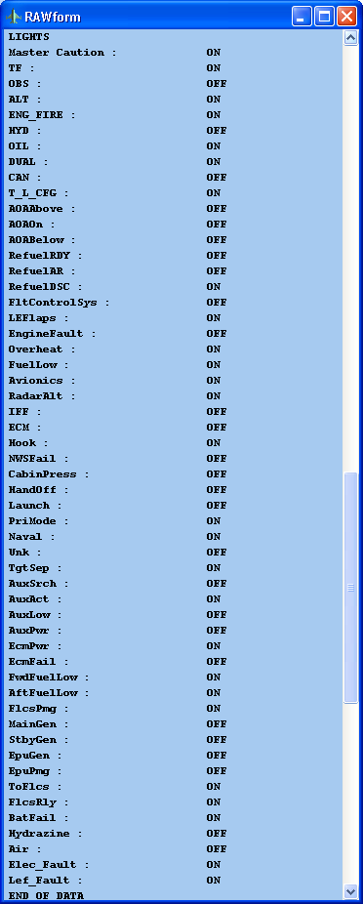

# Mapping Falcon 4 to FSUIPC Values

|  |  |  |  |
| --- | --- | --- | --- |
| Value | Falcon 4 Allied Forces Description | FSUIPC Value and description | Conversion Notes |

|  |  |  |  |
| --- | --- | --- | --- |
| ShipNorth As Single | Position of aircraft in North-South direction | 0560, 4, Latitude of aircraft in FS units. High Order  0564, 4, Latitude of aircraft in FS units. Low Order  Used by FreeFD ND | Lat_Zero_Point = 123  Long_zero_point = 33.851  Feet_in_lat = 365519.613  XFeet_In_Lat = 365500  Const Long_Coeffecient = 0.20833333 |

|  |  |  |  |
| --- | --- | --- | --- |
| ShipEast As Single | Position of aircraft in East-West direction | 0568, 4, Longitude of aircraft in FS format. High Order  056C, 4, Longitude of aircraft in FS format. Low Order  Used by FreeFD ND | See GPS Out code |

|  |  |  |  |
| --- | --- | --- | --- |
| ShipDown As Single | Elevation of Aircraft | 0574, 4, Altitude, in metres and fractional metres.  Used by FreeFD EADI | FSUIPC.x0574 = Int(F4_Data.ShipDown) * -0.3048 |

|  |  |  |  |
| --- | --- | --- | --- |
| ShipNorthRate As Single | Velocity of Aircraft in North-South direction(ft/sec) |  |  |

|  |  |  |  |
| --- | --- | --- | --- |
| ShipEastRate As Single | Velocity of Aircraft in East-West direction (ft/sec) |  |  |

|  |  |  |  |
| --- | --- | --- | --- |
| ShipDownRate As Single | Rate of Descent/Climb | 02C8, 4, Vertical speed, signed, as 256 * metres/sec. For the more usual ft/min you need to apply the conversion *60*3.28084/256  Used by FreeFD EADI | FSUIPC_MASTER_DATA.x02C8 = F4_Data.ShipDownRate * 0.768946875 * 100 |

|  |  |  |  |
| --- | --- | --- | --- |
| alpha As Single | Ownship Angle of Attack (Degrees) | 2ED0, 8, Incidence "alpha", in radians, as a double (FLOAT64). This is the aircraft body angle of attack (AoA) not the wing AoA.  Not used by FreeFD, Simkits, or Flight Illusion |  |

|  |  |  |  |
| --- | --- | --- | --- |
| beta As Single | Ownship Beta (Degrees) | 2ED8, 8, Incidence "beta", in radians, as a double (FLOAT64). This is the side slip angle.  Not used by FreeFD, Simkits, or Flight Illusion |  |

|  |  |  |  |
| --- | --- | --- | --- |
| gamma As Single | Ownship Gamma (Radians) |  |  |

|  |  |  |  |
| --- | --- | --- | --- |
| pitch As Single | Ownship Pitch Angle (Radians) | 0578, 4, Pitch, *360/(65536*65536) for degrees. 0=level, -ve=pitch up, +ve=pitch down  Used by FreeFD EADI | FSUIPC_MASTER_DATA.x0578 = F4_Data.pitch * 683564547 |

|  |  |  |  |
| --- | --- | --- | --- |
| roll As Single | Ownship Roll Angle (Radians) | 057C, 4, Bank, *360/(65536*65536) for degrees. 0=level, -ve=bank right, +ve=bank left  Used by FreeFD EADI | FSUIPC_MASTER_DATA.x057C = F4_Data.roll * 683564547 |

|  |  |  |  |
| --- | --- | --- | --- |
| yaw As Single | Ownship Yaw Angle (Radians) (can also magnetic heading) | Possible Use | 02A0, 2, Magnetic variation (signed, -ve = West). For degrees *360/65536. Convert True headings to Magnetic by subtracting this value, Magnetic headings to True by adding this value. |

|  |  |  |  |
| --- | --- | --- | --- |
| mach As Single | Ownship Mach number (Mach) | 11C6, 2, Mach speed *20480.  Not used by FreeFD, Simkits, or Flight Illusion |  |

|  |  |  |  |
| --- | --- | --- | --- |
| kias As Single | Ownship Indicated Airspeed (Knots) | 02BC, 4, IAS: Indicated Air Speed, as knots * 128  Used by FreeFD EADI | FSUIPC_MASTER_DATA.x02BC = Int(F4_Data.kias) * 128 |

|  |  |  |  |
| --- | --- | --- | --- |
| vt As Single | Ownship True Airspeed (Ft/Sec) | 02B8, 4, TAS: True Air Speed, as knots * 128  Used by FreeFD EADI |  |

|  |  |  |  |
| --- | --- | --- | --- |
| gs As Single | Ownship G-Force (Gs) | 11BA, 2, G Force: units unknown, but /625 seems to give quite sensible values.  Not used by FreeFD, Simkits, or Flight Illusion |  |

|  |  |  |  |
| --- | --- | --- | --- |
| windOffset As Single | Wind delta to FPM (Radians) |  |  |

|  |  |  |  |
| --- | --- | --- | --- |
| nozzlePos As Single | Ownship engine nozzle percent open (0-100) | Nothing Applicable in FS2004 |  |

|  |  |  |  |
| --- | --- | --- | --- |
| internalFuel As Single | Ownship internal fuel (Lbs) | 0B7C, 4, Fuel: left main tank level, % * 128 * 65536  Used by FreeFD EADI | FSUIPC_MASTER_DATA.x0B7C = F4_Data.internalFuel |

|  |  |  |  |
| --- | --- | --- | --- |
| externalFuel As Single | Ownship external fuel (Lbs) | 0B94, 4, Fuel: right main tank level, % * 128 * 65536  Used by FreeFD EADI | FSUIPC_MASTER_DATA.x0B94 = F4_Data.externalFuel |

|  |  |  |  |
| --- | --- | --- | --- |
| fuelFlow As Single | Ownship fuel flow (Lbs/Hour) | 0918, 8, Engine 1 Fuel Flow Pounds per Hour, as floating point double (FLOAT64)  Used by FreeFD ECAS | FSUIPC_MASTER_DATA.x0918 = F4_Data.fuelFlow |

|  |  |  |  |
| --- | --- | --- | --- |
| rpm As Single | Ownship engine rpm (Percent 0-103) | 0898, 2, Engine 1 Jet N1 as 0 - 16384 (100%), or Prop RPM (derive RPM by multiplying this value by the RPM Scaler (see 08C8) and dividing by 65536). Note that Prop RPM is signed and negative for counter-rotating propellers.  Used by FreeFD ECAS | FSUIPC_MASTER_DATA.x0898 = F4_Data.rpm * 100 |

|  |  |  |  |
| --- | --- | --- | --- |
| ftit As Single | Ownship Forward Turbine Inlet Temp (Degrees C) | 08BE, 2, Engine 1 EGT, 16384 = 860 C. [Note that for Props this value is not actually correct. For FS2004 at least you will get the correct value from 3B70.  Used by FreeFD ECAS | FSUIPC_MASTER_DATA.x08BE = F4_Data.ftit * 19 |

|  |  |  |  |
| --- | --- | --- | --- |
| gearPos As Single | Ownship Gear position 0 = up, 1 = down; | Possible | 0BE8, 4, Gear control: 0=Up, 16383=Down |

|  |  |  |  |
| --- | --- | --- | --- |
| speedBrake As Single | Ownship speed brake position 0 = closed, 1 = 60 Degrees open | 0BD0, 4, Spoilers control, 0 off to 16383 fully deployed (4800 is set by arming)  Used by FreeFD ECAS |  |

|  |  |  |  |
| --- | --- | --- | --- |
| epuFuel As Single | Ownship EPU fuel (Percent 0-100) |  |  |

|  |  |  |  |
| --- | --- | --- | --- |
| oilPressure As Single | Ownship Oil Pressure (Percent 0-100) | 08BA, 2, Engine 1 Oil pressure, 16384 = 55 psi. Not that in some FS2000 aircraft (the B777) this can exceed the 16-bit capacity of this location. FSUIPC limits it to fit, i.e.65535 = 220 psi  Used by FreeFD ECAS |  |

|  |  |  |  |
| --- | --- | --- | --- |
| lightBits As Long | Cockpit Indicator Lights, one bit per bulb. See enum |  |  |

|  |  |  |  |
| --- | --- | --- | --- |
| headPitch As Single | Head pitch offset from design eye (radians) |  |  |

|  |  |  |  |
| --- | --- | --- | --- |
| headRoll As Single | Head roll offset from design eye (radians) |  |  |

|  |  |  |  |
| --- | --- | --- | --- |
| headYaw As Single | Head yaw offset from design eye (radians) |  |  |

|  |  |  |  |
| --- | --- | --- | --- |
| lightBits2 As Long | Cockpit Indicator Lights, one bit per bulb. See enum |  |  |

|  |  |  |  |
| --- | --- | --- | --- |
| lightBits3 As Long | Cockpit Indicator Lights, one bit per bulb. See enum |  |  |

|  |  |  |  |
| --- | --- | --- | --- |
| ChaffCount As Single | Number of Chaff left | Nothing Applicable in FS2004 |  |

|  |  |  |  |
| --- | --- | --- | --- |
| FlareCount As Single | Number of Flare left | Nothing Applicable in FS2004 |  |

|  |  |  |  |
| --- | --- | --- | --- |
| NoseGearPos As Single | Position of the nose landinggear | 0BEC, 4, Gear position (nose): 0=full up, 16383=full down  Used by FreeFD ECAS |  |

|  |  |  |  |
| --- | --- | --- | --- |
| LeftGearPos As Single | Position of the left landinggear | 0BF4, 4, Gear position (left): 0=full up, 16383=full down  Used by FreeFD ECAS |  |

|  |  |  |  |
| --- | --- | --- | --- |
| RightGearPos As Single | Position of the right landinggear | 0BF0, 4, Gear position (right): 0=full up, 16383=full down  Used by FreeFD ECAS |  |

|  |  |  |  |
| --- | --- | --- | --- |
| AdiIlsHorPos As Single | Position of horizontal ILS bar | 0C49, 1, NAV1 Glideslope Needle: -127 up to +127 down  Used by FreeFD EADI | Needle values appear to max out at 0.2 |

|  |  |  |  |
| --- | --- | --- | --- |
| AdiIlsVerPos As Single | Position of vertical ILS bar | 0C48, 1, NAV1 Localiser Needle: -127 left to +127 right  Used by FreeFD ECAS | Needle values appear to max out at 0.2 |

|  |  |  |  |
| --- | --- | --- | --- |
| fill_in As Single | Placeholder 2004 11 26 |  |  |

|  |  |  |  |
| --- | --- | --- | --- |
| courseState As Integer | HSI_STA_CRS_STATE |  |  |

|  |  |  |  |
| --- | --- | --- | --- |
| headingState As Integer | HSI_STA_HDG_STATE |  |  |

|  |  |  |  |
| --- | --- | --- | --- |
| totalStates As Integer | HSI_STA_TOTAL_STATES ??? |  |  |

|  |  |  |  |
| --- | --- | --- | --- |
| courseDeviation As Single | HSI_VAL_CRS_DEVIATION |  |  |

|  |  |  |  |
| --- | --- | --- | --- |
| desiredCourse As Single | HSI_VAL_DESIRED_CRS | 07CC, 2, Autopilot heading value, as degrees*65536/360  Used by FreeFD ECAS |  |

|  |  |  |  |
| --- | --- | --- | --- |
| distanceToBeacon As Single | HSI_VAL_DISTANCE_TO_BEACON | 0C29, 5, DME1 distance as character string, either "nn.n" or "nnn." (when > 99.9 nm). The 5th character may be a zero or a space. Don't rely on it.  Used by FreeFD EADI | WARNING THIS IS A STRING |

|  |  |  |  |
| --- | --- | --- | --- |
| bearingToBeacon As Single | HSI_VAL_BEARING_TO_BEACON | 0C6A, 2, ADF1: relative bearing to NDB ( *360/65536 for degrees, -ve left, +ve right)  Used by FreeFD ND | Not so sure on this one |

|  |  |  |  |
| --- | --- | --- | --- |
| currentHeading As Single | HSI_VAL_CURRENT_HEADING | 0580, 4, Heading, *360/(65536*65536) for degrees TRUE.  Used by FreeFD EADI | If (F4_Data.currentHeading * 11930464.71) < 2147483647# Then  FSUIPC_MASTER_DATA.x0580 = F4_Data.currentHeading * 11930464.71  Else  FSUIPC_MASTER_DATA.x0580 = ((F4_Data.currentHeading - 180) * 11930464.71) - 2147483647#  End If |

|  |  |  |  |
| --- | --- | --- | --- |
| desiredHeading As Single | HSI_VAL_DESIRED_HEADING |  |  |

|  |  |  |  |
| --- | --- | --- | --- |
| deviationLimit As Single | HSI_VAL_DEV_LIMIT |  |  |

|  |  |  |  |
| --- | --- | --- | --- |
| halfDeviationLimit As Single | HSI_VAL_HALF_DEV_LIMIT |  |  |

|  |  |  |  |
| --- | --- | --- | --- |
| localizerCourse As Single | HSI_VAL_LOCALIZER_CRS |  |  |

|  |  |  |  |
| --- | --- | --- | --- |
| airbaseX As Single | HSI_VAL_AIRBASE_X |  |  |

|  |  |  |  |
| --- | --- | --- | --- |
| airbaseY As Single | HSI_VAL_AIRBASE_Y |  |  |

|  |  |  |  |
| --- | --- | --- | --- |
| totalValues As Single | HSI_VAL_TOTAL_VALUES ??? |  |  |

|  |  |  |  |
| --- | --- | --- | --- |
| TrimPitch As Single | Value of trim in pitch axis, -0.5 to +0.5 |  |  |

|  |  |  |  |
| --- | --- | --- | --- |
| TrimRoll As Single | Value of trim in roll axis, -0.5 to +0.5 |  |  |

|  |  |  |  |
| --- | --- | --- | --- |
| TrimYaw As Single | Value of trim in yaw axis, -0.5 to +0.5 |  |  |

|  |  |  |  |
| --- | --- | --- | --- |
| hsiBits As Long | HSI flags |  |  |

|  |  |  |  |
| --- | --- | --- | --- |
| DEDLines As String * 130 | DED 6 * 26 usable chars |  |  |

|  |  |  |  |
| --- | --- | --- | --- |
| Invert As String * 130 | DED 6 * 26 usable chars |  |  |

|  |  |  |  |
| --- | --- | --- | --- |
| PFLLines As String * 130 | PFL 6 * 26 usable chars |  |  |

|  |  |  |  |
| --- | --- | --- | --- |
| PFLInvert As String * 130 | PFL 6 * 26 usable chars |  |  |

|  |  |  |  |
| --- | --- | --- | --- |
| UFCTChan As Single | UFC TACAN Channel |  |  |

|  |  |  |  |
| --- | --- | --- | --- |
| AUXTChan As Single | AUX TACAN Channel |  |  |

|  |  |  |  |
| --- | --- | --- | --- |
| RWRObjectCount As Long | Number of valid threat object |  |  |

|  |  |  |  |
| --- | --- | --- | --- |
| RWRSymbol(39) As Long | Type of threat |  |  |

|  |  |  |  |
| --- | --- | --- | --- |
| Bearing(39) As Single | Bearing to threat (radians) |  |  |

|  |  |  |  |
| --- | --- | --- | --- |
| MissileActivity(39) As Long | Missile is active or beam rider |  |  |

|  |  |  |  |
| --- | --- | --- | --- |
| MissileLaunch(39) As Long | Missile is launched |  |  |

|  |  |  |  |
| --- | --- | --- | --- |
| Selected(39) As Long | Threat is Selected |  |  |

|  |  |  |  |
| --- | --- | --- | --- |
| Lethality(39) As Single | Lethal Range |  |  |

|  |  |  |  |
| --- | --- | --- | --- |
| NewDetection(39) As Long | New for F4 |  |  |

|  |  |  |  |
| --- | --- | --- | --- |
| FWDFuel As Single | Forward Fuel Tank Quantity |  |  |

|  |  |  |  |
| --- | --- | --- | --- |
| AFTFuel As Single | Aft Fuel Tank Quantity |  |  |

|  |  |  |  |
| --- | --- | --- | --- |
| TotalFuel As Single | Total Fuel Tank Quantity |  |  |

|  |  |  |  |
| --- | --- | --- | --- |
| VersionNum As Integer | Version of sh.mem file |  |  |

|  |  |  |  |
| --- | --- | --- | --- |
|  |  |  |  |

|  |  |  |  |
| --- | --- | --- | --- |
|  |  |  |  |

|  |  |  |  |
| --- | --- | --- | --- |
| lightBit(1)=&H1 | MasterCaution |  |  |

|  |  |  |  |
| --- | --- | --- | --- |
| lightBit(2)=&H2 | TF |  |  |

|  |  |  |  |
| --- | --- | --- | --- |
| lightBit(3)=&H4 | OBS |  |  |

|  |  |  |  |
| --- | --- | --- | --- |
| lightBit(4)=&H8 | ALT |  |  |

|  |  |  |  |
| --- | --- | --- | --- |
| lightBit(5)=&H20 | ENG_FIRE | 3366, 1, This byte reflects the FS2004 "Engine on Fire" flags. I'm not sure if FS actually simulates such events, but it appears to have allocated Gauge-accessible variables to indicate them. This byte uses bits 2^0-2^3 as flags for fires in Engines 1 to 4, respec |  |

|  |  |  |  |
| --- | --- | --- | --- |
| lightBit(6)=&H40 | CONFIG |  |  |

|  |  |  |  |
| --- | --- | --- | --- |
| lightBit(7)=&H80 | HYD |  |  |

|  |  |  |  |
| --- | --- | --- | --- |
| lightBit(8)=&H100 | OIL |  |  |

|  |  |  |  |
| --- | --- | --- | --- |
| lightBit(9)=&H200 | DUAL |  |  |

|  |  |  |  |
| --- | --- | --- | --- |
| lightBit(10)=&H400 | CAN |  |  |

|  |  |  |  |
| --- | --- | --- | --- |
| lightBit(11)=&H800 | T_L_CFG |  |  |

|  |  |  |  |
| --- | --- | --- | --- |
| lightBit(12)=&H1000 | AOAAbove |  |  |

|  |  |  |  |
| --- | --- | --- | --- |
| lightBit(13)=&H2000 | AOAOn |  |  |

|  |  |  |  |
| --- | --- | --- | --- |
| lightBit(14)=&H4000 | AOABelow |  |  |

|  |  |  |  |
| --- | --- | --- | --- |
| lightBit(15)=&H8000 | RefuelRDY |  |  |

|  |  |  |  |
| --- | --- | --- | --- |
| lightBit(16)=&H10000 | RefuelAR |  |  |

|  |  |  |  |
| --- | --- | --- | --- |
| lightBit(17)=&H20000 | RefuelDSC |  |  |

|  |  |  |  |
| --- | --- | --- | --- |
| lightBit(18)=&H40000 | FltControlSys |  |  |

|  |  |  |  |
| --- | --- | --- | --- |
| lightBit(19)=&H80000 | LEFlaps |  |  |

|  |  |  |  |
| --- | --- | --- | --- |
| lightBit(20)=&H100000 | EngineFault |  |  |

|  |  |  |  |
| --- | --- | --- | --- |
| lightBit(21)=&H200000 | Overheat |  |  |

|  |  |  |  |
| --- | --- | --- | --- |
| lightBit(22)=&H400000 | FuelLow |  |  |

|  |  |  |  |
| --- | --- | --- | --- |
| lightBit(23)=&H800000 | Avionics |  |  |

|  |  |  |  |
| --- | --- | --- | --- |
| lightBit(24)=&H1000000 | RadarAlt |  |  |

|  |  |  |  |
| --- | --- | --- | --- |
| lightBit(25)=&H2000000 | IFF |  |  |

|  |  |  |  |
| --- | --- | --- | --- |
| lightBit(26)=&H4000000 | ECM |  |  |

|  |  |  |  |
| --- | --- | --- | --- |
| lightBit(27)=&H8000000 | Hook |  |  |

|  |  |  |  |
| --- | --- | --- | --- |
| lightBit(28)=&H10000000 | NWSFail |  |  |

|  |  |  |  |
| --- | --- | --- | --- |
| lightBit(29)=&H20000000 | CabinPress |  |  |

|  |  |  |  |
| --- | --- | --- | --- |
| lightBit2(1)=&H1 | HandOff |  |  |

|  |  |  |  |
| --- | --- | --- | --- |
| lightBit2(2)=&H2 | launch |  |  |

|  |  |  |  |
| --- | --- | --- | --- |
| lightBit2(3)=&H4 | PriMode |  |  |

|  |  |  |  |
| --- | --- | --- | --- |
| lightBit2(4)=&H8 | Naval |  |  |

|  |  |  |  |
| --- | --- | --- | --- |
| lightBit2(5)=&H10 | Unk |  |  |

|  |  |  |  |
| --- | --- | --- | --- |
| lightBit2(6)=&H20 | TgtSep |  |  |

|  |  |  |  |
| --- | --- | --- | --- |
| lightBit2(7)=&H1000 | AuxSrch |  |  |

|  |  |  |  |
| --- | --- | --- | --- |
| lightBit2(8)=&H2000 | AuxAct |  |  |

|  |  |  |  |
| --- | --- | --- | --- |
| lightBit2(9)=&H4000 | AuxLow |  |  |

|  |  |  |  |
| --- | --- | --- | --- |
| lightBit2(10)=&H8000 | AuxPwr |  |  |

|  |  |  |  |
| --- | --- | --- | --- |
| lightBit2(11)=&H10000 | EcmPwr |  |  |

|  |  |  |  |
| --- | --- | --- | --- |
| lightBit2(12)=&H20000 | EcmFail |  |  |

|  |  |  |  |
| --- | --- | --- | --- |
| lightBit2(13)=&H40000 | FwdFuelLow |  |  |

|  |  |  |  |
| --- | --- | --- | --- |
| lightBit2(14)=&H80000 | AftFuelLow |  |  |

|  |  |  |  |
| --- | --- | --- | --- |
| lightBit2(15)=&H100000 | EPUOn |  |  |

|  |  |  |  |
| --- | --- | --- | --- |
| lightBit2(16)=&H200000 | JFSOn |  |  |

|  |  |  |  |
| --- | --- | --- | --- |
| lightBit2(17)=&H400000 | SEC |  |  |

|  |  |  |  |
| --- | --- | --- | --- |
| lightBit2(18)=&H800000 | OXY_LOW |  |  |

|  |  |  |  |
| --- | --- | --- | --- |
| lightBit2(19)=&H1000000 | PROBEHEAT |  |  |

|  |  |  |  |
| --- | --- | --- | --- |
| lightBit2(20)=&H2000000 | SEAT_ARM |  |  |

|  |  |  |  |
| --- | --- | --- | --- |
| lightBit2(21)=&H4000000 | BUC |  |  |

|  |  |  |  |
| --- | --- | --- | --- |
| lightBit2(22)=&H8000000 | FUEL_OIL_HOT |  |  |

|  |  |  |  |
| --- | --- | --- | --- |
| lightBit2(23)=&H10000000 | ANTI_SKID |  |  |

|  |  |  |  |
| --- | --- | --- | --- |
| lightBit2(24)=&H20000000 | TFR_ENGAGED |  |  |

|  |  |  |  |
| --- | --- | --- | --- |
| lightBit2(25)=&H40000000 | GEARHANDLE |  |  |

|  |  |  |  |
| --- | --- | --- | --- |
| lightBit3(1)=&H1 | Flcspmg |  |  |

|  |  |  |  |
| --- | --- | --- | --- |
| lightBit3(2)=&H2 | MainGen |  |  |

|  |  |  |  |
| --- | --- | --- | --- |
| lightBit3(3)=&H4 | StbyGen |  |  |

|  |  |  |  |
| --- | --- | --- | --- |
| lightBit3(4)=&H8 | EPUGen |  |  |

|  |  |  |  |
| --- | --- | --- | --- |
| lightBit3(5)=&H10 | EPUpmg |  |  |

|  |  |  |  |
| --- | --- | --- | --- |
| lightBit3(6)=&H20 | ToFlcs |  |  |

|  |  |  |  |
| --- | --- | --- | --- |
| lightBit3(7)=&H40 | FlcsRly |  |  |

|  |  |  |  |
| --- | --- | --- | --- |
| lightBit3(8)=&H80 | BatFail |  |  |

|  |  |  |  |
| --- | --- | --- | --- |
| lightBit3(9)=&H100 | Hydrazine |  |  |

|  |  |  |  |
| --- | --- | --- | --- |
| lightBit3(10)=&H200 | Air |  |  |

|  |  |  |  |
| --- | --- | --- | --- |
| lightBit3(11)=&H400 | Elec_Fault |  |  |

|  |  |  |  |
| --- | --- | --- | --- |
| lightBit3(12)=&H800 | Lef_Fault |  |  |

|  |  |  |  |
| --- | --- | --- | --- |
|  |  |  |  |

|  |  |  |  |
| --- | --- | --- | --- |
| hsiBit(1)=&H1 | HSITOTrue |  |  |

|  |  |  |  |
| --- | --- | --- | --- |
| hsiBit(2)=&H2 | HSIILSWARN |  |  |

|  |  |  |  |
| --- | --- | --- | --- |
| hsiBit(3)=&H4 | HSICRSWARN |  |  |

|  |  |  |  |
| --- | --- | --- | --- |
| hsiBit(4)=&H8 | HSIFLAGINIT |  |  |

|  |  |  |  |
| --- | --- | --- | --- |
| hsiBit(5)=&H10 | HSITotalFlags(?) |  |  |

|  |  |  |  |
| --- | --- | --- | --- |
| hsiBit(6)=&H20 | ADIOFFFlag |  |  |

|  |  |  |  |
| --- | --- | --- | --- |
| hsiBit(7)=&H40 | ADIAUXFlag |  |  |

|  |  |  |  |
| --- | --- | --- | --- |
| hsiBit(8)=&H80 | ADIGSFlag |  |  |

|  |  |  |  |
| --- | --- | --- | --- |
| hsiBit(9)=&H100 | ADILOCFlag |  |  |

|  |  |  |  |
| --- | --- | --- | --- |
| hsiBit(10)=&H200 | ADIOFFFlag |  |  |

|  |  |  |  |
| --- | --- | --- | --- |
| hsiBit(11)=&H400 | HSIOFFFlag |  |  |

|  |  |  |  |
| --- | --- | --- | --- |
| hsiBit(12)=&H800 | VVIOFFFlag |  |  |

|  |  |  |  |
| --- | --- | --- | --- |
| hsiBit(13)=&H1000 | AOAOFFFlag |  |  |

|  |  |  |  |
| --- | --- | --- | --- |
| hsiBit(14)=&H2000 | AVTRLight |  |  |

|  |  |  |  |
| --- | --- | --- | --- |
|  |  |  |  |

# Lomac Export LUA Script (as of 6th Feb 2006)

The LUA export script has been purposefully divided into groups. Each group generates a string, which is then assembled with all other strings at the end of the script. This allows you to easily add/delete/modify components of the script without impacting on other components.

**WARNING:** As of Flaming Cliffs 1.12, you also need to modify config.lua. The value EnableExportScript = true needs to be included. If you don’t the script will export nothing. This is also case sensitive, if you set it to ‘True’ nothing happens.

|  |
| --- |
| LUA Export Script |

|  |
| --- |
| -- Data export script for Lock On version 1.1. |

|  |
| --- |
| -- Copyright (C) 2004, Eagle Dynamics. |

|  |
| --- |
| -- See http://www.lua.org for Lua script system info |

|  |
| --- |
| -- Look into ./Temp/Error.log for this script errors, please. |

|  |
| --- |
|  |

|  |
| --- |
| function LuaExportStart() |

|  |
| --- |
| end |

|  |
| --- |
|  |

|  |
| --- |
|  |

|  |
| --- |
| function LuaExportBeforeNextFrame() |

|  |
| --- |
| -- Works just before every simulation frame. |

|  |
| --- |
| end |

|  |
| --- |
|  |

|  |
| --- |
| function LuaExportAfterNextFrame() |

|  |
| --- |
| -- Works just after every simulation frame. |

|  |
| --- |
|  |

|  |
| --- |
|  |

|  |
| --- |
| end |

|  |
| --- |
|  |

|  |
| --- |
|  |

|  |
| --- |
| function LuaExportStop() |

|  |
| --- |
| end |

|  |
| --- |
|  |

|  |
| --- |
| function LuaExportActivityNextEvent(t) |

|  |
| --- |
|  |

|  |
| --- |
| local tNext = t + 0.1 |

|  |
| --- |
|  |

|  |
| --- |
| local t = LoGetModelTime() |

|  |
| --- |
| local missionstarttime = LoGetMissionStartTime() |

|  |
| --- |
| local name = LoGetPilotName() |

|  |
| --- |
| local airspeed = LoGetIndicatedAirSpeed() |

|  |
| --- |
| local altBar = LoGetAltitudeAboveSeaLevel() |

|  |
| --- |
| local altRad = LoGetAltitudeAboveGroundLevel() |

|  |
| --- |
| local AOA = LoGetAngleOfAttack() |

|  |
| --- |
| local accelunits = LoGetAccelerationUnits() |

|  |
| --- |
| local vsi = LoGetVerticalVelocity() |

|  |
| --- |
| local pitch, bank, yaw = LoGetADIPitchBankYaw() |

|  |
| --- |
| local engine = LoGetEngineInfo() |

|  |
| --- |
| local HSIInfo = LoGetControlPanel_HSI() |

|  |
| --- |
| local MCPDisplay = LoGetMCPState() |

|  |
| --- |
| local stations = LoGetPayloadInfo() |

|  |
| --- |
| local GlideDeviation = LoGetGlideDeviation() |

|  |
| --- |
| local SideDeviation = LoGetSideDeviation() |

|  |
| --- |
| local SlipBallPos = LoGetSlipBallPosition() |

|  |
| --- |
| local TargetInfo = LoGetLockedTargetInformation() |

|  |
| --- |
| local RouteInfo = LoGetRoute() |

|  |
| --- |
| local NavInfo = LoGetNavigationInfo() |

|  |
| --- |
| local AtmosphereInfo = LoGetBasicAtmospherePressure() |

|  |
| --- |
|  |

|  |
| --- |
|  |

|  |
| --- |
| dofile "lua.lua" |

|  |
| --- |
|  |

|  |
| --- |
| -- The Basic Networking Stuff |

|  |
| --- |
| local host, port = "guagepc", 8080 |

|  |
| --- |
| socket = require("socket") |

|  |
| --- |
| local ip = socket.try(socket.dns.toip(host)) |

|  |
| --- |
| local udp = socket.try(socket.udp()) |

|  |
| --- |
|  |

|  |
| --- |
|  |

|  |
| --- |
| local a = "" |

|  |
| --- |
|  |

|  |
| --- |
| -- General Aircraft Information |

|  |
| --- |
| local TimeAndPilot = string.format("Modelt = %.2f, startt = %.2f, name = %s,\n", t, missionstarttime, name) |

|  |
| --- |
|  |

|  |
| --- |
| local AirspeedAltitude = string.format("airpseed = %.2f, altBar = %.2f, alrRad =%.2f,\n", airspeed, altBar, altRad) |

|  |
| --- |
|  |

|  |
| --- |
| local GVSIBackPitchYaw = string.format("accelunits =%.2f, vsi = %.2f, pitch = %.2f, bank = %.2f, yaw = %.2f, AOA = %.2f, AtmosPressure= %.0f,\n", accelunits , vsi,pitch, bank, yaw, AOA, AtmosphereInfo ) |

|  |
| --- |
|  |

|  |
| --- |
| local LeftEngineStr = string.format("RPMleft = %.1f, LeftHydPress = %.4f, LeftTemp = %.0f,\n",engine.RPM.left, engine.HydraulicPressure.left, engine.Temperature.left) |

|  |
| --- |
|  |

|  |
| --- |
| local RightEngineStr = string.format("RPMRight = %.1f, RightHydPress = %.4f, RightTemp = %.0f,", engine.RPM.right, engine.HydraulicPressure.right, engine.Temperature.right) |

|  |
| --- |
|  |

|  |
| --- |
| local FuelStr = string.format("FuelInt = %.0f, FuelExt = %.0f,\n", engine.fuel_internal, engine.fuel_external ) |

|  |
| --- |
|  |

|  |
| --- |
|  |

|  |
| --- |
| -- HSI |

|  |
| --- |
| if HSIInfo then |

|  |
| --- |
| HSIInfoStr = string.format("HSIADF=%f, HSIRMI=%f, HSICompass=%f,\n", HSIInfo.ADF, HSIInfo.RMI, HSIInfo.Compass) |

|  |
| --- |
| else |

|  |
| --- |
| HSIInfoStr = "" |

|  |
| --- |
| end |

|  |
| --- |
|  |

|  |
| --- |
|  |

|  |
| --- |
| -- Warning Indicators |

|  |
| --- |
| MCPDisplayStr = "" |

|  |
| --- |
| MCPWrkStr = "" |

|  |
| --- |
| MCPWrkStrB = "" |

|  |
| --- |
| if MCPDisplay then |

|  |
| --- |
|  |

|  |
| --- |
| for i_MCP,MCPVal in MCPDisplay do |

|  |
| --- |
| if MCPVal then |

|  |
| --- |
| MCPWrkStr = string.format("%s = True,", i_MCP) |

|  |
| --- |
| else |

|  |
| --- |
| MCPWrkStr = string.format("%s = False,", i_MCP) |

|  |
| --- |
| end |

|  |
| --- |
|  |

|  |
| --- |
| MCPWrkStrB = string.format("%s %s", MCPDisplayStr, MCPWrkStr ) |

|  |
| --- |
| MCPDisplayStr = MCPWrkStrB |

|  |
| --- |
| end |

|  |
| --- |
| end |

|  |
| --- |
| MCPWrkStrB = string.format("%s\n", MCPDisplayStr) |

|  |
| --- |
| MCPDisplayStr = MCPWrkStrB |

|  |
| --- |
|  |

|  |
| --- |
|  |

|  |
| --- |
| -- Current Route and Route Plan |

|  |
| --- |
| RouteDisplayStr = "" |

|  |
| --- |
| if RouteInfo then |

|  |
| --- |
|  |

|  |
| --- |
| RouteDisplayStr = string.format("Current Way Point = %d ,wpt_pos = (%f, %f ,%f) ,nextWP =%d\n%s",RouteInfo.goto_point.this_point_num,RouteInfo.goto_point.world_point.x,RouteInfo.goto_point.world_point.y,RouteInfo.goto_point.world_point.z,RouteInfo.goto_point.next_point_num,a) |

|  |
| --- |
|  |

|  |
| --- |
| for num,wpt in pairs(RouteInfo.route) do |

|  |
| --- |
| localRouteWrk = string.format("%s WayPointNo= %d ,wpt_pos = (%f, %f ,%f) ,nextWP =%d\n",RouteDisplayStr ,wpt.this_point_num,wpt.world_point.x,wpt.world_point.y,wpt.world_point.z,wpt.next_point_num) |

|  |
| --- |
| RouteDisplayStr = localRouteWrk |

|  |
| --- |
| end |

|  |
| --- |
| end |

|  |
| --- |
|  |

|  |
| --- |
|  |

|  |
| --- |
| -- a holds the current information |

|  |
| --- |
| NAVDisplayStr = "" |

|  |
| --- |
| localNavWrk = "" |

|  |
| --- |
| if NavInfo then |

|  |
| --- |
| if NavInfo.ACS.autothrust then |

|  |
| --- |
| AutoThrust= "True" |

|  |
| --- |
| else |

|  |
| --- |
| AutoThrust= "False" |

|  |
| --- |
| end |

|  |
| --- |
| NAVDisplayStr = string.format("MasterMode=%s, SubMode=%s, ACS=%s, AutoThrust=%s\n",NavInfo.SystemMode.master,NavInfo.SystemMode.submode,NavInfo.ACS.mode,AutoThrust) |

|  |
| --- |
| localNavWrk = string.format("%s HeadingReq=roll %f,pitch %f, speed %d",NAVDisplayStr, NavInfo.Requirements.roll,NavInfo.Requirements.pitch,NavInfo.Requirements.speed) |

|  |
| --- |
| NAVDisplayStr = localNavWrk |

|  |
| --- |
| end |

|  |
| --- |
|  |

|  |
| --- |
|  |

|  |
| --- |
|  |

|  |
| --- |
| -- Targets |

|  |
| --- |
| TgtStr = "" |

|  |
| --- |
| localTgtwrk = "" |

|  |
| --- |
| if TargetInfo then |

|  |
| --- |
| -- seems a bit bougus always seem to have locked target when you don't |

|  |
| --- |
| for i,cur in pairs(TargetInfo) do |

|  |
| --- |
| TheTarget = LoGetObjectById(cur.ID) |

|  |
| --- |
| localTgtwrk = string.format("%sTarget=%s,Country=%s, Collation=%s, ID = %d, Convergence=%f,Distance=%f\n",TgtStr, TheTarget.Name, TheTarget.Country, TheTarget.Coalition, cur.ID,cur.convergence_velocity,cur.distance) |

|  |
| --- |
| TgtStr = localTgtwrk |

|  |
| --- |
| end |

|  |
| --- |
| else |

|  |
| --- |
| TgtStr = "No Target\n" |

|  |
| --- |
| end |

|  |
| --- |
|  |

|  |
| --- |
|  |

|  |
| --- |
|  |

|  |
| --- |
|  |

|  |
| --- |
| WeaponStr = "" |

|  |
| --- |
| WeaponWrkStr = "" |

|  |
| --- |
| WeaponWrkStrB = "" |

|  |
| --- |
| CurrentStation = "" |

|  |
| --- |
| if stations then |

|  |
| --- |
| for i_st,st in pairs (stations.Stations) do |

|  |
| --- |
|  |

|  |
| --- |
| -- Get the display name for each weapon |

|  |
| --- |
| local name = LoGetNameByType(st.weapon.level1,st.weapon.level2,st.weapon.level3,st.weapon.level4); |

|  |
| --- |
| if name then |

|  |
| --- |
| WeaponWrkStr = string.format(" weapon = %s , count = %d ",name,st.count) |

|  |
| --- |
| if (i_st == stations.CurrentStation) then |

|  |
| --- |
| CurrentStation = string.format("\nCurrent Weapon=%s Station %s",name, i_st) |

|  |
| --- |
| end |

|  |
| --- |
| else |

|  |
| --- |
| WeaponWrkStr = string.format(" weapon = {%d,%d,%d,%d} ,count = %d ", st.weapon.level1,st.weapon.level2,st.weapon.level3,st.weapon.level4,st.count) |

|  |
| --- |
| end |

|  |
| --- |
|  |

|  |
| --- |
| WeaponWrkStrB = string.format("%s",WeaponStr ) |

|  |
| --- |
| if (st.container == true) then |

|  |
| --- |
| WeaponStr = string.format("%s Station No %s %s Container\n",WeaponWrkStrB ,i_st,WeaponWrkStr ) |

|  |
| --- |
| else |

|  |
| --- |
| WeaponStr = string.format("%s Station No %s %s\n",WeaponWrkStrB ,i_st,WeaponWrkStr ) |

|  |
| --- |
| end |

|  |
| --- |
| end |

|  |
| --- |
| end |

|  |
| --- |
| WeaponWrkStr = string.format("%s\n%s", CurrentStation, WeaponStr) |

|  |
| --- |
| WeaponStr = WeaponWrkStr |

|  |
| --- |
|  |

|  |
| --- |
|  |

|  |
| --- |
| -- LatLongSlip |

|  |
| --- |
| LatLongSlipStr = "" |

|  |
| --- |
| MyPlane = LoGetObjectById(LoGetPlayerPlaneId()) |

|  |
| --- |
| LatPos = MyPlane.LatLongAlt.Lat |

|  |
| --- |
| LongPos = MyPlane.LatLongAlt.Long |

|  |
| --- |
| LatLongSlipStr = string.format("MyLat=%s, MyLong=%s, GlideDev=%.2f, SideDev=%.2f, SlipBall=%.2f\n", LatPos, LongPos, GlideDeviation, SideDeviation,SlipBallPos) |

|  |
| --- |
|  |

|  |
| --- |
|  |

|  |
| --- |
|  |

|  |
| --- |
|  |

|  |
| --- |
| -- Threat Warning system |

|  |
| --- |
| TWSStr = "" |

|  |
| --- |
| TWSWrkStrA = "" |

|  |
| --- |
| TWSWrkStrB = "" |

|  |
| --- |
| local TWS = LoGetTWSInfo() |

|  |
| --- |
| if TWS then |

|  |
| --- |
|  |

|  |
| --- |
| TWSStr = string.format("Current TWS Mode=%s\n", TWS.Mode) |

|  |
| --- |
|  |

|  |
| --- |
| for i_em,em in pairs (TWS.Emitters) do |

|  |
| --- |
| TWSWrkStrA = string.format("%semid=%s, Az=%f, Type=%s.",TWSStr,em.ID, em.Azimuth,em.Type.level1) |

|  |
| --- |
| TWSWrkStrB = string.format("%s, Signal=%s, Priority=%s,Power=%s\n",em.Type.level2, em.SignalType,em.Priority, em.Power) |

|  |
| --- |
| TWSStr = string.format("%s %s", TWSWrkStrA ,TWSWrkStrB ) |

|  |
| --- |
| end |

|  |
| --- |
| end |

|  |
| --- |
|  |

|  |
| --- |
|  |

|  |
| --- |
| Group1Str = string.format("%s %s %s %s", TimeAndPilot, AirspeedAltitude, GVSIBackPitchYaw, LeftEngineStr) |

|  |
| --- |
| Group2Str = string.format("%s %s %s %s", RightEngineStr, FuelStr, HSIInfoStr, MCPDisplayStr) |

|  |
| --- |
| Group3Str = string.format("%s %s %s %s",RouteDisplayStr, NAVDisplayStr, TgtStr, WeaponStr) |

|  |
| --- |
| Group4Str = string.format("%s %s",LatLongSlipStr, TWSStr) |

|  |
| --- |
| StringToSend = string.format("%s %s %s %s", Group1Str, Group2Str, Group3Str, Group4Str) |

|  |
| --- |
|  |

|  |
| --- |
| socket.try(udp:sendto( StringToSend , ip, port)) |

|  |
| --- |
|  |

|  |
| --- |
| return tNext |

|  |
| --- |
| end |

# Output from Lomac Data

|  |
| --- |
| **Modelt = 21.90, startt = 54000.00, name = Pilot1,** |
| airpseed = 151.40, altBar = 9138.00, altRad =9138.00, |
| accelunits =1.00, vsi = -0.73, pitch = 0.04, bank = 0.00, yaw = 1.19, AOA = 2.65, AtmosPressure= 760, |
| RPMleft = 67.5, LeftHydPress = 0.0000, LeftTemp = 320, |
| RPMRight = 67.5, RightHydPress = 0.0000, RightTemp = 320, FuelInt = 1451, FuelExt = 1597, |
| HSIADF=1.191215, HSIRMI=1.191215, HSICompass=1.191213, |
| RightTailPlaneFailure = False, EOSFailure = False, ECMFailure = False, RightAileronFailure = False, MasterWarning = False, RightEngineFailure = False, CannonFailure = False, MLWSFailure = False, ACSFailure = False, RadarFailure = False, HelmetFailure = False, HUDFailure = False, LeftMainPumpFailure = False, RightWingPumpFailure = False, LeftWingPumpFailure = False, MFDFailure = False, RWSFailure = False, GearFailure = False, HydraulicsFailure = False, AutopilotFailure = True, FuelTankDamage = False, LeftAileronFailure = False, CanopyOpen = False, RightMainPumpFailure = False, StallSignalization = False, LeftEngineFailure = False, AutopilotOn = False, LeftTailPlaneFailure = False, |
| Current Way Point = 1 ,wpt_pos = (24.671503, 9144.000000 ,30735.792969) ,nextWP =2 |
| WayPointNo= 0 ,wpt_pos = (-24040.080078, 9144.000000 ,91059.468750) ,nextWP =1 |
| WayPointNo= 1 ,wpt_pos = (24.671503, 9144.000000 ,30735.792969) ,nextWP =2 |
| WayPointNo= 2 ,wpt_pos = (18998.800781, 609.600037 ,37832.695313) ,nextWP =-1 |
| MasterMode=NAV, SubMode=ROUTE, ACS=OFF, AutoThrust=False |
| HeadingReq=roll -0.000014,pitch 0.049362, speed 308 |
| Current Weapon=AIM-120C Station 2 |
| Station No 1 weapon = {0,0,0,0} ,count = 0 |
| Station No 2 weapon = AIM-120C , count = 1 |
| Station No 3 weapon = {0,0,0,0} ,count = 0 |
| Station No 4 weapon = {0,0,0,0} ,count = 0 |
| Station No 5 weapon = AIM-9M , count = 1 |
| Station No 6 weapon = AIM-9M , count = 1 |
| Station No 7 weapon = AIM-7M , count = 1 |
| Station No 8 weapon = AIM-7M , count = 1 |
| Station No 9 weapon = AIM-7M , count = 1 |
| Station No 10 weapon = AIM-7M , count = 1 |
| Station No 11 weapon = fuel tank 1000 gal , count = 1 |
| MyLat=44.910015246439, MyLong=35.349900521639, GlideDev=-1.00, SideDev=-1.00, SlipBall=0.00 |
| Current TWS Mode=0 |
| emid=16778496, Az=0.609741, Type=1. 1, Signal=scan, Priority=160.48529052734,Power=0.48528504371643 |

# LUA Script to Get Coordinates

Reference <http://forum.lockon.ru/showthread.php?t=17814>

--data for recalculation

zeroX = 5000000

zeroZ = 6600000

centerX = 11465000 - zeroX --circle center centerZ = 6500000 - zeroZ

pnSxW_X = 4468608 - zeroX -- point 40dgN : 24dgE pnSxW_Z = 5730893 - zeroZ

pnNxW_X = 5357858 - zeroX -- point 48dgN : 24dgE pnNxW_Z = 5828649 - zeroZ

pnSxE_X = 4468608 - zeroX -- point 40dgN : 42dgE pnSxE_Z = 7269106 - zeroZ

pnNxE_X = 5357858 - zeroX -- point 48dgN : 42dgE pnNxE_Z = 7171350 - zeroZ

lenNorth = math.sqrt((pnNxW_X-centerX)*(pnNxW_X-centerX) + (pnNxW_Z-centerZ)*(pnNxW_Z-centerZ))

lenSouth = math.sqrt((pnSxW_X-centerX)*(pnSxW_X-centerX) + (pnSxW_Z-centerZ)*(pnSxW_Z-centerZ))

lenN_S = lenSouth - lenNorth

RealAngleMaxLongitude = math.atan ((pnSxW_Z - centerZ)/(pnSxW_X - centerX)) * 180/pi

-- borders

EndWest = 24

EndEast = 42

EndNorth = 48

EndSouth = 40

MiddleLongitude = (EndWest + EndEast) / 2 ToLengthN_S = ((EndNorth - EndSouth) / lenN_S) ToAngleW_E = (MiddleLongitude - EndWest) / RealAngleMaxLongitude

ToDegree = 360/(2*pi)

function getLongitude(x, z) -- degrees , (x (meters) - to North, z (meters) - to East)

ang = - math.atan (((z - centerZ)) / (x - centerX)) * ToDegree

return ang * ToAngleW_E + MiddleLongitude

end

function getLatitude(x, z) --degrees (x (meters) - to North, z (meters) - to East)

len = lenSouth - math.sqrt((x-centerX)*(x-centerX) + (z-centerZ)*(z-centerZ))

return len * ToLengthN_S + EndSouth

end

function getXYCoords(inLatitudeDegrees, inLongitudeDegrees) -- args: 2 numbers // Return two value in order: X, Y

-- Lo coordinates system

realAng = (inLongitudeDegrees - MiddleLongitude) / ToAngleW_E / ToDegree

realLen = lenSouth - (inLatitudeDegrees - EndSouth) / ToLengthN_S

outX = centerX - realLen * cos (realAng)

outZ = centerZ + realLen * sin (realAng)

return outX, outY

end

## PCB Circuit Diagrams

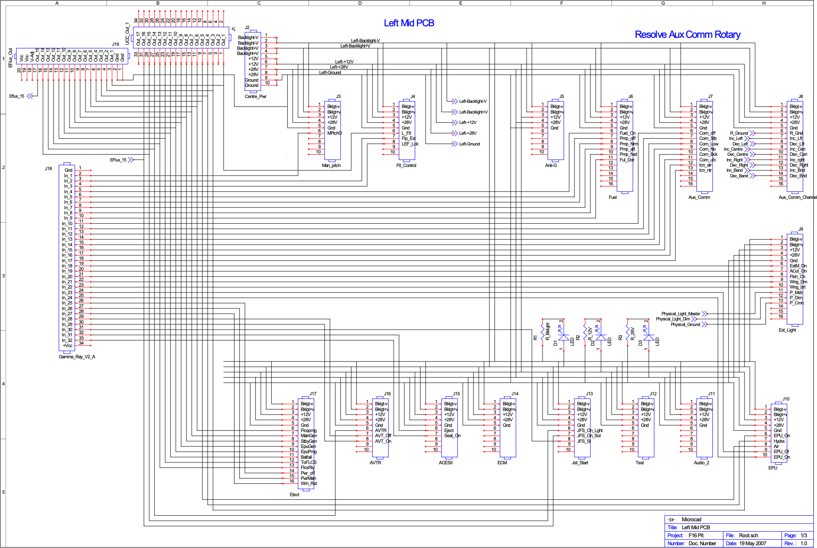

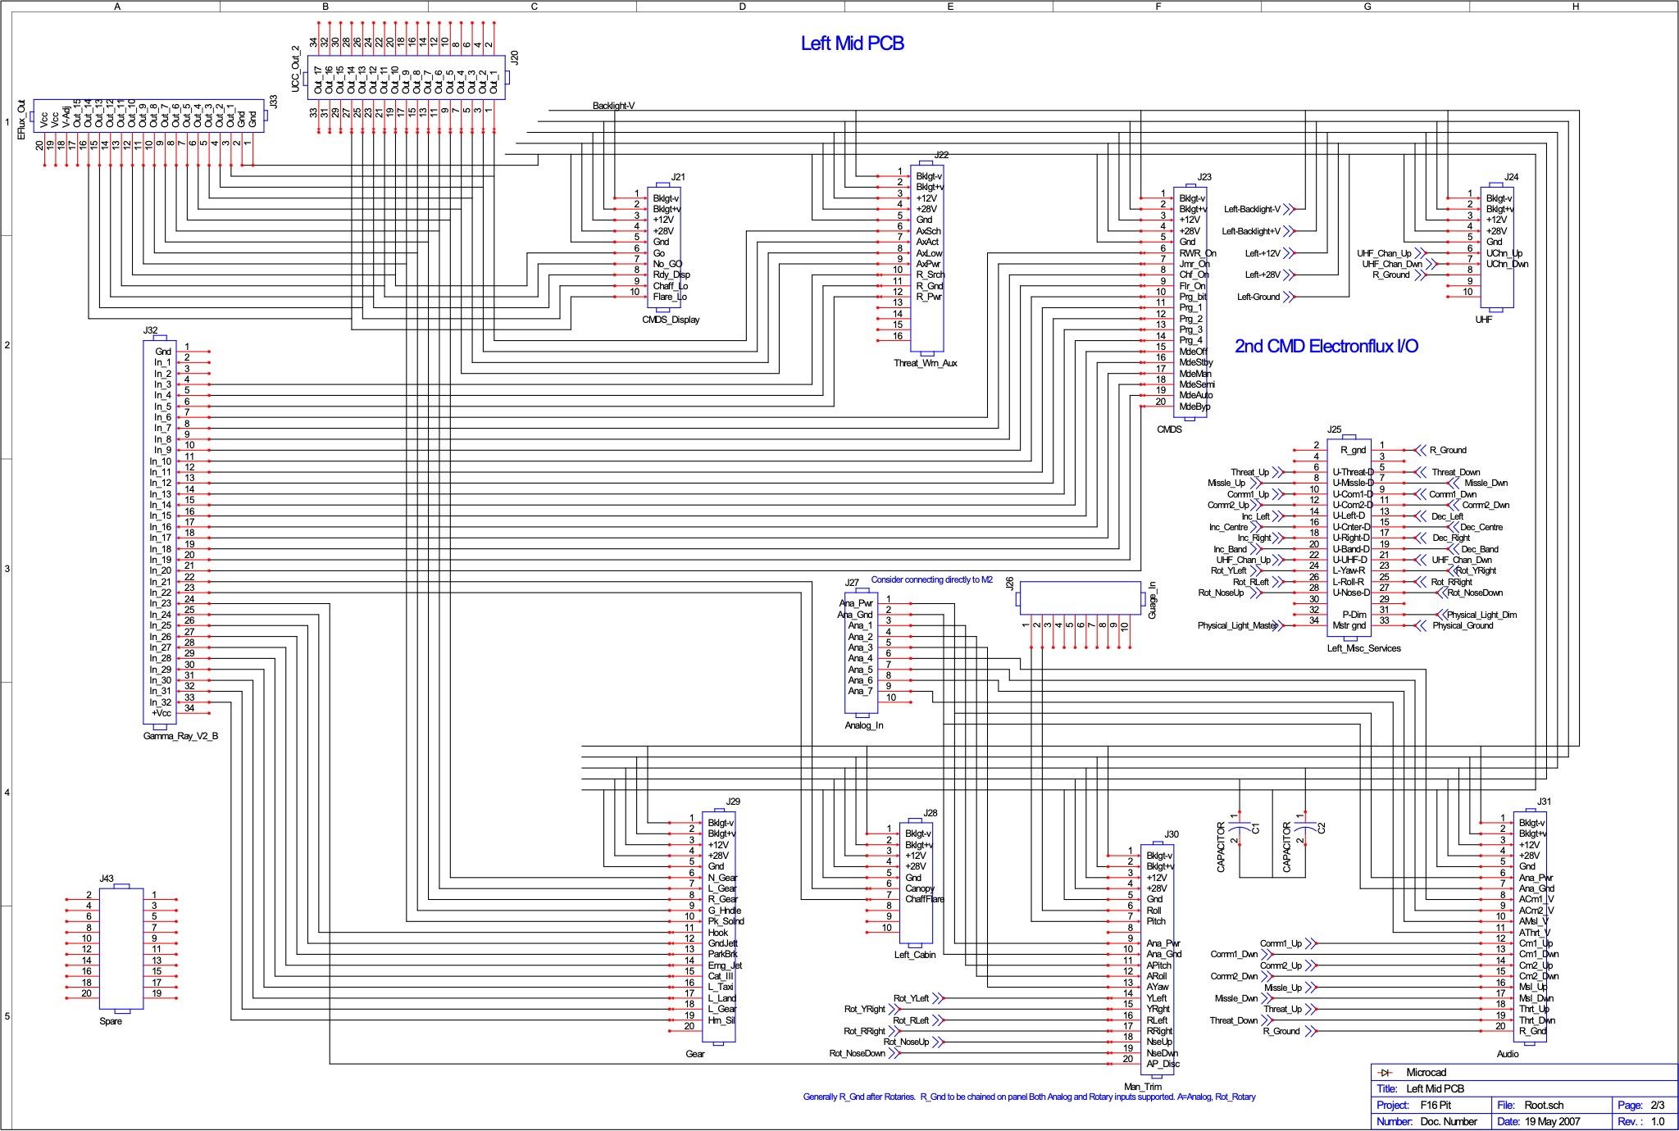

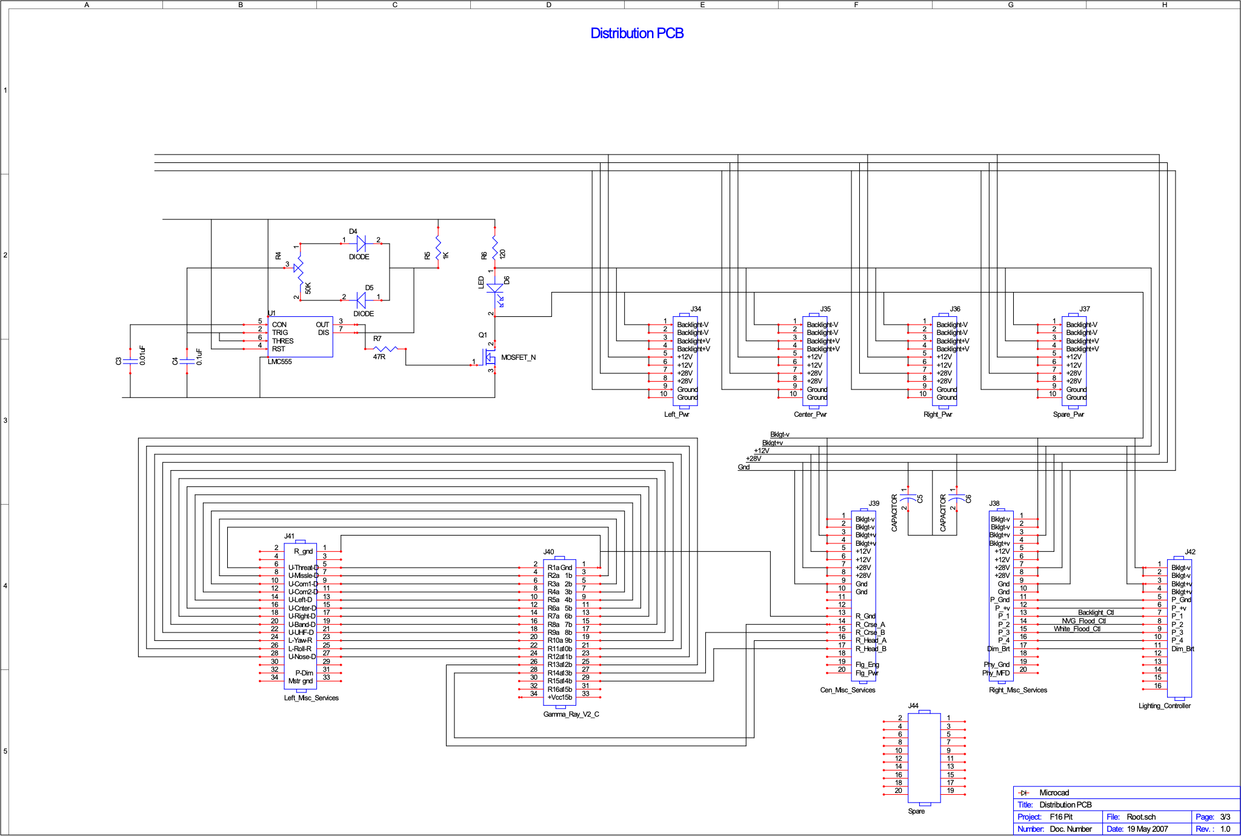

Right PCB

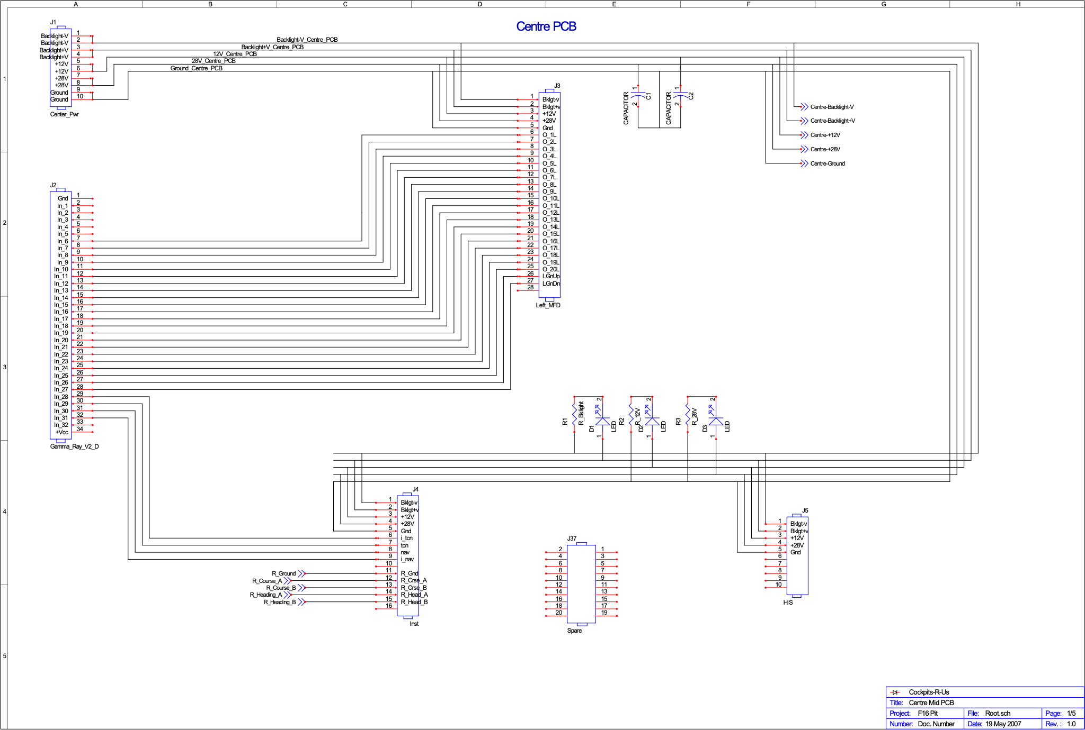

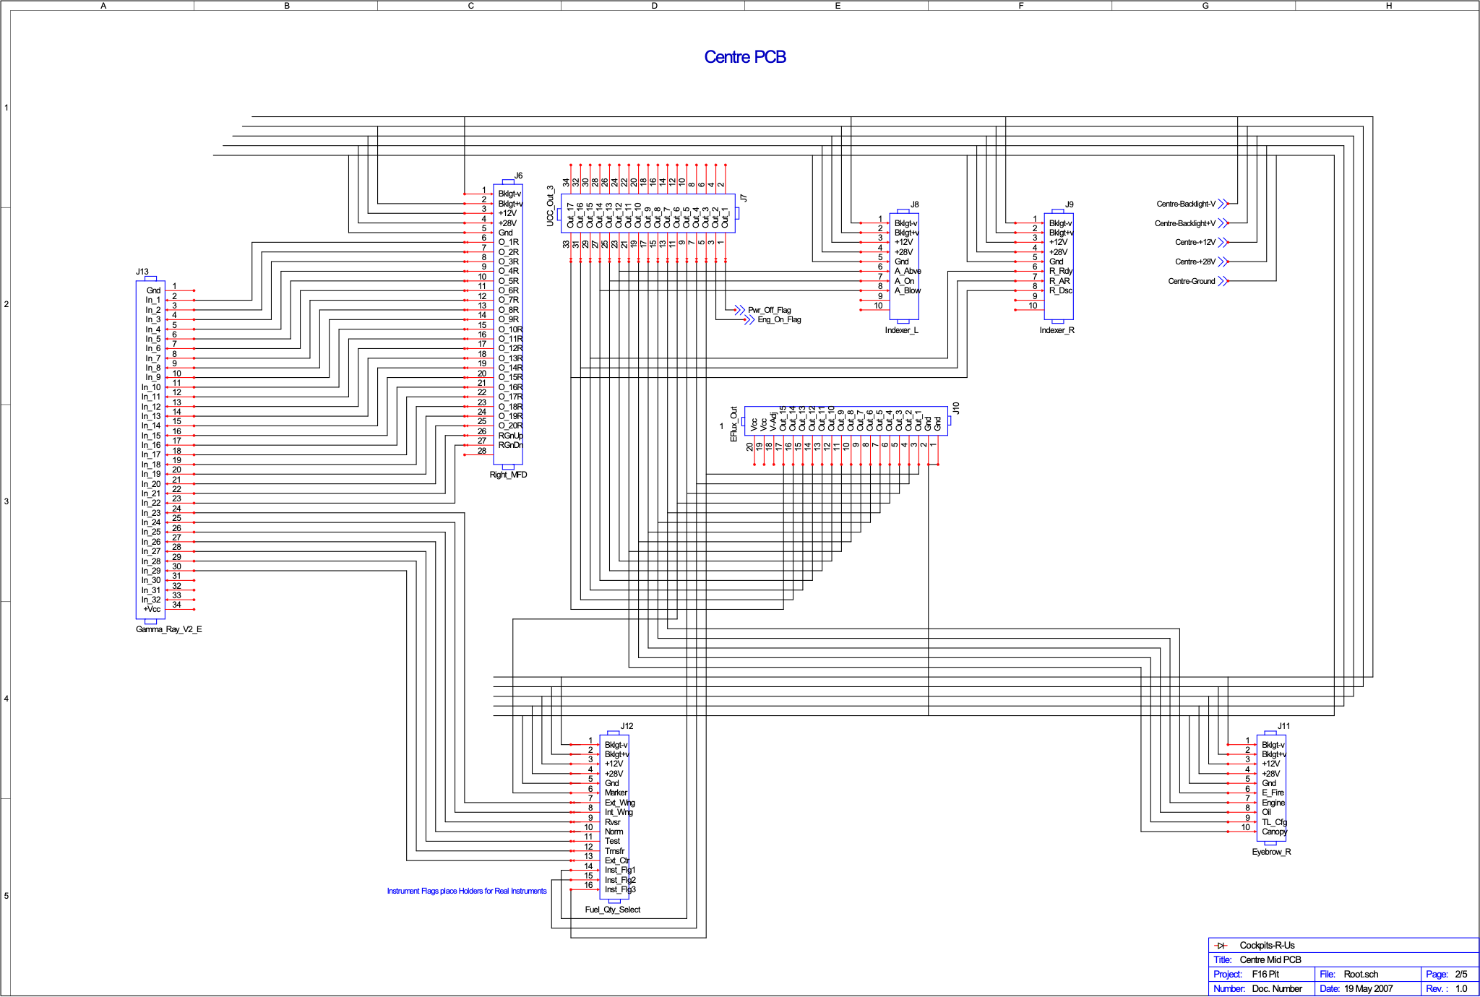

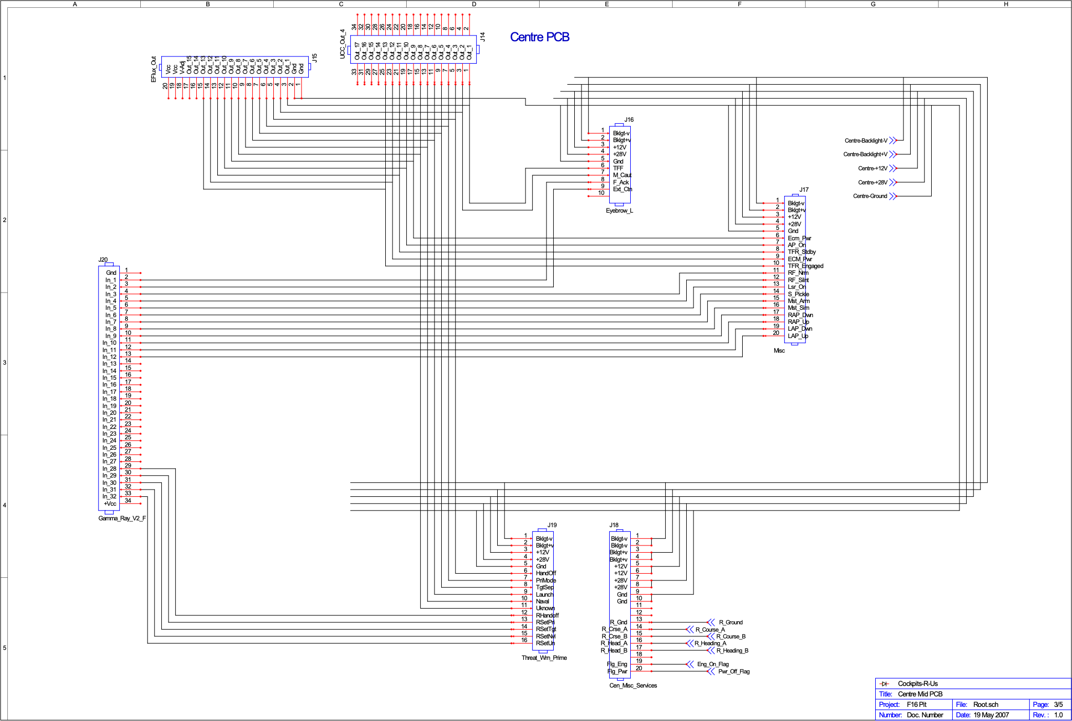

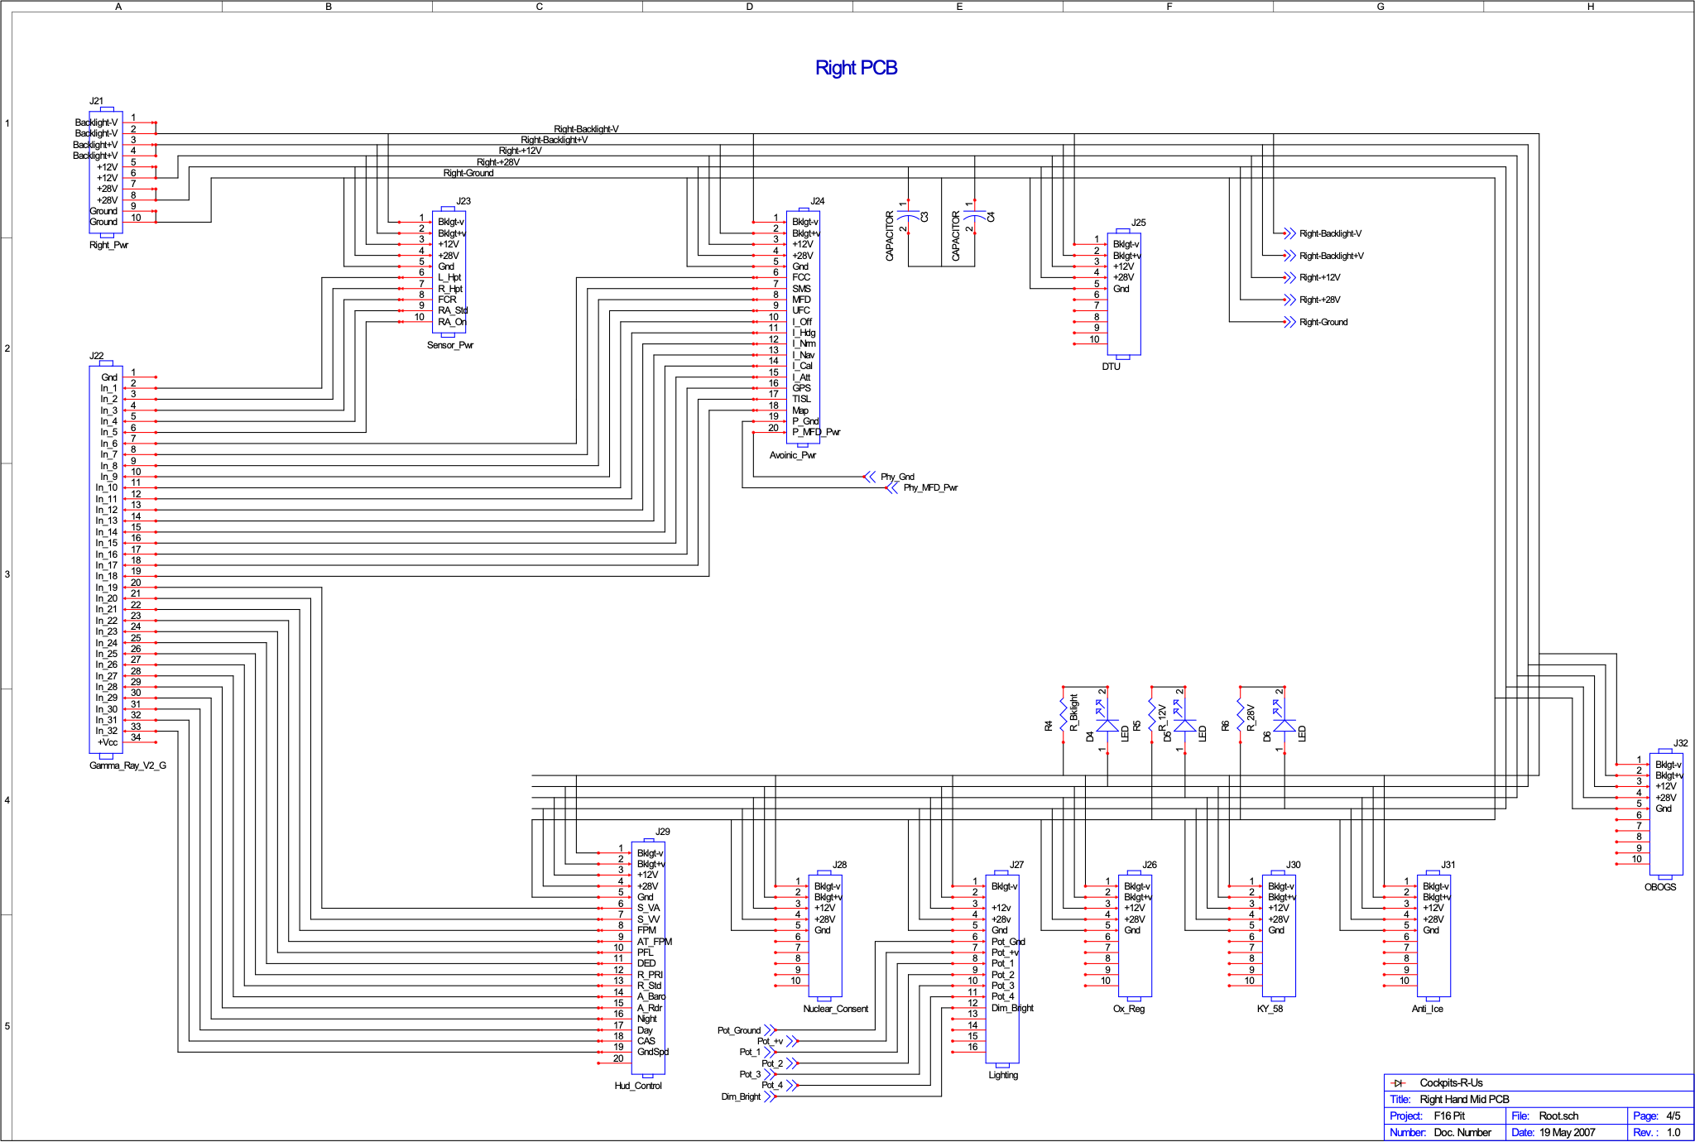

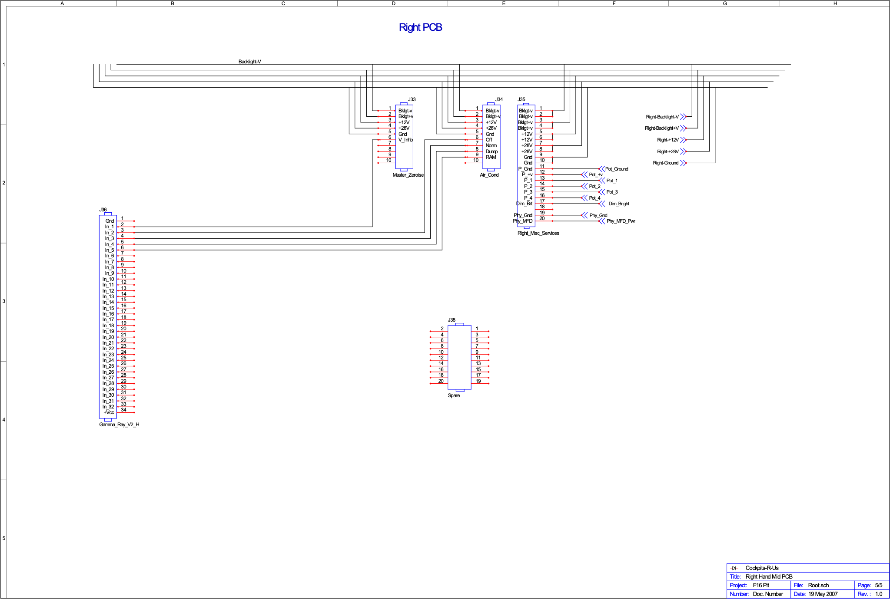

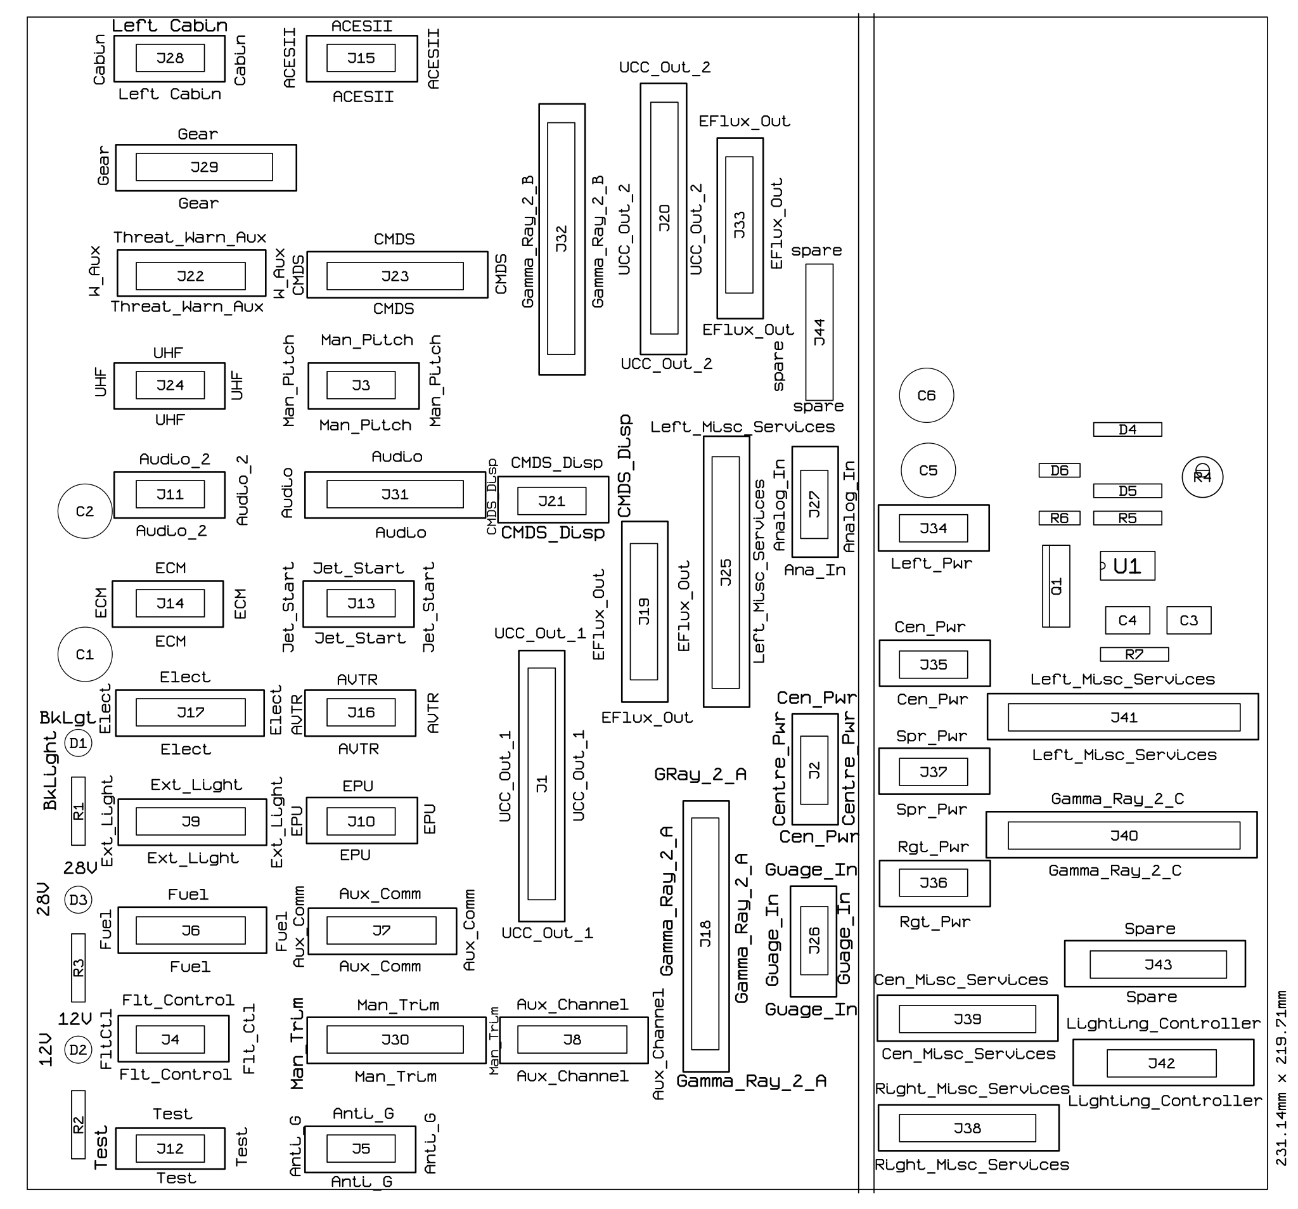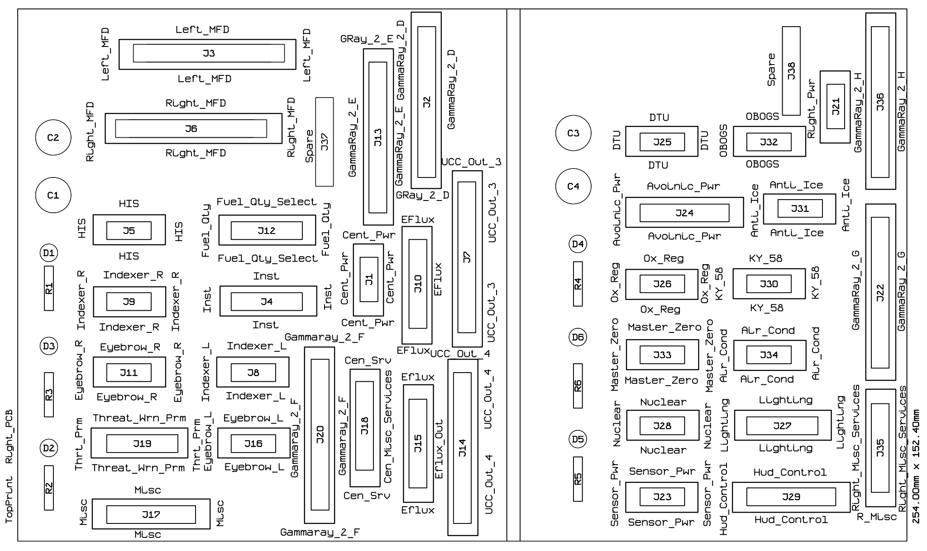

Capturing the PCB with multiple layers and colours. Tried MSPaint, Picssa2, and Office Picture editor, couldn’t find a way to chage the colour of the lines in the EMF file exported from WinQCad. Utliimately found by bringing all layers into Powerpoint the files stayed correctly overlayed.

Insert Picture from file (for Top, Bottom, and top Print) Then Right-click and edit picture, asked if you whnt to change to an Office Object, click yes. Can then select object – Right Click Format Object, select lines and then choose colour fro the layer. Then push modified layer ti back. Once the colours have been set you can then group them together. Colours used, Dark Blue for top layer, Dark Green for Bottom, and Red for Top print.

Then copy and paste directly into Word, it will paste as an Office Drawing Object.

## PCB Connectors – Quantities

There are two Cen_Misc_Services, Left_Misc_Services, Right_Misc_Services, Right_Pwr, three Centre_Pwr– to be investigated

Connector Totals:

|  |  |
| --- | --- |
| Connector Size | Quantity |
| 10 Pin | 36 |
| 16 Pin | 11 |
| 20 Pin | 19 |
| 34 Pin | 16 |
|  |  |
| Total Connectors | 82 |

|  |  |  |
| --- | --- | --- |
| Connector | Type | Location |
|  |  |  |
| Audio | CON-HDR::2x10 | J31 |
| Avoinic_Pwr | CON-HDR::2x10 | J24 |
| Cen_Misc_Services | CON-HDR::2x10 | J18 |
| Cen_Misc_Services | CON-HDR::2x10 | J39 |
| CMDS | CON-HDR::2x10 | J23 |
| EFlux_Out | CON-HDR::2x10 | J10 |
| EFlux_Out | CON-HDR::2x10 | J15 |
| EFlux_Out | CON-HDR::2x10 | J19 |
| EFlux_Out | CON-HDR::2x10 | J33 |
| Gear | CON-HDR::2x10 | J29 |
| Hud_Control | CON-HDR::2x10 | J29 |
| Man_Trim | CON-HDR::2x10 | J30 |
| Misc | CON-HDR::2x10 | J17 |
| Right_Misc_Services | CON-HDR::2x10 | J35 |
| Right_Misc_Services | CON-HDR::2x10 | J38 |
| Spare | CON-HDR::2x10 | J37 |
| Spare | CON-HDR::2x10 | J38 |
| Spare | CON-HDR::2x10 | J43 |
| Spare | CON-HDR::2x10 | J44 |
| 19 | 19 |  |
| Gamma_Ray_V2_A | CON-HDR::2x17 | J18 |
| Gamma_Ray_V2_B | CON-HDR::2x17 | J32 |
| Gamma_Ray_V2_C | CON-HDR::2x17 | J40 |
| Gamma_Ray_V2_D | CON-HDR::2x17 | J2 |
| Gamma_Ray_V2_E | CON-HDR::2x17 | J13 |
| Gamma_Ray_V2_F | CON-HDR::2x17 | J20 |
| Gamma_Ray_V2_G | CON-HDR::2x17 | J22 |
| Gamma_Ray_V2_H | CON-HDR::2x17 | J36 |
| Left_MFD | CON-HDR::2x17 | J3 |
| Left_Misc_Services | CON-HDR::2x17 | J25 |
| Left_Misc_Services | CON-HDR::2x17 | J41 |
| Right_MFD | CON-HDR::2x17 | J6 |
| UCC_Out_1 | CON-HDR::2x17 | J1 |
| UCC_Out_2 | CON-HDR::2x17 | J20 |
| UCC_Out_3 | CON-HDR::2x17 | J7 |
| UCC_Out_4 | CON-HDR::2x17 | J14 |
| 16 | 16 |  |
| ACESII | CON-HDR::2x5 | J15 |
| Air_Cond | CON-HDR::2x5 | J34 |
| Analog_In | CON-HDR::2x5 | J27 |
| Anti_Ice | CON-HDR::2x5 | J31 |
| Anti-G | CON-HDR::2x5 | J5 |
| Audio_2 | CON-HDR::2x5 | J11 |
| AVTR | CON-HDR::2x5 | J16 |
| Center_Pwr | CON-HDR::2x5 | J1 |
| Center_Pwr | CON-HDR::2x5 | J35 |
| Centre_Pwr | CON-HDR::2x5 | J2 |
| CMDS_Display | CON-HDR::2x5 | J21 |
| DTU | CON-HDR::2x5 | J25 |
| ECM | CON-HDR::2x5 | J14 |
| EPU | CON-HDR::2x5 | J10 |
| Eyebrow_L | CON-HDR::2x5 | J16 |
| Eyebrow_R | CON-HDR::2x5 | J11 |
| Flt_Control | CON-HDR::2x5 | J4 |
| Guage_In | CON-HDR::2x5 | J26 |
| HIS | CON-HDR::2x5 | J5 |
| Indexer_L | CON-HDR::2x5 | J8 |
| Indexer_R | CON-HDR::2x5 | J9 |
| Jet_Start | CON-HDR::2x5 | J13 |
| KY_58 | CON-HDR::2x5 | J30 |
| Left_Cabin | CON-HDR::2x5 | J28 |
| Left_Pwr | CON-HDR::2x5 | J34 |
| Man_pitch | CON-HDR::2x5 | J3 |
| Master_Zeroise | CON-HDR::2x5 | J33 |
| Nuclear_Consent | CON-HDR::2x5 | J28 |
| OBOGS | CON-HDR::2x5 | J32 |
| Ox_Reg | CON-HDR::2x5 | J26 |
| Right_Pwr | CON-HDR::2x5 | J21 |
| Right_Pwr | CON-HDR::2x5 | J36 |
| Sensor_Pwr | CON-HDR::2x5 | J23 |
| Spare_Pwr | CON-HDR::2x5 | J37 |
| Test | CON-HDR::2x5 | J12 |
| UHF | CON-HDR::2x5 | J24 |
| 36 | 36 |  |
| Aux_Comm | CON-HDR::2x8 | J7 |
| Aux_Comm_Channel | CON-HDR::2x8 | J8 |
| Elect | CON-HDR::2x8 | J17 |
| Ext_Light | CON-HDR::2x8 | J9 |
| Fuel | CON-HDR::2x8 | J6 |
| Fuel_Qty_Select | CON-HDR::2x8 | J12 |
| Inst | CON-HDR::2x8 | J4 |
| Lighting | CON-HDR::2x8 | J27 |
| Lighting_Controller | CON-HDR::2x8 | J42 |
| Threat_Wrn_Aux | CON-HDR::2x8 | J22 |
| Threat_Wrn_Prime | CON-HDR::2x8 | J19 |
| 11 | 11 |  |
| 82 | 82 |  |

## PCB Connectors Alphabetically Sorted

|  |  |  |
| --- | --- | --- |
| Connector | Type | Location |
| ACESII | CON-HDR::2x5 | J15 |
| Air_Cond | CON-HDR::2x5 | J34 |
| Analog_In | CON-HDR::2x5 | J27 |
| Anti_Ice | CON-HDR::2x5 | J31 |
| Anti-G | CON-HDR::2x5 | J5 |
| Audio | CON-HDR::2x10 | J31 |
| Audio_2 | CON-HDR::2x5 | J11 |
| Aux_Comm | CON-HDR::2x8 | J7 |
| Aux_Comm_Channel | CON-HDR::2x8 | J8 |
| Avoinic_Pwr | CON-HDR::2x10 | J24 |
| AVTR | CON-HDR::2x5 | J16 |
| Cen_Misc_Services | CON-HDR::2x10 | J18 |
| Cen_Misc_Services | CON-HDR::2x10 | J39 |
| Center_Pwr | CON-HDR::2x5 | J1 |
| Center_Pwr | CON-HDR::2x5 | J35 |
| Centre_Pwr | CON-HDR::2x5 | J2 |
| CMDS | CON-HDR::2x10 | J23 |
| CMDS_Display | CON-HDR::2x5 | J21 |
| DTU | CON-HDR::2x5 | J25 |
| ECM | CON-HDR::2x5 | J14 |
| EFlux_Out | CON-HDR::2x10 | J10 |
| EFlux_Out | CON-HDR::2x10 | J15 |
| EFlux_Out | CON-HDR::2x10 | J19 |
| EFlux_Out | CON-HDR::2x10 | J33 |
| Elect | CON-HDR::2x8 | J17 |
| EPU | CON-HDR::2x5 | J10 |
| Ext_Light | CON-HDR::2x8 | J9 |
| Eyebrow_L | CON-HDR::2x5 | J16 |
| Eyebrow_R | CON-HDR::2x5 | J11 |
| Flt_Control | CON-HDR::2x5 | J4 |
| Fuel | CON-HDR::2x8 | J6 |
| Fuel_Qty_Select | CON-HDR::2x8 | J12 |
| Gamma_Ray_V2_A | CON-HDR::2x17 | J18 |
| Gamma_Ray_V2_B | CON-HDR::2x17 | J32 |
| Gamma_Ray_V2_C | CON-HDR::2x17 | J40 |
| Gamma_Ray_V2_D | CON-HDR::2x17 | J2 |
| Gamma_Ray_V2_E | CON-HDR::2x17 | J13 |
| Gamma_Ray_V2_F | CON-HDR::2x17 | J20 |
| Gamma_Ray_V2_G | CON-HDR::2x17 | J22 |
| Gamma_Ray_V2_H | CON-HDR::2x17 | J36 |
| Gear | CON-HDR::2x10 | J29 |
| Guage_In | CON-HDR::2x5 | J26 |
| HIS | CON-HDR::2x5 | J5 |
| Hud_Control | CON-HDR::2x10 | J29 |
| Indexer_L | CON-HDR::2x5 | J8 |
| Indexer_R | CON-HDR::2x5 | J9 |
| Inst | CON-HDR::2x8 | J4 |
| Jet_Start | CON-HDR::2x5 | J13 |
| KY_58 | CON-HDR::2x5 | J30 |
| Left_Cabin | CON-HDR::2x5 | J28 |
| Left_MFD | CON-HDR::2x17 | J3 |
| Left_Misc_Services | CON-HDR::2x17 | J25 |
| Left_Misc_Services | CON-HDR::2x17 | J41 |
| Left_Pwr | CON-HDR::2x5 | J34 |
| Lighting | CON-HDR::2x8 | J27 |
| Lighting_Controller | CON-HDR::2x8 | J42 |
| Man_pitch | CON-HDR::2x5 | J3 |
| Man_Trim | CON-HDR::2x10 | J30 |
| Master_Zeroise | CON-HDR::2x5 | J33 |
| Misc | CON-HDR::2x10 | J17 |
| Nuclear_Consent | CON-HDR::2x5 | J28 |
| OBOGS | CON-HDR::2x5 | J32 |
| Ox_Reg | CON-HDR::2x5 | J26 |
| Right_MFD | CON-HDR::2x17 | J6 |
| Right_Misc_Services | CON-HDR::2x10 | J35 |
| Right_Misc_Services | CON-HDR::2x10 | J38 |
| Right_Pwr | CON-HDR::2x5 | J21 |
| Right_Pwr | CON-HDR::2x5 | J36 |
| Sensor_Pwr | CON-HDR::2x5 | J23 |
| Spare | CON-HDR::2x10 | J37 |
| Spare | CON-HDR::2x10 | J38 |
| Spare | CON-HDR::2x10 | J43 |
| Spare | CON-HDR::2x10 | J44 |
| Spare_Pwr | CON-HDR::2x5 | J37 |
| Test | CON-HDR::2x5 | J12 |
| Threat_Wrn_Aux | CON-HDR::2x8 | J22 |
| Threat_Wrn_Prime | CON-HDR::2x8 | J19 |
| UCC_Out_1 | CON-HDR::2x17 | J1 |
| UCC_Out_2 | CON-HDR::2x17 | J20 |
| UCC_Out_3 | CON-HDR::2x17 | J7 |
| UCC_Out_4 | CON-HDR::2x17 | J14 |
| UHF | CON-HDR::2x5 | J24 |

____________________

**LEFT PCB**

J2

BACKLIGHT-V

BACKLIGHT-V

BACKLIGHT+V

BACKLIGHT+V

+12V LEFT

+12V LEFT

+28V LEFT

+28V LEFT

GROUND

GROUND

J3

BKLGT-V

BKLGT+V

+12V LEFT

+28V LEFT,

GND LEFT

MPTCHO NET49_1,

7 OPEN,

8 OPEN,

9 OPEN,

10 OPEN

J4

BKLGT-V

BKLGT+V

+12V LEFT

+28V LEFT

GND LEFT

L_FLT

FLP_EXT

LEF_LCK

9 OPEN

10 OPEN

J5

BKLGT-V

BKLGT+V

+12V LEFT

+28V LEFT

GND LEFT

6 OPEN,

7 OPEN,

8 OPEN,

9 OPEN,

10 OPEN

);

J6

BKLGT-V

BKLGT+V

+12V LEFT

+28V LEFT

GND LEFT

FUEL_ON

PMP_OFF

PMP_NRM

PMP_AFT

PMP_FWD

FUL_DOR

12 OPEN,

13 OPEN,

14 OPEN,

15 OPEN,

16 OPEN

J7

BKLGT-V

BKLGT+V

+12V LEFT

+28V LEFT

GND LEFT

COM_OFF

COM_STB

COM_LOW

COM_NO

COM_BCK

COM_UFC

TCN_ATR

TCN_NTR

14 OPEN,

15 OPEN,

16 OPEN

J8

BKLGT-V

BKLGT+V

+12V LEFT

+28V LEFT

GND LEFT

R_GND

INC_LFT

DEC_LFT

INC_CEN

DEC_CEN

INC_RGHT

DEC_RGHT

INC_BND

DEC_BND

15 OPEN,

16 OPEN

J9

BKLGT-V

BKLGT+V

+12V LEFT

+28V LEFT

GND LEFT

EXTM_ON

ACOL_ON

FLSH_ON

WNG_DM

WNG_BRT

P_MSTR

P_DIM

P_CMN

14 OPEN,

15 OPEN,

16 OPEN

J10

BKLGT-V

BKLGT+V

+12V LEFT

+28V LEFT

GND LEFT

EPU_ON

HYDRA

AIR

EPU_OF

EPU_ON

J11

BKLGT-V

BKLGT+V

+12V LEFT

+28V LEFT

GND LEFT

6 OPEN,

7 OPEN,

8 OPEN,

9 OPEN,

10 OPEN

J12

BKLGT-V

BKLGT+V

+12V LEFT

+28V LEFT

GND LEFT

6 OPEN,

7 OPEN,

8 OPEN,

9 OPEN,

10 OPEN

J13

BKLGT-V

BKLGT+V

+12V LEFT

+28V LEFT

GND LEFT

JFS_ON_LGHT

JFS_ON_SOL

JFS_ST

9 OPEN,

10 OPEN

J14

BKLGT-V

BKLGT+V

+12V LEFT

+28V LEFT

GND LEFT

6 OPEN,

7 OPEN,

8 OPEN,

9 OPEN,

10 OPEN

J15

BKLGT-V

BKLGT+V

+12V LEFT

+28V LEFT

GND LEFT

EJECT

SEAT_ON

8 OPEN,

9 OPEN,

10 OPEN

J16

BKLGT-V

BKLGT+V

+12V LEFT

+28V LEFT

GND LEFT

AVTR

AVT_OFF

AVT_ON

9 OPEN

10 OPEN

J17

BKLGT-V

BKLGT+V

+12V LEFT

+28V LEFT

GND LEFT

FLCSPMG

MAINGEN

STBYGEN

EPUGEN

EPUPMG

BATFAIL

TOFLCS

FLCSRLY

PWR_OFF

PWRMAIN

WRN_RST

J21

BKLGT-V

BKLGT+V

+12V LEFT

+28V LEFT

GND LEFT

GO NET5_2,

NO_GO

RDY_DISP

CHAFF_LO

FLARE_LO

J22

BKLGT-V

BKLGT+V

+12V LEFT

+28V LEFT

GND LEFT

AXSCH

AXACT

AXLOW

AXPWR

R_SRCH

R_GND

R_PWR

13 OPEN,

14 OPEN,

15 OPEN,

16 OPEN

J23

BKLGT-V

BKLGT+V

+12V LEFT

+28V LEFT

GND LEFT

RWR_ON

JMR_ON

CHF_ON

FLR_ON

PRG_BIT

PRG_1

PRG_2

PRG_3

PRG_4

MDEOFF

MDESTBY

MDEMAN

MDESEMI

MDEAUTO

MDEBYP

J24

BKLGT-V

BKLGT+V

+12V LEFT

+28V LEFT

GND LEFT

UCHN_UP UHF_CHAN_UP_2,

UCHN_DWN UHF_CHAN_DWN_2,

8 R_GROUND_1,

9 OPEN,

10 OPEN

J25

R_GND

2 OPEN,

3 OPEN,

4 OPEN,

5 THREAT_DOWN_2,

U-THREAT-D THREAT_UP_2,

7 MISSLE_DWN_2,

U-MISSLE-D MISSLE_UP_2,

9 COMM1_DWN_2,

U-COM1-D COMM1_UP_2,

11 COMM2_DWN_2,

U-COM2-D COMM2_UP_2,

13 DEC_LEFT_1,

U-LEFT-D INC_LEFT_1,

15 DEC_CENTRE_1,

U-CNTER-D INC_CENTRE_1,

17 DEC_RIGHT_1,

U-RIGHT-D INC_RIGHT_1,

19 DEC_BAND_1,

U-BAND-D INC_BAND_1,

21 UHF_CHAN_DWN_2,

U-UHF-D UHF_CHAN_UP_2,

23 ROT_YRIGHT_2,

L-YAW-R ROT_YLEFT_2,

25 ROT_RRIGHT_2,

L-ROLL-R ROT_RLEFT_2,

27 ROT_NOSEDOWN_2,

U-NOSE-D ROT_NOSEUP_2,

29 OPEN,

30 OPEN,

P-DIM PHYSICAL_LIGHT_DIM_1,

32 OPEN,

GND PHYSICAL_GROUND_1,

MSTR PHYSICAL_LIGHT_MASTER_1

J26

1 NET54_2,

2 NET55_2,

3 OPEN,

4 OPEN,

5 OPEN,

6 OPEN,

7 OPEN,

8 OPEN,

9 OPEN,

10 OPEN

J27

ANA_PWR NET50_2,

ANA_GND NET49_2,

ANA_1 NET53_2,

ANA_2 NET52_2,

ANA_3 NET51_2,

ANA_4 NET48_2,

ANA_5 NET47_2,

ANA_6 NET46_2,

ANA_7 NET45_2,

10 OPEN

J28

BKLGT-V

BKLGT+V

+12V LEFT

+28V LEFT

GND LEFT

CANOPY

CHAFFFLARE

8 OPEN,

9 OPEN,

10 OPEN

);

J29

BKLGT-V

BKLGT+V

+12V LEFT

+28V LEFT

GND LEFT

N_GEAR

L_GEAR

R_GEAR

G_HNDLE

PK_SOLND

HOOK

GNDJETT

PARKBRK

EMG_JET

CAT_III

L_TAXI

L_LAND

L_GEAR

HRN_SIL

20 OPEN

J30

BKLGT-V

BKLGT+V

+12V LEFT

+28V LEFT

GND LEFT

ROLL

PITCH

8 OPEN,

ANA_PWR

ANA_GND

APITCH

AROLL

AYAW

YLEFT

YRGHT

RLEFT

RRIGHT

NSEUP

NSEDWN

AP_DISC

J31

BKLGT-V

BKLGT+V

+12V LEFT

+28V LEFT

GND LEFT

ANA_PWR

ANA_GND

ACM1_V

ACM2_V

AMSL_V

ATHRT_V

CM1_UP

CM1_DWN

CM2_UP

CM2_DWN

MSL_UP

MSL_DWN

THRT_UP

THRT_DWN

R_GND);

J34

BACKLIGHT-V

BACKLIGHT-V

BACKLIGHT+V

BACKLIGHT+V

+12V

+12V

+28V

+28V

GROUND

GROUND

J35

BACKLIGHT-V

BACKLIGHT-V

BACKLIGHT+V

BACKLIGHT+V

+12V

+12V

+28V

+28V

GROUND

GROUND

J36

BACKLIGHT-V

BACKLIGHT-V

BACKLIGHT+V

BACKLIGHT+V

+12V

+12V

+28V

+28V

GROUND

GROUND

J37

BACKLIGHT-V

BACKLIGHT-V

BACKLIGHT+V

BACKLIGHT+V

+12V

+12V

+28V

+28V

GROUND

GROUND

);

J38

BKLGT-V

BKLGT-V

BKLGT+V

BKLGT+V

+12V

+12V

+28V

+28V

GND

GND,

P_GND

P_+V

P_1 BACKLIGHT_CTL_3,

P_2 NVG_FLOOD_CTL_3,

P_3 WHITE_FLOOD_CTL_3,

P_4

DIM_

18 OPEN,

PHY_GND OPEN,

PHY_MFD OPEN

);

J39

BKLGT-V

BKLGT-V

BKLGT+V

BKLGT+V

+12V

+12V

+28V

+28V

GND

GND

11 OPEN,

12 OPEN,

R_GND

R_CRSE_A

R_CRSE_B

R_HEAD_A

R_HEAD_B

18 OPEN,

FLG_ENG OPEN,

FLG_PWR OPEN

J41

R_GND

2 OPEN,

3 OPEN,

4 OPEN,

5

U-THREAT-D

7

U-MISSLE-D

9

U-COM1-D

11

U-COM2-D

13

U-LEFT-D

15

U-CNTER-D

17

U-RIGHT-D

19

U-BAND-D

21

U-UHF-D

23

L-YAW-R

25,

L-ROLL-R

27

U-NOSE-D

29 OPEN,

30 OPEN,

P-DIM OPEN,

32 OPEN,

GND OPEN,

MSTR OPEN

);

J42 :

BKLGT-V

BKLGT-V

BKLGT+V

BKLGT+V

P_GND

P_+V

P_1 BACKLIGHT_CTL_3,

P_2 NVG_FLOOD_CTL_3,

P_3 WHITE_FLOOD_CTL_3,

P_4 NET38_3,

DIM_BRT

12 OPEN,

13 OPEN,

14 OPEN,

15 OPEN,

16 OPEN

_________________________

**RIGHT PCB**

J1 : CONNECTOR__HEADER_10 PORT MAP

(

BACKLIGHT-V

BACKLIGHT-V

BACKLIGHT+V

BACKLIGHT+V

+12V

+12V

+28V

+28V

GROUND

GROUND

J2

GND OPEN,

IN_1 OPEN,

IN_2 OPEN,

IN_3 OPEN,

IN_4 OPEN,

IN_5 OPEN,

IN_6 NET29_1,

IN_7 NET28_1,

IN_8 NET27_1,

IN_9 NET26_1,

IN_10 NET25_1,

IN_11 NET24_1,

IN_12 NET23_1,

IN_13 NET22_1,

IN_14 NET21_1,

IN_15 NET20_1,

IN_16 NET19_1,

IN_17 NET18_1,

IN_18 NET17_1,

IN_19 NET16_1,

IN_20 NET15_1,

IN_21 NET14_1,

IN_22 NET13_1,

IN_23 NET12_1,

IN_24 NET11_1,

IN_25 NET10_1,

IN_26 NET9_1,

IN_27 NET8_1,

IN_28 NET7_1,

IN_29 NET6_1,

IN_30 NET5_1,

IN_31 NET4_1,

IN_32 OPEN,

+VCC OPEN

J3

BKLGT-V

BKLGT+V

+12V

+28V

GND ,

O_1L NET29_1,

O_2L NET28_1,

O_3L NET27_1,

O_4L NET26_1,

O_5L NET25_1,

O_6L NET24_1,

O_7L NET23_1,

O_8L NET22_1,

O_9L NET21_1,

O_10L NET20_1,

O_11L NET19_1,

O_12L NET18_1,

O_13L NET17_1,

O_14L NET16_1,

O_15L NET15_1,

O_16L NET14_1,

O_17L NET13_1,

O_18L NET12_1,

O_19L NET11_1,

O_20L NET10_1,

LGNUP NET9_1,

LGNDN NET8_1,

28 OPEN

J4

BKLGT-V

BKLGT+V

+12V

+28V

GND ,

I_TCN

TCN

NAV

I_NAV

10 OPEN,

R_GND

R_CRSE_A

R_CRSE_B

R_HEAD_A

R_HEAD_B

16 OPEN

J5

BKLGT-V

BKLGT+V

+12V

+28V

GND ,

6 OPEN,

7 OPEN,

8 OPEN,

9 OPEN,

10 OPEN

J6

BKLGT-V

BKLGT+V

+12V

+28V

GND ,

O_1R NET29_2,

O_2R NET28_2,

O_3R NET27_2,

O_4R NET26_2,

O_5R NET25_2,

O_6R NET24_2,

O_7R NET23_2,

O_8R NET22_2,

O_9R NET21_2,

O_10R NET20_2,

O_11R NET19_2,

O_12R NET18_2,

O_13R NET17_2,

O_14R NET16_2,

O_15R NET15_2,

O_16R NET14_2,

O_17R NET13_2,

O_18R NET12_2,

O_19R NET11_2,

O_20R NET10_2,

RGNUP NET9_2,

RGNDN NET8_2,

28 OPEN

J7

OUT_1 PWR_OFF_FLAG_2,

2 OPEN,

OUT_2 ENG_ON_FLAG_2,

4 OPEN,

OUT_3 NET30_2,

6 OPEN,

OUT_4 NET31_2,

8 OPEN,

OUT_5 NET32_2,

10 OPEN,

OUT_6 NET33_2,

12 OPEN,

OUT_7 NET38_2,

14 OPEN,

OUT_8 NET37_2,

16 OPEN,

OUT_9 NET36_2,

18 OPEN,

OUT_10 NET35_2,

20 OPEN,

OUT_11 NET34_2,

22 OPEN,

OUT_12 NET44_2,

24 OPEN,

OUT_13 NET43_2,

26 OPEN,

OUT_14 NET42_2,

28 OPEN,

OUT_15 NET41_2,

30 OPEN,

OUT_16 NET40_2,

32 OPEN,

OUT_17 NET39_2,

34 OPEN

J8

BKLGT-V

BKLGT+V

+12V

+28V

GND ,

A_ABVE

A_ON

A_BLOW

9 OPEN,

10 OPEN

J9

BKLGT-V

BKLGT+V

+12V

+28V

GND ,

R_RDY NET41_2,

R_AR NET40_2,

R_DSC NET39_2,

9 OPEN,

10 OPEN

J10

GND ,

GND ,

OUT_1 NET30_2,

OUT_2 NET31_2,

OUT_3 NET32_2,

OUT_4 NET33_2,

OUT_5 NET38_2,

OUT_6 NET37_2,

OUT_7 NET36_2,

OUT_8 NET35_2,

OUT_9 NET34_2,

OUT_10 NET44_2,

OUT_11 NET43_2,

OUT_12 NET42_2,

OUT_13 NET41_2,

OUT_14 NET40_2,

OUT_15 NET39_2,

V-ADJ OPEN,

VCC OPEN,

VCC OPEN

J11

BKLGT-V

BKLGT+V

+12V

+28V

GND ,

E_FIRE

ENGINE

OIL

TL_CFG

CANOPY

J12

BKLGT-V

BKLGT+V

+12V

+28V

GND ,

MARKER

EXT_WNG

INT_WNG

RVSR

NORM

TEST

TRNSFR

EXT_CTR

INST_FLG1

INST_FLG2

INST_FLG3

J13

GND OPEN,

IN_1 NET29_2,

IN_2 NET28_2,

IN_3 NET27_2,

IN_4 NET26_2,

IN_5 NET25_2,

IN_6 NET24_2,

IN_7 NET23_2,

IN_8 NET22_2,

IN_9 NET21_2,

IN_10 NET20_2,

IN_11 NET19_2,

IN_12 NET18_2,

IN_13 NET17_2,

IN_14 NET16_2,

IN_15 NET15_2,

IN_16 NET14_2,

IN_17 NET13_2,

IN_18 NET12_2,

IN_19 NET11_2,

IN_20 NET10_2,

IN_21 NET9_2,

IN_22 NET8_2,

IN_23 NET7_2,

IN_24 NET6_2,

IN_25 NET5_2,

IN_26 NET4_2,

IN_27 NET3_2,

IN_28 NET2_2,

IN_29 NET1_2,

IN_30 OPEN,

IN_31 OPEN,

IN_32 OPEN,

+VCC OPEN

J14

OUT_1 NET30_3,

2 OPEN,

OUT_2 NET29_3,

4 OPEN,

OUT_3 NET23_3,

6 OPEN,

OUT_4 NET22_3,

8 OPEN,

OUT_5 NET21_3,

10 OPEN,

OUT_6 NET20_3,

12 OPEN,

OUT_7 NET19_3,

14 OPEN,

OUT_8 NET18_3,

16 OPEN,

OUT_9 NET28_3,

18 OPEN,

OUT_10 NET27_3,

20 OPEN,

OUT_11 NET26_3,

22 OPEN,

OUT_12 NET25_3,

24 OPEN,

OUT_13 NET24_3,

26 OPEN,

OUT_14 OPEN,

28 OPEN,

OUT_15 OPEN,

30 OPEN,

OUT_16 OPEN,

32 OPEN,

OUT_17 OPEN,

34 OPEN

J15

GND ,

GND ,

OUT_1 NET30_3,

OUT_2 NET29_3,

OUT_3 NET23_3,

OUT_4 NET22_3,

OUT_5 NET21_3,

OUT_6 NET20_3,

OUT_7 NET19_3,

OUT_8 NET18_3,

OUT_9 NET28_3,

OUT_10 NET27_3,

OUT_11 NET26_3,

OUT_12 NET25_3,

OUT_13 NET24_3,

OUT_14 OPEN,

OUT_15 OPEN,

V-ADJ OPEN,

VCC OPEN,

VCC OPEN

J16

BKLGT-V

BKLGT+V

+12V

+28V

GND ,

TFF

M_CAUT

F_ACK

EXT_CTN

10 OPEN

J17

BKLGT-V

BKLGT+V

+12V

+28V

GND ,

ECM_PWR

AP_ON

TFR_STDBY

ECM_PWR

TFR_ENGAGED

RF_NRM

RF_SILNT

LSR_ON

S_PICKLE

MST_ARM

MST_SIM

RAP_DWN

RAP_UP

LAP_DWN

LAP_UP

J18

BKLGT-V

BKLGT-V

BKLGT+V

BKLGT+V

+12V

+12V

+28V

+28V

GND ,

GND ,

11 OPEN,

12 OPEN,

R_GND

R_CRSE_A

R_CRSE_B

R_HEAD_A

R_HEAD_B

18 OPEN,

FLG_ENG

FLG_PWR

J19

BKLGT-V

BKLGT+V

+12V

+28V

GND ,

HANDOFF

PRIMODE

TGTSEP

LAUNCH

NAVAL

UKNOWN

RHANDOFF

RSETPRI

RSETTGT

RSETNVL

RSETUN

J20

GND OPEN,

IN_1 NET17_3,

IN_2 NET16_3,

IN_3 NET15_3,

IN_4 NET14_3,

IN_5 NET13_3,

IN_6 NET12_3,

IN_7 NET11_3,

IN_8 NET10_3,

IN_9 NET9_3,

IN_10 NET8_3,

J21

BACKLIGHT-V

BACKLIGHT-V

BACKLIGHT+V

BACKLIGHT+V

+12V

+12V

+28V

+28V

GROUND ,

GROUND

J23

BKLGT-V

BKLGT+V

+12V

+28V

GND ,

L_HPT

R_HPT

FCR

RA_STD

RA_ON

J24

BKLGT-V

BKLGT+V

+12V

+28V

GND ,

FCC

SMS

MFD

UFC

I_OFF

I_HDG

I_NRM

I_NAV

I_CAL

I_ATT

GPS

TISL

MAP

P_GND PHY_MFD_PWR_4,

P_MFD_PWR PHY_GND_4

);

J25

BKLGT-V

BKLGT+V

+12V

+28V

GND ,

6 OPEN,

7 OPEN,

8 OPEN,

9 OPEN,

10 OPEN;

J26 : CONNECTOR__HEADER_10 PORT MAP

(

BKLGT-V

BKLGT+V

+12V

+28V

GND ,

6 OPEN,

7 OPEN,

8 OPEN,

9 OPEN,

10 OPEN

J27

BKLGT-V

BKLGT+V

+12V

+28V

GND ,

POT_GND POT_GROUND_4,

POT_+V POT_+V_4,

POT_1 POT_1_4,

POT_2 POT_2_4,

POT_3 POT_3_4,

POT_4 POT_4_4,

DIM_BRIGHT DIM_BRIGHT_4,

13 OPEN,

14 OPEN,

15 OPEN,

16 OPEN

J28

BKLGT-V

BKLGT+V

+12V

+28V

GND ,

6 OPEN,

7 OPEN,

8 OPEN,

9 OPEN,

10 OPEN

);

J29 : CONNECTOR__HEADER_20 PORT MAP

(

BKLGT-V

BKLGT+V

+12V

+28V

GND ,

S_VA

S_VV

FPM

AT_FPM

PFL

DED

R_PRI

R_STD

A_BARO

A_RDR

NIGHT

DAY

CAS

GNDSPD

20 OPEN

J30

BKLGT-V

BKLGT+V

+12V

+28V

GND ,

6 OPEN,

7 OPEN,

8 OPEN,

9 OPEN,

10 OPEN

J31

BKLGT-V

BKLGT+V

+12V

+28V

GND ,

6 OPEN,

7 OPEN,

8 OPEN,

9 OPEN,

10 OPEN

J32

BKLGT-V

BKLGT+V

+12V

+28V

GND ,

6 OPEN,

7 OPEN,

8 OPEN,

9 OPEN,

10 OPEN

J33

BKLGT-V

BKLGT+V

+12V

+28V

GND ,

V_INHB NET5_5,

7 OPEN,

8 OPEN,

9 OPEN,

10 OPEN

J34

BKLGT-V

BKLGT+V

+12V

+28V

GND ,

OFF

NORM

DUMP

RAM

10 OPEN

J35

BKLGT-V

BKLGT-V

BKLGT+V

BKLGT+V

+12V

+12V

+28V

+28V

GND ,

GND ,

P_GND POT_GROUND_4,

P_+V POT_+V_4,

P_1 POT_1_4,

P_2 POT_2_4,

P_3 POT_3_4,

P_4 POT_4_4,

DIM_BRT DIM_BRIGHT_4,

18 OPEN,

PHY_GND PHY_GND_4,

PHY_MFD PHY_MFD_PWR_4

J36

GND OPEN,

IN_1 NET5_5,

IN_2 NET4_5,

IN_3 NET3_5,

IN_4 NET2_5,

IN_5 NET1_5,

IN_6 OPEN,

IN_7 OPEN,

IN_8 OPEN,

IN_9 OPEN,

IN_10 OPEN,

IN_11 OPEN,

IN_12 OPEN,

IN_13 OPEN,

IN_14 OPEN,

IN_15 OPEN,

IN_16 OPEN,

IN_17 OPEN,

IN_18 OPEN,

IN_19 OPEN,

IN_20 OPEN,

IN_21 OPEN,

IN_22 OPEN,

IN_23 OPEN,

IN_24 OPEN,

IN_25 OPEN,

IN_26 OPEN,

IN_27 OPEN,

IN_28 OPEN,

IN_29 OPEN,

IN_30 OPEN,

IN_31 OPEN,

IN_32 OPEN,

+VCC OPEN

1. Source [http://forum.lockon.ru/showthread.php?p=134132&posted=1#post134132](http://forum.lockon.ru/showthread.php?p=134132&posted=1%23post134132). See my FSSServer document for a complete LUA Export file.
2. I have experienced intermittent boot failures after installing the USB-to-Serial converter, I’m guessing Windows XP thinks there may be a mouse attached to the serial port, and when it tries to discover the mouse Windows XP gets confused and hangs. As a short term work around the USB port is unplugged when the computer is started, a longer term solution is hopefully going to be the disabling of Windows auto-discovery of serial ports.
3. I ultimately solved this problem by removing the PFC electronic and using Beta Innovations Joystick controller.
4. Something worth trying is using the Beta Innovation Device Manager to Select which of the eight Plasma input maps to the Joystick inputs. This has the benefit of no possible false inputs.
5. http://touch-buddy.com/forums/showthread.php?t=555
6. It seems that the Parallax card doesn’t start well unless the PSU is powered up before the second computer is powered on. This is bogus, as the Parallax is running from a plug-pack, to be investigated}. Looks like the root cause couldbe the slow ramp time of the plug-pack PSU.
7. <http://www.modtronix.com/> LCD204B-YHY - LCD Character Module Display, 4x20 characters, STN yellow/green, yellow/green LED backlight, Transflective, 6:00
8. <http://www.usbmicro.com/> U421
9. While testing both Side and Glide returned -1.00
10. While testing SlipballPosition returned 0.00
11. [www.sysinternals.com](http://www.sysinternals.com/) Have a range of very powerful tools for monitoring processes, disks, networks, and serial ports.